**User Guide**

**Installation**

To use this application, you need Python 3 installed. Follow these steps:

1. Download or clone the project files.
2. Open a terminal or command prompt in the project directory.
3. Install the necessary Python packages with the following command:
4. pip install customtkinter networkx matplotlib

**Quick Start**

1. Run the application by executing the main Python file.
2. The main window will appear. On the left, you'll see the note explorer.
3. Click the **"New Note"** button to create your first note. You can choose to make it a top-level note or a child of a selected note.
4. The new note will appear in the editor in the middle pane. Give it a title and add some content.
5. Add tags in the "Tags" field at the bottom, separated by commas (e.g., python, projects, ideas).
6. Click **"Save"** to save your changes.

**Core Features**

**1. Creating and Managing Notes**

* **Create:** Click "New Note". If you have a note selected in the tree, the new note will become its child. If not, it will be a top-level note.
* **Delete:** Select a note in the tree on the left and click the "Delete" button.

*(Placeholder* for Screenshot: A view of the main UI, *highlighting the "New Note" and "Delete" buttons and the note tree.)*

**2. Linking Notes**

1. Open the note you want to link *from*.
2. Click the **"Link to Note"** button in the right-hand panel.
3. A dialog will appear listing all other notes. Select the note you want to link *to* and click "Link".
4. The linked note will now appear in the "Linked Notes" panel on the right. You can click it to navigate directly to that note.

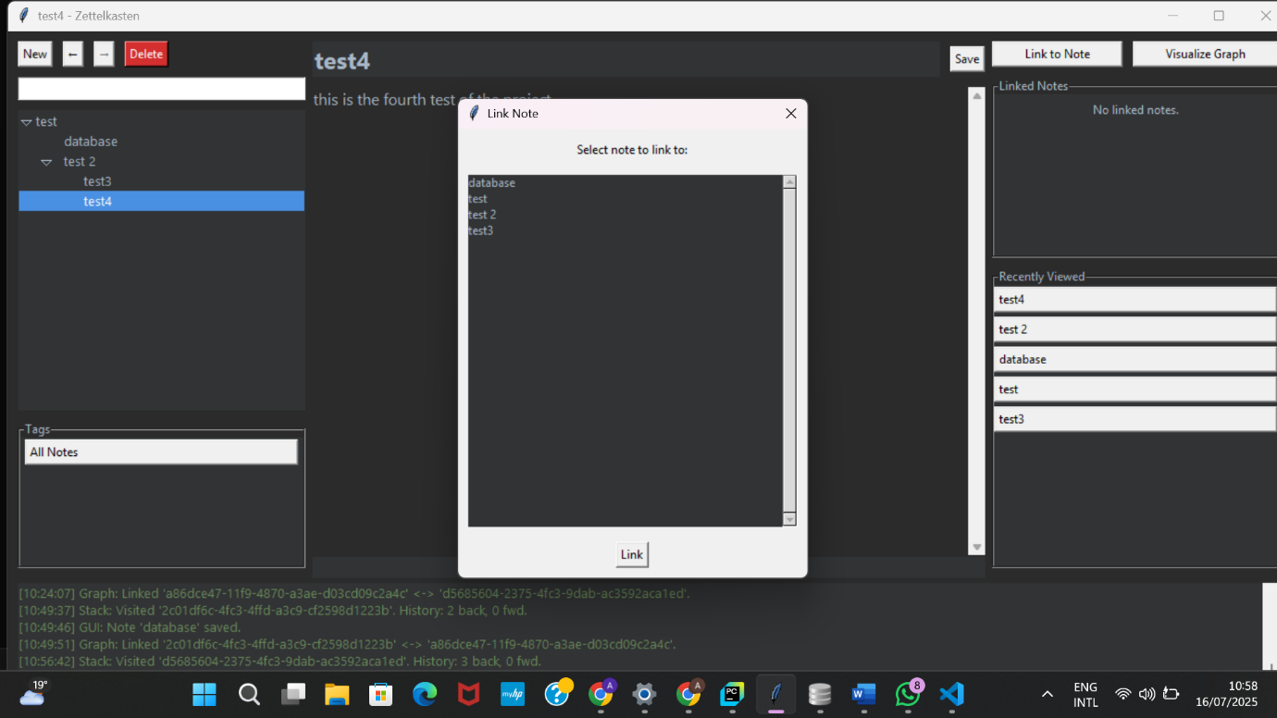

**3. Visualizing the Graph**

* Click the **"Visualize Graph"** button in the right-hand panel.
* A new window will open, displaying a graph of all your notes and the links between them. This helps you see the connections between your ideas.

*(Placeholder for Screenshot: The matplotlib graph visualization window showing interconnected nodes.)*