Screenshots of MRDSS trainings based on member’s positions. Reminder there are 3 main trainings for each position: Individual Training, Education and Training, and Comprehensive Medical Readiness Program (CMRP). This document will go through each training for each position before it goes into another training.

INDIVIDUAL TRAINING RECORD – READINESS TRAINING

**Physician:**

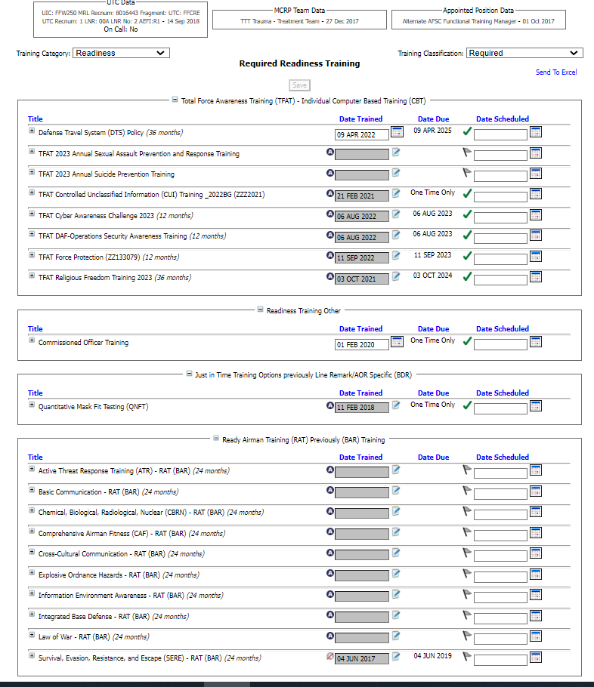

**Physician Assistant:**

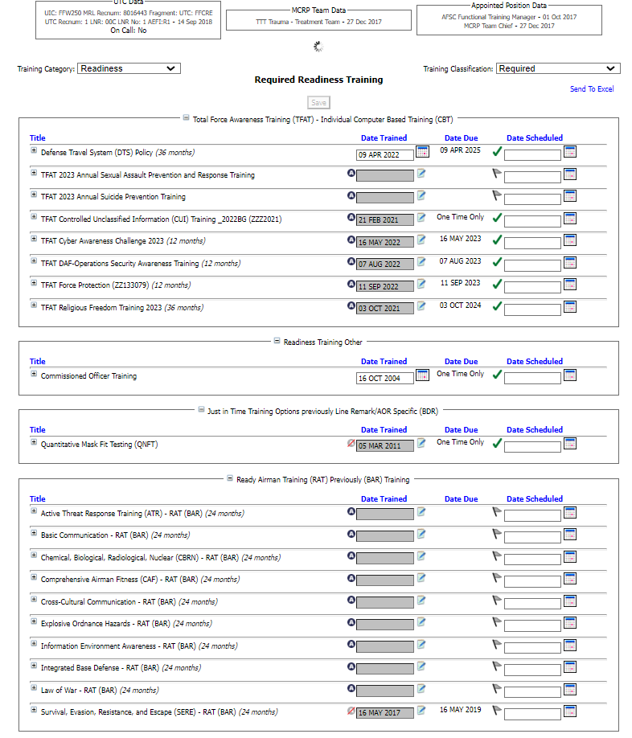

**Nurse:**

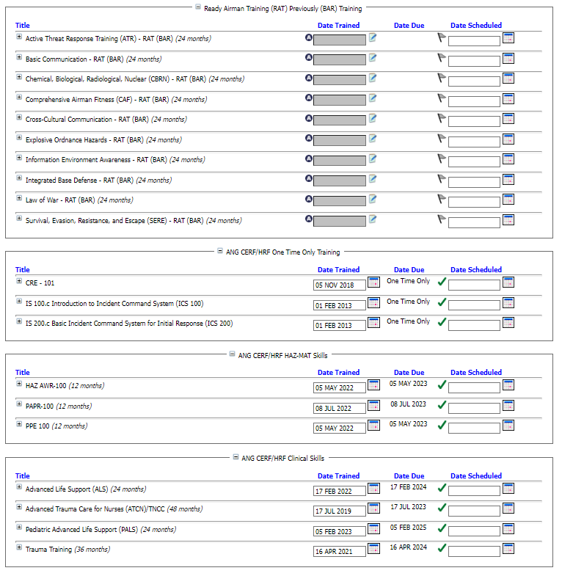

**Medic:**

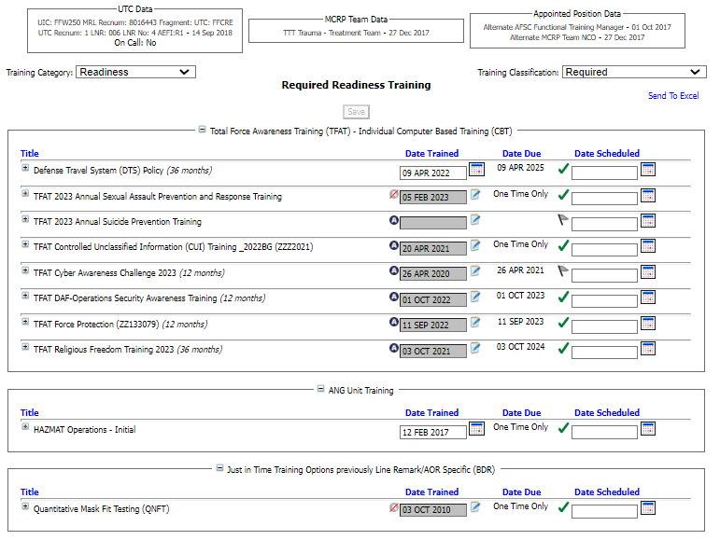

**Bioenvironmental Engineer Technician:**

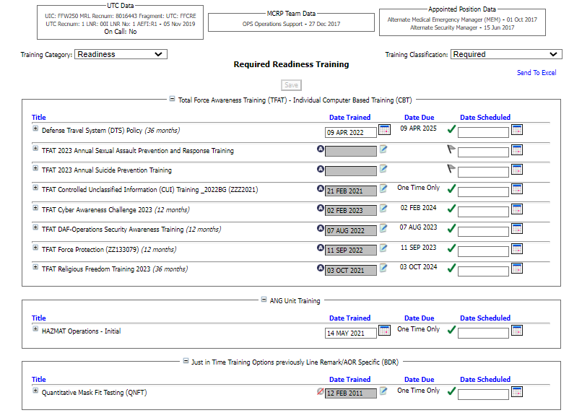

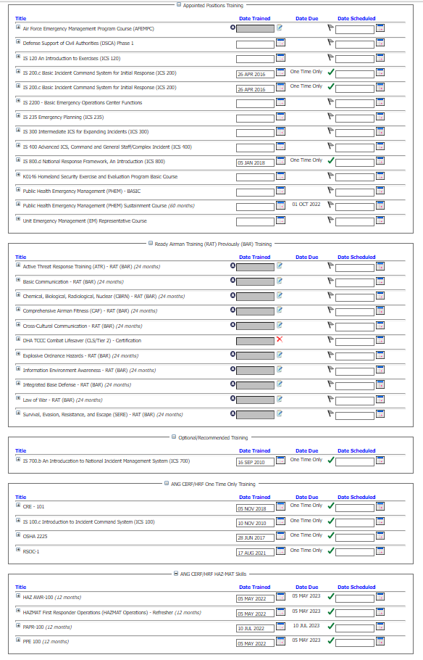

**Administration:**

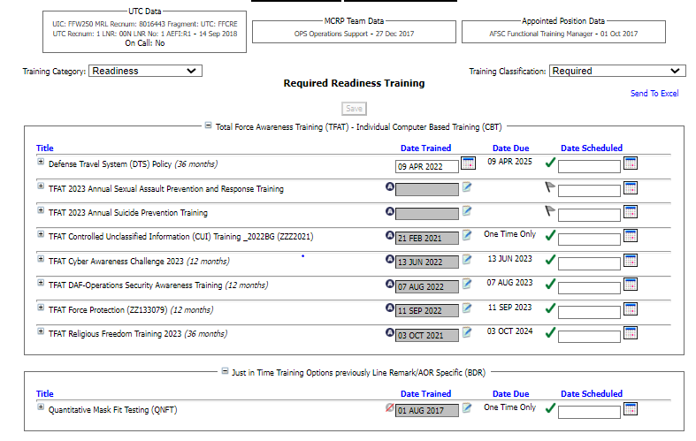

INDIVIDUAL TRAINING RECORD – EDUCATION AND TRAINING

**Physician:**

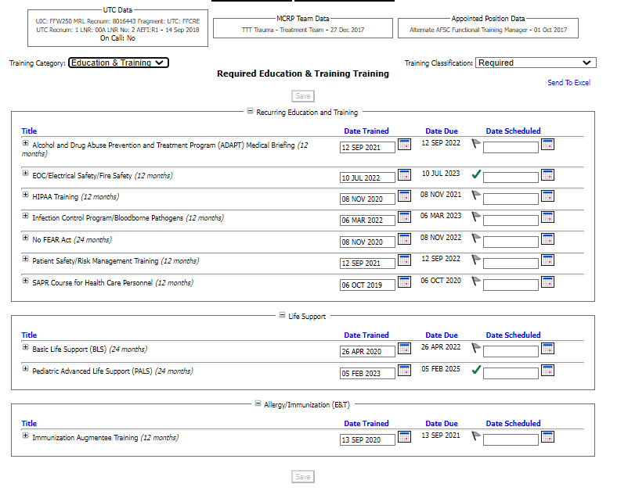

**Physician Assistant:**

**Nurse:**

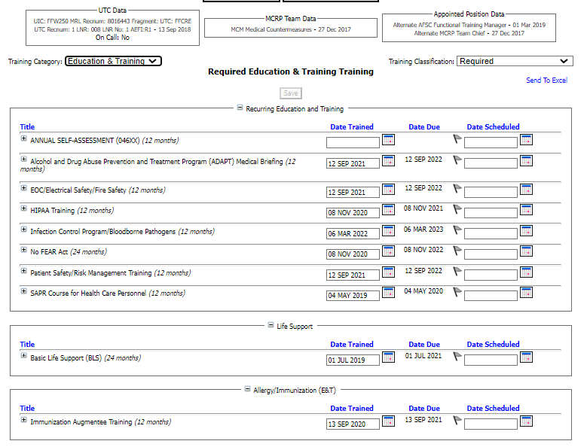

**Medic**

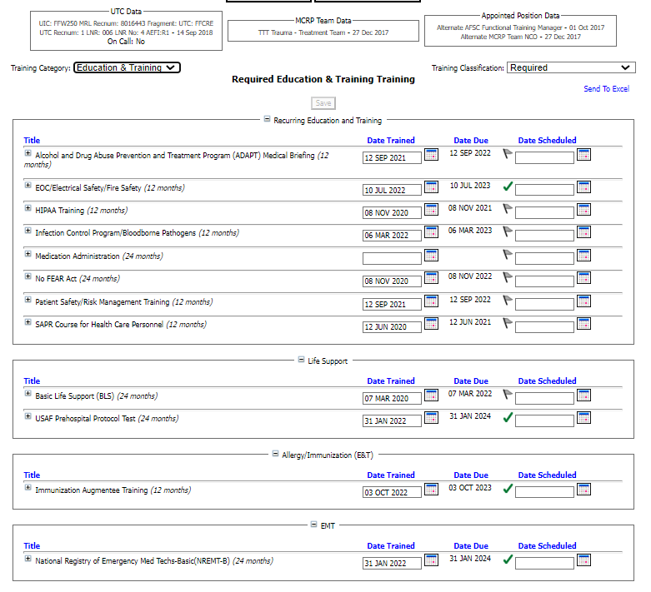

**Bioenvironmental Engineer:**

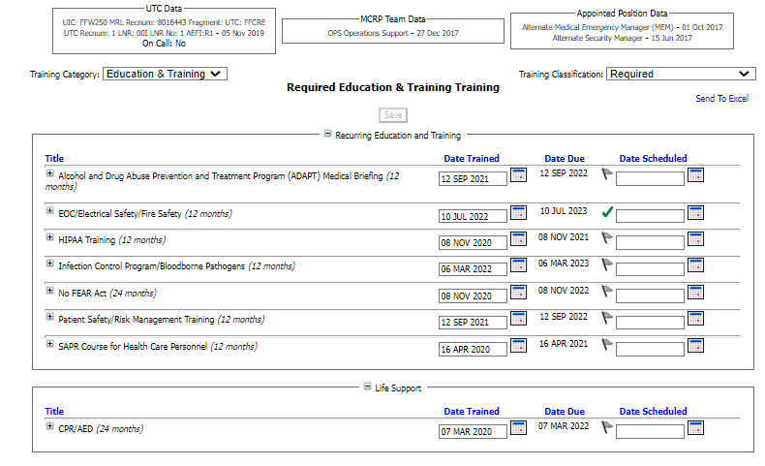

**Administration:**

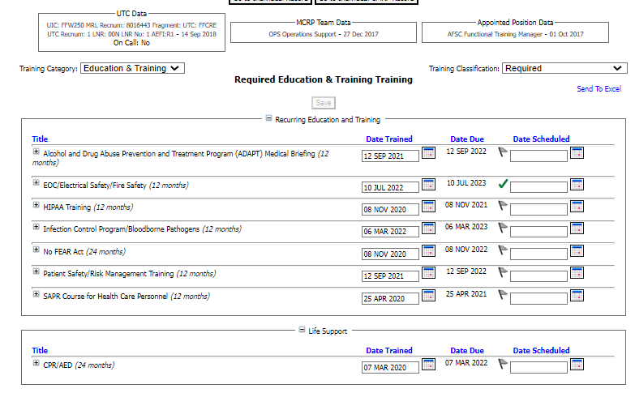

INDIVIDUAL TRAINING – COMPREHENSIVE MEDICAL READINESS PROGRAM (CMRP)

**Physician:**

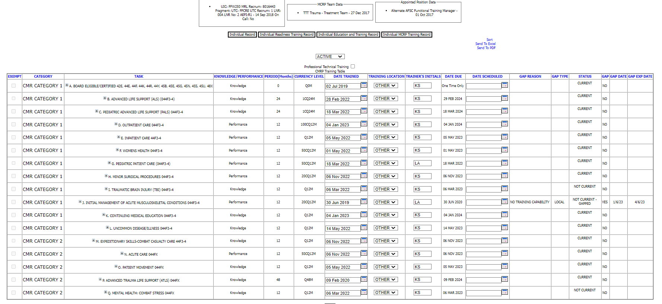

**Physician Assistant:**

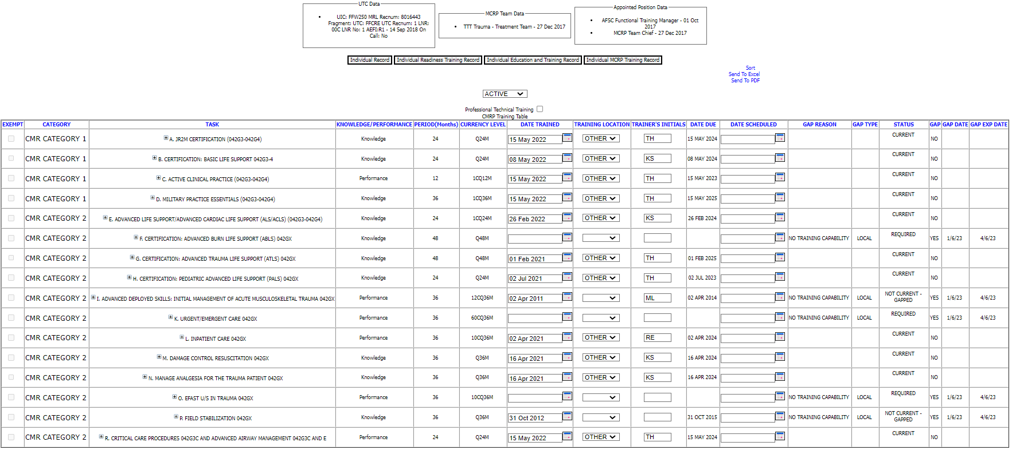

**Nurse:** 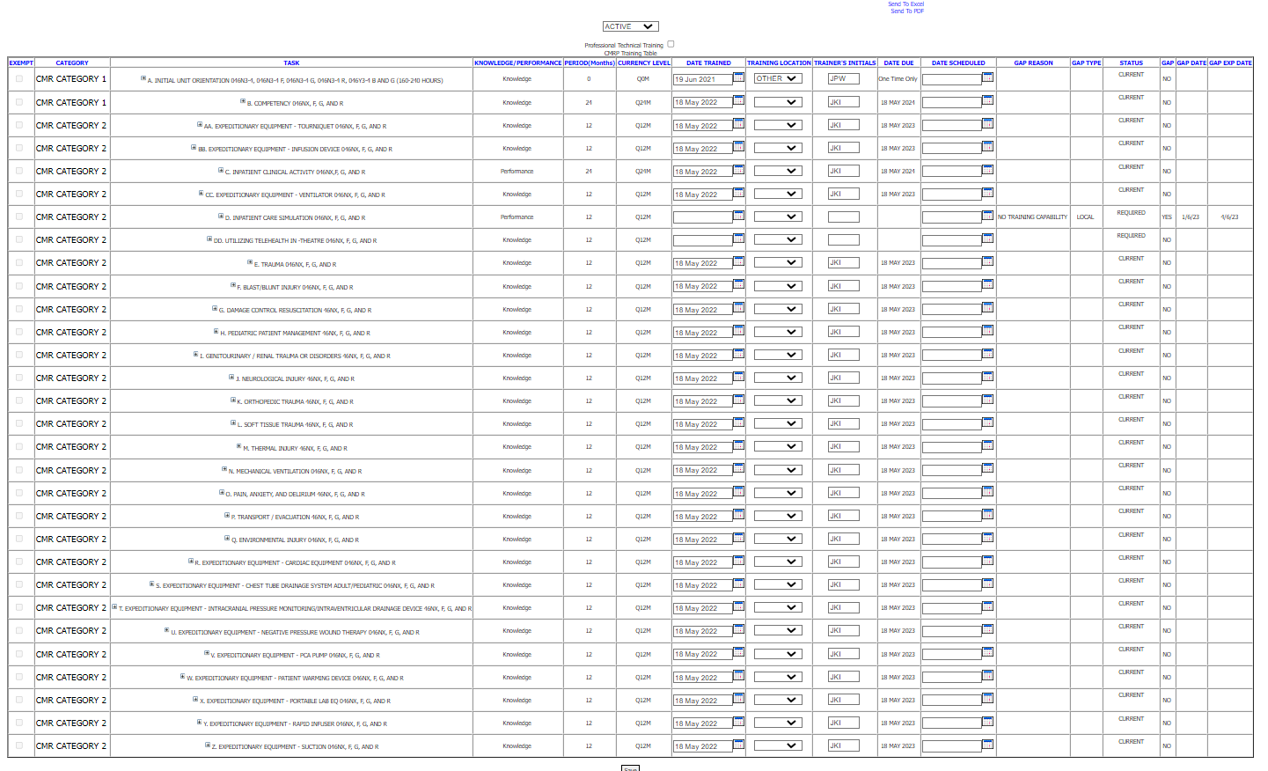

**Medic:**

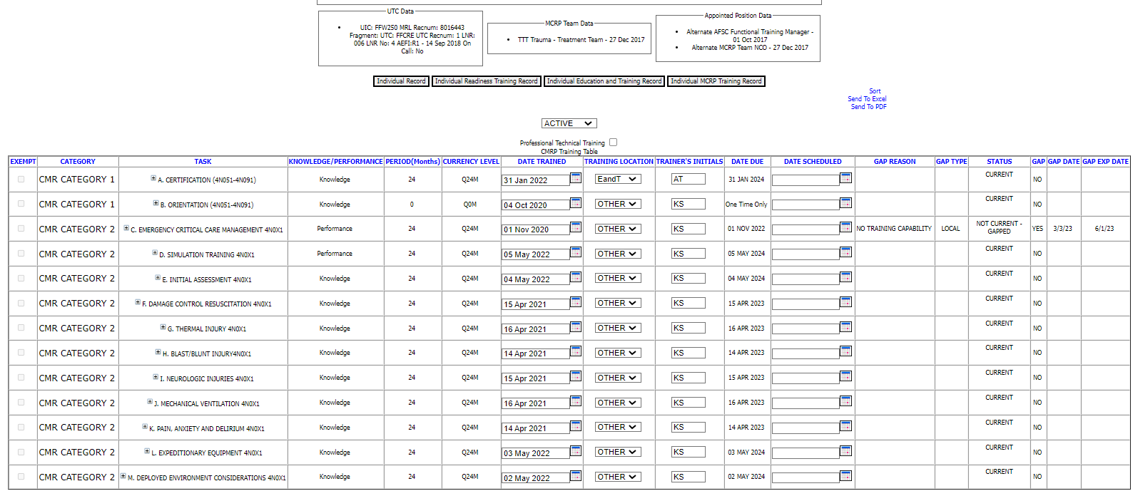

**Bioenvironmental Engineer:**

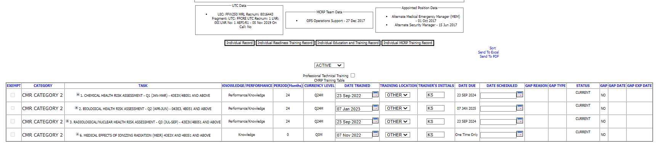

**Administration for this Training: Comprehensive Medical Readiness Program (CMRP)**

**This category consist of around 5 different jobs. Let me know when you get here and you need this information. It gets a little technical with people’s jobs. The other 2 trainings above for Administration is pretty straight forward.**