# Graphs and Applications of Matrices

From: <http://www.math.utah.edu/~gustafso/s2019/2270/labs/lab3-adjacency.pdf>

And <https://www.eecs.yorku.ca/course_archive/2006-07/W/2011/Notes/graphs_part1.pdf>

## Graphs

A graph is a set of points, called vertices or nodes, and edges that connect them. For example, a vertex represents an airport with an airport code, and an edge represents a flight route between two airports and stores the mileage of the route

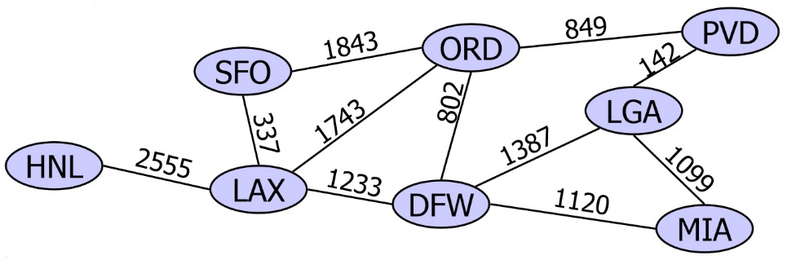

## Edge Types and Terminology

Directed (represented with arrow) and undirected. A directed graph is one in which all edges are directed, e.g. a flight network. A route network would be an undirected graph.

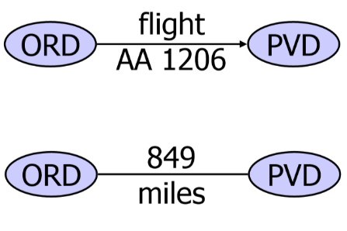

*Adjacent vertices* are connected by an edge. U and V are adjacent

*Degree* of a vertex refers to how many end vertices of an edge are incident on a vertex. W has degree 4

A *loop* is an edge with both ends incident on the same vertex, e.g. J

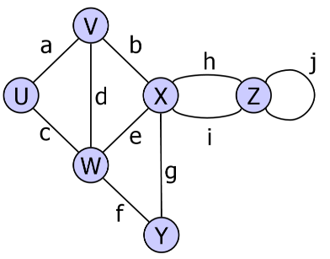

A graph is *connected* if there is a path from every vertex to every other vertex

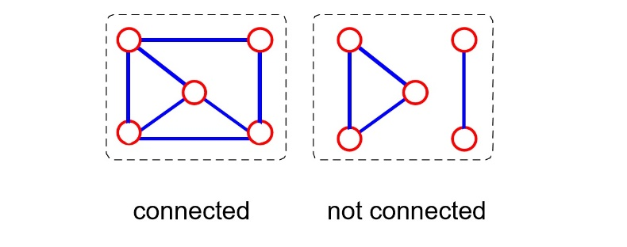

## Sample Graph Applications

Electronic circuits: printed circuit boards; integrated circuit

Transportation networks: Highway network; flight network

Computer networks: Local area network; internet

|  |  |
| --- | --- |
|  | http://www.airlinereporter.com/wp-content/uploads/2014/05/Tokyo-Metro-Map1.jpg |

## Representations of Graphs: Adjacency Matrices

A 2D matrix (or array) of size *n x n*, where *n* is the number of vertices in the graph, may be used to represent a graph. Recall that two vertices connected by an edge are said to be adjacent. Consider matrix A below. A i,j = 1 if there is an edge connecting vertices I and j. Otherwise, A i,j = 0

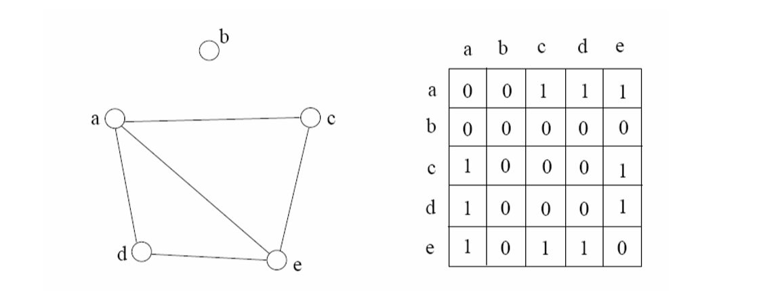

Adjacency Matrix Example:

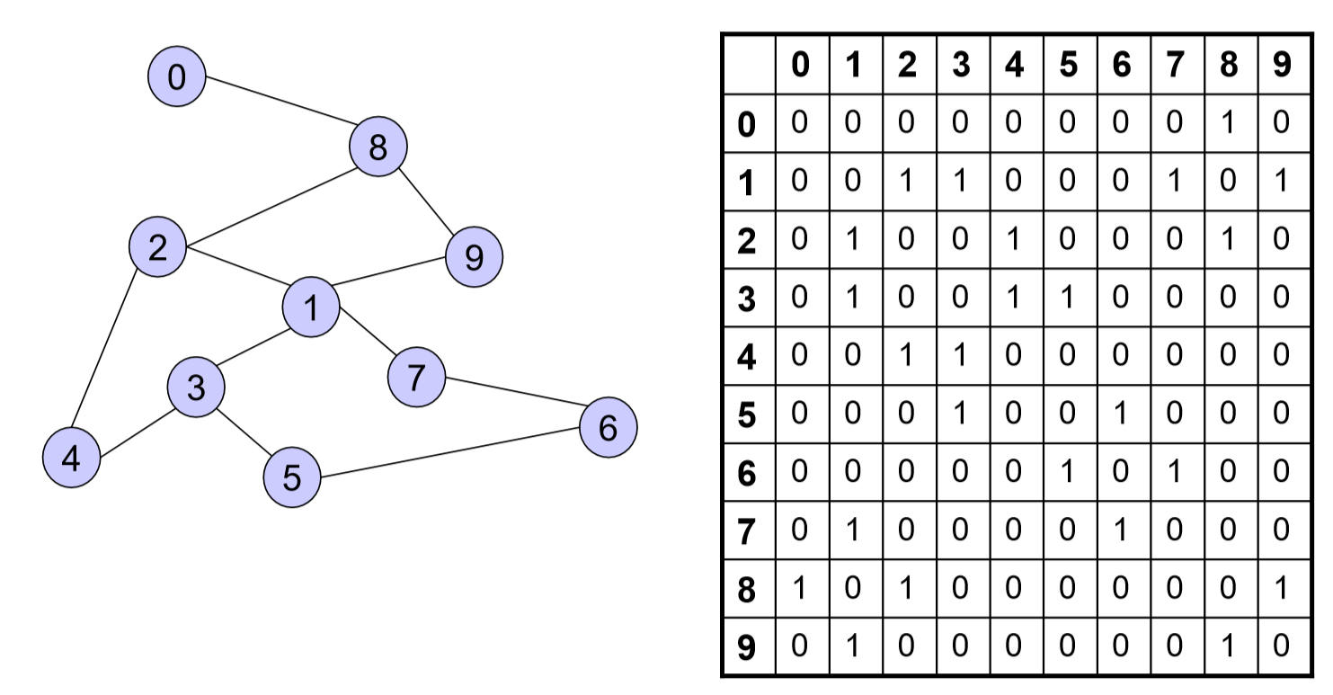

## Applications of Adjacency Matrices

Airline or railway route maps may be represented by adjacency matrices. Below is a northern route map for Cape Air from May 2001. Here the vertices are the cities to which Cape Air flies, and two vertices are connected if a direct flight exists between them.

|  |  |
| --- | --- |
|  | It might be important to know if two vertices are connected by a sequence of two edges, even if they are not connected by a single edge. Notice that A and C are connected by a two-edge sequence (actually, there are four distinct ways to go from A to C in two steps). In the route map, Provincetown and Hyannis are connected by a two-edge sequence, meaning that a passenger would have to stop in Boston while flying between those cities on Cape Air. |

If the vertices in the Cape Air graph respectively correspond to Boston, Hyannis, Martha's Vineyard, Nantucket, New Bedford, Providence, and Provincetown, then the adjacency matrix, *F*, for Cape Air is

|  |  |
| --- | --- |
| F = |  |

Which vertices are connected by a two-edge sequence? How many different two-edge sequences connect each pair of vertices? Given matrix *F* above, represent matrix *F2* and *F3* below. What does each represent?

|  |  |  |  |
| --- | --- | --- | --- |
| F2 = |  | F3 = |  |
|  |  |  |  |

What would be easy to see from a small graph is harder to see from the adjacency matrix. However, the opposite is true of very large graphs.

## Other Matrix Applications

Encryption; Representing systems of equations; Transforming 3D images; colour filters.

