Python OOP Intro

A **module**, also known as a **namespace**, is a Python file that contains a collection of variable names, known as attributes. It’s like a library of tools you can access by importing the .py file.

A **class** is a collection of related **objects**, including **attributes** (like characteristics) and **methods** (like actions).

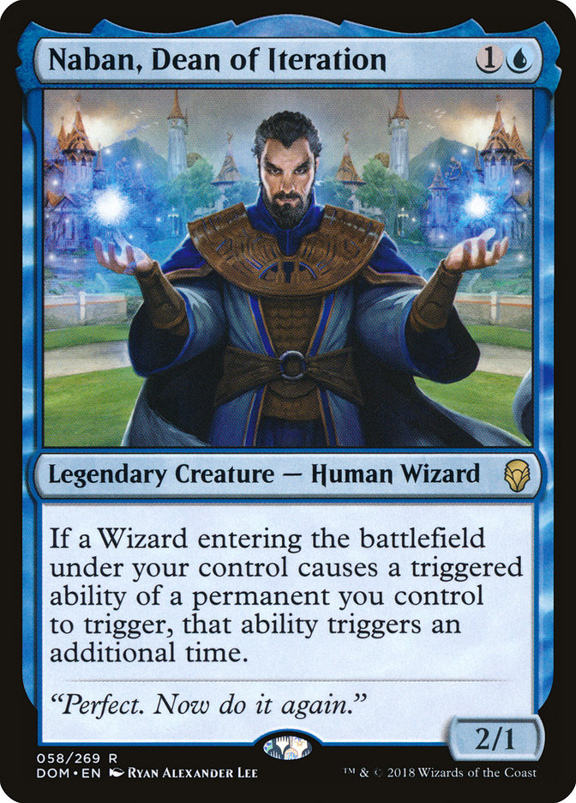 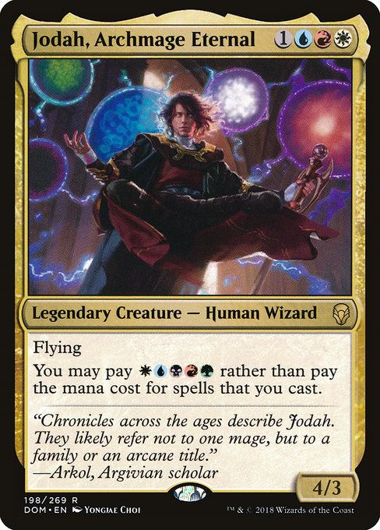

class Wizard:

name = "Defaultanor" # set attribute, ‘name’ for the class ‘Wizard’

creature = “Human Wizard”

attire = [“Cape”, “Robes”, “Staff”]

def change_name(self, new_name): # note that the first argument is self

self.name = new_name # access the class attribute with the self keyword

player1 = Wizard() # instantiate the class

print(player1.name) # print the current object name

player1.change_name("Novador") # change the name using the change_name method

print(player1.name)

You can also define attributes at runtime using the init method

class Wizard:

def __init__(self, name):

self.name = name

def change_name(self, new_name):

self.name = new_name

# two variables are instantiated

naban = Wizard("Naban")

jodah = Wizard("Jodah")

# print the names of the two variables

print(naban.name)

print(jodah.name)

Maybe you want to define a number of attributes at once:

class Wizard:

def __init__(self, name, talent, cost_white, cost_red, cost_black, cost_blue, cost_green, cost_gen, power, toughness):

self.name = name

self.cost = [cost_white, cost_red, cost_black, cost_blue, cost_green, cost_gen]

self.talent = talent

self.power = power

self.toughness = toughness

# two variables are instantiated

naban = Wizard("Naban", "Looping", 0, 0, 0, 1, 0, 1, 1, 2)

jodah = Wizard("Jodah", "Flying", 1, 1, 0, 1, 0, 1, 4, 3)

print(naban.name, naban.talent, naban.cost)

print(jodah.name, jodah.talent, jodah.cost)

time.sleep(5) #going to need to import the time module to use this

print(“FIGHT!”)

time.sleep(2)

print(“BIFF! ”, “\U0001F4A5”)

time.sleep(2)

print(“BAM! “, “\U0001F4A5”)

time.sleep(2)

print(“\U0001F4A5”, “ POW!”)

time.sleep(5)

if (naban.toughness <= jodah.power):

print(“Jodah Wins”)

else:

print(“Naban Wins”)

Now add one of these wizards to the battle. How would you stage a wizard fight?

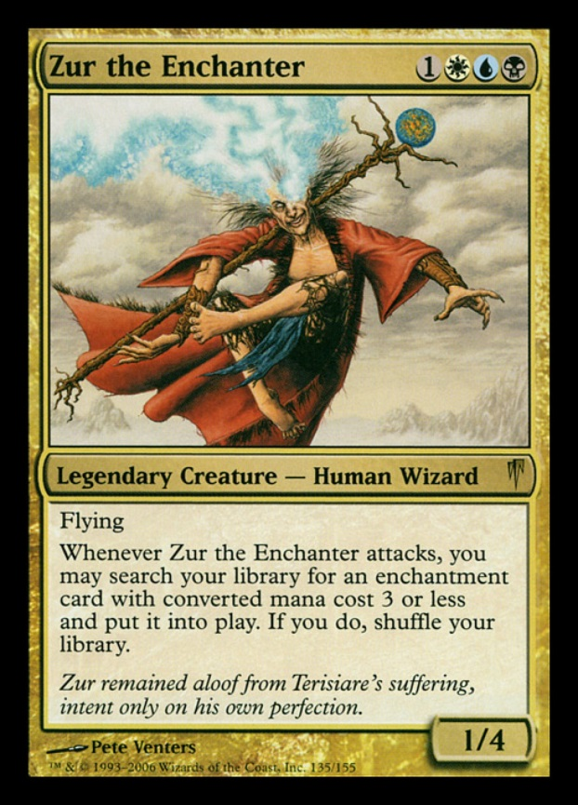 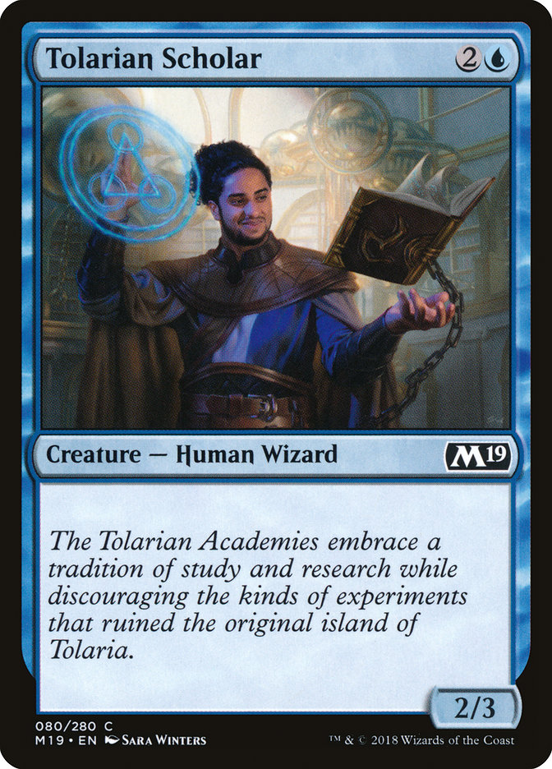

Your turn. Make another class for these characters:

