Software Architecture Document
Neighborhood Tool Sharing Platform
Group 3 — ICS 613 Software Engineering
Rion Sawabe, Ivan Wu, Nick Fairhart, Yafei Wang, Loreto Coloma
Status: Draft for team review · Date: June 18, 2026

Contents

1. Introduction
Purpose. This document records the architecture of the Neighborhood Tool Sharing platform and, just as importantly, the reasoning behind it. It is intended to be read, edited, and extended by the team as the design evolves. The significant decisions are captured as Architecture Decision Records (Section 5) so the context behind each choice is preserved rather than re-litigated.
Scope. The platform is an invite-only web application for a single private neighborhood community whose members lend and borrow tools. The first release targets the core borrowing, listing, reservation, messaging, notification, review, and moderation workflows defined in the team’s requirements packet (34 user stories across 8 sections). Production-grade operational depth and growth beyond a single small community are explicitly out of scope for this release.

2. Architecture Drivers
Architecture is shaped by four kinds of force: what the system must do, how well it must do it, the fixed limits it operates within, and the risks that could derail it. Much of this was already implicit in the requirements packet; this section surfaces and organizes it.

2.1 Functional requirements
The functional requirements are well developed (34 user stories). The architectural heart of the system is the reservation lifecycle — REQUESTED → APPROVED → PICKED_UP → RETURNED, with DENIED and CANCELLED as terminal states. The remaining areas orbit that state machine:
- Account & profile — registration via invite token, email verification, login, profile management, account deletion
- Tool listings — create, edit, deactivate, and admin-control listings with photos and lending rules
- Browse & search — keyword, category, and date-range availability search
- Reservations — the lifecycle above, plus overlap handling, auto-cancel, and HST date normalization
- Messaging & notifications — per-reservation message threads and in-app notifications
- Reviews & ratings — post-return reviews, ratings, and damage-report trust signals
- Reporting & moderation — reporting, violation tracking, suspension, reactivation, and admin reports

2.2 Quality attributes (prioritized)
The team ranked the quality attributes that matter most. A second lens — architectural significance, i.e. how strongly each one forces a structural decision — is noted because it differs from raw product priority and explains where the design spends its effort.
Rank | Quality attribute | Role in the architecture
1 | Maintainability | Top priority for a small team learning the stack on a short timeline. Drives the layered structure and clear module boundaries; the strongest force in the design.
2 | Usability | A real product priority for non-technical neighbors, but largely local to the presentation layer — it shapes screens, not system structure.
3 | Security | Invite-only access plus pervasive permission checks. Architecturally significant: it becomes a single authorization chokepoint rather than scattered checks.
4 | Correctness / data integrity | Ranked low initially, but recognized as highly architecturally significant: the no-overlap invariant and atomic cross-module operations force real structural boundaries (Sections 3 and 5).
Deprioritized by design. Performance and scalability are intentionally low priority: the team’s own assumptions state the app will remain small-scale with no need for medium- or large-scale growth. Choosing not to engineer for scale that is out of scope is itself a deliberate architectural decision.

2.3 Constraints
- A five-person student team working over a short (roughly two- to three-week) timeline.
- Team members are still learning parts of the stack; tech-stack incompatibility is a known risk.
- A single, private, invite-only neighborhood community — not a public marketplace.
- A full-stack web application delivered to web and mobile browsers.
- Small scale; growth beyond the community is out of scope for this release.

2.4 Risks
The team identified four primary delivery risks. They are process and capacity risks more than structural ones, but they reinforce the bias toward keeping the architecture simple:
- Task misunderstanding — mitigated by clear task assignment and open communication.
- Getting stuck on the same error — mitigated by asking the team early for help.
- Poor task assignment — mitigated by agreeing on per-sprint capacity before assigning.
- Tech-stack incompatibility — mitigated by checking versions and compatibility up front and testing integration early.

3. Significant Decisions & Cross-Cutting Concerns
Before choosing a pattern, the team identified the decisions that are hard to reverse and the concerns that thread through multiple parts of the system. Each is realized in the architecture and recorded as an ADR in Section 5.
Reservation engine as the sole writer of reservation state. The no-overlap invariant and the reservation state machine are the most correctness-critical part of the system. To keep the invariant in one enforceable place, a single reservation-engine module owns all reservation-state writes.
Single authorization chokepoint. Nearly every story specifies authentication, active-account, and permission checks. Rather than duplicating these across dozens of handlers, access is enforced once at the presentation/business boundary. Account suspension is enforced here as one additional condition.
Cascade-and-notify operations. Several operations — user suspension, listing deactivation, damage reporting, overdue auto-cancel — share one shape: a single event must atomically change several modules and then send notifications. These are coordinated by a cascade orchestrator rather than being scattered inline.
HST date normalization (cross-cutting). Reservation correctness depends on consistent date comparisons across time zones. All reservation-relevant dates are normalized to Hawaii Standard Time. This concern has no single component home — it threads through reservations, search, auto-cancel, and review windows — which is exactly why it is documented explicitly.

4. Architecture Overview
Chosen style: a layered monolith. The system is built as a single deployable (a monolith) organized internally into layers. Several well-known patterns stack at different altitudes rather than competing: the application is client–server by virtue of being a web app; layered internally (presentation → business logic → data access → database); uses MVC inside the presentation layer; and adds a lightweight, in-process event seam for side effects. Only the monolith-vs-microservices choice was a genuinely hard, expensive-to-reverse decision; the rest follow from it and from the priority on maintainability.
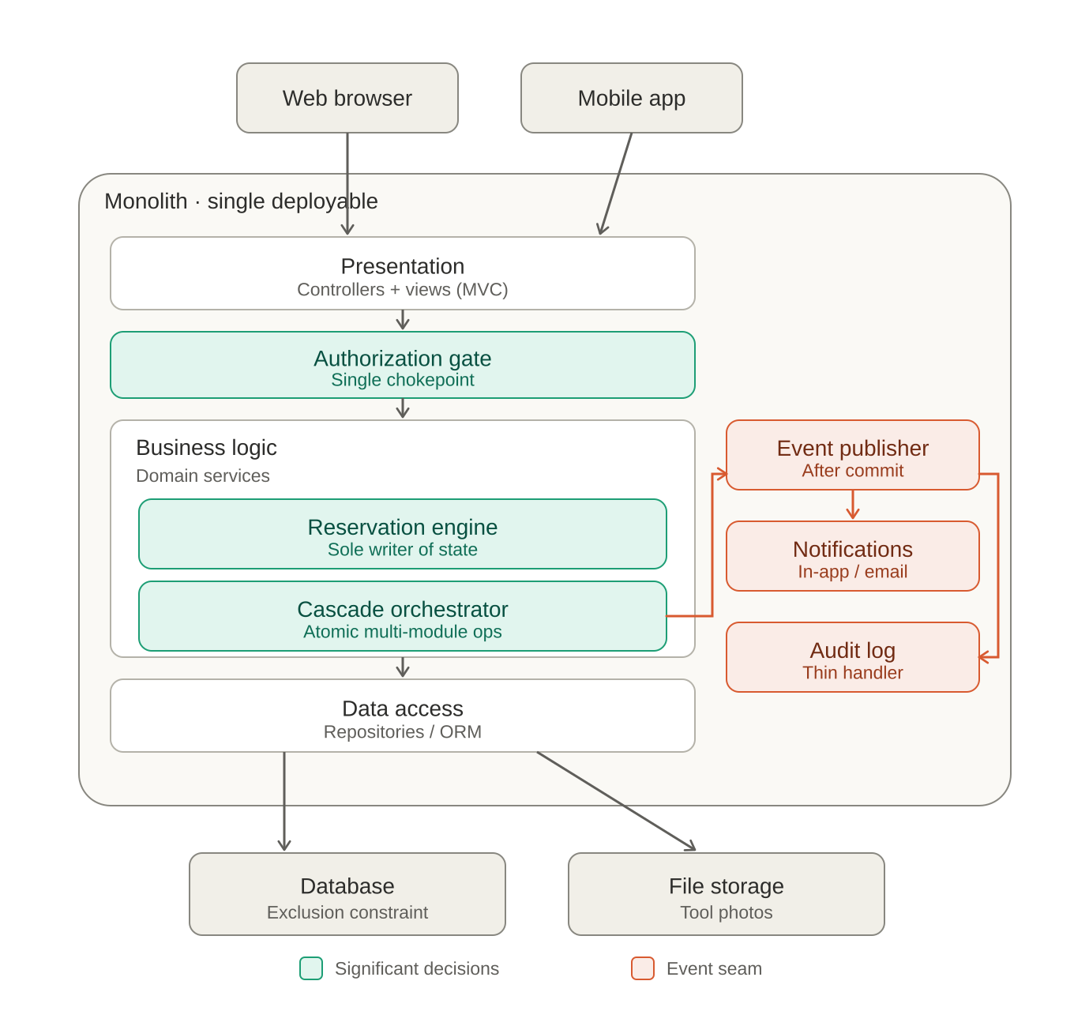
Figure 1. Component-and-connector view of the layered monolith.
How a request flows. A request enters from a web or mobile client into the presentation layer, then passes the authorization gate, which answers “authenticated, active, and permitted?” once. Only past the gate does it reach business logic, where the reservation engine and cascade orchestrator live. The data-access layer is the only component that talks to the database, where the exclusion constraint backstops the no-overlap guarantee. Each layer depends only on the one below it.
The event seam. Drawn inside the monolith because it is in-process, the seam is fed only by the orchestrator and only after the transaction commits. Atomic state changes finish inside the transaction; the publisher then fans out to thin handlers (notifications, audit log) that cannot roll anything back. Tool photos live in file storage rather than relational rows.

////////////////////

4.1 Frontend Architecture and Components
The frontend is the presentation layer of the Neighborhood Tool Sharing platform. Its main responsibility is to provide a clear, browser-based interface for authenticated neighborhood members to register, log in, manage profiles, browse tools, create and manage tool listings, request reservations, track reservation status, send reservation-thread messages, receive notifications, leave reviews, and access limited admin workflows when the user has admin privileges.
The frontend follows the layered monolith design by keeping user interface responsibilities separate from backend business logic. The frontend does not directly modify reservation state or enforce core business rules by itself. Instead, it collects user input, performs basic client-side validation, displays system state, and sends requests to backend API endpoints. The backend remains responsible for authorization, reservation state transitions, conflict detection, persistence, and cross-module operations.

Frontend Component Groups
The frontend will be organized into several major component groups:
1. Authentication and Session Components
These components support invite-only access and secure session handling. They include the login page, registration page, email verification page, forgot-password page, logout action, and session-aware navigation. Protected routes will check whether a user is authenticated before allowing access to member-only pages. If the user is not authenticated, the frontend redirects the user to the login page or displays an appropriate unauthorized-access message based on the backend response.
2. Shared Layout and Navigation Components
The shared layout includes the main application shell, header/navigation bar, sidebar or menu if needed, dashboard layout, page containers, and common status displays. The navigation should change based on user status and role. For example, regular members see tool browsing, reservations, messages, notifications, and profile links, while admins also see moderation or administration links.
3. Profile Components
Profile components support profile setup, profile editing, and public profile viewing. The profile setup page is shown after email verification or first login. The edit profile page allows members to update display name, bio, profile photo, and location/neighborhood information. Public profile pages show non-private information such as display name, optional photo, optional bio, average rating, review history, and active tool listings.
4. Tool Listing Components
Tool listing components support creating, editing, viewing, deleting, and deactivating tool listings. The create/edit listing forms include fields for tool name, description, condition, category, lending rules, borrower notes, latest return time, and photo uploads. The frontend validates required fields, photo count, image type, file size, and latest_return_time format before submitting to the backend. Tool detail components display the photo gallery, owner profile link, category, condition, availability, lending rules, notes, rating, and return-time information.
5. Browse and Search Components
Browse and search components allow authenticated members to view available tools. The browse page supports keyword search, category filtering, and date-range availability filtering. Search results display the tool thumbnail, name, owner, category, condition, availability status, rating, and latest return time if available. Date inputs are shown as Hawaii Standard Time dates so users understand that all reservation windows are interpreted in HST.
6. Reservation Components
Reservation components support the core borrowing workflow. Borrowers can submit reservation requests with start and end dates, cancel REQUESTED or APPROVED reservations before pickup, confirm pickup, and confirm return. Owners can approve or deny REQUESTED reservations and cancel APPROVED reservations when the tool becomes unavailable. The frontend displays reservation status clearly using the system states REQUESTED, APPROVED, DENIED, CANCELLED, PICKED_UP, and RETURNED. UI buttons should only appear when the current user role and reservation status allow that action.
7. Messaging Components
Messaging components support private reservation-thread communication between the borrower and owner. Messages are only available within the context of a reservation thread and are not intended to be a general-purpose direct messaging system. The frontend displays messages in chronological order, shows sender and timestamp information, and makes closed threads read-only when the reservation is RETURNED or CANCELLED.
8. Notification Components
Notification components include the notification badge, notification list, and notification detail display. Notifications alert users about reservation requests, approvals, denials, cancellations, pickup confirmation, return confirmation, auto-cancellations, report updates, and admin actions. The frontend will display unread notification counts and allow users to view notification history.
9. Review and Rating Components
Review components support submitting ratings and optional text reviews after a reservation reaches RETURNED status. The frontend validates that a rating is selected and displays review history on public member profile pages. Review-related components also show average rating and trust signals where applicable.
10. Admin Components
Admin components support limited administrative workflows needed for the project scope. These may include inviting a new member, viewing invite status, revoking unused invites, reviewing reported listings, managing allowed tool categories, viewing moderation history, suspending or reactivating members, and viewing active reservations. Admin-only UI routes and controls should be hidden from non-admin users and protected by backend authorization checks.

Frontend Route Structure
The frontend route structure can be organized around the main user workflows:
- /login
- /register
- /verify-email
- /forgot-password
- /dashboard
- /profile/setup
- /profile/edit
- /members/:memberId
- /tools
- /tools/:toolId
- /tools/new
- /tools/:toolId/edit
- /reservations
- /reservations/:reservationId
- /reservations/:reservationId/messages
- /notifications
- /reviews
- /admin/invites
- /admin/reports
- /admin/categories
- /admin/moderation
- /admin/reservations
The exact route names may change during implementation, but the route structure should keep member workflows, reservation workflows, and admin workflows clearly separated.

Protected Routes and Authorization Behavior
The frontend will implement protected routes for all member-only pages. Unauthenticated users should not be able to access tool listings, member profiles, reservation details, message threads, notifications, reviews, or admin pages. If an unauthenticated user attempts to access a protected page, the frontend redirects the user to the login page.
Frontend route protection improves user experience, but it is not the final security boundary. The backend authorization gate remains responsible for enforcing authentication, active-account status, role permissions, and suspended-account restrictions. The frontend should handle backend 401 Unauthorized and 403 Forbidden responses consistently by showing appropriate messages and redirecting when needed.

API Service Layer
The frontend will use an API service layer to keep backend communication separate from UI components. Instead of calling backend endpoints directly inside every component, shared service modules will group requests by feature area. Example service modules include:
- authService
- profileService
- toolService
- reservationService
- messageService
- notificationService
- reviewService
- adminService
This structure improves maintainability because API paths, request formats, response handling, and error handling are centralized. It also makes frontend components easier to read and easier to test.

Form Validation and User Feedback
The frontend will provide basic client-side validation before submitting forms to the backend. This includes required fields, display-name length, image format, image size, photo count, category selection, date-range inputs, latest_return_time format, rating range, and required report reasons.
Client-side validation is used for usability, but backend validation remains authoritative. If the backend rejects a request, the frontend will display the returned error message and preserve user input where appropriate so the user does not lose their work.

HST Date and Time Handling
Reservation date inputs will be presented to users as Hawaii Standard Time calendar dates. The frontend should clearly display a note that all reservation dates and return times are interpreted in HST. The frontend should avoid browser-local timezone assumptions for reservation date inputs. Dates and timestamps returned from the backend should be displayed consistently in HST so users see the same reservation window regardless of their browser locale.

4.2 Frontend Technology Stack
The frontend technology stack should be kept simple and compatible with the team’s implementation timeline. The recommended frontend stack is:
- Frontend framework/library: React, or the team-approved frontend framework
- Language: JavaScript or TypeScript, depending on team agreement
- Routing: React Router or the framework’s routing system
- API communication: Fetch API or Axios
- Styling: CSS modules, Bootstrap, Tailwind CSS, or another team-approved styling approach
- Form handling and validation: Built-in form handling with reusable validation helpers, or a lightweight validation library if needed
- Testing: Frontend component/unit tests where feasible, coordinated with the QA Lead’s code quality plan
- Build tooling: The framework’s standard build tool, such as Vite if using React
The final technology choices should match the backend framework, deployment plan, and team familiarity. Because the project timeline is short, the frontend should avoid unnecessary libraries unless they clearly reduce implementation time or improve maintainability.

Frontend Design Priorities
The frontend design prioritizes clarity, maintainability, and implementation feasibility. The interface should make reservation status and allowed actions easy to understand. Buttons should appear only when the user has permission and when the current item status allows the action. Reusable components should be used for repeated UI patterns such as forms, status badges, listing cards, reservation cards, notification items, and confirmation dialogs.
The first implementation priority should be the core authenticated member workflow: login, profile setup, browsing tools, viewing tool details, submitting reservation requests, approving/denying requests, cancelling before pickup, confirming pickup, and confirming return. Admin and moderation features can be implemented after the core tool-sharing workflow is stable, unless the team decides they are required for the R1 milestone.

////////////////////
—-----------

4.3 Backend Technical Design

4.3.1. Architecture Diagram + Components

N-Tier Architecture
The backend follows a strict N-Tier pattern with four layers plus cross-cutting concerns:
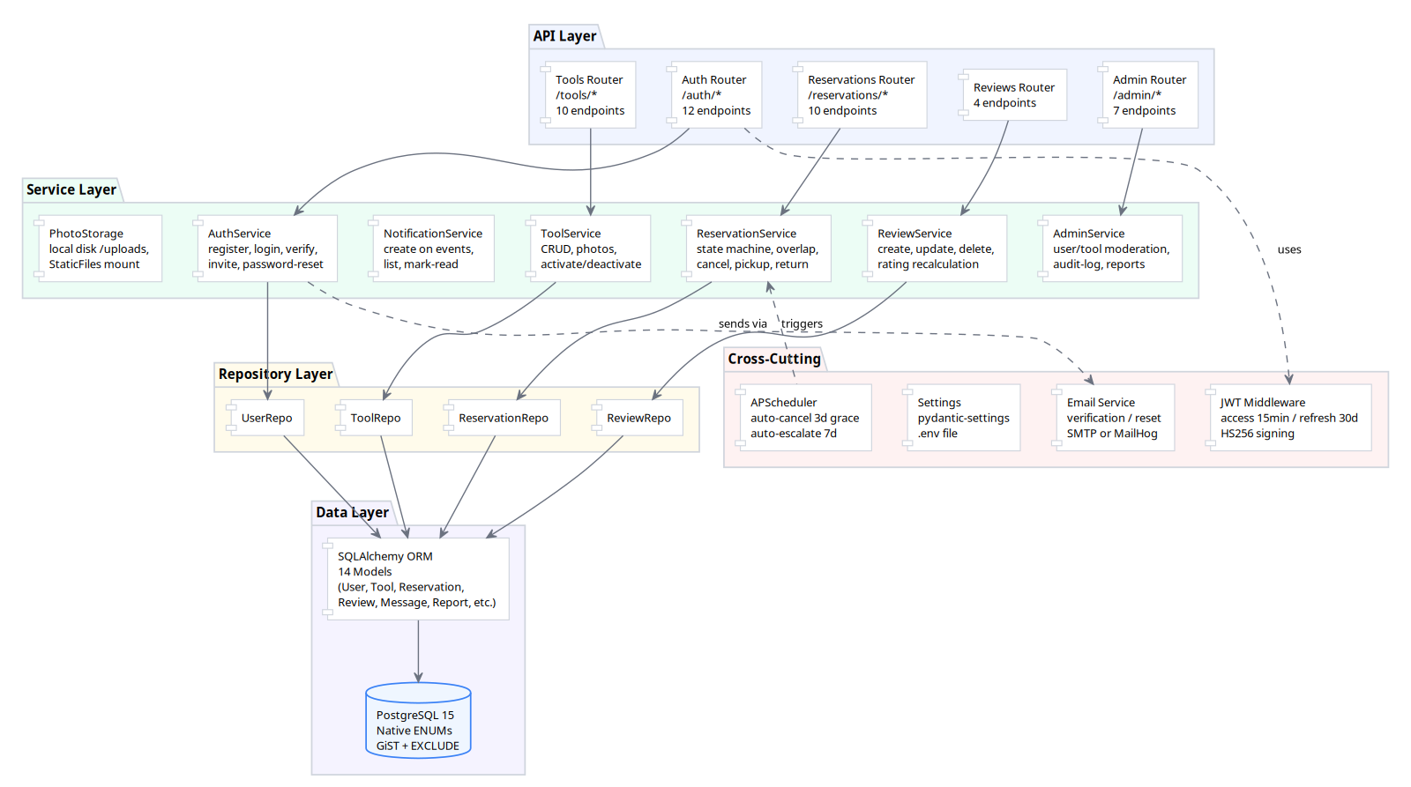
Figure 1: N-Tier Architecture — API → Service → Repository → Data

Component Inventory
Component | File | Responsibility
Application Factory | app/main.py | FastAPI app creation, CORS, exception handlers, static file mount, scheduler startup
Config | app/config.py | pydantic-settings from .env: DB URL, JWT secret, token TTLs, CORS origins, upload dir
Security | app/core/security.py | bcrypt password hashing (12 rounds), JWT mint/verify (HS256), access+refresh token pair
Exceptions | app/core/exceptions.py | AppError base class, VerifyTokenError with resend_available flag
DB Session | app/db/session.py | SQLAlchemy engine, SessionLocal factory, get_db() FastAPI dependency
API v1 Router | app/api/v1/__init__.py | Aggregates 9 feature routers under /api/v1
Auth Router | app/api/v1/auth.py | 12 endpoints: register, verify-email, resend, login, refresh, logout, /me CRUD, forgot/reset-password, invites
Tools Router | app/api/v1/tools.py | 11 endpoints: CRUD, photo upload/delete, deactivate/reactivate, availability filter
Reservations Router | app/api/v1/reservations.py | 10 endpoints: full lifecycle (create, list, approve, deny, cancel, pickup, return, damage, force-return)
Messages Router | app/api/v1/messages.py | Reservation thread messaging
Notifications Router | app/api/v1/notifications.py | Notification list and mark-read
Reviews Router | app/api/v1/reviews.py | 4 endpoints: create per-reservation, list, edit (24h), delete (24h)
Admin Router | app/api/v1/admin.py | User deactivate/reactivate/delete, tool deactivate/reactivate, audit-log, reports
AuthService | app/services/auth.py | Registration with invite, email verification, login, token refresh, logout, forgot/reset-password, invite creation, profile update, account deletion
ToolService | app/services/tool.py | Tool CRUD, photo upload (1-5 limit, 5MB, image-only), deactivation/reactivation with audit, availability date-range filter
ReservationService | app/services/reservation.py | State machine enforcement, overlap rejection (409), concurrent-safety via DB EXCLUDE, cancel, pickup, return, damage-report, admin force-return
UserService | app/services/user.py | Profile CRUD
ReviewService | app/services/review.py | Review create/update/delete, rating recalculation on trust_score, 30-day window, 24h edit window
NotificationService | app/services/notification.py | Create on status changes, list, mark-read
AdminService | app/services/admin.py | User deactivate/suspend/reactivate, tool deactivate/reactivate, audit-log queries, reports
Scheduler | app/services/scheduler.py | APScheduler: auto-cancel overdue pickups (3-day grace), auto-escalate overdue returns (7-day), HST-aware
PhotoStorage | app/services/photo_storage.py | Local disk storage under backend/uploads/, served via FastAPI StaticFiles mount at /uploads
User Model | app/models/user.py | UUID PK, UNIQUE(email), status ENUM(EMAIL_PENDING/ACTIVE/SUSPENDED/DELETED), trust_score, damage_reported, violation_count. PII anonymized on deletion per US7.
InviteToken Model | app/models/invite.py | UUID PK, UNIQUE(token), status ENUM(sent/used/expired/revoked), FK→users, expires_at. Token auto-emailed per v5 Admin Invites story.
EmailVerificationToken | app/models/email_verification.py | 6 columns, UUID PK, UNIQUE(token), FK→users CASCADE, expires_at + used_at
PasswordResetToken | app/models/password_reset.py | 6 columns, UUID PK, UNIQUE(token), FK→users CASCADE, expires_at + used_at
Tool Model | app/models/tool.py | UUID PK, FK→users, 5-category ENUM, 5-condition ENUM, is_active, deactivation/reactivation audit, deleted_at for soft-delete, rating aggregates
Photo Model | app/models/photo.py | URL + display_order, CASCADE from tools
Reservation Model | app/models/reservation.py | 18 columns, UUID PK, 6-state ENUM, EXCLUDE GiST constraint, damage report fields, admin force-resolution fields
Message Model | app/models/message.py | 5 columns, UUID PK, FK→reservations CASCADE, FK→users(sender_id), body TEXT, created_at index
Notification Model | app/models/notification.py | 6 columns, UUID PK, FK→users CASCADE, type VARCHAR(50), payload JSON, read_at, dual composite indexes
Review Model | app/models/review.py | UNIQUE(reservation_id, reviewer_id), 24h edit tracking
ListingReport Model | app/models/listing_report.py | UNIQUE(tool_id, reporter_id), 3-state ENUM
SuspensionRecord Model | app/models/suspension_record.py | Historical audit trail per member, 2-action ENUM
AdminAuditLog Model | app/models/admin_audit_log.py | Immutable audit: actor, action_type, target_type/id, reason, metadata JSON
ListingRules Model | app/models/listing_rules.py | Single-row config. ICEBOX per v5 phasing (US28 simplified to category dropdown; this model may not be implemented).

4.3.2. Technology Stack
Technology | Version | Rationale
FastAPI | ≥0.115, <0.120 | Course requirement. Native async, auto OpenAPI docs, Pydantic integration.
Uvicorn | ≥0.32, <0.40 | Production ASGI server, standard in FastAPI ecosystem.
SQLAlchemy | ≥2.0, <2.1 | Course requirement. 2.x declarative style with Mapped annotations.
psycopg2-binary | ≥2.9, <3.0 | PostgreSQL driver. binary package avoids compile deps.
Alembic | ≥1.14, <2.0 | Schema versioning, autogenerate from SQLAlchemy models.
Pydantic | ≥2.10, <3.0 | Course requirement. Request/response schemas, settings management.
pydantic-settings | ≥2.7, <3.0 | .env file loading with validation.
email-validator | ≥2.2, <3.0 | RFC-compliant email validation in Pydantic schemas.
python-multipart | ≥0.0.20, <1.0 | Multipart form parsing for photo uploads.
python-jose[cryptography] | ≥3.3, <4.0 | JWT creation and verification with HS256.
bcrypt | ≥4.0, <5.0 | Industry-standard password hashing. 12 rounds. Replaced passlib due to Python 3.13 crypt removal.
python-dotenv | ≥1.0, <2.0 | .env file parsing.
APScheduler | ≥3.10, <4.0 | In-process scheduler for auto-cancel (3-day grace) and auto-escalation (7-day overdue).
pytest | ≥8.3, <9.0 | Standard Python test framework.
pytest-asyncio | ≥0.24, <1.0 | Async test support.
httpx | ≥0.28, <1.0 | ASGI-compatible test client for FastAPI.
ruff | ≥0.8, <1.0 | Fast Python linter (replaces flake8/isort).
mypy | ≥1.13, <2.0 | Static type analysis.
PostgreSQL | 15 (Docker) | Course requirement. Native ENUM types, EXCLUDE constraints, GiST indexes.

Key Design Decisions
- UUID4 string PKs (36-char) — prevents ID enumeration, simplifies multi-service merges.
- PostgreSQL native ENUMs — type-safe at DB level, readable in raw SQL.
- EXCLUDE GiST constraint — prevents double-booking at the database level, no app-level locking.
- APScheduler over Celery — in-process scheduler avoids Redis dependency for the MVP.
- bcrypt over passlib — passlib uses stdlib crypt removed in Python 3.13.
- Stateless logout — client discards tokens. No server-side deny-list. Future Redis plug-in point.
- Local photo storage — URL-based model makes swapping to S3 a config change only.
- HST timezone throughout — all date comparisons use HST (UTC-10).

4.3.3. Data Model (ERD)
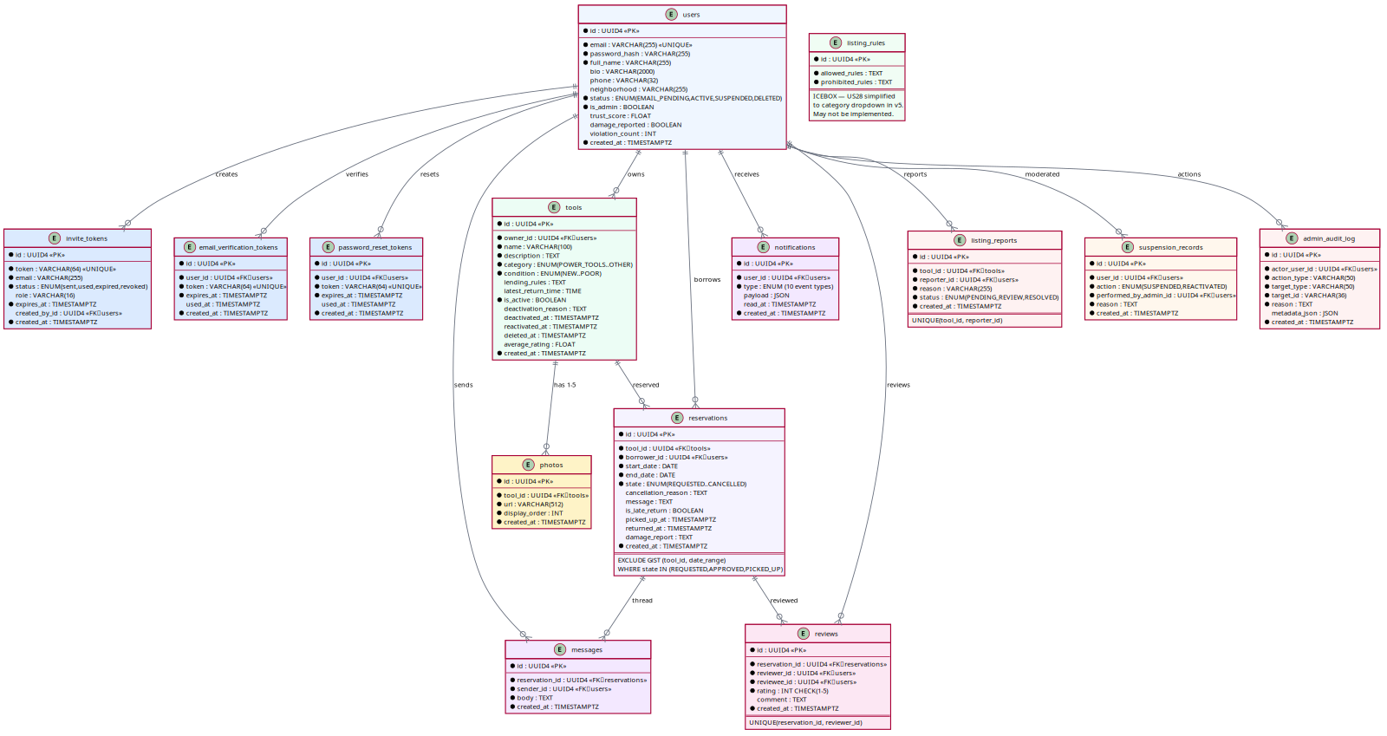
Figure 2: Entity-Relationship Diagram — 14 tables with relationships

Table Summary
Table | Key Constraints
users | UNIQUE(email), status ENUM, is_admin flag
invite_tokens | UNIQUE(token), FK→users(created_by_id), expires_at
email_verification_tokens | UNIQUE(token), FK→users CASCADE, expires_at
password_reset_tokens | UNIQUE(token), FK→users CASCADE, expires_at
tools | FK→users(owner_id), category ENUM, is_active index
photos | FK→tools(CASCADE), 1-5 per tool enforced in service layer
reservations | FK→tools, FK→users(borrower), state ENUM, EXCLUDE GiST
messages | FK→reservations CASCADE, FK→users(sender_id)
notifications | FK→users CASCADE, type+created_at indexes
reviews | FK→reservations, FK→users, UNIQUE(reservation_id, reviewer_id)
listing_reports | FK→tools, FK→users, UNIQUE(tool_id, reporter_id)
suspension_records | FK→users, action ENUM
admin_audit_log | FK→users(actor), action_type+target_id indexes
listing_rules | Single-row config

Reservation State Machine
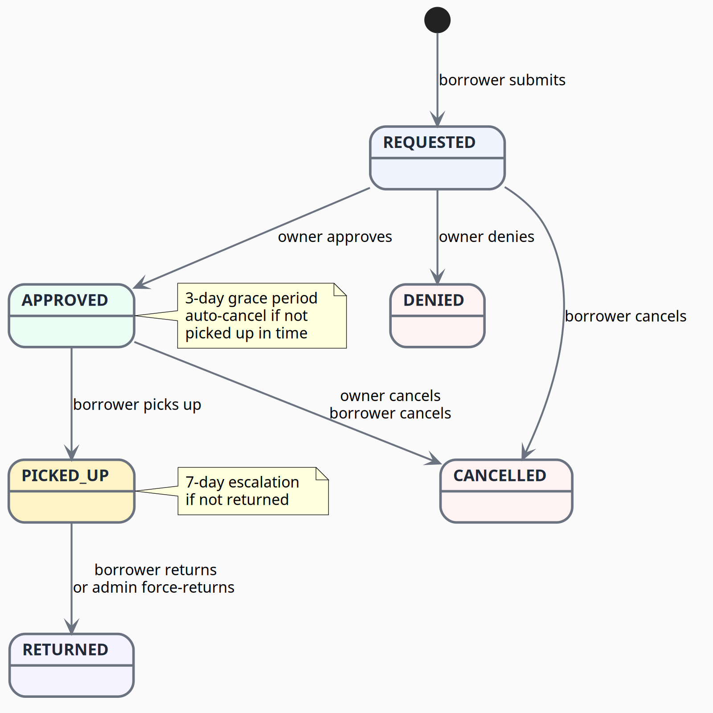
Figure 3: Reservation State Machine — 6 states, 8 transitions
- Normal flow: REQUESTED → APPROVED → PICKED_UP → RETURNED
- Rejection: REQUESTED → DENIED (terminal)
- Cancellation: REQUESTED or APPROVED → CANCELLED (terminal, borrower or owner)
- Auto-cancel: APPROVED not picked up within 3-day grace period → CANCELLED
- Escalation: PICKED_UP not returned within 7 days → admin notified
- Force-return: Admin can force PICKED_UP → RETURNED in disputes

4.3.4. Key API Endpoints
All endpoints are prefixed with /api/v1. Authentication: JWT Bearer token in Authorization header.

Auth (/auth)
Endpoint | Auth | Purpose
POST /auth/register | Public | Register with invite token — creates EMAIL_PENDING user
POST /auth/verify-email | Public | Consume verification token — auto-login, returns access+refresh
POST /auth/resend-verification | Public | Resend verification email (anti-enumeration: always 200)
POST /auth/login | Public | Email+password → access+refresh tokens
POST /auth/refresh | Public | Rotate refresh token → new pair
POST /auth/logout | Member | Stateless logout (client discards tokens)
GET /auth/me | Member | Current user profile
PUT /auth/me | Member | Update profile (full_name, bio, photo, neighborhood)
DELETE /auth/me | Member | Soft-delete account — blocks if active reservations (409)
POST /auth/forgot-password | Public | Request reset email (anti-enumeration: always 200)
POST /auth/reset-password | Public | Consume reset token + set new password
POST /auth/invites | Admin | Create invite token for email

Tools (/tools)
Endpoint | Auth | Purpose
POST /tools | Member | Create listing with photos (multipart)
GET /tools | Member | List active tools — filters: category, date-range availability
GET /tools/me | Member | Caller's own listings (incl. inactive)
GET /tools/{id} | Member | Single tool detail (active only)
PATCH /tools/{id} | Owner | Partial update — blocked if PICKED_UP
DELETE /tools/{id} | Owner | Soft-delete — blocked if active reservations
POST /tools/{id}/photos | Owner | Upload photo (1-5 limit, 5MB max, image-only)
DELETE /tools/{id}/photos/{pid} | Owner | Remove photo (cannot remove last)
POST /tools/{id}/deactivate | Owner/Admin | Deactivate listing with reason — auto-cancels REQUESTED/APPROVED
POST /tools/{id}/reactivate | Admin | Reactivate deactivated listing

Reservations (/reservations)
Endpoint | Auth | Purpose
POST /reservations | Member | Submit request — overlap check, self-own blocked
GET /reservations | Member | List reservations (filtered by role: borrower/owner)
GET /reservations/{id} | Member | Single reservation detail
POST /reservations/{id}/approve | Owner | REQUESTED → APPROVED
POST /reservations/{id}/deny | Owner | REQUESTED → DENIED with optional reason
POST /reservations/{id}/cancel | Borrower/Owner | REQUESTED/APPROVED → CANCELLED with reason
POST /reservations/{id}/mark-picked-up | Borrower | APPROVED → PICKED_UP (on/after start_date only)
POST /reservations/{id}/mark-returned | Borrower | PICKED_UP → RETURNED (late-return detection)
POST /reservations/{id}/mark-damaged | Owner | File damage report (7-day window from return)
POST /reservations/{id}/admin-force-return | Admin | Force PICKED_UP → RETURNED (dispute resolution)

Other Routers
Endpoint | Auth | Purpose
GET/POST /reservations/{id}/messages | Party/Admin | List/send thread messages (REQUESTED/APPROVED/PICKED_UP only)
GET /notifications | Member | List notifications (newest first)
POST /notifications/{id}/read | Member | Mark as read
POST /reservations/{id}/review | Party | Submit review (RETURNED only, 30-day window, 1-5 rating)
PATCH /reviews/{id} | Author | Edit within 24h window
DELETE /reviews/{id} | Author | Delete within 24h window
POST /admin/users/{id}/deactivate | Admin | Deactivate member account
POST /admin/users/{id}/reactivate | Admin | Reactivate member account
GET /admin/audit-log | Admin | Query moderation history (filterable)
GET /admin/reports | Admin | Generate moderation reports
GET /api/v1/health | Public | {"status": "ok"}

4.3.5. Risks and Tradeoffs

HIGH Priority Risks
# | Risk | Impact | Mitigation | Status
R1 | Reservation double-booking race condition | Two borrowers could reserve the same tool for overlapping dates | PostgreSQL EXCLUDE GiST constraint enforces at DB level — atomic, application-cannot-bypass. Service layer catches IntegrityError → HTTP 409. | Mitigated
R2 | Email delivery in local dev | SMTP setup per-developer is fragile, emails may silently fail | MailHog Docker container for dev (catches all outbound SMTP, shows web UI). Production: Gmail SMTP with App Password. Each dev uses their own sender account. | Mitigated
R3 | JWT secret exposed in dev | Dev default secret in .env would allow token forgery | Settings validator crashes the app at boot if ENVIRONMENT=production but SECRET_KEY is the dev default. | Mitigated
R4 | Photo storage scalability | Local disk storage (/uploads) wont scale beyond single server | Model stores URLs, not binary. Swapping to S3 is a config change in photo_storage.py — no model/schema changes needed. | Accepted
R5 | Background scheduler runs in-process | APScheduler is single-process, no persistence across restarts | Scheduler is no-op in tests. For MVP single-server deploy, in-process is sufficient. Task logic already isolated for future Celery swap. | Accepted

MEDIUM Priority Risks
# | Risk | Impact | Mitigation | Status
R6 | Token revocation after logout | Logout is client-side only; stolen token valid until expiry | password_changed_at invalidates all JWTs with iat before that timestamp. Access tokens short-lived (15 min). Future Redis deny-list plug-in point. | Partially mitigated
R7 | ENUM migration pain | Adding a category or reservation state requires Alembic migration | Categories locked to 5 per design decision. Reservation states stable (6 states). Trade-off: type safety vs migration overhead. Accepted for MVP. | Accepted
R8 | Email enumeration via forgot-password | Attacker can probe which emails are registered | Both endpoints always return 200 with generic "if the email exists, we sent it" message. | Mitigated
R9 | No refresh-token storage on server | Cannot revoke specific sessions (only all sessions via password change) | Acceptable for MVP (course project). password_changed_at mechanism covers critical case (password reset). | Accepted
R10 | UUID strings as PKs are larger/slower | 36-char strings vs 4-byte ints for joins and indexes | For small-scale app (~100 users, ~500 tools, ~1000 reservations), performance difference negligible. Security benefit (no ID enumeration) outweighs storage cost. | Accepted

Tradeoffs Explicitly Made
Decision | Rationale
APScheduler (in-process) vs Celery+Redis | In-process avoids Redis dependency. Sufficient for 2 background tasks. Task logic is service-layer functions — easy to wrap in Celery later.
bcrypt vs passlib | passlib depends on stdlib crypt removed in Python 3.13. bcrypt library is maintained and future-proof.
Local photo storage vs S3 | MVP: local disk is zero-config. URL-based model abstraction means swapping storage backend requires changing one file.
Stateless logout vs DB deny-list | Reduces DB writes on every logout. Access token TTL is 15 min — stolen tokens have limited window. Password-reset invalidates all sessions.
UUID PKs vs auto-increment | Prevents ID enumeration. Easier to merge across services. Alembic handles String PKs cleanly.
PostgreSQL ENUMs vs VARCHAR+CHECK | ENUMs are self-documenting, type-safe in SQLAlchemy, and produce meaningful Alembic migrations. Migration cost is infrequent (states are stable).

—-----------
Visual Domain Model referred Ivan’s domain model document
To address Group 1's feedback that we missed the visual of the domain model, we have created and attached it here.

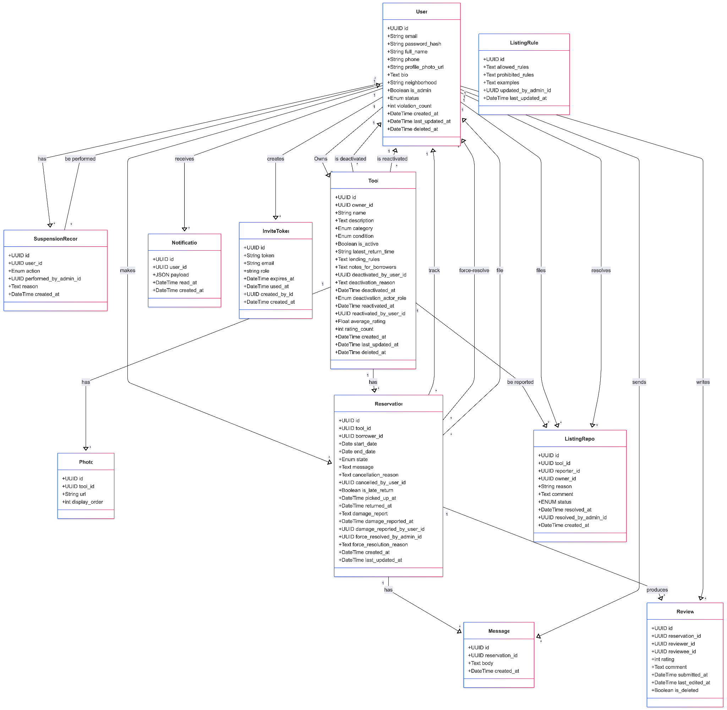
—------------

5. Architecture Decision Records
Each ADR captures one significant decision, its context, and its consequences, so future readers understand not just what was chosen but why.

ADR-001: Monolith over microservices
Status: Accepted
Context. A five-person team is building a small, invite-only, single-community app on a short timeline, with growth out of scope. Maintainability is the top priority, and the core correctness invariant plus several atomic cross-module operations depend on a single shared database with real transactions.
Decision. Build and deploy the system as a single monolith.
Consequences.
- Simple local development, a single deployment, and a shared database that makes overlap checks and cascades straightforward transactions.
- Lowest operational complexity — no network calls, distributed tracing, or per-service infrastructure for a learning team to manage.
- Internal boundaries must be maintained by discipline; the layered structure (ADR-002) addresses this.
- The whole app scales as one unit, which is acceptable because scaling is out of scope.
Alternative considered.
- Microservices — rejected. A database-per-service would turn the overlap check and the atomic cascades into distributed sagas, making the hardest problem harder, and the model assumes a team-per-service that does not exist here.

ADR-002: Layered internal structure
Status: Accepted
Context. Maintainability is the team’s top quality attribute, and an unstructured codebase risks becoming a “big ball of mud.” The team needs clear boundaries to work in parallel and change safely.
Decision. Organize the monolith into presentation, business-logic, and data-access layers over the database, with each layer depending only on the one below it.
Consequences.
- Clear separation of concerns; each significant decision gets a natural home, and framework MVC fits inside the presentation layer.
- Easier onboarding and parallel work for the team.
- A change can ripple across layers, and some boilerplate is needed to pass data between them.

ADR-003: Reservation engine owns all reservation-state writes
Status: Accepted
Context. The no-overlap invariant and the reservation state machine are the most correctness-critical logic in the system. If reservation writes are scattered across controllers, the invariant has no single owner and inconsistent state results.
Decision. A single reservation-engine module in the business layer owns the state machine and is the only component permitted to write reservation rows. A database exclusion constraint enforces non-overlap as a backstop.
Consequences.
- The invariant lives in one findable place, serving both correctness and maintainability at once.
- The database constraint makes double-booking impossible even under concurrent requests (first commit wins, with no application-level locking).
- All reservation mutations must route through the engine’s interface; direct table writes are disallowed by convention and code review.

ADR-004: Single authorization chokepoint
Status: Accepted
Context. Almost every user story specifies authentication, active-account, and permission checks. Implemented ad hoc, that is dozens of duplicated checks — error-prone and a security risk. Suspension also needs to block actions.
Decision. Enforce authentication, active-account status, and authorization at one chokepoint at the presentation/business boundary, before any business logic runs. Suspension is one additional condition at this gate.
Consequences.
- One place to reason about access, with consistent 401/403 behavior across the system.
- Suspension becomes a single state check rather than a cascade of blocks.
- The gate must be comprehensive; any path that bypasses it is a vulnerability, so all requests are routed through it.

ADR-005: Side-effects-only in-process event seam
Status: Accepted
Context. User suspension, listing deactivation, damage reports, and overdue auto-cancel must atomically change several modules and then notify affected users. Making the state changes themselves event-driven would create distributed-transaction problems inside the monolith, while a full message broker would be over-engineering at this scale.
Decision. Run the atomic state mutations as direct, orchestrated calls inside one transaction (the cascade orchestrator). Publish lightweight in-process domain events only for side effects that tolerate eventual consistency — notifications and audit logging — after the transaction commits. Use the framework’s built-in event mechanism, keep handlers thin and single-purpose, allow only a flat fan-out (handlers do not publish further events), and maintain a small, documented event catalog.
Consequences.
- Loose coupling for side effects: a new reaction is added by adding a subscriber, not by editing core logic.
- Atomic correctness is preserved, and a failing notification cannot roll back a core operation.
- The flow is less linear to trace than direct calls — the accepted cost of the seam.
Tripwires (revisit this decision, or fall back to direct orchestration, if any appear).
- A need for persisted events, retries, dead-letter handling, or ordering guarantees.
- Handlers that need to publish further events (event chains).

ADR-006: Hawaii Standard Time as the canonical time zone
Status: Accepted
Context. Reservation correctness depends on consistent date comparisons, users may be in different time zones, and the requirements specify Hawaii Standard Time. This concern is cross-cutting: every date comparison in reservations, search availability, auto-cancel, and review windows depends on it.
Decision. Normalize all reservation-relevant dates to HST (UTC-10) on the server before any comparison, treat UI date input as HST calendar dates, and record real-time event timestamps in HST.
Consequences.
- Eliminates false conflicts and gaps caused by time-zone differences; one rule governs the whole system.
- Must be applied consistently everywhere dates are compared — easy to overlook precisely because it is cross-cutting, which is why it is recorded here explicitly.

6. Code Quality Tools
Tools that will be utilized in Frontend
Tool: ESLint
Purpose: Check React/TypeScript code quality and common issues
Run command: npm run lint
When used: before commits and before opening a pull request

Tool: Prettier
Purpose: Keep frontend code formatting consistent
Run command: npm run format:check or npm run format
When used: before commits and before opening a pull request

Tool: TypeScript compiler
Purpose: Check type errors in React components, props, and API response types
Run command: npm run typecheck
When used: before pushes and before opening a pull request

Tool: Vitest / React Testing Library
Purpose: Frontend component and UI behavior testing, if available in the frontend setup
Run command: npm test or npm run test
When used: during development and before pull requests when tests are available

Tool: Production build check
Purpose: Confirm the frontend compiles successfully
Run command: npm run build
When used: before opening a pull request or merging frontend changes

Tools that will be utilized in Backend
Tool: Ruff Version: >=0.8
Purpose: Linter & formatter. Checks E/F/I/N/W (PEP8), UP (pyupgrade), B (bugbear), C4 (comprehensions), SIM (simplify), ASYNC rules. Formatter enforces double quotes, space indentation, 100-char line length.
Run command: ruff check src/ (lint), ruff format --check src/ (format check)
When used: Before every commit — catch syntax errors, import issues, and style violations

Tool: mypy Version: >=1.13
Purpose: Static type checker
Strict mode: disallow_untyped_defs, disallow_incomplete_defs, check_untyped_defs. Uses pydantic.mypy plugin.
Run command: mypy src/
When used: Before every commit — catches type mismatches and missing annotations

Tool: pytest Version: >=8.3
Purpose: Test runner with pytest-asyncio. Async-mode auto, httpx for async HTTP client, factory-boy for test data factories.
Run command: pytest
When used: During development (write/test cycle) and before every push — ensures existing behavior isn't broken

Tools that will be utilized in DevOps

7. Open Questions
These product decisions remain open and should be resolved by the team before or during implementation. Several are surfaced directly by the architecture diagram.
- Notification channel — In-app only, email, or both? This determines whether the notifications handler needs an outbound email path.
- Authentication approach — Custom authentication versus social sign-in — foundational to every “logged-in user” check.
- Suspension cascade rules — The suspension stories do not define what happens to a suspended member’s live listings and in-flight reservations. Define these rules before implementing the cascade in the orchestrator.
- File storage for tool photos — Local file storage versus an object store, and how photos are referenced from listings.
- Minimum admin reporting set — Which reports are required for the first release (e.g., active users, active listings, reservation counts, reported issues)?
- Entering wrong passwords for login — How many times can users mistakenly input the wrong password to log in to the system? If the number exceeds the upper limit, the user can not attempt to log in for a certain amount of time?
- The frequency of changing the display name — How frequently can users change the display name? This is the web application for the invite-only community, so too frequent changes to display names may undermine trust among members.
- The valid time of the session token for login — How long is the valid time of the session token for login? If the time exceeds the valid period, may the user be logged out automatically?
- The limitation of requesting a password reset — How often are users allowed to request a password reset in a certain period of time?
- Accepted formats for Photos — What are the accepted formats for photos, such as .jpeg, .png?
- Read mark for messages — Do messages have a read mark once the receiver reads the message?
- Report for inappropriate review — Reporting inappropriate tools to the admin is possible. Is it possible to report inappropriate reviews to the admin as well?
- Notification before the return day — Do members receive a notification or reminder, such as 1 day before?
- Report for inappropriate user profile — Is there a button or a functionality to report an inappropriate user profile to the admin to keep the community safe?

