Technical Design Document — Backend
ICS 613 — Neighborhood Tool Sharing Platform | Group 3 | June 20, 2026
Scope: Backend only (FastAPI + PostgreSQL)
Source: Real codebase under backend — all details reflect actual implementation

1. Architecture Diagram + Components

N-Tier Architecture
The backend follows a strict N-Tier pattern with four layers plus cross-cutting concerns:
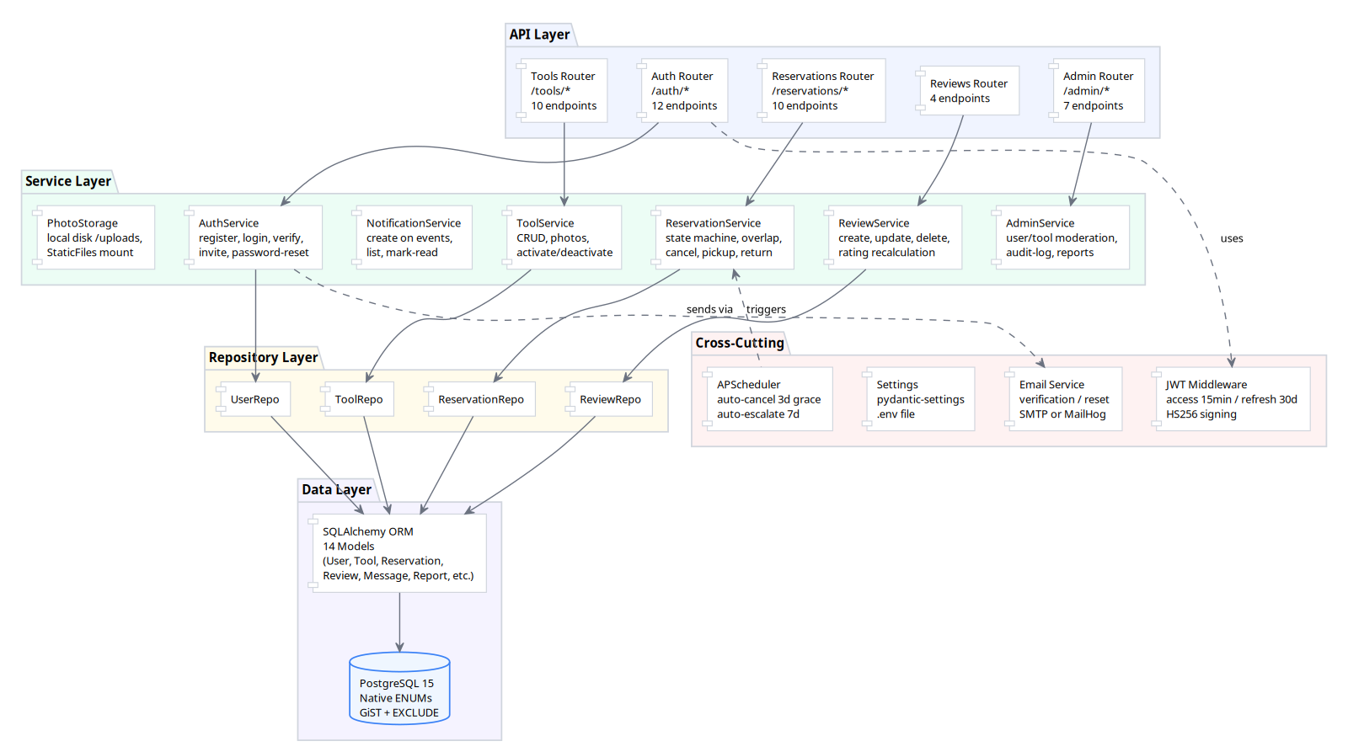
Figure 1: N-Tier Architecture — API → Service → Repository → Data

Component Inventory
Component | File | Responsibility
Application Factory | app/main.py | FastAPI app creation, CORS, exception handlers, static file mount, scheduler startup
Config | app/config.py | pydantic-settings from .env: DB URL, JWT secret, token TTLs, CORS origins, upload dir
Security | app/core/security.py | bcrypt password hashing (12 rounds), JWT mint/verify (HS256), access+refresh token pair
Exceptions | app/core/exceptions.py | AppError base class, VerifyTokenError with resend_available flag
DB Session | app/db/session.py | SQLAlchemy engine, SessionLocal factory, get_db() FastAPI dependency
API v1 Router | app/api/v1/__init__.py | Aggregates 9 feature routers under /api/v1
Auth Router | app/api/v1/auth.py | 12 endpoints: register, verify-email, resend, login, refresh, logout, /me CRUD, forgot/reset-password, invites
Tools Router | app/api/v1/tools.py | 11 endpoints: CRUD, photo upload/delete, deactivate/reactivate, availability filter
Reservations Router | app/api/v1/reservations.py | 10 endpoints: full lifecycle (create, list, approve, deny, cancel, pickup, return, damage, force-return)
Messages Router | app/api/v1/messages.py | Reservation thread messaging
Notifications Router | app/api/v1/notifications.py | Notification list and mark-read
Reviews Router | app/api/v1/reviews.py | 4 endpoints: create per-reservation, list, edit (24h), delete (24h)
Admin Router | app/api/v1/admin.py | User deactivate/reactivate/delete, tool deactivate/reactivate, audit-log, reports
AuthService | app/services/auth.py | Registration with invite, email verification, login, token refresh, logout, forgot/reset-password, invite creation, profile update, account deletion
ToolService | app/services/tool.py | Tool CRUD, photo upload (1-5 limit, 5MB, image-only), deactivation/reactivation with audit, availability date-range filter
ReservationService | app/services/reservation.py | State machine enforcement, overlap rejection (409), concurrent-safety via DB EXCLUDE, cancel, pickup, return, damage-report, admin force-return
UserService | app/services/user.py | Profile CRUD
ReviewService | app/services/review.py | Review create/update/delete, rating recalculation on trust_score, 30-day window, 24h edit window
NotificationService | app/services/notification.py | Create on status changes, list, mark-read
AdminService | app/services/admin.py | User deactivate/suspend/reactivate, tool deactivate/reactivate, audit-log queries, reports
Scheduler | app/services/scheduler.py | APScheduler: auto-cancel overdue pickups (3-day grace), auto-escalate overdue returns (7-day), HST-aware
PhotoStorage | app/services/photo_storage.py | Local disk storage under backend/uploads/, served via FastAPI StaticFiles mount at /uploads
User Model | app/models/user.py | UUID PK, UNIQUE(email), status ENUM(EMAIL_PENDING/ACTIVE/SUSPENDED/DELETED), trust_score, damage_reported, violation_count. PII anonymized on deletion per US7.
InviteToken Model | app/models/invite.py | UUID PK, UNIQUE(token), status ENUM(sent/used/expired/revoked), FK→users, expires_at. Token auto-emailed per v5 Admin Invites story.
EmailVerificationToken | app/models/email_verification.py | 6 columns, UUID PK, UNIQUE(token), FK→users CASCADE, expires_at + used_at
PasswordResetToken | app/models/password_reset.py | 6 columns, UUID PK, UNIQUE(token), FK→users CASCADE, expires_at + used_at
Tool Model | app/models/tool.py | UUID PK, FK→users, 5-category ENUM, 5-condition ENUM, is_active, deactivation/reactivation audit, deleted_at for soft-delete, rating aggregates
Photo Model | app/models/photo.py | URL + display_order, CASCADE from tools
Reservation Model | app/models/reservation.py | 18 columns, UUID PK, 6-state ENUM, EXCLUDE GiST constraint, damage report fields, admin force-resolution fields
Message Model | app/models/message.py | 5 columns, UUID PK, FK→reservations CASCADE, FK→users(sender_id), body TEXT, created_at index
Notification Model | app/models/notification.py | 6 columns, UUID PK, FK→users CASCADE, type VARCHAR(50), payload JSON, read_at, dual composite indexes
Review Model | app/models/review.py | UNIQUE(reservation_id, reviewer_id), 24h edit tracking
ListingReport Model | app/models/listing_report.py | UNIQUE(tool_id, reporter_id), 3-state ENUM
SuspensionRecord Model | app/models/suspension_record.py | Historical audit trail per member, 2-action ENUM
AdminAuditLog Model | app/models/admin_audit_log.py | Immutable audit: actor, action_type, target_type/id, reason, metadata JSON
ListingRules Model | app/models/listing_rules.py | Single-row config. ICEBOX per v5 phasing (US28 simplified to category dropdown; this model may not be implemented).

2. Technology Stack
Technology | Version | Rationale
FastAPI | ≥0.115, <0.120 | Course requirement. Native async, auto OpenAPI docs, Pydantic integration.
Uvicorn | ≥0.32, <0.40 | Production ASGI server, standard in FastAPI ecosystem.
SQLAlchemy | ≥2.0, <2.1 | Course requirement. 2.x declarative style with Mapped annotations.
psycopg2-binary | ≥2.9, <3.0 | PostgreSQL driver. binary package avoids compile deps.
Alembic | ≥1.14, <2.0 | Schema versioning, autogenerate from SQLAlchemy models.
Pydantic | ≥2.10, <3.0 | Course requirement. Request/response schemas, settings management.
pydantic-settings | ≥2.7, <3.0 | .env file loading with validation.
email-validator | ≥2.2, <3.0 | RFC-compliant email validation in Pydantic schemas.
python-multipart | ≥0.0.20, <1.0 | Multipart form parsing for photo uploads.
python-jose[cryptography] | ≥3.3, <4.0 | JWT creation and verification with HS256.
bcrypt | ≥4.0, <5.0 | Industry-standard password hashing. 12 rounds. Replaced passlib due to Python 3.13 crypt removal.
python-dotenv | ≥1.0, <2.0 | .env file parsing.
APScheduler | ≥3.10, <4.0 | In-process scheduler for auto-cancel (3-day grace) and auto-escalation (7-day overdue).
pytest | ≥8.3, <9.0 | Standard Python test framework.
pytest-asyncio | ≥0.24, <1.0 | Async test support.
httpx | ≥0.28, <1.0 | ASGI-compatible test client for FastAPI.
ruff | ≥0.8, <1.0 | Fast Python linter (replaces flake8/isort).
mypy | ≥1.13, <2.0 | Static type analysis.
PostgreSQL | 15 (Docker) | Course requirement. Native ENUM types, EXCLUDE constraints, GiST indexes.

Key Design Decisions
- UUID4 string PKs (36-char) — prevents ID enumeration, simplifies multi-service merges.
- PostgreSQL native ENUMs — type-safe at DB level, readable in raw SQL.
- EXCLUDE GiST constraint — prevents double-booking at the database level, no app-level locking.
- APScheduler over Celery — in-process scheduler avoids Redis dependency for the MVP.
- bcrypt over passlib — passlib uses stdlib crypt removed in Python 3.13.
- Stateless logout — client discards tokens. No server-side deny-list. Future Redis plug-in point.
- Local photo storage — URL-based model makes swapping to S3 a config change only.
- HST timezone throughout — all date comparisons use HST (UTC-10).

3. Data Model (ERD)
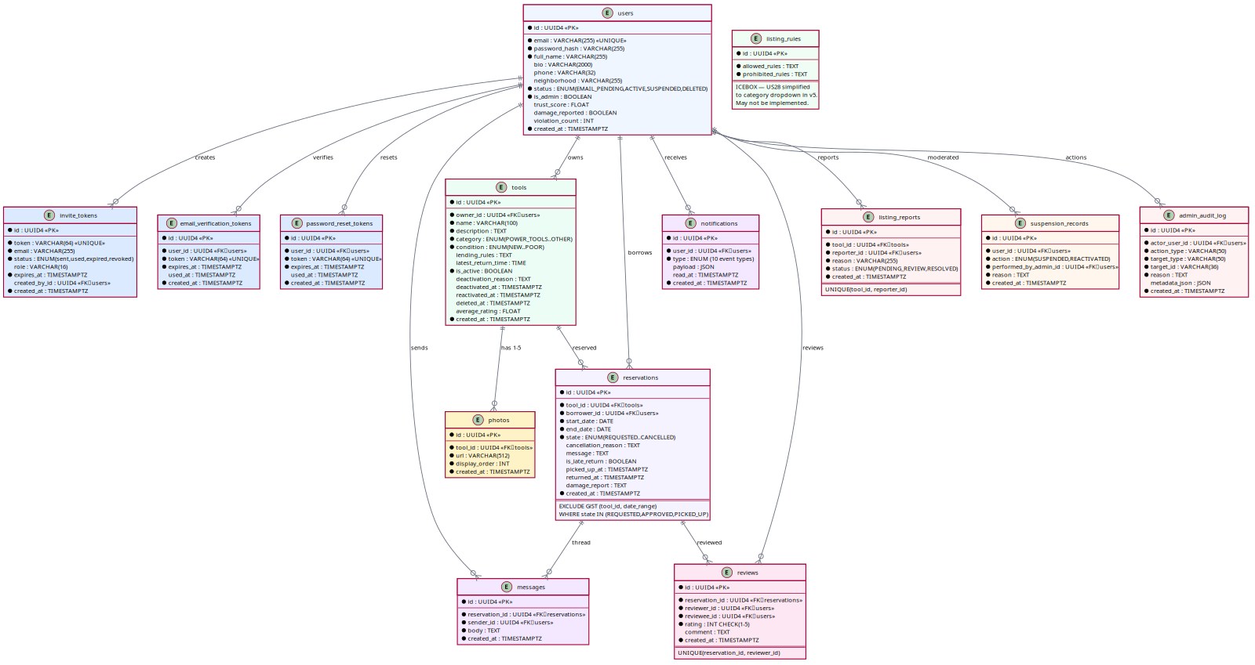
Figure 2: Entity-Relationship Diagram — 14 tables with relationships

Table Summary
Table | Key Constraints
users | UNIQUE(email), status ENUM, is_admin flag
invite_tokens | UNIQUE(token), FK→users(created_by_id), expires_at
email_verification_tokens | UNIQUE(token), FK→users CASCADE, expires_at
password_reset_tokens | UNIQUE(token), FK→users CASCADE, expires_at
tools | FK→users(owner_id), category ENUM, is_active index
photos | FK→tools(CASCADE), 1-5 per tool enforced in service layer
reservations | FK→tools, FK→users(borrower), state ENUM, EXCLUDE GiST
messages | FK→reservations CASCADE, FK→users(sender_id)
notifications | FK→users CASCADE, type+created_at indexes
reviews | FK→reservations, FK→users, UNIQUE(reservation_id, reviewer_id)
listing_reports | FK→tools, FK→users, UNIQUE(tool_id, reporter_id)
suspension_records | FK→users, action ENUM
admin_audit_log | FK→users(actor), action_type+target_id indexes
listing_rules | Single-row config

Reservation State Machine
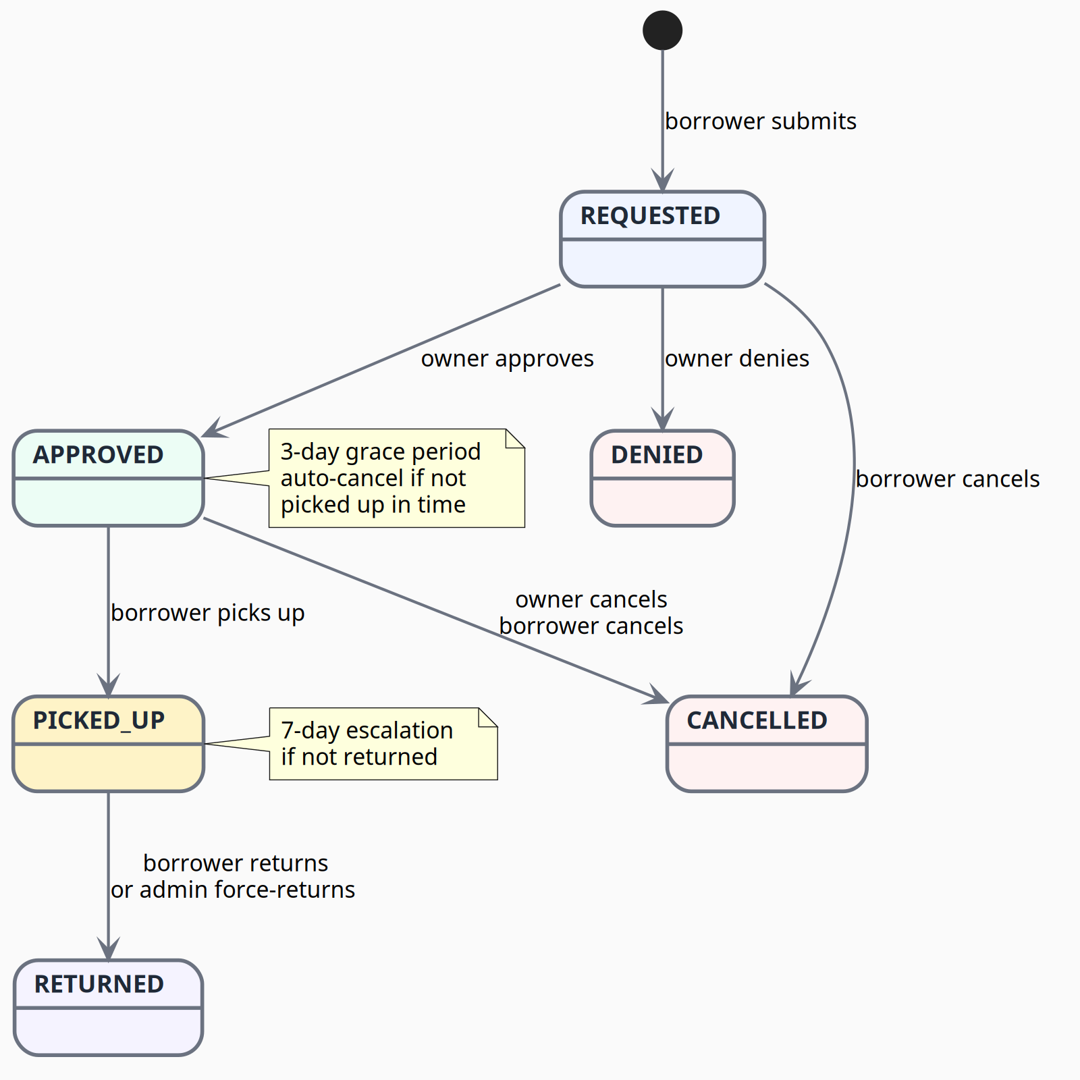
Figure 3: Reservation State Machine — 6 states, 8 transitions
- Normal flow: REQUESTED → APPROVED → PICKED_UP → RETURNED
- Rejection: REQUESTED → DENIED (terminal)
- Cancellation: REQUESTED or APPROVED → CANCELLED (terminal, borrower or owner)
- Auto-cancel: APPROVED not picked up within 3-day grace period → CANCELLED
- Escalation: PICKED_UP not returned within 7 days → admin notified
- Force-return: Admin can force PICKED_UP → RETURNED in disputes

4. Key API Endpoints
All endpoints are prefixed with /api/v1. Authentication: JWT Bearer token in Authorization header.

Auth (/auth)
Endpoint | Auth | Purpose
POST /auth/register | Public | Register with invite token — creates EMAIL_PENDING user
POST /auth/verify-email | Public | Consume verification token — auto-login, returns access+refresh
POST /auth/resend-verification | Public | Resend verification email (anti-enumeration: always 200)
POST /auth/login | Public | Email+password → access+refresh tokens
POST /auth/refresh | Public | Rotate refresh token → new pair
POST /auth/logout | Member | Stateless logout (client discards tokens)
GET /auth/me | Member | Current user profile
PUT /auth/me | Member | Update profile (full_name, bio, photo, neighborhood)
DELETE /auth/me | Member | Soft-delete account — blocks if active reservations (409)
POST /auth/forgot-password | Public | Request reset email (anti-enumeration: always 200)
POST /auth/reset-password | Public | Consume reset token + set new password
POST /auth/invites | Admin | Create invite token for email

Tools (/tools)
Endpoint | Auth | Purpose
POST /tools | Member | Create listing with photos (multipart)
GET /tools | Member | List active tools — filters: category, date-range availability
GET /tools/me | Member | Caller's own listings (incl. inactive)
GET /tools/{id} | Member | Single tool detail (active only)
PATCH /tools/{id} | Owner | Partial update — blocked if PICKED_UP
DELETE /tools/{id} | Owner | Soft-delete — blocked if active reservations
POST /tools/{id}/photos | Owner | Upload photo (1-5 limit, 5MB max, image-only)
DELETE /tools/{id}/photos/{pid} | Owner | Remove photo (cannot remove last)
POST /tools/{id}/deactivate | Owner/Admin | Deactivate listing with reason — auto-cancels REQUESTED/APPROVED
POST /tools/{id}/reactivate | Admin | Reactivate deactivated listing

Reservations (/reservations)
Endpoint | Auth | Purpose
POST /reservations | Member | Submit request — overlap check, self-own blocked
GET /reservations | Member | List reservations (filtered by role: borrower/owner)
GET /reservations/{id} | Member | Single reservation detail
POST /reservations/{id}/approve | Owner | REQUESTED → APPROVED
POST /reservations/{id}/deny | Owner | REQUESTED → DENIED with optional reason
POST /reservations/{id}/cancel | Borrower/Owner | REQUESTED/APPROVED → CANCELLED with reason
POST /reservations/{id}/mark-picked-up | Borrower | APPROVED → PICKED_UP (on/after start_date only)
POST /reservations/{id}/mark-returned | Borrower | PICKED_UP → RETURNED (late-return detection)
POST /reservations/{id}/mark-damaged | Owner | File damage report (7-day window from return)
POST /reservations/{id}/admin-force-return | Admin | Force PICKED_UP → RETURNED (dispute resolution)

Other Routers
Endpoint | Auth | Purpose
GET/POST /reservations/{id}/messages | Party/Admin | List/send thread messages (REQUESTED/APPROVED/PICKED_UP only)
GET /notifications | Member | List notifications (newest first)
POST /notifications/{id}/read | Member | Mark as read
POST /reservations/{id}/review | Party | Submit review (RETURNED only, 30-day window, 1-5 rating)
PATCH /reviews/{id} | Author | Edit within 24h window
DELETE /reviews/{id} | Author | Delete within 24h window
POST /admin/users/{id}/deactivate | Admin | Deactivate member account
POST /admin/users/{id}/reactivate | Admin | Reactivate member account
GET /admin/audit-log | Admin | Query moderation history (filterable)
GET /admin/reports | Admin | Generate moderation reports
GET /api/v1/health | Public | {"status": "ok"}

5. Risks and Tradeoffs

HIGH Priority Risks
# | Risk | Impact | Mitigation | Status
R1 | Reservation double-booking race condition | Two borrowers could reserve the same tool for overlapping dates | PostgreSQL EXCLUDE GiST constraint enforces at DB level — atomic, application-cannot-bypass. Service layer catches IntegrityError → HTTP 409. | Mitigated
R2 | Email delivery in local dev | SMTP setup per-developer is fragile, emails may silently fail | MailHog Docker container for dev (catches all outbound SMTP, shows web UI). Production: Gmail SMTP with App Password. Each dev uses their own sender account. | Mitigated
R3 | JWT secret exposed in dev | Dev default secret in .env would allow token forgery | Settings validator crashes the app at boot if ENVIRONMENT=production but SECRET_KEY is the dev default. | Mitigated
R4 | Photo storage scalability | Local disk storage (/uploads) wont scale beyond single server | Model stores URLs, not binary. Swapping to S3 is a config change in photo_storage.py — no model/schema changes needed. | Accepted
R5 | Background scheduler runs in-process | APScheduler is single-process, no persistence across restarts | Scheduler is no-op in tests. For MVP single-server deploy, in-process is sufficient. Task logic already isolated for future Celery swap. | Accepted

MEDIUM Priority Risks
# | Risk | Impact | Mitigation | Status
R6 | Token revocation after logout | Logout is client-side only; stolen token valid until expiry | password_changed_at invalidates all JWTs with iat before that timestamp. Access tokens short-lived (15 min). Future Redis deny-list plug-in point. | Partially mitigated
R7 | ENUM migration pain | Adding a category or reservation state requires Alembic migration | Categories locked to 5 per design decision. Reservation states stable (6 states). Trade-off: type safety vs migration overhead. Accepted for MVP. | Accepted
R8 | Email enumeration via forgot-password | Attacker can probe which emails are registered | Both endpoints always return 200 with generic "if the email exists, we sent it" message. | Mitigated
R9 | No refresh-token storage on server | Cannot revoke specific sessions (only all sessions via password change) | Acceptable for MVP (course project). password_changed_at mechanism covers critical case (password reset). | Accepted
R10 | UUID strings as PKs are larger/slower | 36-char strings vs 4-byte ints for joins and indexes | For small-scale app (~100 users, ~500 tools, ~1000 reservations), performance difference negligible. Security benefit (no ID enumeration) outweighs storage cost. | Accepted

Tradeoffs Explicitly Made
Decision | Rationale
APScheduler (in-process) vs Celery+Redis | In-process avoids Redis dependency. Sufficient for 2 background tasks. Task logic is service-layer functions — easy to wrap in Celery later.
bcrypt vs passlib | passlib depends on stdlib crypt removed in Python 3.13. bcrypt library is maintained and future-proof.
Local photo storage vs S3 | MVP: local disk is zero-config. URL-based model abstraction means swapping storage backend requires changing one file.
Stateless logout vs DB deny-list | Reduces DB writes on every logout. Access token TTL is 15 min — stolen tokens have limited window. Password-reset invalidates all sessions.
UUID PKs vs auto-increment | Prevents ID enumeration. Easier to merge across services. Alembic handles String PKs cleanly.
PostgreSQL ENUMs vs VARCHAR+CHECK | ENUMs are self-documenting, type-safe in SQLAlchemy, and produce meaningful Alembic migrations. Migration cost is infrequent (states are stable).

