REVA RESEARCH CONCLAVE - 2025
2nd International Conference of on Sustainable Energy and Environmental Technologies-2025 (ICSEET-2025)
Date: 11th December, 2025 (Pre-Conference)
12th-13th December, 2025 (Conference)
(Offline and Online Mode)

Organized by
Department of Chemistry
School of Applied Sciences
REVA University, Bengaluru-560064, India
About REVA University:
REVA University has been established under the REVA University Act, 2012. The University is located in Bengaluru on a sprawling green campus, spread over 45 acres of land, built with state-of-the-art infrastructure creating an environment conducive to higher learning and research.
The founder of REVA University believe in the motto’ Knowledge is Power’. Driven with a philanthropic vision and a missionary zeal, the campus is built to transform students into outstanding citizens. The university prides itself in contributing to the holistic development of every student. The university currently offers 33 undergraduate programmes, 23 full-time postgraduate programmes, 2 part-time postgraduate programmes, Ph.D. programmes in various disciplines and several certificate / diploma and PG diploma programmes in engineering, architecture, science and technology,
Commerce, Management Studies, Law, Arts & Humanities, and Performing Arts.
The programmes offered by REVA University are well planned and designed based on in-depth analysis and research with emphasis on knowledge assimilation, practical applications, hands-on training, global and industrial relevance, and social significance.

About School of Applied Sciences:
The School of Applied Sciences offers graduate and post graduate programs which are incredibly fascinating and practice oriented, is also conceived to conduct project oriented studies and research. It mainly aims to attract talented youth and train them to acquire knowledge and skills which are useful to industrial sector, research laboratories and educational institutions. The academic insights gained through these comprehensive courses are efficiently linked to industry exposure. Research based learning and innovative practices are given precedence over theoretical studies. The school presently offers B.Sc., in MCG, BStCs, BBG, and M.Sc., in Chemistry, Mathematics, Physics, Biochemistry, Microbial Technology and Biotechnology. The school facilitates research leading to Ph.D., in Physical, Chemical and Biological disciplines.
About the Chemistry Department
The Department of Chemistry started with PhD program in the year 2016 and M.Sc. Chemistry program in 2017. The department has a diverse group of highly qualified, experienced and com mitted faculty members. The department has well-established and a dedicated R & D center, Center of Excellence equipped with advanced instruments to support cutting-edge research in Electrochemistry, Organic Synthesis, and Nanomaterials, enabling impactful PhD research. The Department of Chemistry has received Rs. 4.5 crores of funds from external funding agencies such as DST, SERB, COIR, KSCST, etc to establish and encourage excellence in research. Currently, around 96 research scholars are pursuing their PhD under the guidance of experienced research supervisors.
The industry-aligned postgraduate curriculum, developed with academic and industry experts, emphasizes practical skills, innovation, and sustainability. The M.Sc. program offers spe specializations in Inorganic, Analytical, and Organic Chemistry, with a mandatory four-month research internship in the final semester. In addition, foundation courses, seminars, workshops, skill development programs, FDPs, and academic conferences are regularly conducted to foster the holistic development of students.
About the Conference:
The International Conference on Sustainable Energy and Environmental Technologies-2025 (ICSEET-2025) is being organized to exchange knowledge between academic institutions, industries and public. The main focus of ICSEET-2025 is on the latest innovations on energy storage devices, conversion devices and environmental aspects which are the major driving forces for the economy and in general society. The topics of the conference are covered by eminent speakers, aspiring to share their knowledge to the broad audience across the globe. The conference provides platform to present their scientific findings from India and around the globe as an oral, poster presentation and also involve in the panel discussion.
Themes of the Conference:
• Green and sustainable chemistry
• Catalysis: Water Splitting Reactions, Photocatalysis, Electrocatalysis
• Energy conversion devices: Solar cells-polymer solar cells, dye-sensitized solar cells, perovskite solar cells, quantum dot solar cells, hybrid solar cells, silicon solar cells etc.
• Energy storage devices: Polymer batteries, Li-ion batteries, Na-ion batteries, K-ion batteries, Zinc-Magnesium batteries, Redox flow batteries, Super capacitors etc.
• Fuel Cells – Direct methanol fuel cells, Solid-oxide fuel cells, Reversible fuel cells, phosphoric acid fuel cells, Alkaline fuel cells, Molten carbonate fuel cells etc.
• Environmental aspects: CO₂ Reduction, CO Oxidation, Nitrate reduction (Ammonia Synthesis), etc.,

Chief Patrons
Dr. P. Shyama Raju,
Chancellor, REVA University

Mr. Umesh S. Raju
Pro-Chancellor, REVA University

Patrons
Dr. Sanjay R. Chitnis
Vice Chancellor, REVA University

Dr. M. Dhanmjaya
Registrar, REVA University

Dr. S. H. Bharathi
Dean, School of Applied Sciences, REVA University

Dr. B. P. Divakar
Director, R & I, REVA University

Dr. P. Visweswara Rao
Director, IRRC, REVA University

Prof. B. R. Shilpa
Director, School of Applied Sciences, REVA University

Conference Chair
Dr. M. B. Madhusudana Reddy
Professor and Head of the Department
Department of Chemistry
REVA University

Convener
Dr. D. H. Nagaraju
Professor
Department of Chemistry
REVA University

Organizing Committee :

Dr. S. Ashoka
Dr. P. Geethanjali
Dr. P. Komala
Dr. B. Lakshmi
Dr. A. Mubeena
Dr. G. Nagendra
Dr. H.Nagarajaiah
Dr. K. Ramakrishna Reddy
Dr. Sakthivel Kandaiah
Dr. Satish Reddy
Dr. R. Sreekanth
Dr. K. R. Shwetha
Dr. S. Shivakumara
Dr. M. Shivanna
Dr. M. Srinivas
Dr. Swagata Haldar
Dr. Venkata Narayana Palakollu

Advissory Committee

Dr. Eswaramoorthy Muthusamy, JNCASR, Bangalore.
Dr. Jagadeesh Rajenahally, Leibniz Institute of Catalysis, Germany
Dr. Xuezhu Xu, South China Normal University, Guangzhou, China
Dr. Rajashekhar Karpoormath, University of KwaZulu-Natal, Durban, South Africa
Dr. B. Srikanth Jonnalagadda, University of KwaZulu-Natal, Durban, South Africa
Dr. M. Jagadeesh, IIT, Tirupati
Dr. Prashantha Kalappa, Director, Adichinchanagiri University
Dr. Ravindra Vikram Singh, Director, Merck
Dr. K. Hanumae Gowd , Central University of Karnataka, Kalburgi
Dr. M. Arun Isloor, NIT-K, Surathkal
Dr. T. Madhusudana Reddy , Sri Venkateswara University
Dr. Santanu Kuamr Pal, IISEAR, Mohali
Dr. B. E. Kumara Swamy, Kuvempu University, Shimoga
Dr. Srinivasa Budagumpi, Centre for for Nano and Material Sciences, Jain, Bangalore
Dr. Ravi Kumar, Atria University
Dr. K. S. Anantha Raju, HoD, Dayananda Sagar College
Dr. S. Girish Kumar, RV College of Engineering, Bangalore
Dr. T. Ramakrishnappa, HoD, BMSIT, Bangalore
Dr. Manjunath Krishnappa, NMIT, Bnaglore
Dr. Y. Veera Manohara Reddy, University of Delhi, New Delhi.
Dr. K. L. Nagashree, HoD, BMSCE, Bangalore
Dr. K. Mahesh Kumar, R&D cell co-ordinator, S B Arts and K C P Science College, Vijayapur
Dr. K. Kantharaju, Rani Chennamma University, Belagavi
Dr. B. M. Praveen Director, Srinivasa University
Dr. H. P. Nagaswarupa, Davanagere
Dr. K. Chandra Babu Naidu, Geetham University, Bangalore
Dr. P. S. Kehsava Murthy,CFTRI, Mysore
Dr. Anjaneyulu Ponnam, Central University of Karnataka, Kalburgi
Dr. G. Nagaraju, SIT, Tumkur
Dr. P. Sanjeev Maradur, PPISR, Bangalore
Dr. G. P. Nagabhushana, PES University, Bangalore.
Dr. Anitha Varghese, Christ University.

List of speakers
Professor. Dr. Prashanth Menezes
Head of Department - Materials Chemistry for Catalysis at Helmholtz-Zentrum Berlin(@HZBde) & Group Leader at Technische Universität Berlin (@TUBerlin)

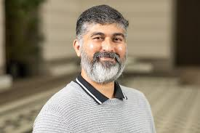

Xuezhu Xu
Associate Professor
South China Advanced Optoelectronic Academy, South China Normal University, China.

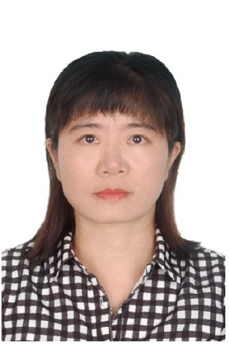

Prof. Dr. Mohamed Mamlouk

Professor, School of Engineering
Room C401a, Merz Court
University of Newcastle
upon Tyne, United Kingdom
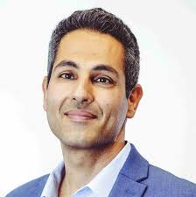

Dr. V. Ganesh
Senior Principal Scientist
Central Electrochemical Research Institute (CECRI) Karaikudi, 630003 Tamilnadu, India

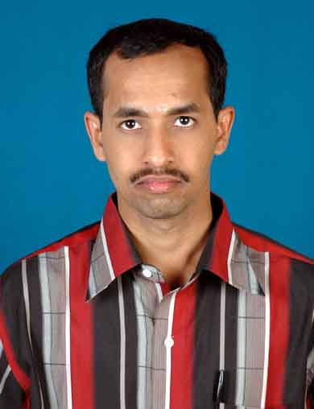

Prof. Muhammed Musthafa
Associate Professor
Indian Institute of Science and Education Research (IISEAR) Pune, India
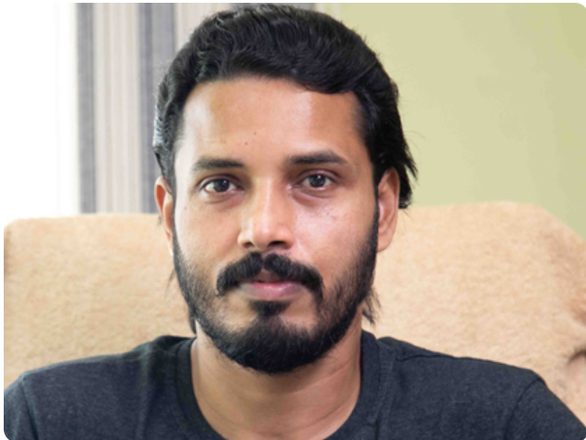

Dr. Subrata Kundu
Senior principal scientist
Central Electrochemical Research Institute (CECRI) Karaikudi, 630003 Tamilnadu, India
Prof. Dr. Muhammed Musthafa
Indian Institute of Science and Technology, Pune, India

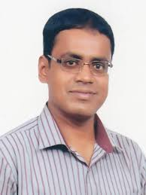

Prof. Dr. Rakesh Kumar Pandey
Mahatma Gandhi Central University,
Mothihari, Bihar



Prof. Shahid Rasul

Associate Professor

School: Engineering, Physics and Mathematics,
Northumbria University, Newcastle
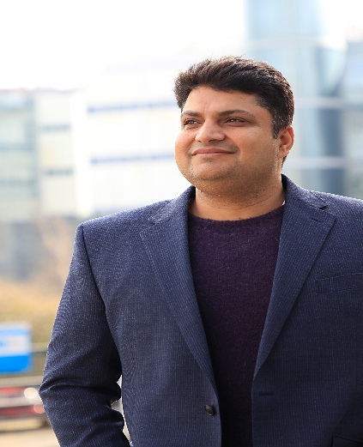

Dr. Rochan Sinha
Co-founder & CTO
Newtrace Private Limited
Bangalore

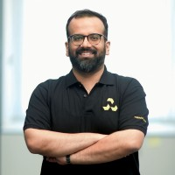

Dr.S. Ramakrishnan YET TO RECEIVE the Photo

Scienstist
Hindustan Petroleum Corporation Limited, R&D
Green hydrogen II Electrocatalyst/Memebrane for AEM/PEM electrolyzer, Fuel cell, Sea water electrolyzer and battery
Namakkal, Tamil Nadu, India

Dr. S. Radha YET TO RECEIVE the photo

Director, Hypower Green Energy Technologies
Bangalore

Dr. Manav Saxena
Head, Center for Research Excellence and Innovation
Associate Professor
Centre for Nano & Material Sciences
JAIN (deemed-to-be University), Ramanagara
Karnataka-562112, India
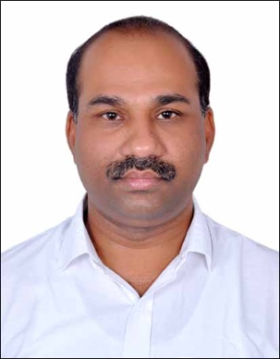

Dr. Ravi Kumar
Associate Professor
Atria University
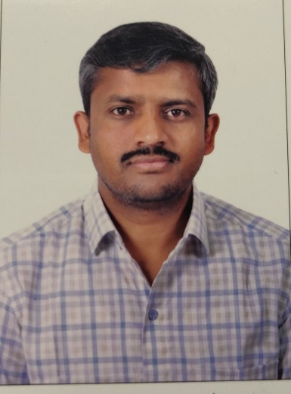

Registration Fee:
Pre-Conference & Conference (11-13th Dec 2025): Rs.2000.00
Conference (12th -13th Dec 2025):
Faculty/Research Scholar: Rs. 1500.00
UG/PG Students: Rs. 500.00
Industry Delegates: Rs. 2000.00
Foreign Delegates: USD 100.00

ACCOUNT DETAILS & QR CODE

Sponsors:

Department of Science and Technology, Govt. Of India, India

2)

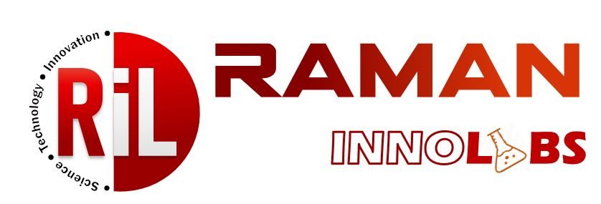
Manufacturers and Suppliers of:
Quartz wares, Alumina wares, Quartz and Alumina tubes, Furnaces, Ovens, Heating Systems, Glass wares, Autoclaves, Advanced Research Materials
High Vacuum systems- Vacuum pumps and etc.
ramaninnolabs@gmail.com
8884733828, 7795989765

3)


300/2 Chamundeshwari Layout
Doddabommasandra Main Road
Vidyaranyapura
Bengalore 560097Elixir Technologies
300/2 Chamundeshwari Layout, Doddabommasandra Main Road, Vidyaranyapura,
Bengaluru – 560097

Contact Information

Icseet.2025@gmail.com
Mobile: 9480224757 (Dr. Madhusudana Reddy
9900634435 (Dr. Nagaraju D H)
9885057117 (Dr. Ramakrishna Reddy)
9844722805 (Dr. Nagendra G)
9964556195 (Dr. Shivanna)
9964076373 (Dr. Nagarajaih)
9900404059 (Dr. Shwetha)

Account Details for registration

