Milestone 3 Report

Team06: Quiztopia

Rusho Bin Nabi, Matthew Niemczyk, Daniel Peck, Danica Porter, and Menachem Rubin.

# Overview:

For our project, we want our users to be able to signup, login, view, create, and edit flashcards, store their flashcards in an organized system, and join classes to receive better instruction from their teachers. We broke these tasks into 5 separate groups: User Authentication, Flashcard Storage, Classroom Interactions, Flashcard Study Exercises, and Database Management.

## Entity Relationship Diagram:

For the specific entities stored on our servers, we came up with 6 primary entities we would need: User, Folder, Set, Flashcard, Class, and Roster. The User entity contains the necessary personal information that we need to operate the site. More specifically, their name, username, password, and references to their root folders and the classes to which they belong. Next, we have the Folder system. This contains the title of the Folder, its parent node and its children. Also, it contains Sets to store the users’ flashcards in an organized fashion. Each Set contains a title, description and list of flashcards. Each flashcard has a term, definition, and a proficiency between 0 and 100. Finally, we have the Class and Rosters. Each class has a name, description and folder for organizing their cards. They also store their Owner, Teachers, and Students.

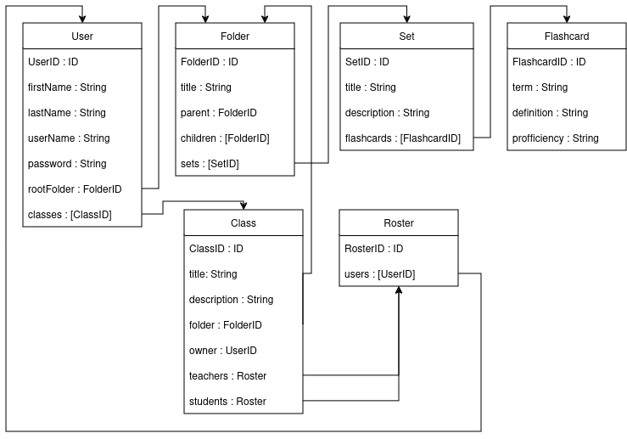

## Context Diagram:

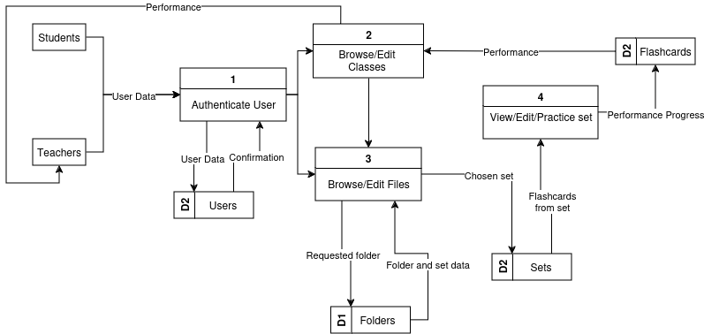

# User Authentication: (Needs lvl-0)

## Data Flow Diagrams:

### Level-0:

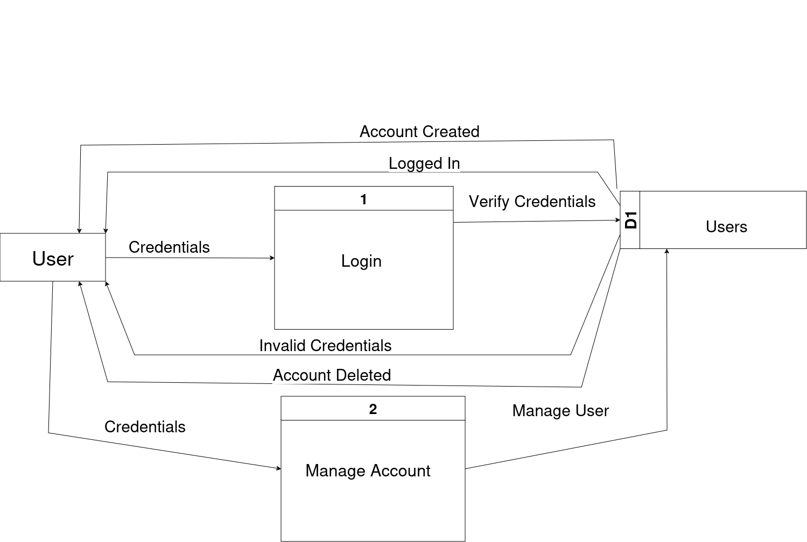

### Level-1:

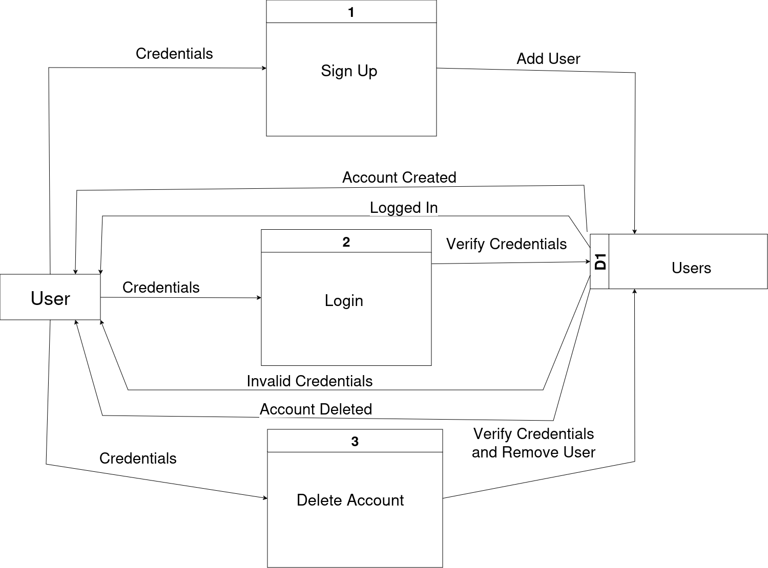

### Level-2:

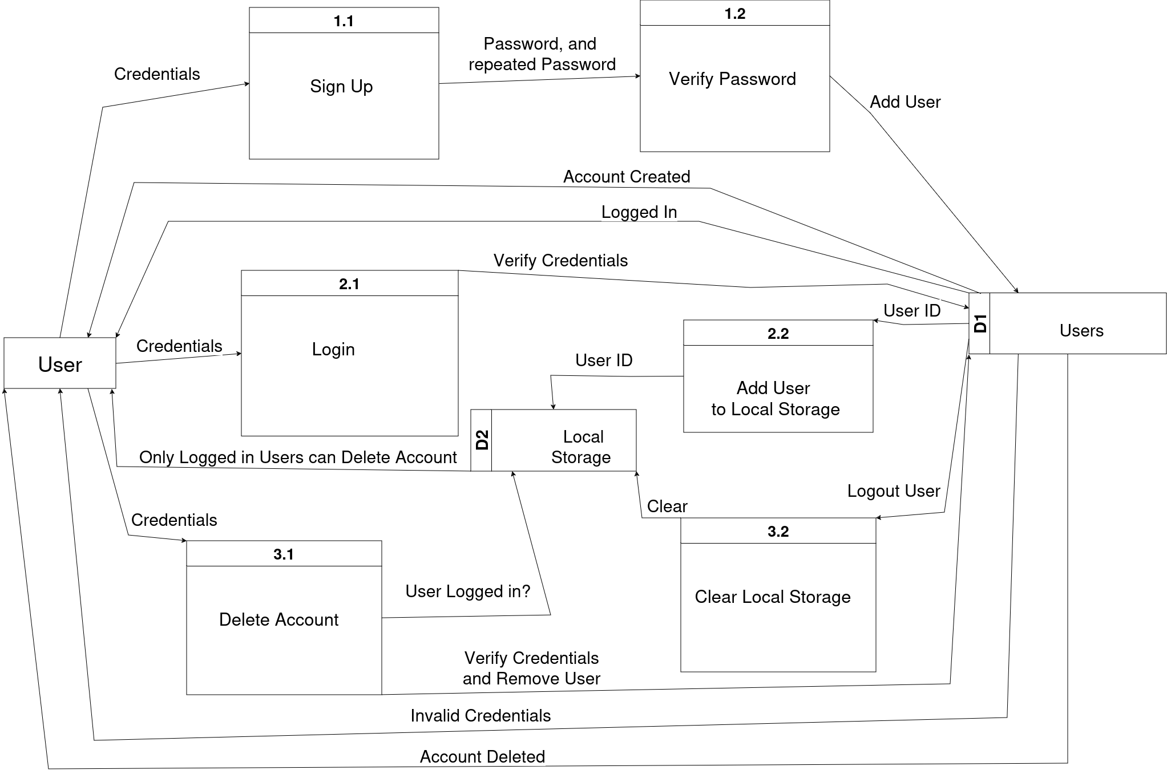

## Mockup:

### Signup page:

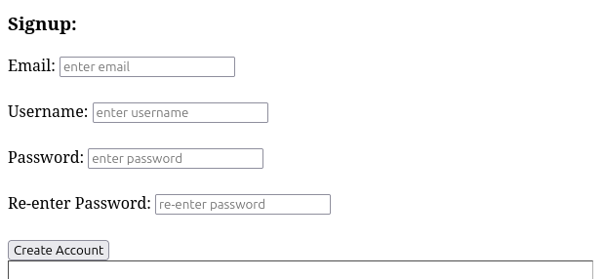

### Login:

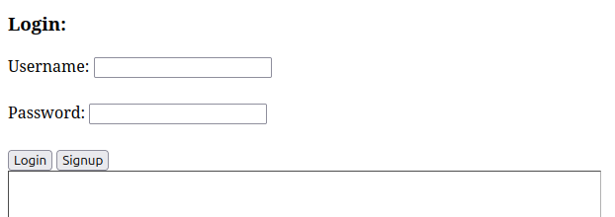

### Home page:

# Flashcard File System:

## Data Flow Diagrams:

### Level-0:

The user can navigate through the file system by selecting a Folder or a Set. Selecting a Folder opens that folder to the user for continued navigation. Selecting a set opens the set viewing window. The user can also edit some of the information in either a folder or a set.

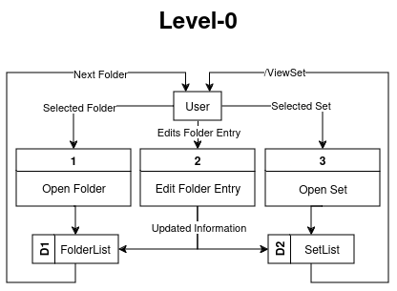

### Level-1:

The user can navigate through the system as described above, but now we are going to get into the different editing processes. From the file system, the user can move, delete, or edit a Folder or Set.

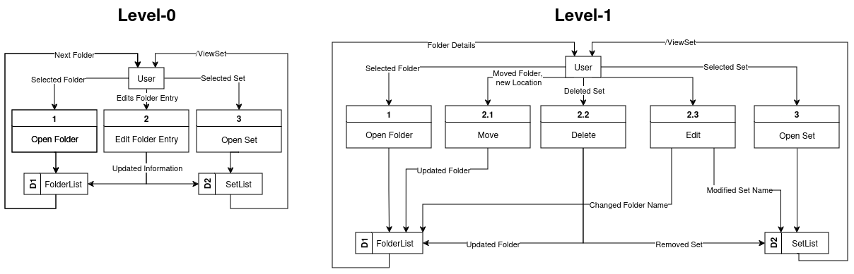

### Level-2:

The user needs to be able to clearly see the folder information without getting every single detail about the child folders.

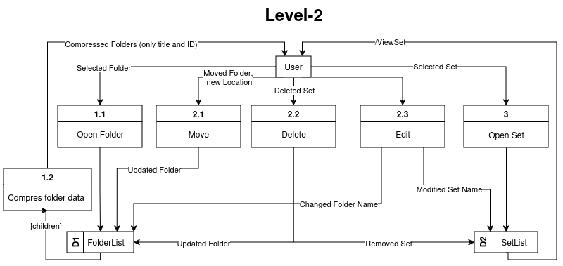

## Mockup:

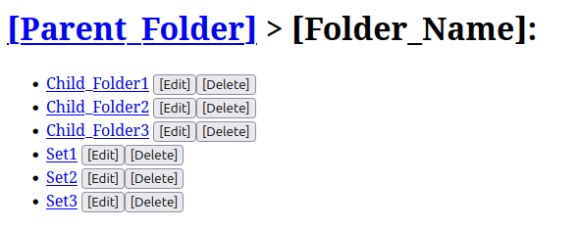

# Classroom Functionality:

## Data Flow Diagrams:

### Level-0:

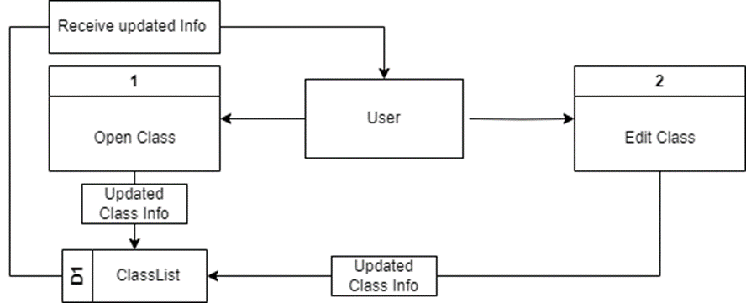

### Level-1:

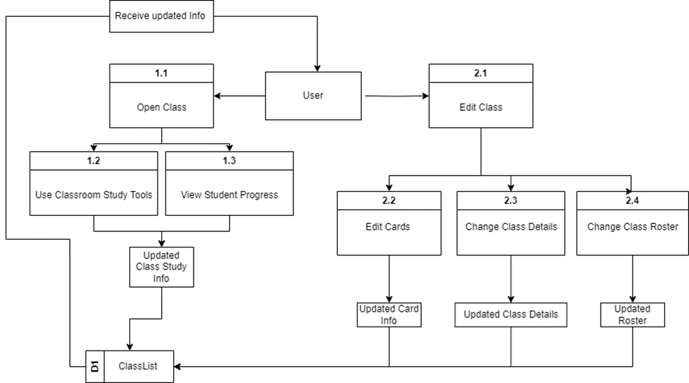

### Level-2:

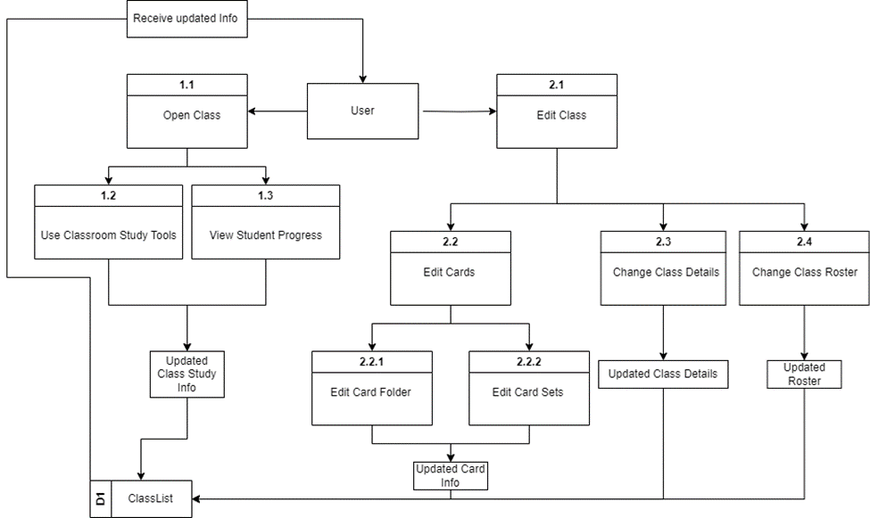

## Mockup:

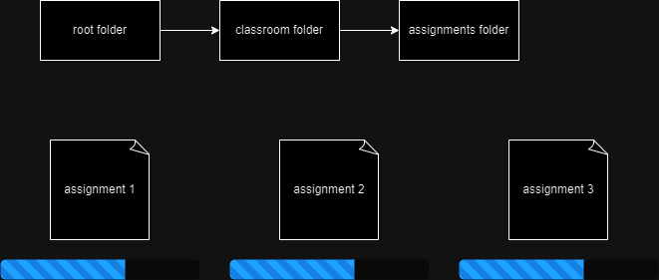

# Flashcard Study Exercises: (Needs mockups)

## Dataflow Diagrams:

### Level-0:

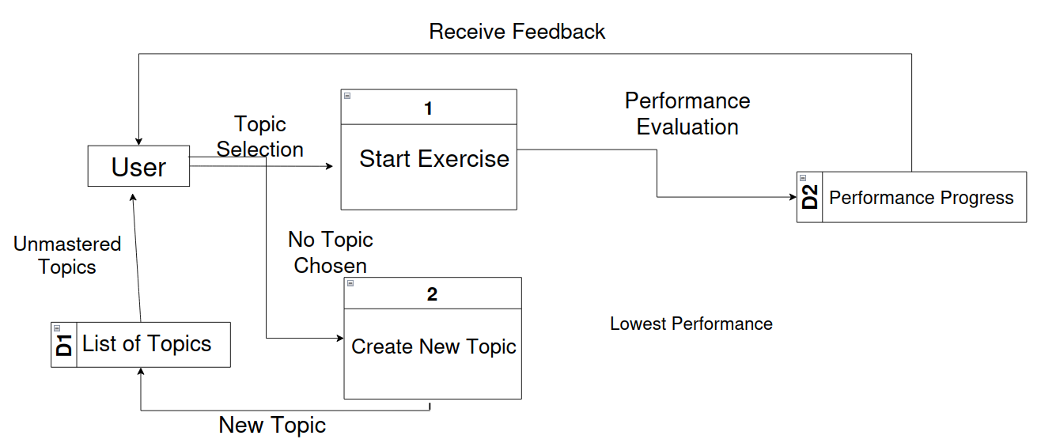

### Level-1:

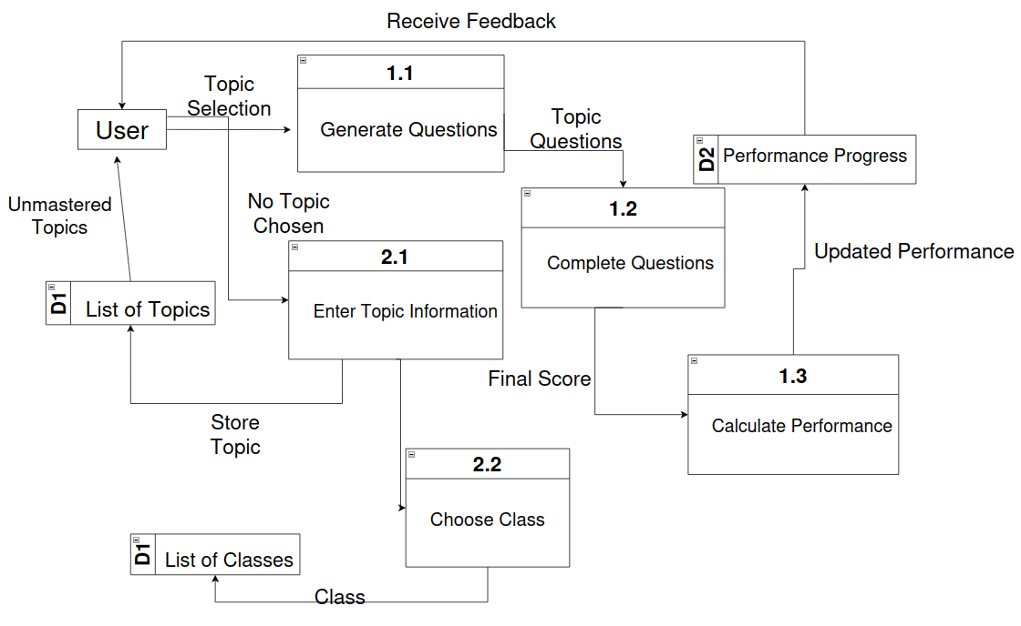

### Level-2:

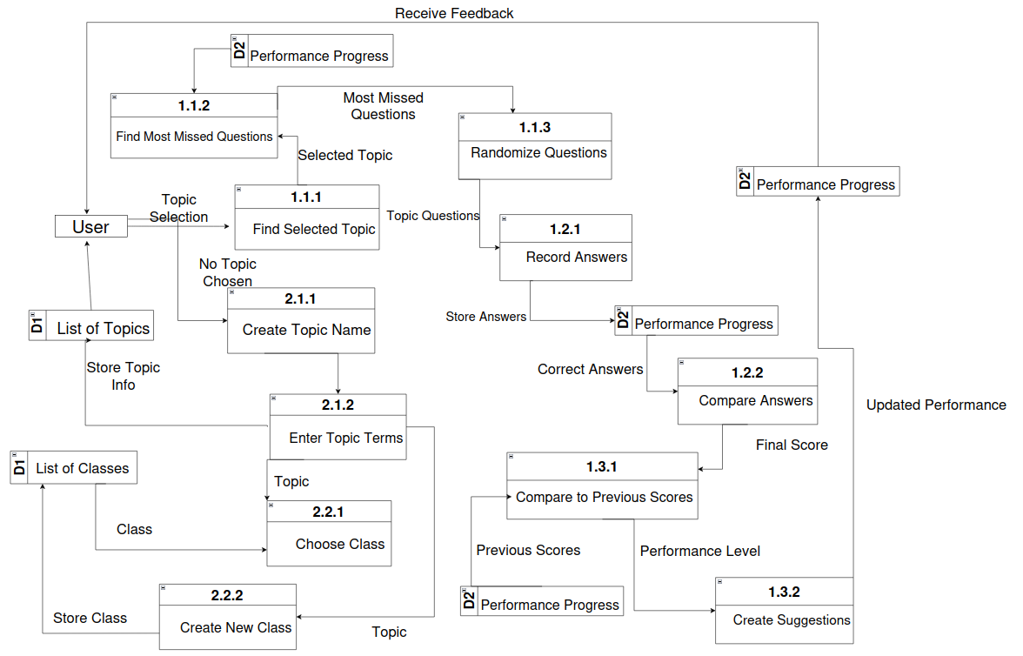

## Mockups:

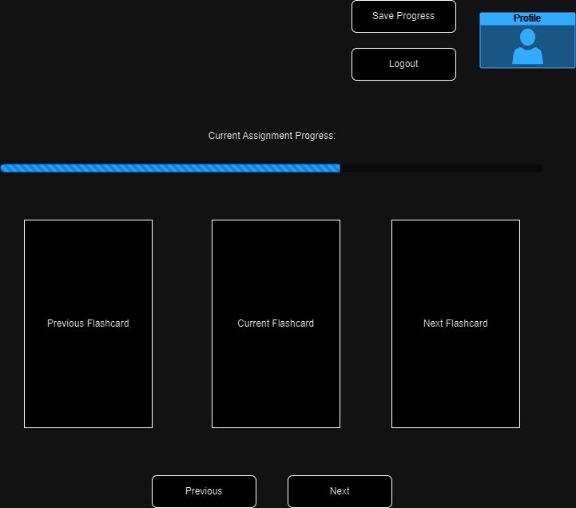

# Database Management:

## Data Flow Diagrams:

### Level-0:

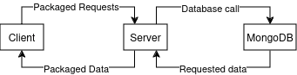

### Level-1:

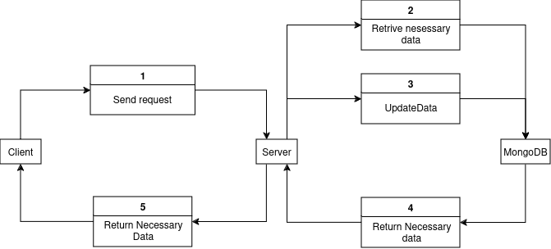

### Level-2:

