Instructions to setup the Android development environment for TPadTablet

- Clone the code repository from GitHub: https://github.com/ICST-AHMI/TPadTablet_code
- Download and install Android Development Tool: http://developer.android.com/sdk/index.html
  - Start Android Studio

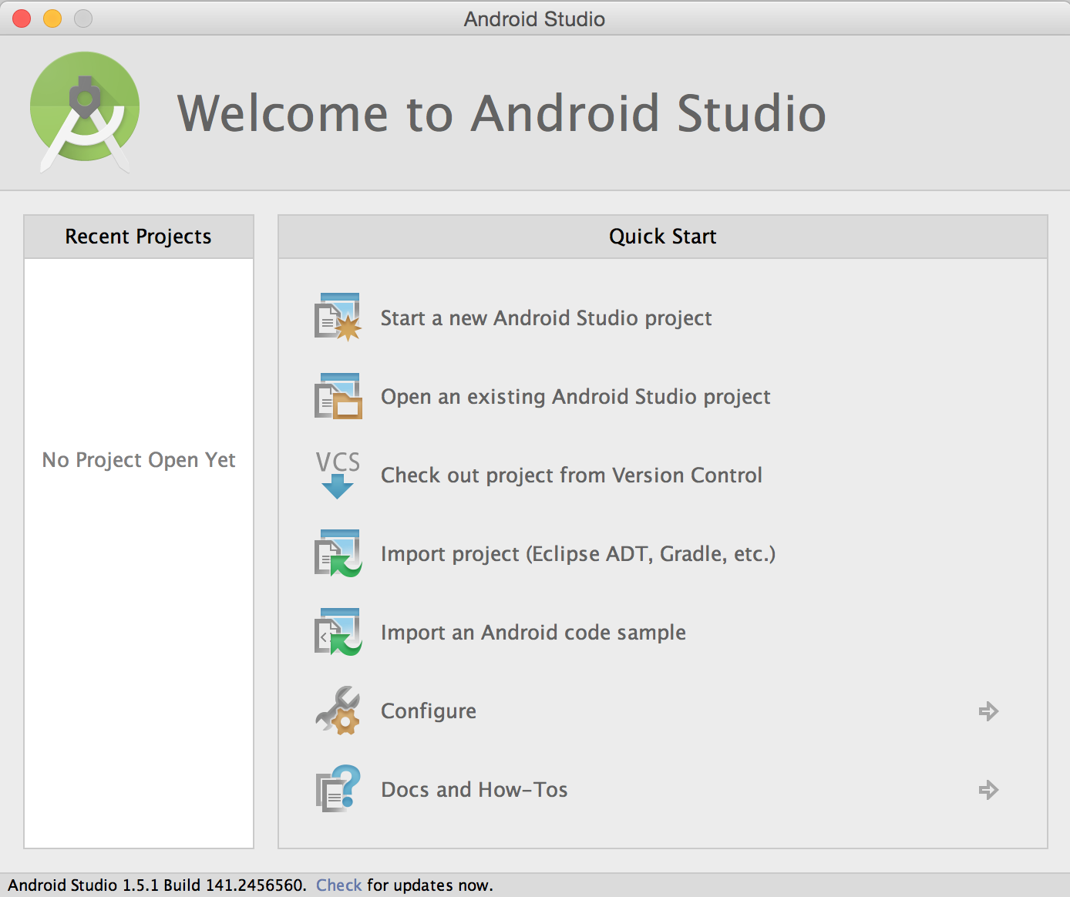
  - In the Welcome window, go to Configure...
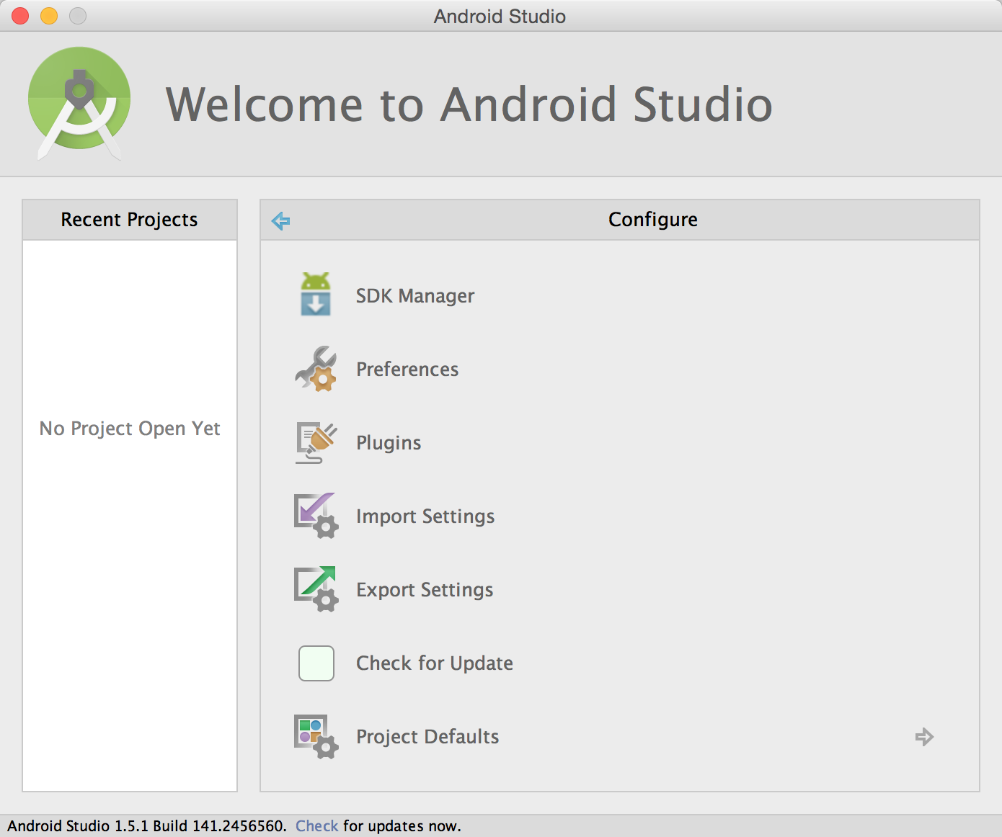
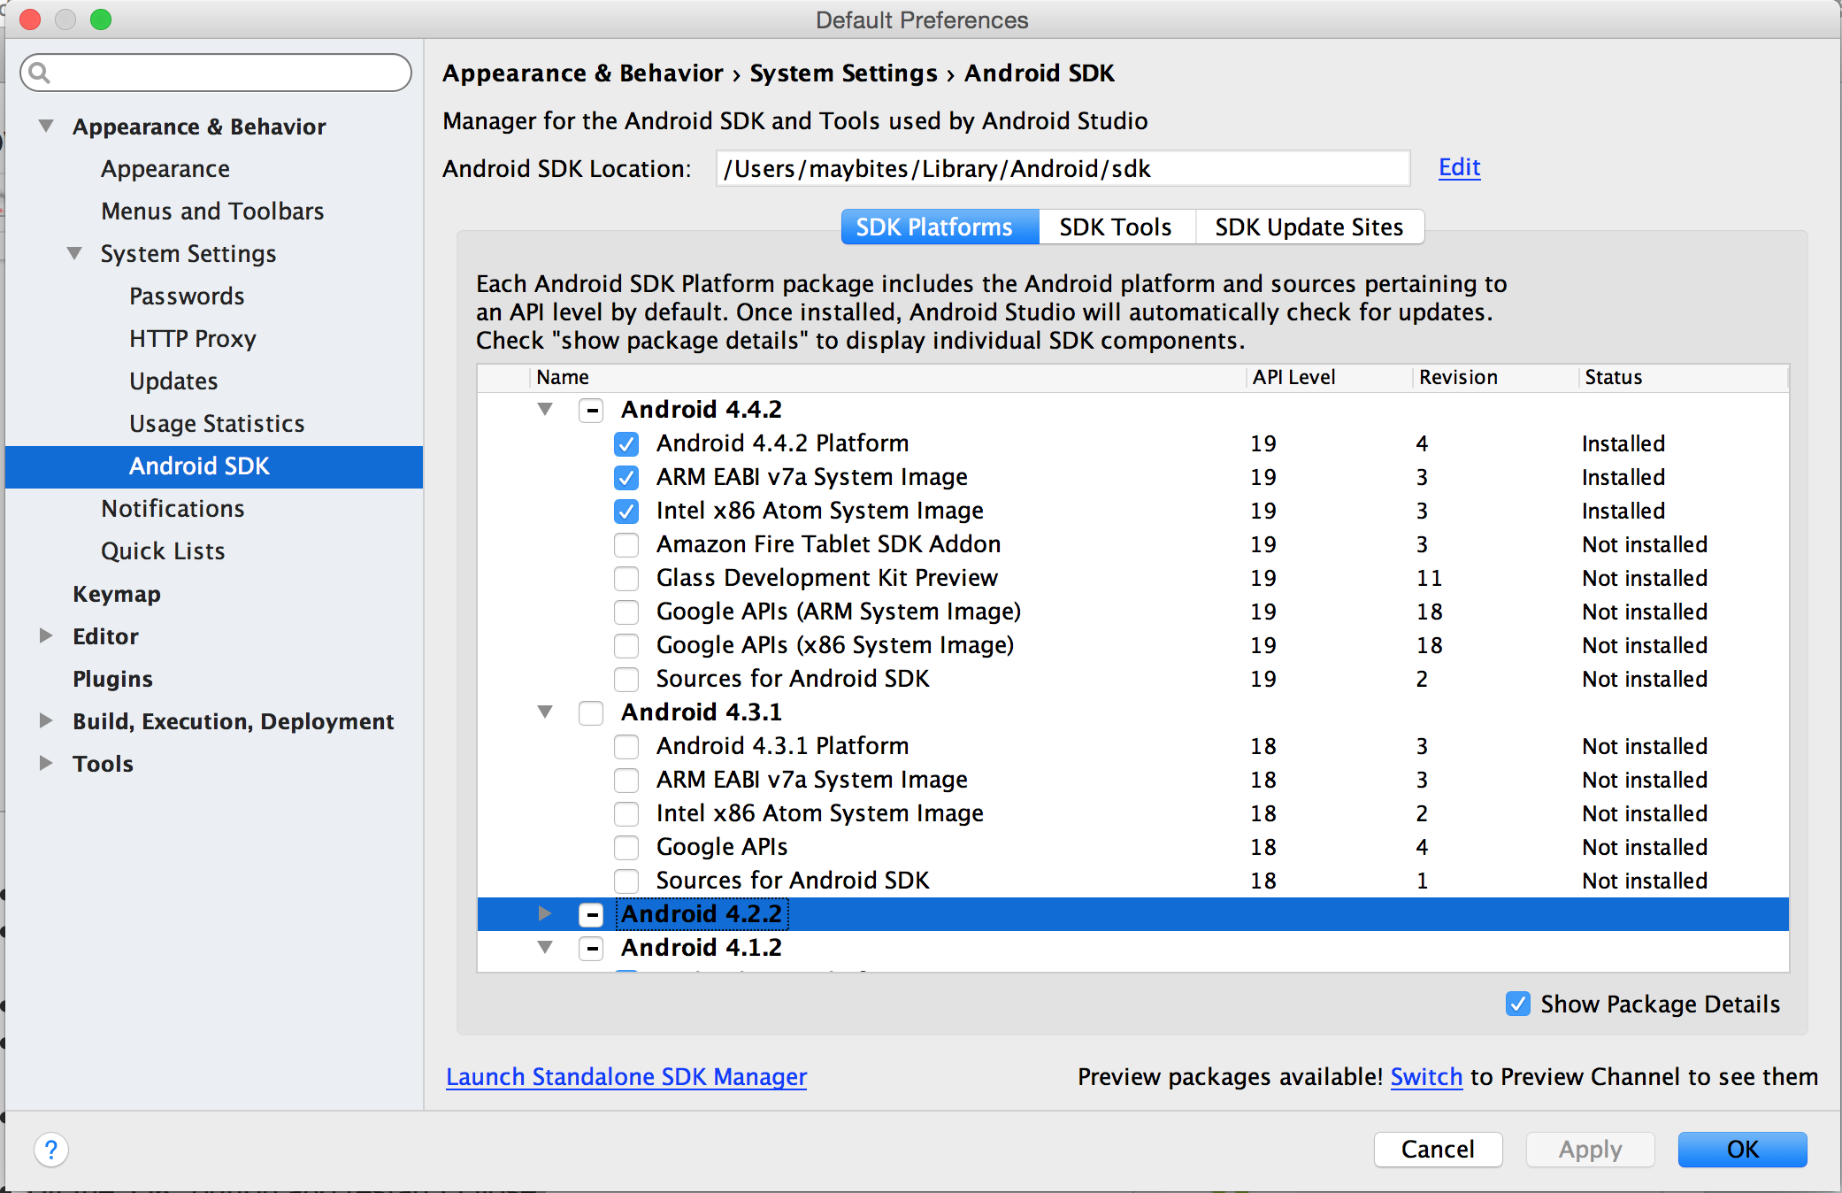
  - go to SDK-Manager
  - Under SDK-Plattforms
    - toggle on “Show Package Details”
    - select Android 4.4.2 Platform (API level 19)
    - select ARM EABI v7a System Image
    - select Intel x86 Atom System Image
    - press Apply. The SDK and the System Images will be downloaded and installed.
  - Under SDK-Tools
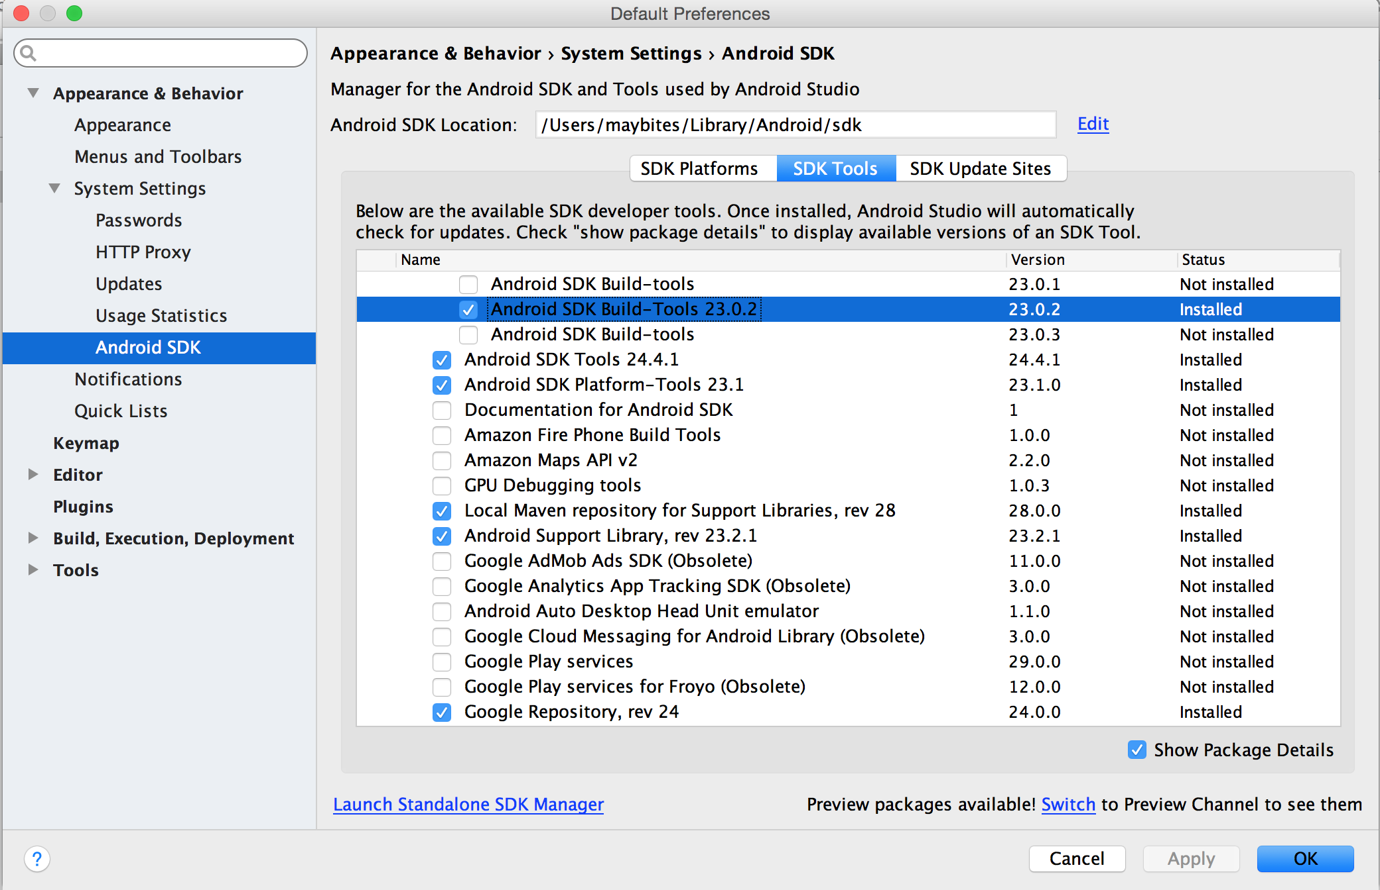
    - toggle on “Show Package Details”
    - select Android SDK Build Tools (latest version)
    - select Android SDK Tools (latest version)
    - select Android SDK Platform
    - select Google Repository
    - press Apply. The packages will be downloaded and installed.
  - close Android Studio.
- Download and install eclipse: https://eclipse.org/downloads/
  - Start eclipse.
  - Install Android Plugins for eclipse
    - Menu Help>Install new Sowftware...
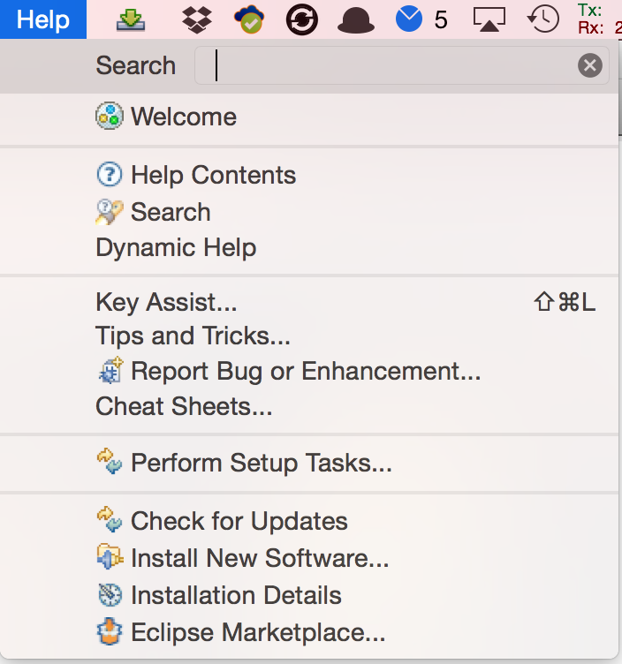

    - Add...
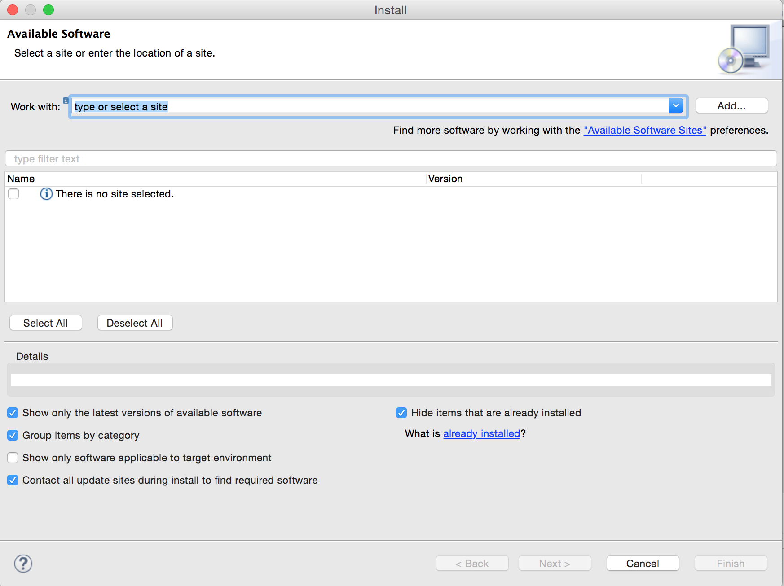
    - Give the repository a name like 'ADT Repo'.
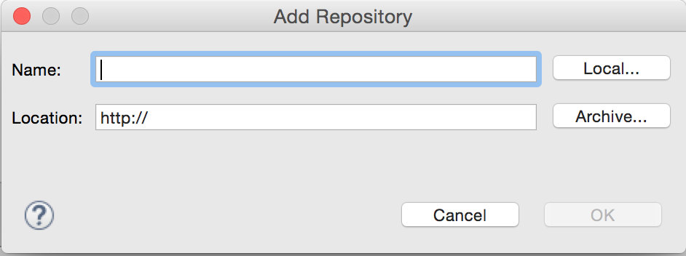
    - Location: http://dl-ssl.google.com/android/eclipse/.
    - ok.

  - Now that we have the plugin repo setup we need to install the plugin from it.
    - On the 'Install Software' screen, select the repo you just created from the 'Work with' selector.
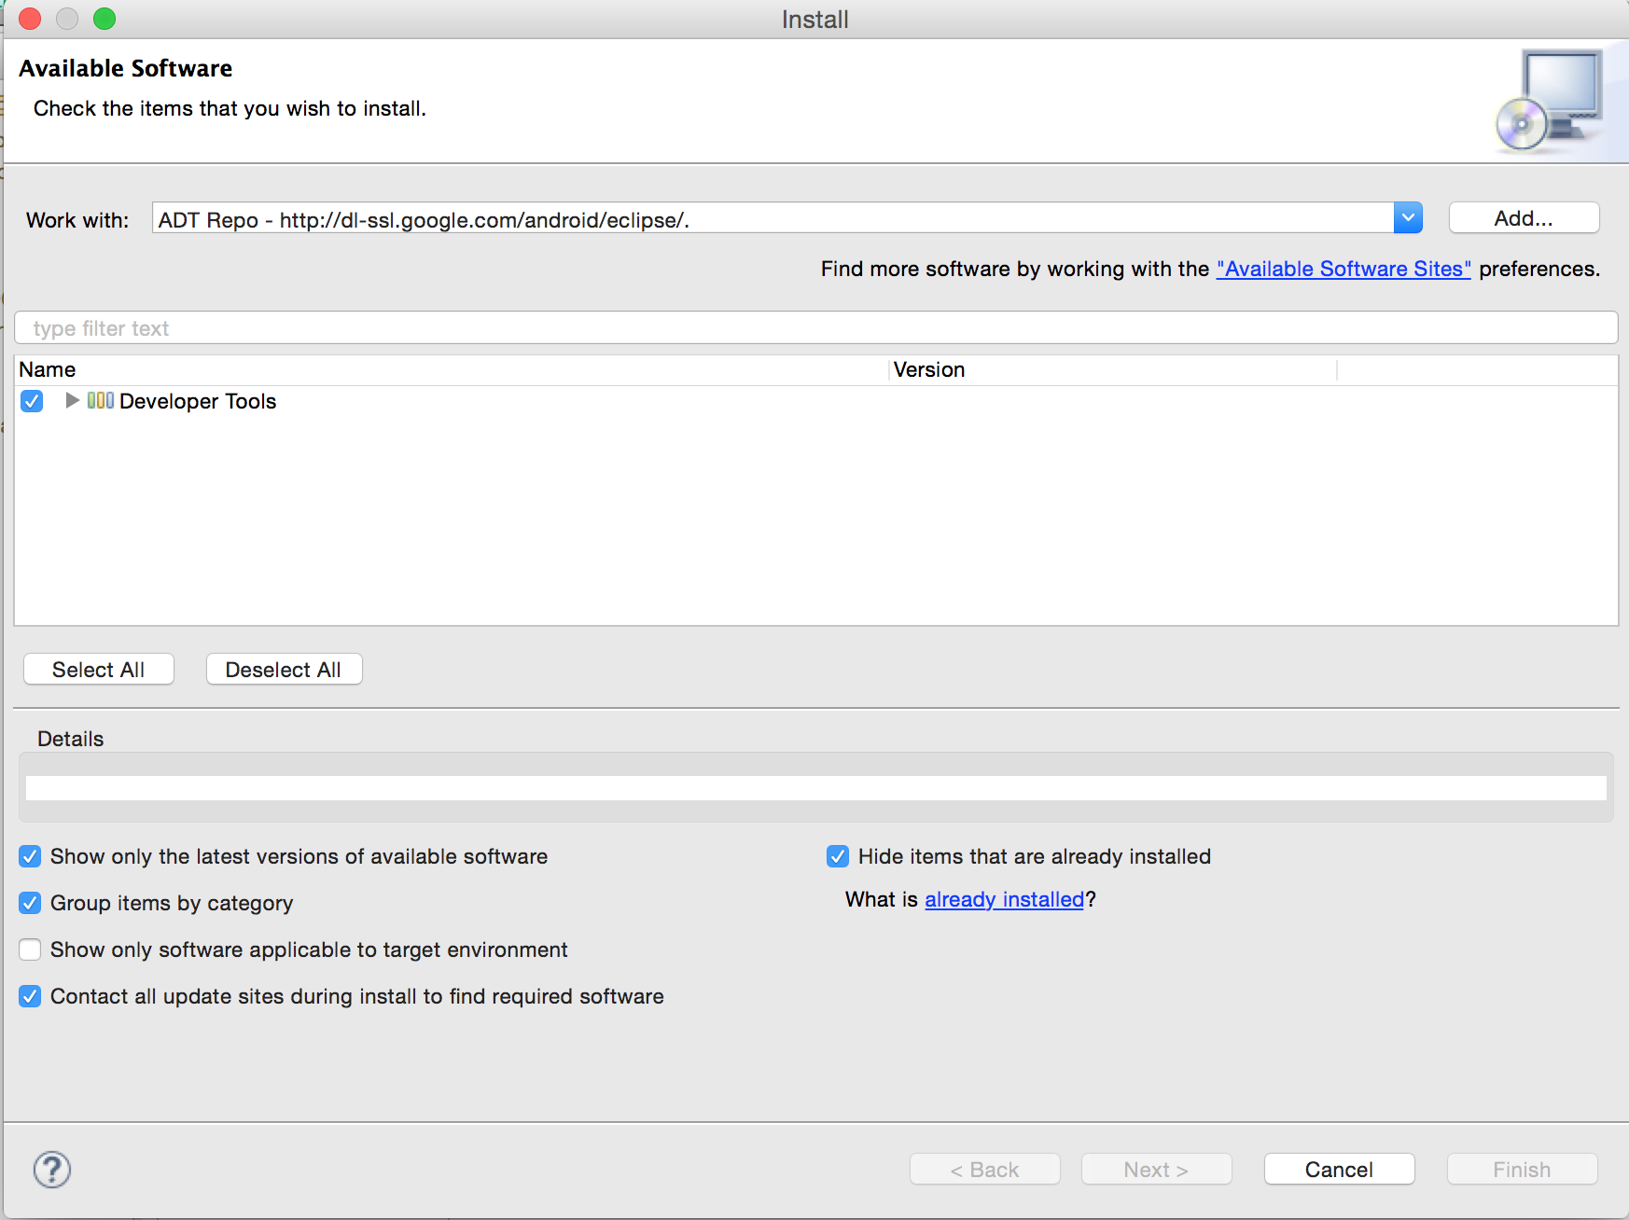
    - Select the 'Developer Tools' option from the listed below options.
    - Click 'Next' and accept the agreements.
    - Click 'Finish' and let it install. It might take a while depending on your internet speed.
  - You'll most likely have to restart Eclipse after you install the ADT Plugin so do that before you continue.
    - Mac/Linux: After Eclipse has restarted, click 'Eclipse' in the application menu.
    - Windows: After Eclipse has restarted, click 'Window' in the application menu.
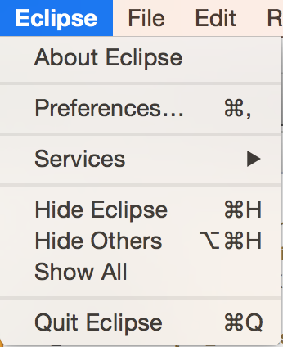
    - Then select 'Preferences'.
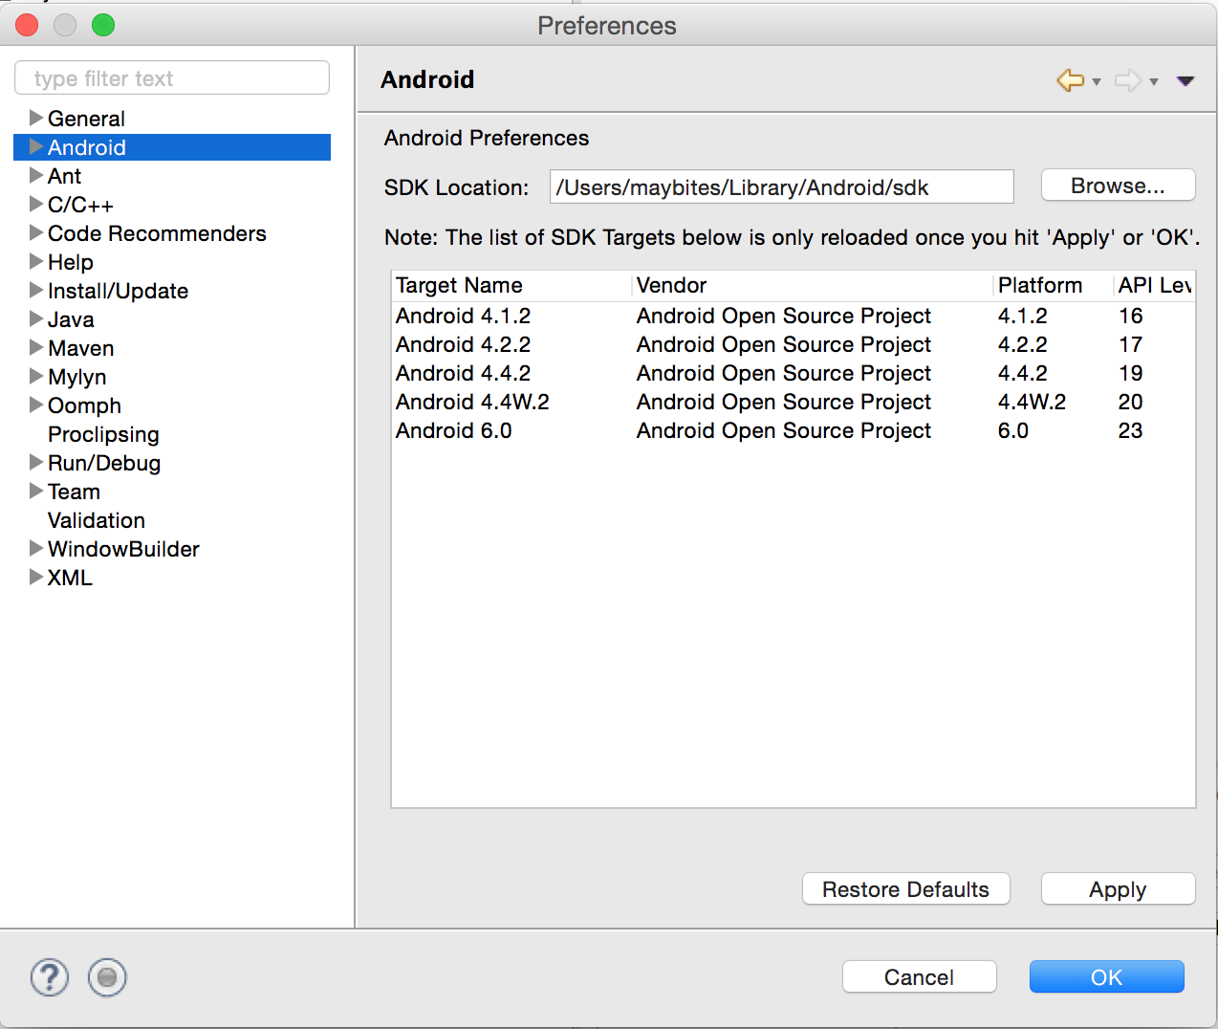
    - In the Preferences window, select the Android tab on the left side and it's corresponding drop down menu.
    - This is the ADT Preferences screen. It will allow you to change setting, remove the SDK and make editor preferences for your development.
    - Click 'Browse' on the right side of the screen.
    - Search for the folder in which you installed the Android SDK into and select it. (on OSX it is ~username/Library/Android/sdk.
    - Hit the 'Apply' button on the Preferences screen.
    - You should see the Android version you installed early to show up if all went well.
    - If not, try reselecting the folder. (Make sure the folder contains the folders 'build-tools','platform','extras' and etc.
    - Hit the 'OK' button and restart Eclipse.

  - Now you can create the first eclipse project.
    - Right click inside the Package Explorer Tab

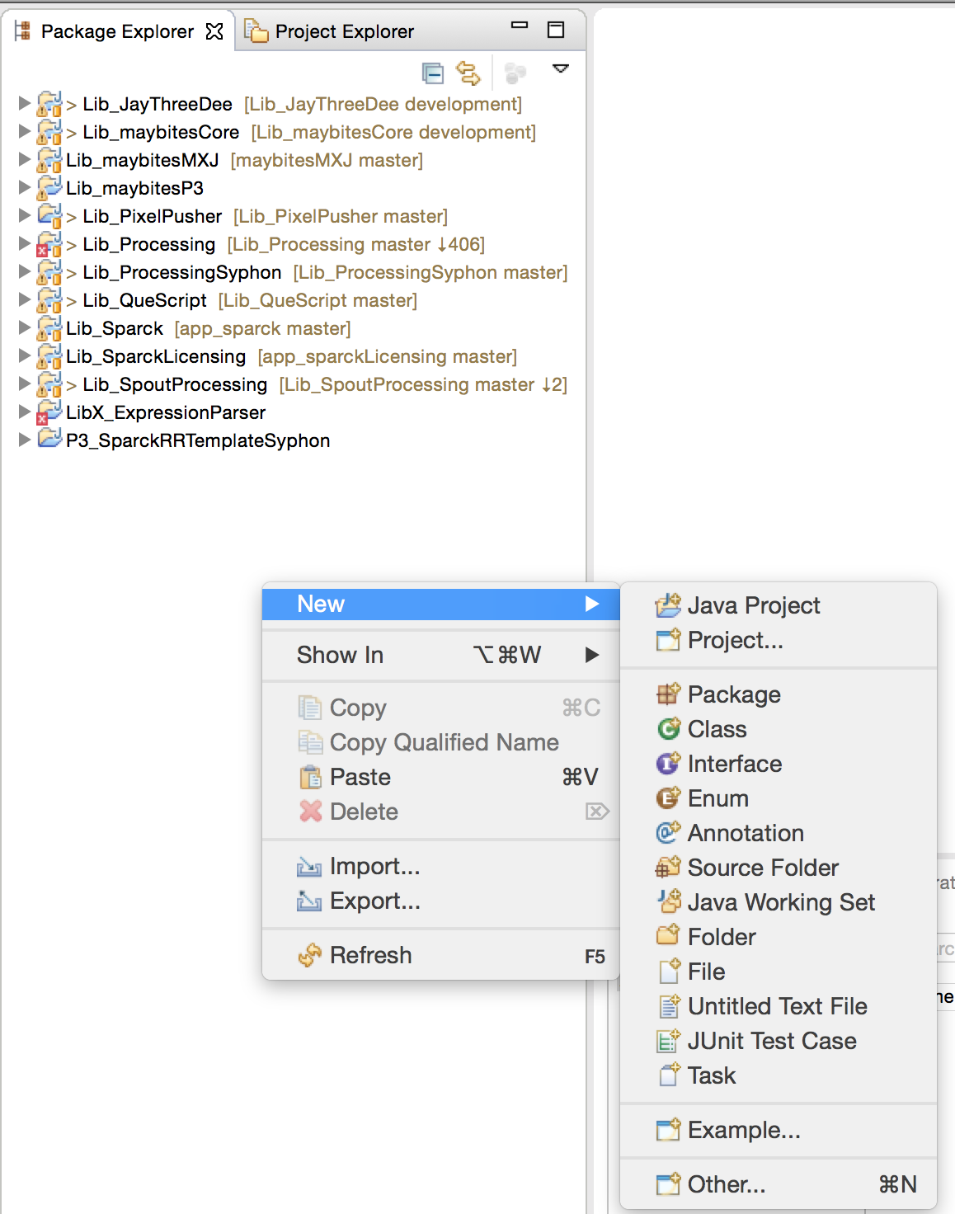
    - Select New > Java Project

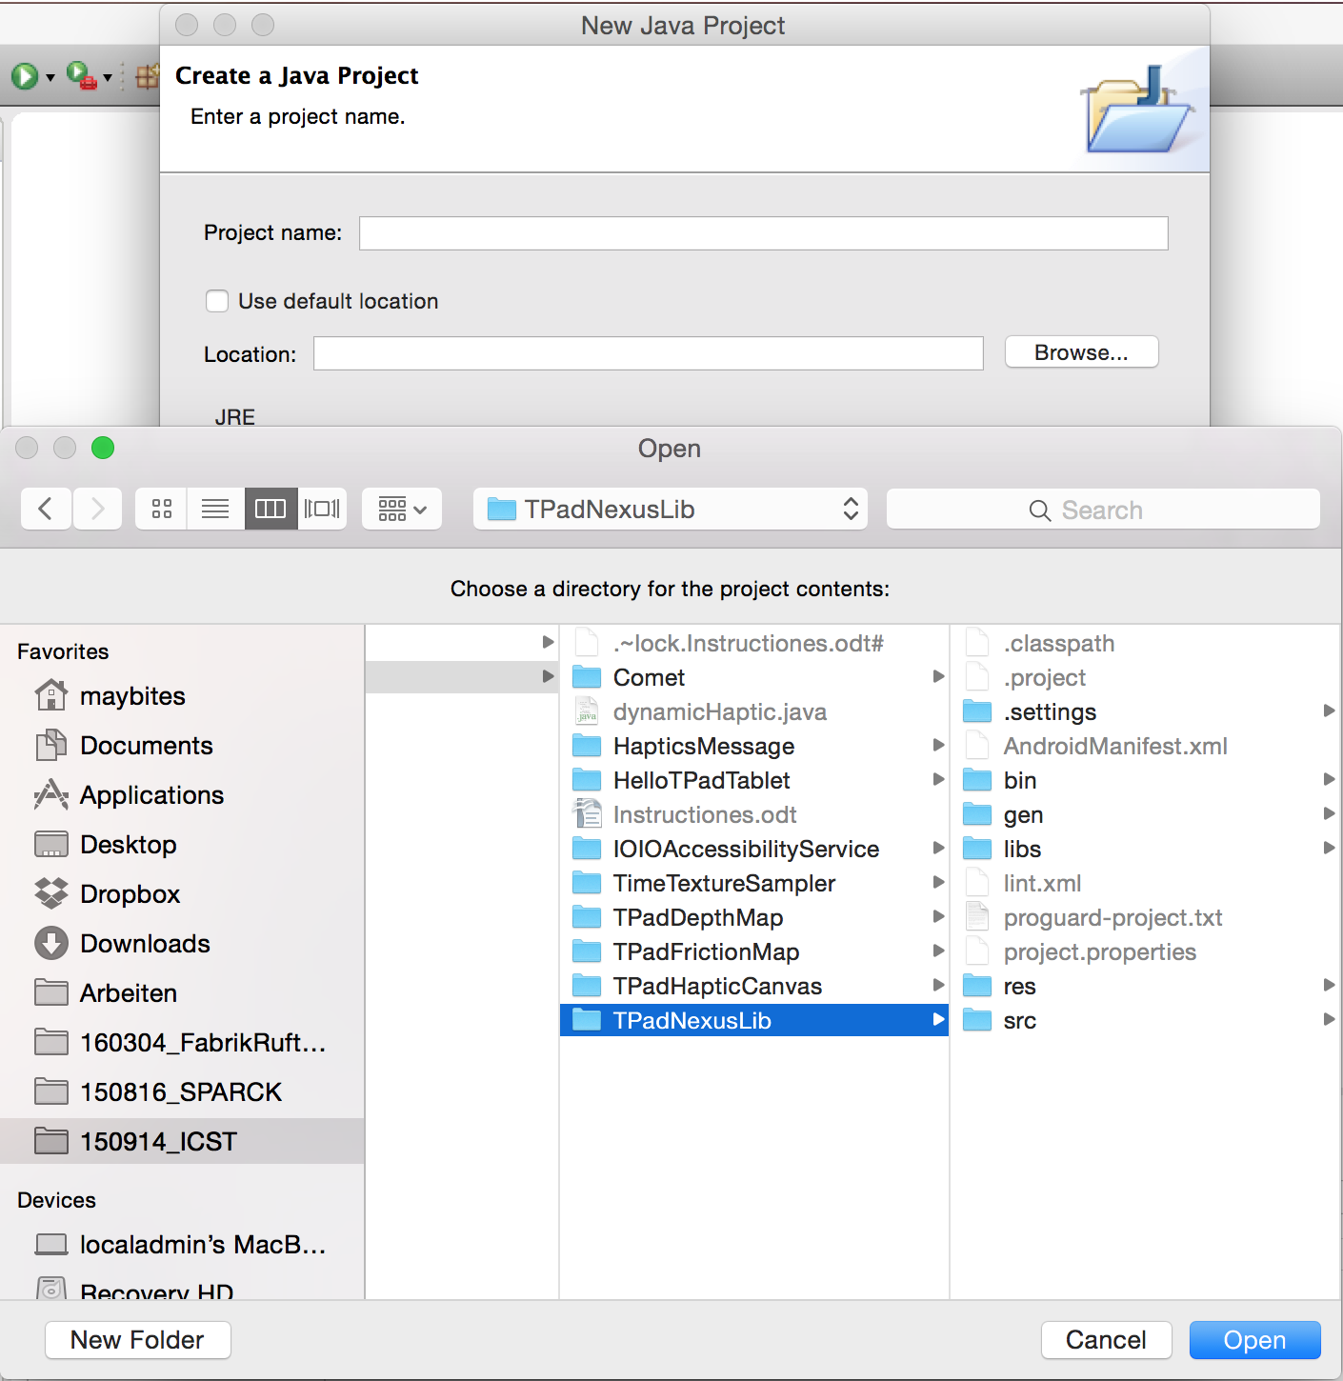
    - Deselect “Use default Location”
    - press “Browse...” and navigate to the eclipse folder inside your clone of the repository
    - select TpadNexusLib
    - press finish.
  - Create another new Project
    - repeat the above process, this time you select one of the other projects.
    - In this case I chose the Hello Project:
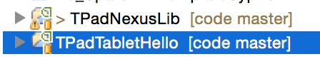

  - Attach the TPadTablet via USB cable to your computer
  - press the little down-arrow next to the “Run” Symbol
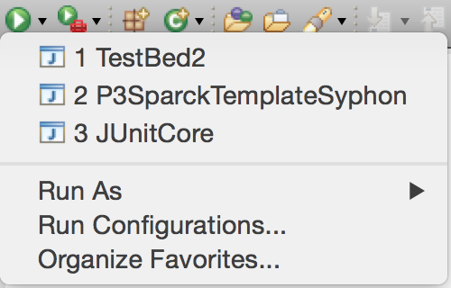
  - select Run Configurations...
  - right-click on Android Apps...
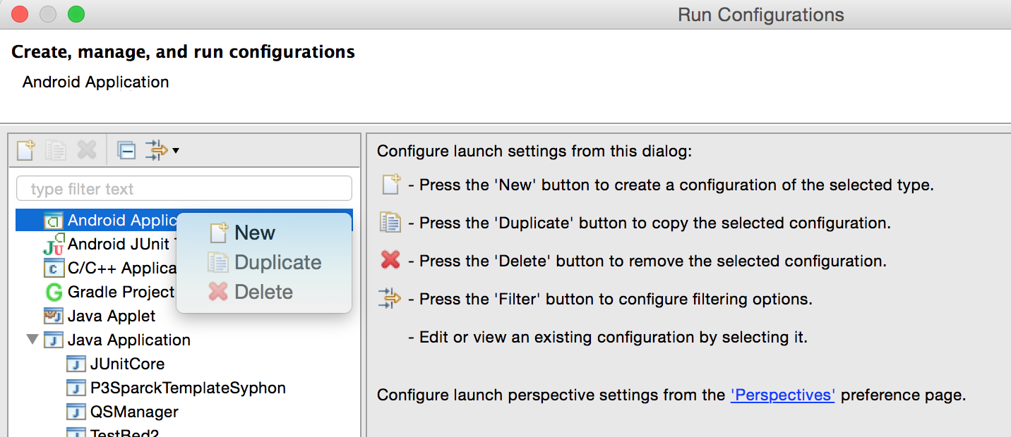
  - select New
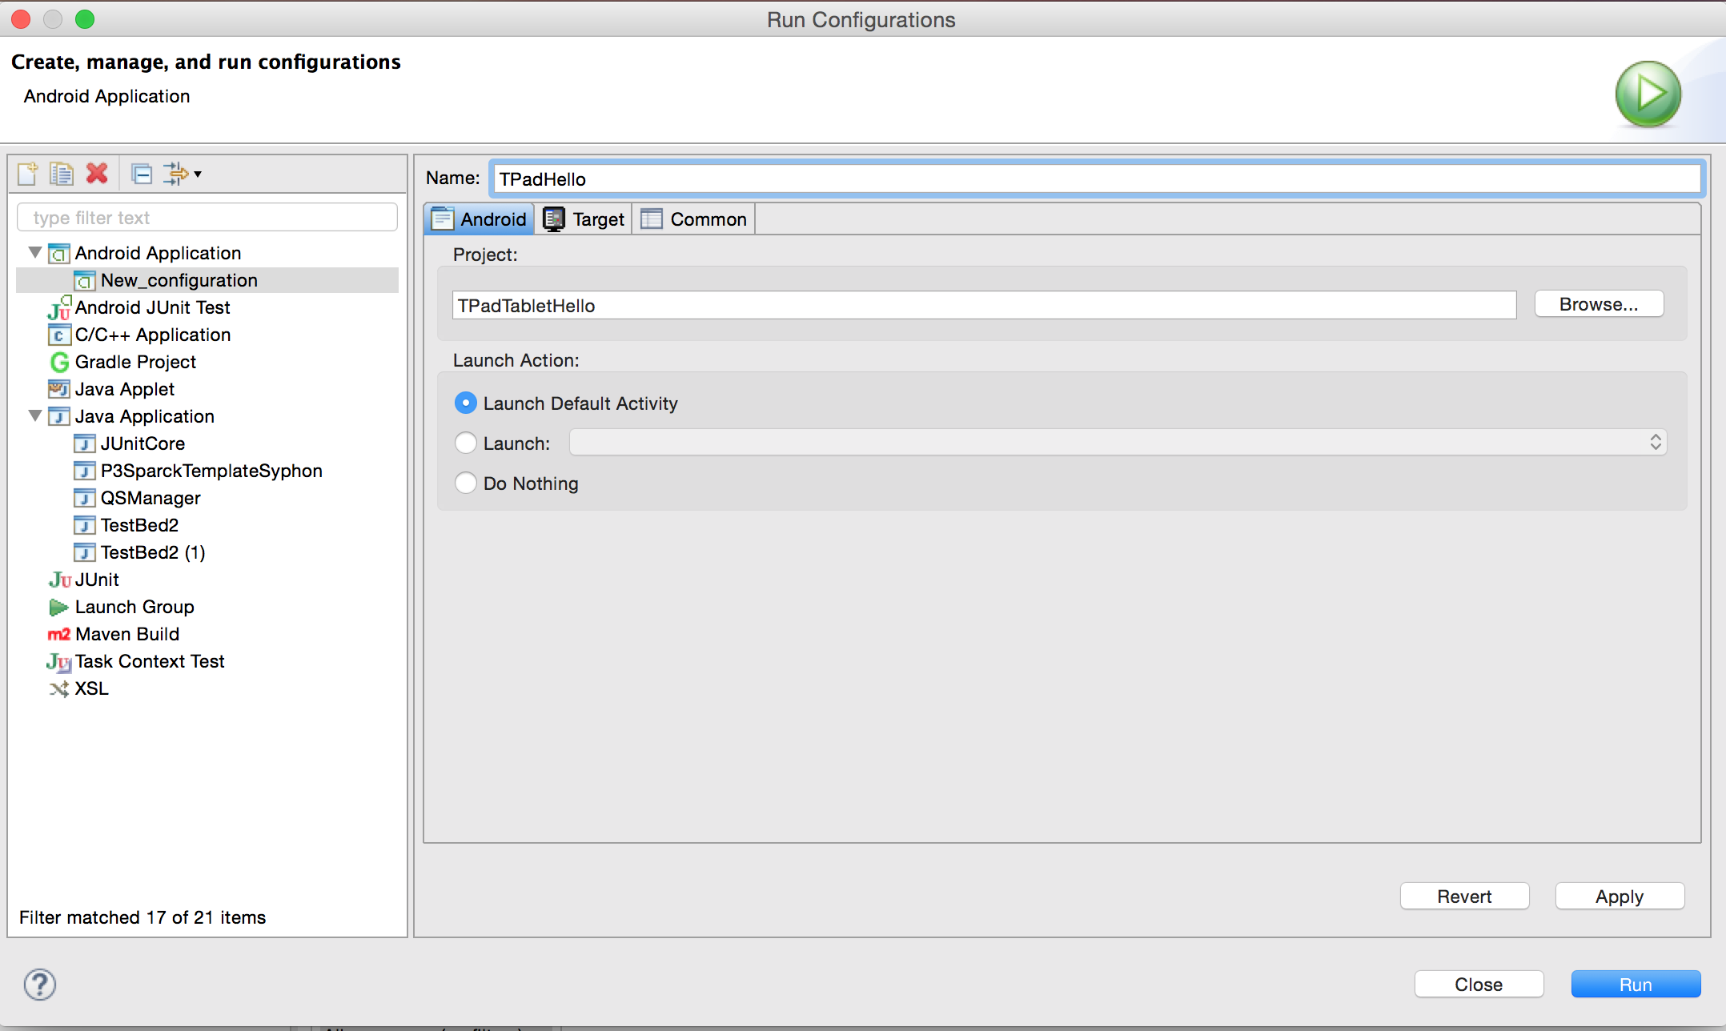
  - change the Name and select your Project via “Browse...”
  - got to tab “Target”

  - select “Always prompt to pick a device”
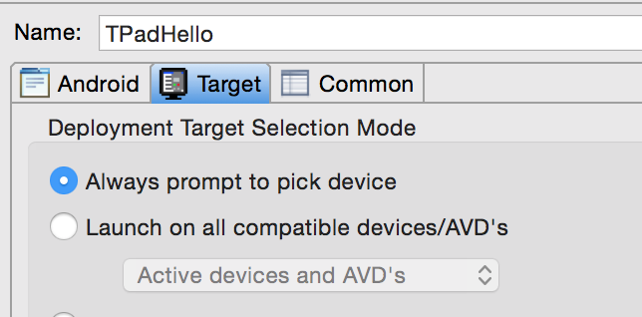
  - Go to your Tablet > Settings > Developer Options
  - deselect USB Debugging
  - reselect USB Debugging
  - System asks if it is ok to Allow: select OK
  - System asks if it is ok to Allow from connected Computer: select OK
  - back in eclipse: press Run
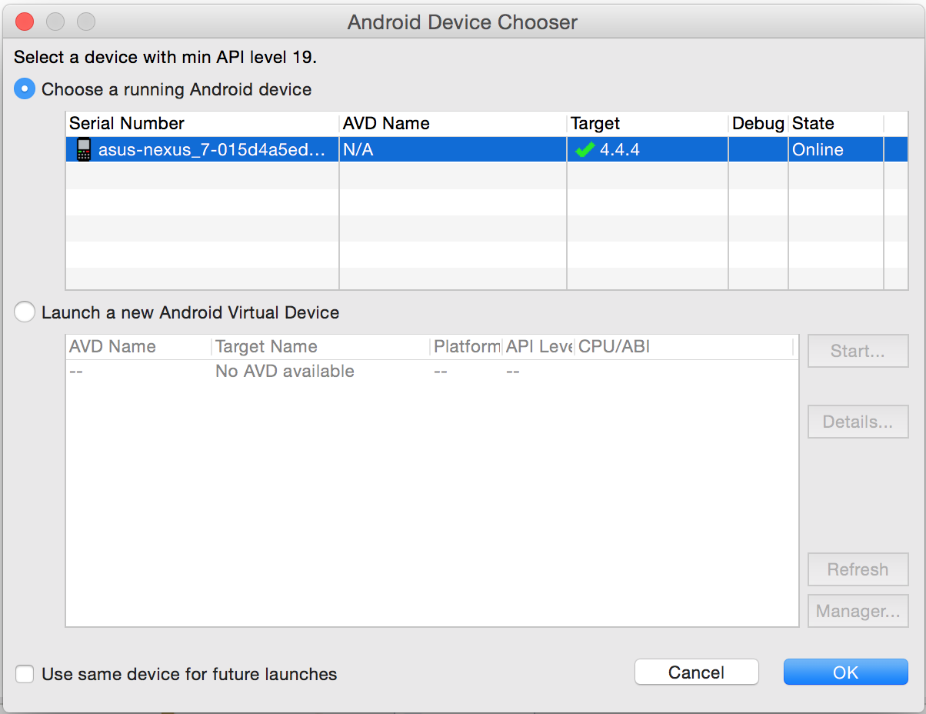
  - the Android Device Chooser window pops up.
  - select your TpadTablet
  - press OK

The Application is now compiled and executed on your Tablet

