Option : Webdesign

|  |  |  |
| --- | --- | --- |
| **Duration** |  | 180 minutes |
| **Available resources** |  | Provided only |

Candidate :

|  |  |
| --- | --- |
| **Name** |  |
| **First name** |  |
| **Email** |  |
| **Trainer** |  |
|  | |
| **Start of the test** |  |
| **Delivery of the test** |  |

# Instructions

## Introduction

This document describes the tasks to be performed for the 2014 Championships in the category WebDesign. It’s advised to read carefully and look at the different media provided, such as images and text attached.

You have 3 hours to complete as many tasks as possible without using any external resources other than those provided.

You are free to perform the required tasks with all the skills that you have using the tools provided. In addition to the media provided, it’s of course possible to produce new media or modify existing ones if you think it necessary.

You probably will not have enough time to complete all the formal and technical criteria of the tasks. In this case, you must decide the criteria to achieve in priority to win as many points as possible. But be careful to make a version of the site running without errors.

## Rules

To perform the tasks required, you must observe the following rules:

* All Internet access is prohibited during the competition ;
* The use of any communication is prohibited (mobile, tablet, etc.);
* No memory means is permitted (USB, etc.);
* Dialogue with other candidates is prohibited ;
* No headset, headphones or other sound device is tolerated ;
* No personal notes can be accessed nor be near your place of work ;
* A blank notebook and a pen are provided.

The non-compliance with the rule may result in your disqualification from the competition.

## Evaluation

Each task performed will be evaluated on the implementation carried out of various features requested. In addition, the following criteria are also involved in the evaluation.

* All written code must be properly formatted, indented and commented ;
* Each function or method must be documented ;
* The generated HTML and CSS must comply with W3C standards ;
* SQL queries must be protected from any possible injections ;
* No error should occur (the level of error reporting is set to E_ALL).

## Deliverables

All deliverables must be submitted in zip file named "WebDesign_Name_Surname.zip" and it must be placed at the folder location indicated by the supervisor. The deliverables are site files as well as a "dump" of the database.

At the end of the competition you must also submit all documents and notes to the supervisor.

Only entries made in this document and the contents of the zip file will be considered for the evaluation of the work. A blank sheet is available on the last page. Your notebook will not be corrected.

## Tools

The tools available to perform the tasks in this document are:

* Apache
* MySQL
* PHP
* phpMyAdmin
* Notepad++
* Eclipse with PDT (PHP Development Tools)
* IntelliJ PHP Storm
* Mozilla Firefox with Firebug
* Google Chrome
* Internet Explorer

## Documentation

To perform the tasks of this project, you have the following manuals:

* PHP
* MySQL
* jQuery
* Bootstrap

# Project

## Introduction



*One day, one night*, a manager had an idea: create a website to help people in IT technologies. The site must allow users to ask questions through threads and users can respond and vote for the best answer.

Because information technologies are very diverse, the manager wants to assign to each thread some tags to find and classify them.

## Pages

Once the site is completed, it will consist of the following pages:

* **Home**This page contains the welcome message from the manager for visitors and highlights the “hottest” thread of the website.
* **Thread list**This page will provide thread list created by users. The search by name may also be possible. Each item in the list consists of the thread name as well as the first characters of the question.
* **Thread details**This page is used to display the thread selected: the name and the tags as well as comments left by users with a system rating for each one. This page must contain a form to leave a comment.

## Sketch

### Home page



***Task 3*** *– “Hottest” thread*

*The name of the thread have to be followed by a “read more” link:****thread_detail.html?id=[id]*** *where [id] is the thread ID*

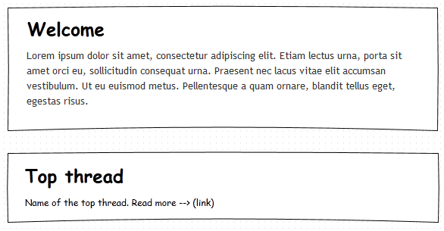

### Thread list



***Task « Bonus »*** *– Performing a search field*

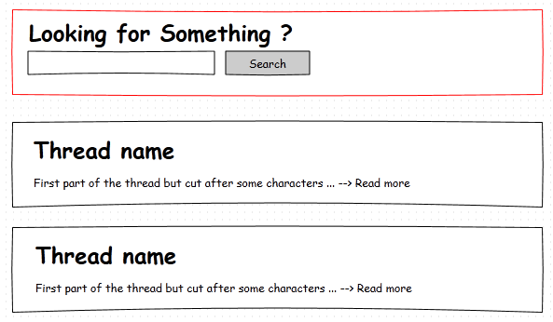

### Thread details

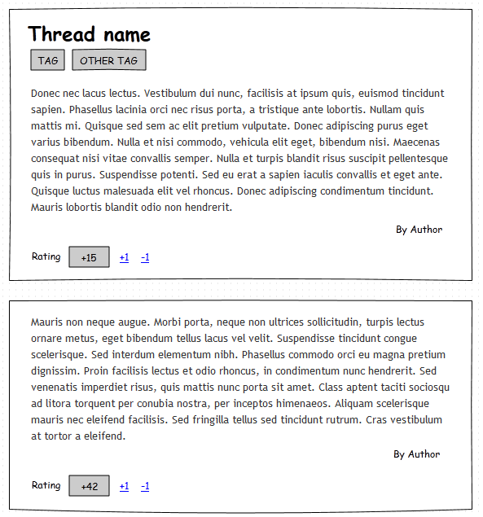

***Task 4*** *– Comment system. The first comment is the question itself. Only the author name is shown, but the email is asked in the form.*

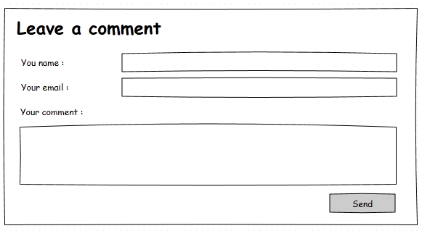

***Task 6*** *– Tag are shown below the thread name. A field allow users to add new tags.*

***Task 5*** *– Rating. Users can rate the comment by +1 and -1 link. The rating sum is shown.*



## Tree directory

**MVC Model**

The controllers are contained in the "**includes/sources**" folder and use the models in the "**includes/models**" folder.

The views are contained in the "**includes/views**" folder. It’s these that will return the user to display the processed data.

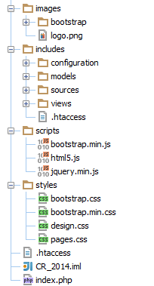

## Starting Database

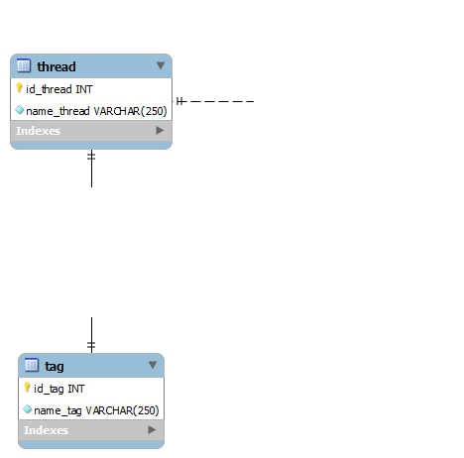

?

?

You can find the code for generating the base (it contains sample data) in the file « **website.sql** ».

# Tasks

Your tasks will be (time spent reading this document, without access to the computer, is 5 minutes):

## Part 1

|  |  |
| --- | --- |
| **Duration :** | 10 minutes |
| **Quality tested :** | Understanding of PHP (OOP and procedural) code, PHP Doc |
| **Work requested :** | * First, install the website on your local server and import the database ("website.sql" file). * You need to understand the architecture of the website that the last developer has started to code. * The last developer did not finish documenting the class "Thread", you must complete it (in the code). |

## Part 2

|  |  |
| --- | --- |
| **Duration :** | 15 minutes |
| **Quality tested :** | Database conception |
| **Work requested :** | * You must design **two tables**: the comment table and the associative table between thread and tag (a thread can have multiple tags and a tag can have multiple threads). * A comment is associated with a thread (the first comment is the question itself) and consists of the name and email of its author, a rating represented by a number, and the content of the comment. |

## Part 3

|  |  |
| --- | --- |
| **Duration :** | 30 minutes |
| **Quality tested :** | PHP, SQL, HTML |
| **Work requested :** | * Show **the** “hottest” thread (with the maximum amount of rating) on the home page as the sketch provided in the previous chapter. |

## Part 4

|  |  |
| --- | --- |
| **Duration :** | 1 hour |
| **Quality tested :** | PHP (POO), Regex, SQL, CSS, HTML |
| **Work requested :** | * Implement the comment system on a thread according to the description in part 2 and following site architecture. See the sketches for more details. * You must check the format of the email address. * You need to handle errors that may occur (blank, invalid email, etc.). |

## Part 5

|  |  |
| --- | --- |
| **Duration :** | 30 minutes |
| **Quality tested :** | PHP, SQL, HTML, Javascript / jQuery |
| **Work requested :** | * Implement the rating system. Each comment can be rated up or down by the user. The rating sum is shown below the comment with rating link +1 and -1. Show sketches for more details. * **Bonus**: The user can only vote once for each comment (sessions) * **Bonus**: Ajax! * **Note**: Don’t waste time, make it simple and functional. |

## Part 6

|  |  |
| --- | --- |
| **Duration :** | 30 minutes |
| **Quality tested :** | PHP, SQL, HTML |
| **Work requested :** | * Create a new form to assign tags to the thread. * When adding a tag, check for it in the database, if it exists, link it to the thread, if not create the tag and link it directly. * Show tag list below the thread name, using the bootstrap “label” CSS class (search in documentation). |

## Bonus

|  |  |
| --- | --- |
| **Duration :** | - |
| **Quality tested :** | PHP, SQL, HTML |
| **Work requested :** | * Create, on the page listing the different threads, an option to search by keywords. See the sketches for more details. |

# Notes

You can leave notes below. They can be taken into consideration for the correction.

