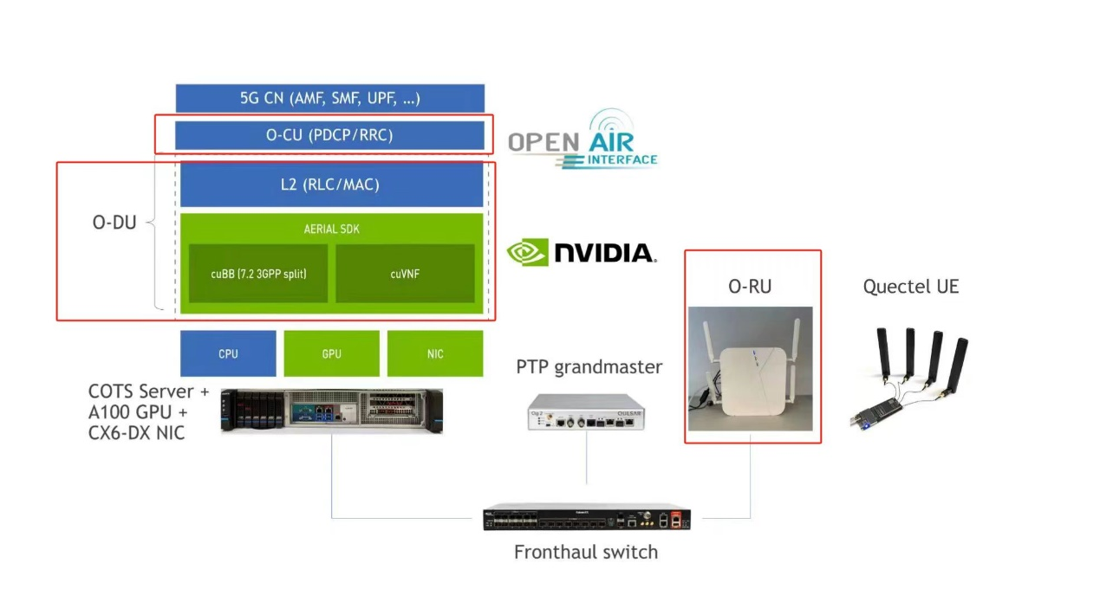
基于NI USRP的 OAI 5G的详细内容可以参考上面的网址 https://kb.ettus.com/OAI_Reference_Architecture_for_5G_and_6G_Research_with_USRP

OAI开源的内容，详细可以参考OAI官网：https://openairinterface.org/

https://ww2.mathworks.cn/help/wireless-testbench/gs/supported-sdr-devices.html
https://ww2.mathworks.cn/help/wireless-testbench/ug/install-support-package-for-ni-usrp-radios.html
https://ww2.mathworks.cn/help/5g/ug/5g-nr-synchronization-signal-capture-using-software-defined-radio.html
https://ww2.mathworks.cn/help/5g/ug/nr-cell-search-and-mib-and-sib1-recovery.html

