**Architecture**

In Figure 1, the design of architecture will consist of 8 components. 1) Unity client, 2) User’s Script, 3) Browser, 4) NodeJS, 5) API Server, 6) HTML Dashboard, 6) Java Spring Boost, 7) Data Store. Our program can be separate into 3 part. First is Unity client part, this part will communicate with API server though Node JS then API server will communicate with Data store by using JAVA Spring boot which we design to use MariaDB for storing data. Second part is custom user scripts which will come from each individual user, each user will send their scripts to HTML dashboard, also through Node JS. Third is Browsers, this part will show the result of part 1 and 2 on the browsers through Node JS.

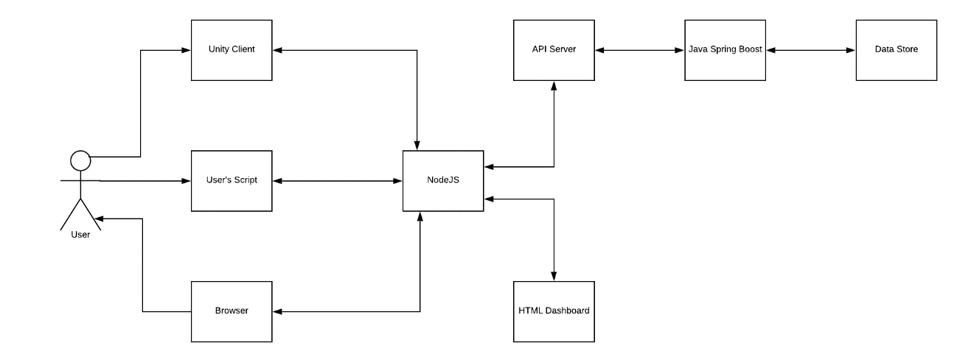

**Figure 1**