GameMapApi

Version: 1.1.0
Description: RESTful for resource manipulation on game environment map, currently it is RESTful skeleton to generate a routing mapping for resource access and webservice using nodeJS the current version demonstrates accessing and modified server json file without persistent save, in the next version mongoDB may be utilised

Author: Pisit Praiwattana, pisit.pra@mahidol.ac.th
Technology: Node Js
Keywords: mapAPI, RESTful, gameEnvironment
Dependencies: (lib for deployment)
express: hosting and routing server
mongoose: interfacing with MongoDB
body-parser: middle ware to filter request based on anything such as content-type must be json
Development Dependencies: (lib for development)
nodemon – monitor the current directory and the server will restart automatically after changed

Routing:
Routing is the process that server calling a suitable response based on the specific client uri (http://website/someName/someID and HTTP request whether it is GET,POST,PUT, DELETE )
Each different route can associated with different handler functions

(/) main port: 3000

RESTful API
definitions:
GET – request information from the API
POST – create information in the API
PUT – edit information in the API
DELETE – terminate information in the API

API designs:
1. GET /environments : receive information of all possible environment hosted in game server
2. GET /environments/1 : receive information of environment id = 1
3. POST /environments : create new environment
4. PUT /environments/1/ : edit information in environment id = 1
5. DELETE /environments/1/ : delete file from environment id = 1

File to hold a list of all environments’id
environmentDB.json

default template:
[
{
"id": "1",
"name": "environment1"
},
{
"id": "2",
"name": "environment2"
}
]

Development APIs:
1. GET /environments : receive information of all possible environment hosted in game server

// GET /environments
// @description return all environments id and its names
app.get('/api/environments', (req, res)=>{
res.type('json'); // shortcut version of set( )
res.send(environments);
});

2. GET /environments/1 : receive information of environment id = 1
Next, return environment information based on id

express lib allow parameterizing the requested url into ‘route paramter’ variable starting with :
Read more on : https://expressjs.com/en/guide/routing.html?source=post_page---------------------------#route-parameters

the :variableName can be referenced using req.params.variableName

// GET /environments/id
// @description receive information of environment id
app.get('/api/environments/:id', (req, res)=>{
res.json(
environments.find(env => env.id == req.params.id)
);
});

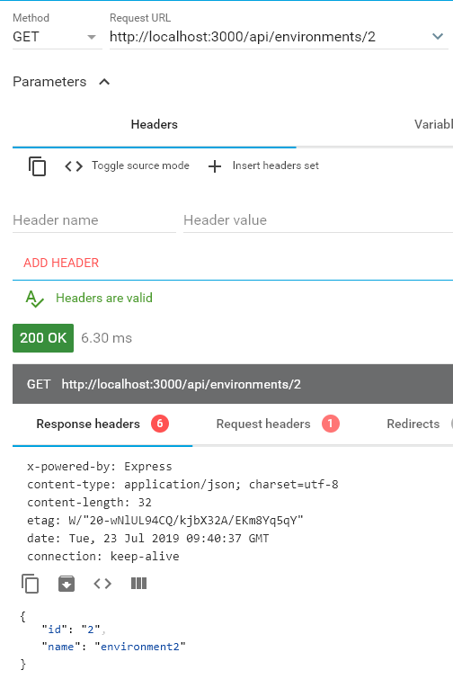
The test request is successful.

3. POST /environments : create new environment

We allow new environment to be generated with the following URL, somehow if the process success, the operation will set return code status = 201 to indicate request success

The operaion in 3.) will utilize middleware. Middleware is a filter for request content before being accepted into app.get or app.post
Body parser allow the content to be specify i.e Content-type is equal to json only

apply middleware by app.use()

const bodyParser = require('body-parser');
// Setup middleware to accept application/json, and application/x-www-form-urlencoded
app.use(bodyParser.json());
app.use(bodyParser.urlencoded({ extended : true }));

Finally, allow post request to be accepted
// POST /environments
// @description create new environment based on the body request json, success code 201
app.post('/api/environments/', (req, res) =>{
environments.push(req.body);
res.status(201).json(req.body);
});

Test sending a new request:
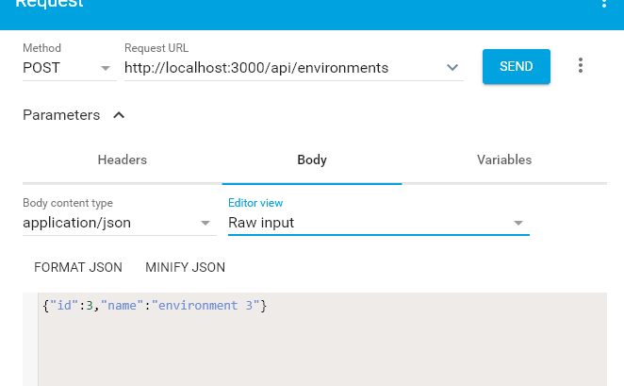

4. PUT /environments/1/ : edit information in environment id = 1
put is for update the content of the json data by utilizing url mapper and Object.assign to inject new field to the environments, the body of the message must be in the format that suitable for the target file

// PUT /environments/:id
// @description update the environments' information using id and message body for update filed
// New custom field can be appended freely based on these codes
app.put('/api/environments/:id', (req,res) => {
const updatedIndex = environments.findIndex(env => env.id == req.params.id);
res.json( Object.assign(environments[updatedIndex], req.body) );
});

Additional fields can be interject as the following example:
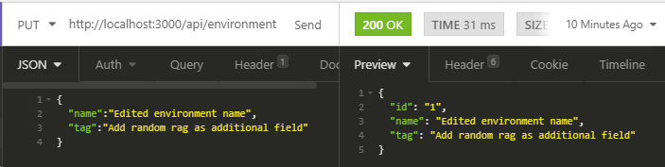

5. DELETE /environments/1/ : delete file from environment id = 1
// DELETE /environments/:id
// @description delete an environment in the list based on the associated id in environmentDB.json
// The splice() method adds/removes items to/from an array, and returns the removed item(s); i.e splice(index, 1) 1 indicated the length to be removed
// 204 means NO CONTENT
app.delete('/api/environments/:id', (req, res) => {
const deletedIndex = environments.findIndex(env => env.id == req.params.id);
environments.splice(deletedIndex, 1);
res.status(204).send();
});
The response message is ‘204’ mean no content and, thus, the resource has been eliminated from the server

Change logs:
1.1.0 Refactoring the package into MVC practices
- Separate routing process and handler functions into Controller
1.0.0 Default RESTful function in one gameserver.js

Reference
1.) Tutorial on using express to create RESTful webservice with Node JS
https://medium.com/@aofleejay/%E0%B8%AA%E0%B8%A3%E0%B9%89%E0%B8%B2%E0%B8%87-restful-api-%E0%B8%94%E0%B9%89%E0%B8%A7%E0%B8%A2-express-express-101-ee37cc4952b4

