Research Project for Final Essay (3000 words)
For the second half of the semester you will work on an individual project according to your research design that you submitted to me. As agreed in class, you will measure your metrics and track your changes over 4 weeks that just started on Monday.
For individual essays, this will be a 3000-word essay, and for teams you will write 2500 words each, because it will take more time to make the sections smooth in one read.

For the structure, you follow the general outline below, and you can use the paper on resilient smart gardens that we discussed in class as an example for what that looks like.
Where appropriate, please use figures and pictures to illustrate your data or your progress or what you did.

Abstract
One sentence each on context (what is the area of research), problem (research question), solution (what you did), and impact (what larger effect your solution may have) – this is the “elevator pitch” for making the audience want to read the entire essay.

Introduction
- Context: Explanation of the application domain of your project.
- Problem / Research Question: What are the questions you want to answer by doing this project?
- Solution: What are you proposing as project? What are you going to do?
- Impact: What do you expect to learn from and be able to pass on after this project?
- Outline: One sentence that gives an overview of the remainder of the article.

Background
- Explain the most important related work
- Structure from more general to more specific to your research and think about the transition to your research design at the end.

Research Design
- Plan: What is your plan?
- Preparation and set-up: How did you set it up?

Implementation
- Process: How did you start of carrying out the steps?
- Progress: How did your project develop over the weeks?
(Please add photographs / screenshots of your progress for each week.)

Results
- Outcomes: What were the measurable outcomes? (Please add photos/screenshots.)
- Experience: What was your experience?
- Answers: What are the answers to your research questions?

Discussion
- Surprises: What surprised you in the outcomes and experience?
- Lessons learned: What would you do different if you had to do it again from scratch?

Conclusion
- Summary: Brief restatement of results.
- Impact and future work: How are you planning to continue from here?

References
- Add adequate sources and references for any facts you cite.
- The easiest way to do this is to go on scholar.google.com and search for research articles around your topic. When you have found and read a good article that has facts you want to cite, click on the “cite” button and copy and paste the reference. I suggest using MLA style for now (see screenshot below).
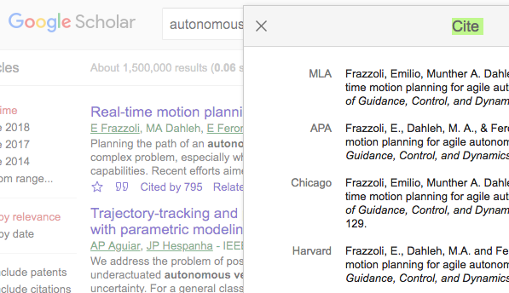
- In your text add “(Frazzoli et al. 2002)” at the end of the sentence where you talk about the facts you took from that article. The full reference needs to appear at the end of your document in a section called references or bibliography.

The essay is due to submit via BeachBoard Dropbox by April 21st 2019.

Checklist of questions:
- Motivation
  - Is the abstract convincing? Makes you want to read the rest?
  - Is the introduction explaining why the reader should care about the topic?
- Organization
  - Does the essay have a good overall structure?
  - Is there a thread? Is it consistent?
  - Do the sections / paragraphs (outer structure) clearly represent the content outline (inner structure)?
- Content
  - Are the claims substantiated? Is there evidence for them?
  - Are there appropriate sources / references?
  - Are the conclusions logical?
- Language
  - Is there a flow? No going off on tangents?
  - Maintain a professional tone, not ‘all over the place’ or too informal/colloquial.
  - Clear sentence structure (not too complex, or run-on sentences)
- Appearance
  - Is the layout well organized / presented?
  - Are the citations correct / complete?
- Visuals
  - Are there tables, figures, and/or diagrams supporting the content?
  - Are there pictures illustrating the content?

Rubric for general writing, which I will adapt to the Research Project Content
- Context and purpose of writing: demonstrates understanding of context, audience, and purpose responsive to task
- Content development: appropriate, relevant and compelling content to illustrate mastery of the topic and shaping the work
- Genre and disciplinary conventions: follows conventions for organization, content presentation, formatting and stylistic choices according to the writing task and discipline
- Sources and evidence: high-quality, relevant sources
- Control of syntax and mechanics: graceful language and fluency
Each criterion gets between 0 and 3 points, with 0 meaning insufficient, 1 meaning ok, 2 meaning good, and 3 exceeding expectations.

