Palmer Penguins Report

from palmerpenguins import load_penguins  
import pandas as pd  
import numpy as np  
  
penguins = load_penguins()  
penguins_cleaned = penguins.dropna()

The *palmer penguins* dataset contains information about 344 penguins, after **discarding** rows with NA values there are 333 penguins left.

Image Credit: Allison Horst

penguins_cleaned.head()

|  | species | island | bill_length_mm | bill_depth_mm | flipper_length_mm | body_mass_g | sex | year |
| --- | --- | --- | --- | --- | --- | --- | --- | --- |
| 0 | Adelie | Torgersen | 39.1 | 18.7 | 181.0 | 3750.0 | male | 2007 |
| 1 | Adelie | Torgersen | 39.5 | 17.4 | 186.0 | 3800.0 | female | 2007 |
| 2 | Adelie | Torgersen | 40.3 | 18.0 | 195.0 | 3250.0 | female | 2007 |
| 4 | Adelie | Torgersen | 36.7 | 19.3 | 193.0 | 3450.0 | female | 2007 |
| 5 | Adelie | Torgersen | 39.3 | 20.6 | 190.0 | 3650.0 | male | 2007 |

The penguins are differentiated by both island and species, but there is clearer clustering by species when looking at the variables: bill_length_mm and flipper_length_mm.

### Island

from plotnine import ggplot, geom_point, aes, stat_smooth, facet_wrap  
(  
 ggplot(penguins_cleaned, aes("bill_length_mm",  
 "flipper_length_mm", color="factor(island)"))  
 + geom_point()  
)

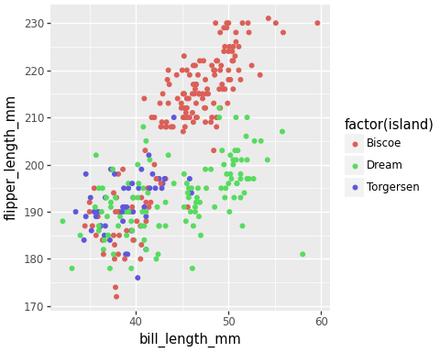

### Sex

(  
 ggplot(penguins_cleaned, aes("bill_length_mm",  
 "flipper_length_mm", color="factor(sex)"))  
 + geom_point()  
)

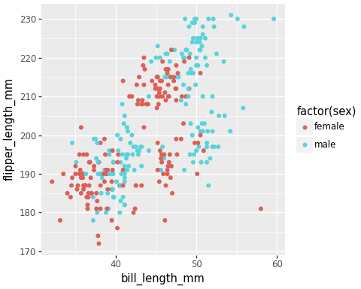

### Species

(  
 ggplot(penguins_cleaned, aes("bill_length_mm",  
 "flipper_length_mm", color="factor(species)"))  
 + geom_point()  
)

