Matplotlib and plotnine

# Penguins data

from palmerpenguins import load_penguins  
import pandas as pd  
import numpy as np  
  
penguins = load_penguins()  
penguins_cleaned = penguins.dropna()  
  
species_counts = penguins_cleaned['species'].value_counts()

# Matplotlib

import matplotlib.pyplot as plt  
  
plot = plt.figure()  
plot.set_figwidth(6)  
plot.set_figheight(3)  
  
plt.bar(species_counts.index, species_counts.values)

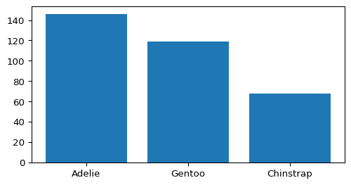

For most flexibility, save chart as an image and then use Quarto formatting of images:

plot.savefig("matplotlib_bar.png")

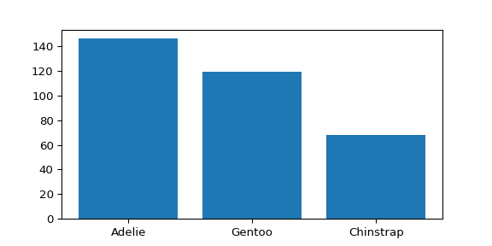

# Plotnine

import plotnine as pn  
  
pn_species_col = (  
 pn.ggplot(species_counts.reset_index(), pn.aes("species",  
 "count"))  
 + pn.geom_col()  
 + pn.theme(figure_size=(3, 6))  
)  
pn_species_col

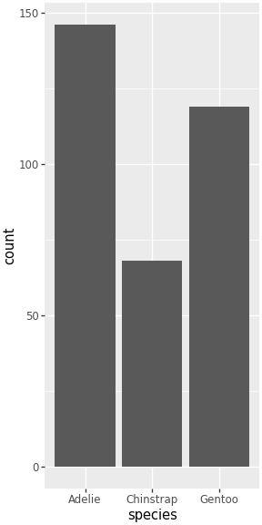

Again, export as image for most flexibility

pn_species_col.save("plotnine_bar.png", dpi=300)

/home/vscode/.local/lib/python3.13/site-packages/plotnine/ggplot.py:615: PlotnineWarning: Saving 3 x 6 in image.  
/home/vscode/.local/lib/python3.13/site-packages/plotnine/ggplot.py:616: PlotnineWarning: Filename: plotnine_bar.png