Quarto Tables in Word

# Simple image insertion

Using Markdown

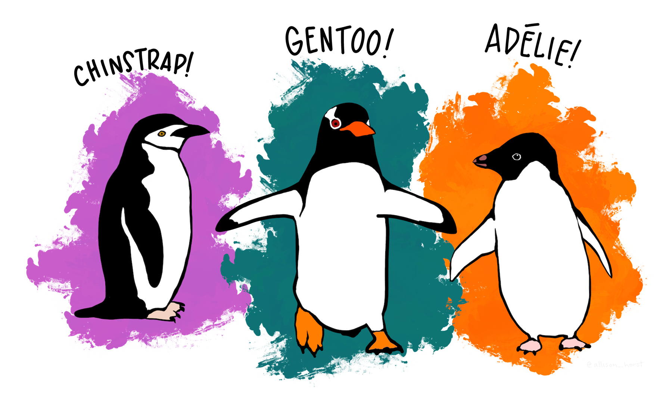

# Fancier image insertion

There isn’t good multi-column support currently.

However you can do things like insert images into tables.

| Common Name | Latin Name | First identified in |
| --- | --- | --- |
| Adélie | Pygoscelis adeliae | 1841 |
| Chinstrap |  | 1781 |
| Gentoo | Pygoscelis papua | 1781 |