Well, hello Word!!

Table of contents

# 1. Heading 1

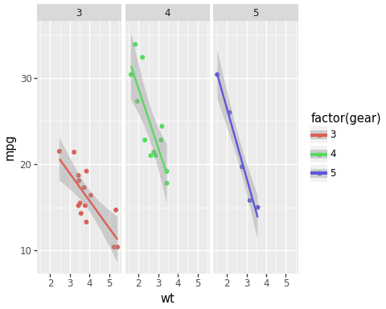

Well, I should be a word doc with weirdly styled text.

## 1.1 Subheading 1

And this sentence will contain an inline number: 32