

The International Committee on Taxonomy of Viruses
Taxonomy Proposal Form, 2025

Part 1a: Details of taxonomy proposals

Title: | Create new genera and species in order Tubulavirales – 34 genera and 48 species in the family Inoviridae and 1 species in the family Paulinoviridae
Code assigned: | 2024.035B

Author(s), affiliation and email address(es):
Given name (+middle initial(s)) | Surname | Affiliation | Email address | Corr. author(s)
Petar | Knezevic | Faculty of Sciences, University of Novi Sad | petar.knezevic@dbe.uns.ac.rs | X
Damir | Gavric, | Faculty of Sciences, University of Novi Sad | damir.gavric@dbe.uns.ac.rs
Rob | Lavigne | KU Leuven, Belgium | rob.lavigne@kuleuven.be
Andrew M | Kropinski | University of Guelph, Canada | Phage.Canada@gmail.com
Dann | Turner | University of the West of England, UK | Dann2.Turner@uwe.ac.uk

Part 1b: Taxonomy Proposal Submission
ICTV Subcommittee:
Animal DNA Viruses and Retroviruses |  | Bacterial viruses | X
Animal minus-strand and dsRNA viruses |  | Fungal and protist viruses
Animal positive-strand RNA viruses |  | Plant viruses
Archaeal viruses |  | General -

List the ICTV Study Group(s) that have seen or have been involved in creating this proposal:
Tubulavirales study group

Optional – complete only if formally voted on by an ICTV Study Group:
Study Group | Number of members
 | Votes in support | Votes against | No vote

Submission date: | 18/07/2024

Part 1c: Feedback from ICTV Executive Committee (EC) meeting
Executive Committee Meeting Decision code: | X
A – Accept
Ac – Accept subject to revision by relevant subcommittee chair. No further vote required
U – Accept without revision but with re-evaluation and email vote by the EC
Uc – Accept subject to revision and re-evaluation and email vote by the EC | X
Ud – Deferred to the next EC meeting, with an invitation to revise based on EC comments
J - Reject
W - Withdrawn

Comments from the Executive Committee:
- There were queries on the low % ID of the Zot and CoaB proteins used to compare against the new taxa.
- Repetition of phages used for comparisons within the tables, were these the closest relatives to the new taxa?
- Provide a more extensive/complete phylogenetic tree comprising all new genera and some existing genera to enable comparisons. Alternatively it could be explained why this was not achievable in the text.
- Please correct typographical errors

Part 1d: Revised Taxonomy Proposal Submission
Response of proposer:
- There were queries on the low % ID of the Zot and CoaB proteins used to compare against the new taxa.
In the table, each newly identified species is highlighted in bold and assigned a specific color, with members of the same genus sharing the same color. Phages included for comparison were selected based on their closest phylogenetic relationship to the newly defined taxa, using the DNA sequences that were available at the time of analysis; this information has been added to the table legends. The number of related phages varies depending on the availability of closely related genomes. The low percentage identity observed in the Zot and CoaB proteins further supports the designation of these phages as novel species and representatives of new genera, in line with current criteria for species and genus demarcation. Additional explanations have been incorporated into the text.

- Repetition of phages used for comparisons within the tables, were these the closest relatives to the new taxa?
Yes, the phages listed multiple times represent the closest known relatives of the analyzed taxa. Their repeated appearance results from conducting separate comparisons for each phage strain or group of closely related strains. This strategy was employed to avoid constructing overly large and complex tables involving all analyzed taxa.

- Provide a more extensive/complete phylogenetic tree comprising all new genera and some existing genera to enable comparisons. Alternatively it could be explained why this was not achievable in the text.
A phylogenetic tree based on the amino acid sequences of the assembly proteins is provided. It includes representatives of all newly proposed genera, along with representative members of existing genera for comparison. The tree places the defined species and genera into a broader phylogenetic context and supports the conclusions drawn from the comparative analyses (Figure 14). In addition, an all-vs-all comparison of intergenomic nucleotide similarity is provided in the supplementary material.

- Please correct typographical errors
Typographical errors have been corrected.

Revision date: | 26/08/2025

Part 3: TAXONOMIC PROPOSAL
https://ictv.global/taxonomy/templates
Taxonomic changes proposed:
Establish new taxon | X | Split taxon
Abolish taxon |  | Merge taxon
Move taxon |  | Promote taxon
Rename taxon |  | Demote taxon
Move and rename

Etymology (origin) of proposed taxonomic names:
Taxon name | Etymology of the term
Nigolovirus | from Latin nigrum olor – black swan
Phargevirus | from Latin phasianus argentum – silver pheasant
Ramphavirus | from scientific name for toucan – Ramphastos
Pilosavirus | from Latin pilosus, pilosa – hairy, shaggy, covered with hair
Pythonevirus | from Latin Python, Pythonis – snake slain at Delphi
Serpentivirus | from Latin serpens, serpentis – snake
Scytalavirus | from Latin scytala, scytalae - cylindrical snake, roller, Band, belt, collar (dog)
Senectutivirus | from Latin senectus, senectutis – gray hairs, shed snake skin
Femenvirus | from Latin femen, feminis – flat vertical band on triglyph
Vittavirus | from Latin vitta, vittae - band, ribbon
Amentovirus | from Latin amentum, amenti - (shoe) thong/strap
Fasceasvirus | from Latin facea, fasceae - band/strip, headband/filet, ribbon
Adiligaturavirus | from Latin adiligatura, adilifaturae - band, binding
Antiavirus | from Latin antia, antiae - locks (pl.) of hair that hang down in front, forelock
Aclydivirus | from Latin aclys, aclydis - small javelin with a strap
Strophivirus | from Latin strophium, strophi(i) – head-band, twisted breast-band
Maeandervirus | from Latin maeander, maeandri - river famous for winding path, roundabout ways/twists/turnings (pl.), wavy line
Semitavirus | from Latin semita, semitae – path
Itinerivirus | from Latin itiner, itineris – passage, path
Actovirus | from Latin actus, actus – path, cart-track, right of way/road for cattle
Aspidivirus | from Latin aspis, aspidis - venomous snake of North Africa
Galbavirus | from Latin galba, galbae – small worm, ash borer/larva of ash spinner
Reticulivirus | from Latin reticulum, reticuli – hair net, network, small (fish) net, small mesh bag
Pubesvirus | from Latin pubes, pubis – private/public parts/hair
Prolivirus | from Latin proles, prolis – offspring, descendant
Plantarivirus | from Latin plantarium, plantarii – slip, cutting (of plant), hair
Propagovirus | from Latin propago, propagini – layer or set by which a plant is propagated; from Latin nulla nihil – zero nothing
Sarmentivirus | from Latin sarmentum, sarmenti – twigs (pl.), cut twigs, brushwood
Acontivirus | from Latin acontias, acontiae – quick-darting snake
Abaestuovirus | from Latin abaestuo, abaestuare v. – wave down
Xiphivirus | from Latin xiphia, xiphiae – sword-shaped comet; swordfish
Catenatiovirus | from Latin catenatio, catenationis – band, clamp, clincher, pin
Circumitovirus | from Latin circumitus, circumitus – circumference
Viscerivirus | from Latin viscus, visceris – offspring

Permission for use of names derived from a living person:
Taxon name | Full name of person from whom the name is derived | Attached

Abstract of Taxonomy Proposal:
Taxonomic rank(s) affected:
Genus, species

Description of current taxonomy:
The order Tubulavirales currently comprise families Inoviridae with 26 genera; Plectroviridae with four genera and Paulinoviridae with two genera

Proposed taxonomic change(s):
Create 38 new genera and 48 new species in the family Inoviridae.
Create one new species in the family Paulinoviridae

Justification:

Based on the indicated demarcation criteria, all new genera and species fulfil criteria for proposed classification, as shown in supplementary tables and figures. These classifications are supported by data from BLASTn, BLASTp, VIRIDIC, CoreGenes3.5 and by phylogenetic analysis of the Zot and CoaB proteins.

- Text of Taxonomy proposal:

Taxonomic rank(s) affected:
Genus, species

Description of current taxonomy:
The order Tubulavirales currently comprise families Inoviridae with 26 genera; Plectroviridae with four genera and Paulinoviridae with two genera

Proposed taxonomic change(s):
Create 38 new genera and 48 new species in the family Inoviridae.
Create one new species in the family Paulinoviridae

Demarcation criteria:
Descriptions of the families Inoviridae, as well as demarcation criteria are described in the ICTV Report chapters and profiles [1, 2] (https://www.ictv.global/report/plectroviridae; https://www.ictv.global/report/inoviridae).

Species demarcation: Phages of the same species share >95% DNA sequence similarity (identity × query coverage) and significant amino-acid sequence similarity of the adhesion protein (CoaA).

Genus demarcation: For genus demarcation, beside considerable similarity of DNA sequences confirmed by BLASTn, the phage should have significant similarity of both Zot and Coat B (major capsid) proteins. Each of the proposed genera comprise phages with similar DNA sequences; phages in different genera differ from each other by >50% in the amino-acid sequence of the major coat (CoaB; p8) and morphogenesis (Zot; p1) proteins as assessed using the BLASTp algorithm.

Justification:
Based on the published demarcation criteria, all new genera and species fulfil criteria for the classification proposed here, as shown in supplementary tables and figures. All tables are prepared using BLASTn and BLASTp algorithms, as well as CoreGenes3.5 [3]. The phylogenetic trees were created using Phylogeny.fr. [4] and MEGA12 [5-8]. To provide further clarification, a matrix of intergenomic similarity between all phages classified and a phylogenetic tree of the Zot morphogenesis protein are provided (Figure 14). A matrix of inter-genomic similarity is also provided (supplementary material). Note that the values of intergenomic similarity differ slightly from those presented in the tables due to the different methods of calculation. Specific justification for each new genus and species follows:

- Genus Nigolovirus and species Nigolovirus 219 (from Latin nigrum olor – black swan); The DNA sequence, as well as the amino acid sequences of the major coat protein and morphogenesis (assembly) proteins of this phage, differ considerably from those of phages with currently available genome sequences (Table 1, Fig. 1, Fig. 14; also see Tables 2-4).
- Genus Phargevirus and species Phargevirus 213 (from Latin phasianus argentum – silver phasant); The DNA sequence, as well as the amino acid sequences of the major coat protein and assembly proteins of this phage, differ considerably from those of phages with currently available genome sequences (Table 2, Fig. 1 and 14; also see Tables 1 and 5).
- Genus Ramphavirus and species Ramphavirus 80 (from scientific name for toucan – Ramphastos); The DNA sequence, as well as the amino acid sequences of the major coat protein and assembly proteins of this phage, differ considerably from those of phages with currently available genome sequences (Table 3, Fig. 1, Fig. 14)
- Genus Pilosavirus and species Pilosavirus PMBT54 (from Latin pilosus, pilosa – hairy, shaggy, covered with hair); There are sequences of two strains, which share a high degree of similarity (97.1%) and belong to the same species. The DNA sequence, as well as the amino acid sequences of the major coat protein and assembly proteins of these phages, differ considerably from those of phages with currently available genome sequences (Table 4, Fig. 1, Fig. 14; also see Table 1)
- Genus Pythonevirus and species Pythonevirus WXY (from Latin Python, Pythonis – snake slain at Delphi); The DNA sequence, morphogenesis, and major coat protein of this phage differ considerably from those of phages with currently available genome sequences (Table 5, Fig. 1, Fig. 14; also see Tables 1 and 2).
- Genus Serpentivirus and species Serpentivirus dolos (from Latin serpens, serpentis – snake); The morphogenesis and major coat protein of this phage show high similarity (approx.. 50%) to those of several other phages, whereas the overall DNA sequence exhibits significantly lower similarity (<27.9%), indicating notable genomic divergence and supporting its classification as a distinct genus. (Table 6, Fig. 1, Fig. 14; ; also see Tables 8-10, 23 and 28).
- Genus Scytalavirus and species Scytalavirus 6 (from Latin scytala, scytalae - cylindrical snake, roller, Band, belt, collar (dog)); The morphogenesis and major coat protein of this phage show high similarity (>50%) to those of several other phages, whereas the overall DNA sequence exhibits significantly lower similarity (<27.9%), indicating notable genomic divergence and supporting its classification as a distinct genus (Table 7, Fig. 2, Fig. 14; also see Tables 6, 8, and 9).
- Genus Senectutivirus and species Senectutivirus 138 (from Latin senectus, senectutis – gray hairs, shed snake skin); The morphogenesis and major coat protein of this phage exhibit relatively high similarity (>50%) to those of several other phages, while the overall DNA sequence shows significantly lower similarity (<22.4%). Although related to members of the genus Scytalavirus, notable genomic divergence supports its classification as a distinct genus (Table 8, Fig. 2, Fig. 14; also see Tables 6, 7, and 9).
- Genus Femenvirus and species Femenvirus 11 and Femenvirus 13 (from Latin femen, feminis – flat vertical band on triglyph); Based on the relatively low DNA sequence similarity (68.3%), the two strains are assigned to different species. The DNA sequences, morphogenesis, and major coat proteins of these phages differ considerably from those of phages with currently available genome sequences, supporting the establishment of a new genus (Table 9, Fig. 2, Fig. 14; also see Tables 6-8 and 23).
- Genus Vittavirus and species Vittavirus Vaf1 (from Latin vitta, vittae - band, ribbon); This phage exhibits substantial divergence in both its DNA sequence and the amino acid sequence of the major capsid protein when compared to all known phages. While it shares 62.8% similarity in the assembly protein amino acid sequence with Saetivirus VFJ, its DNA and major capsid protein sequences show much lower similarity (23.6% and 34.2%, respectively), highlighting its distinct features (Table 10, Fig. 2, Fig. 14; also see Tables 6, 8, 9, and 34).
- New genus Amentovirus and species: Amentovirus 10, Amentovirus 42, and Amentovirus 39 (from Latin amentum, amenti - (shoe) thong/strap); These three species share a relatively high level of DNA sequence similarity (70.5–80.7%). Although the assembly protein shows a high degree of similarity to Antiavirus 20, the sequences of the major coat protein and the overall DNA differ substantially (Table 11, Fig. 3, Fig. 14).
- Genus Fasceasvirus and species: Fasceasvirus 1, Fasceasvirus 25 and Fasceasvirus 30 (from Latin facea, fasceae - band/strip, headband/filet, ribbon); These three species share a considerable level of DNA sequence similarity (34.7–63.4%). The amino acid sequences of their major coat and assembly proteins are highly similar to each other (>55.6%) but differ significantly from those of related phages, including their DNA sequences, supporting their classification within a distinct genus (Table 12, Fig. 3, Fig. 14; also see Tables 6, 8, 9, 13, 14 and 34).
- Genus Adiligaturavirus and species Adiligaturavirus 24 (from Latin adiligatura, adilifaturae - band, binding); The DNA sequence, morphogenesis, and major coat protein of this phage differ considerably from those of phages with currently available genome sequences (Table 13, Fig. 3, Fig. 14; also see Tables 12, 15, and 29).
- Genus Antiavirus and species Antiavirus 20 (from Latin antia, antiae - locks (pl.) of hair that hang down in front, forelock); The DNA sequence shares some similarity with other phages, but the assembly and major coat protein of this phage differ considerably from those of phages with currently available genome sequences (Table 14, Fig. 3, Fig. 14; also see Table 11).
- Genus Aclydivirus and species Aclydivirus 6 (from Latin aclys, aclydis - small javelin with a strap); The DNA sequence, morphogenesis, and major coat protein of this phage differ considerably from those of phages with currently available genome sequences (Table 15, Fig. 3, Fig. 14; also see Tables 13, 29 and 30).
- Genus Strophivirus and species: Strophivirus 33, Strophivirus 31, Strophivirus 32, Strophivirus 36, Strophivirus 37 and Strophivirus 34 (from Latin strophium, strophi(i) – head-band, twisted breast-band); These six new species share substantial DNA sequence similarity (>51.6%) and a high degree of similarity in key proteins. Although these phages exhibit similarity in their DNA sequences and assembly protein with members of the genus Maeandervirus, the amino acid sequence of the major capsid protein differs significantly, supporting their separation from that genus (Table 16, Fig. 4, Fig. 14; also see Tables 18 and 20).
- Genus Maeandervirus and species Maeandervirus 44 and Maeandervirus 40 (from Latin maeander, maeandri - river famous for winding path, roundabout ways/twists/turnings (pl.), wavy line); These two species share similar DNA sequences (63.4%) and a high degree of similarity in key proteins (>95%). In addition to the aforementioned similarity to members of the genus Strophivirus, these phages also share similarity in their assembly protein sequences with other phages. However, the substantial differences in their DNA sequences and major capsid protein sequences support their classification as members of a distinct genus (Table 17, Fig. 4, Fig. 14; also see Tables 3 and 16).
- Genus Semitavirus and species Semitavirus 43 (from Latin semita, semitae – path); This virus shares similarity of amino acid sequence in key proteins with certain other viruses (~50%), but possesses a unique DNA sequence, with no more than 13% similarity to those viruses. This pronounced genomic divergence supports its classification as a member of a distinct genus (Table 18, Fig. 4, Fig. 14; also see Tables 16 and 17).
- Genus Itinerivirus and species Itinerivirus 12 (from Latin itiner, itineris – passage, path); This virus shares a high degree of amino acid sequence similarity in major coat protein with certain other phges (~50%) but possesses a unique DNA sequence and morphogenesis protein (Table 19, Fig. 4, Fig. 14; also see Tables 16 and 17).
- Genus Actovirus and two species Actovirus 41 and Actovirus 45 (from Latin actus, actus – path, cart-track, right of way/road for cattle); These two species share a considerable percentage of DNA sequence similarity (53.5%) and exhibit very high similarity in key proteins (>69%). Although their key proteins show >50% similarity to those of other phages, they clearly form a distinct genus due to their unique DNA sequences, which display less than 9.3% similarity to the most closely related phages (Table 20, Fig. 4, Fig. 14; also see Tables 16-19).
- Genus Aspidivirus and species Aspidivirus 14 and Aspidivirus 19 (from Latin aspis, aspidis - venomous snake of North Africa); These two species share substantial DNA sequence similarity and exhibit very high similarity in both the assembly protein and the major capsid protein. Although they are closely related to the genus Galbavirus based on their DNA and major capsid protein sequences, they differ in the amino acid sequence of the assembly protein, showing 43.1% similarity, which supports their separation from that genus (Table 21, Fig. 5, Fig. 14; also see Tables 15 and 22).
- Genus Galbavirus and species Galbavirus 17 (from Latin galba, galbae – small worm, ash borer/larva of ash spinner) This virus shows similarity to members of the genus Aspidivirus but exhibits significant differences in the amino acid sequence of the assembly protein (Table 22, Fig. 5, Fig. 14; also see Tables 21, 29 and 30).
- Genus Reticulivirus and species Reticulivirus 11 (from Latin reticulum, reticuli – hair net, network, small (fish) net, small mesh bag); This phage shares DNA and amino acid sequences of key proteins to some extent with members of the genera Serpentivirus and Femenvirus (approx. 30%), but possesses a unique DNA sequence that distinguishes it as a member of a separate genus (Table 23, Fig. 6, Fig. 14).
- Genus Pubesvirus and species Pubesvirus 29 (from Latin pubes, pubis – private/public parts/hair); This phage shows over 50% similarity in the major capsid protein sequence to some phages (members of genera Prolivirus and Fibrovirus), but significant differences in both the DNA sequence and the amino acid sequence of the assembly protein distinguish it as a member of a distinct genus (Table 24, Fig. 7, Fig. 14).
- Genus Prolivirus and species Prolivirus 37 (from Latin proles, prolis – offspring, descendant); This virus differs from members of the genus Pubesvirus, although some similarities exist as described above. It shows 56.8% similarity to the major coat protein of Fibrovirus members but differs in the assembly protein and overall DNA sequence. It also shares almost 30% DNA sequence identity with members of the genus Plantarivirus. However, the amino acid sequences of both the major capsid protein and the assembly protein differ significantly. Due to the lack of fulfillment of the criteria required for inclusion in any existing genus or species, these findings support the establishment of a new genus and species. (Table 25, Fig. 7, Fig. 14; also see Tables 24 and 26).
- Genus Plantarivirus and species Plantarivirus 147 (from Latin plantarium, plantarii – slip, cutting (of plant), hair); This phage shows significant DNA sequence similarity only with Prolivirus 37, but differs substantially in the sequences of key genes, which distinguishes it as a member of a new genus (Table 26, Fig. 7, Fig. 14; also see Table 25).
- Genus Propagovirus and species Propagovirus nuni (from Latin propago, propagini – layer or set by which a plant is propagated; from Latin nulla nihil – zero nothing); This phage shows high similarity in key proteins to phages of the genus Fibrovirus, which infect members of the genus Vibrio, but its DNA sequence similarity to these phages does not exceed 16%, supporting its classification as a member of a new genus (Table 27, Fig. 7, Fig. 14; also see Tables 2, 25 and 26).
- Genus Sarmentivirus and species Sarmentivirus 25 (from Latin sarmentum, sarmenti – twigs (pl.), cut twigs, brushwood); This phage possesses a unique DNA sequence as well as unique sequences of key proteins, which supports its classification into a separate new genus (Table 28, Fig. 8, Fig. 14).
- Genus Acontivirus and species Acontivirus 21 (from Latin acontias, acontiae – quick-darting snake); This phage possesses a unique DNA sequence as well as unique sequences of key proteins, which supports its classification into a separate genus and the establishment of a new species (Table 29, Fig. 9, Fig. 14; also see Tables 13-15 and 30)
- Genus Abaestuovirus and species Abaestuovirus 8 (from Latin abaestuo, abaestuare v. – wave down); This phage possesses a unique DNA sequence as well as relatively unique sequences of key proteins, which supports its classification into a separate genus (Table 30, Fig. 9, Fig. 14)
- Genus Xiphivirus and species Xiphivirus 2 (from Latin xiphia, xiphiae – sword-shaped comet; swordfish); This virus is most closely related to Psecadovirus PSH1, sharing over 50% similarity in the assembly protein; however, its DNA sequence and major capsid protein differ significantly, supporting the establishment of a new species and a new genus (Table 31, Fig. 10, Fig. 14).
- Genus Catenatiovirus and species Catenatiovirus 32 (from Latin catenatio, catenationis – band, clamp, clincher, pin); This phage is most similar in DNA sequence to Scuticavirus SMA6, but the similarity is low (8.5%), and there are significant differences in the sequences of key proteins. These distinctions support the establishment of a new species and a new genus (Table 32, Fig. 10, Fig. 14).
- Species Staminivirus 6; This bacteriophage is most closely related to Staminivirus SMA9, sharing significant similarity in DNA sequence (50.7%) and high sequence similarity in key proteins. (Table 33, Fig. 10, Fig. 14).
- Genus Circumitovirus and species Circumitovirus 48 (from Latin circumitus, circumitus – circumference); This phage possesses a unique DNA sequence and shares limited similarity in key proteins (<36%) with phages infecting members of Vibrio and enterobacteria, supporting its classification into a separate genus (Table 34, Fig. 11, Fig. 14).
- Genus Viscerivirus and species Viscerivirus 525 (from Latin viscus, visceris – offspring); This phage possesses a unique DNA sequence as well as unique sequences of key proteins, supporting the classification of the novel species into a new and separate genus (Table 35, Fig. 12, Fig. 14; also see Table 3).
- Species Thomixvirus zuza; This species shares 53.1% DNA sequence similarity with Thomixvirus OH3 from family Paulinoviridae, and a high degree of similarity in key protein sequences, indicating that it represents a new species (Table 36, Fig. 13).

References:
- Knezevic P, Adriaenssens EM, ICTV Report Consortium (2021) ICTV Virus Taxonomy Profile: Plectroviridae, J Gen Virol https://doi.org/10.1099/jgv.0.001597
- Knezevic P, Adriaenssens EM, ICTV Report Consortium (2021) ICTV Virus Taxonomy Profile: Inoviridae, J Gen Virol in press
- Turner D, Reynolds D, Seto D, Mahadevan P. CoreGenes3.5: a webserver for the determination of core genes from sets of viral and small bacterial genomes. BMC Res Notes. 2013;6:140. doi: 10.1186/1756-0500-6-140. PMID: 23566564.
- Dereeper A.. Guignon V., Blanc G., Audic S., Buffet S., Chevenet F., Dufayard J.F., Guindon S., Lefort V., Lescot M., Claverie J.M., Gascuel O. (2008). Phylogeny.fr: robust phylogenetic analysis for the non-specialist. Nucleic Acids Res. W465-9. https://doi.org/10.1186/1756-0500-6-140
- Jones D.T., Taylor W.R., and Thornton J.M. (1992). The rapid generation of mutation data matrices from protein sequences. Computer Applications in the Biosciences 8: 275-282.
- Felsenstein J. (1985). Confidence limits on phylogenies: An approach using the bootstrap. Evolution 39:783-791
- Saitou N. and Nei M. (1987). The neighbor-joining method: A new method for reconstructing phylogenetic trees. Molecular Biology and Evolution 4: 406-425
- Kumar S., Stecher G., Suleski M., Sanderford M., Sharma S., and Tamura K. (2024). Molecular Evolutionary Genetics Analysis Version 12 for adaptive and green computing. Molecular Biology and Evolution 41:1-9.

Accompanying files:
Filename | Description of contents
2024.035B.N.v3.Tubulavirales_sim_matrix.xlsx | All-vs-all intergenomic similarity matrix

Tables, Figures:

Table 1. New genus Nigolovirus (member of the genus is highlighted in orange) and new species Nigolovirus 291 (strain in bold, highlighted in orange) compared with selected most closely related phages
 | GenBank Access. No. | Genome length (nt) | Mol% G+C | No. CDS | DNA (% seq. Ident) | Proteome (No. of homologous proteins; E<10⁻³) | Zot | CoaB
Phage blackswan219-1 | MZ474489.1 | 7703 | 56.5 | 13 | 100 | 13 | 100 | 100
Phage silverpheasant213 | MZ474491.1 | 7022 | 54.3 | 11 | 3.4 | 2 | 8.8 | 0
Inoviridae sp. isolate ctbd3 | MH616883.1 | 7321 | 48.4 | 10 | 0.9 | 0 | 4.84 | 0
Pseudomonas phage PMBT54 | OR047306.1 | 7320 | 48.4 | 13 | 0.9 | 0 | 4.84 | 0
Pseudomonas phage WX_Y | OQ354711.1 | 7205 | 57.5 | 11 | 0 | 2 | 14.25 | 0
Xanthomonas phage XacF1 | NC_074762.1 | 7325 | 58.2 | 13 | 0 | 2 | 24.35 | 0
Pseudomonas phage Pf3 | NC_001418.1 | 5833 | 45.4 | 9 | 0 | 1 | 26.2 | 0

Table 2. New genus Phargevirus (member of the genus is highlighted in blue) and new species Phargevirus 213 (strain in bold, highlighted in blue) compared with selected most closely related phages
 | GenBank Access. No. | Genome length (nt) | Mol% G+C | No. CDS | DNA (% seq. Ident) | Proteome (No. of homologous proteins; E<10⁻³) | Zot | CoaB
Phage silverpheasant213 | MZ474491.1 | 7022 | 54.3 | 11 | 100 | 11 | 100 | 100
Phage blackswan219-1 | MZ474489.1 | 7703 | 56.5 | 13 | 3.4 | 2 | 8.8 | 0
Enterobacteria phage If1 | NC_001954.1 | 8454 | 43.7 | 10 | 0 | 1 | 12.5 | 0
Pseudomonas phage WX_Y | OQ354711.1 | 7205 | 57.5 | 11 | 8.2 | 5 | 19.37 | 0
Inoviridae sp. isolate ctii000 | MH649021.1 | 7006 | 40.3 | 12 | 0.7 | 3 | 32.34 | 70.5
Vibrio phage VP24-2_Ke | NC_073750.1 | 7180 | 42.5 | 13 | 1.4 | 4 | 31.0 | 63.6

Table 3. New genus Ramphavirus (member of the genus is highlighted in light gray) and new species Ramphavirus 80 (strain in bold, highlighted in light gray) compared with selected most closely related phages
 | GenBank Access. No. | Genome length (nt) | Mol% G+C | No. CDS | DNA (% seq. Ident) | Proteome (No. of homologous proteins; E<10⁻³) | Zot | CoaB
Phage toucan80 | MZ474490.1 | 6761 | 51.4 | 12 | 100 | 12 | 100 | 100
Phage blackswan219-1 | MZ474489.1 | 7703 | 56.5 | 13 | 3.3 | 1 | 17.0 | 0
Inoviridae sp. ctbf525 | MH616815.1 | 5715 | 50.8 | 9 | 2.2 | 2 | 0 | 43.0
Inoviridae sp. ctcj40 | MH617768.1 | 5095 | 44.5 | 10 | 0.8 | 1 | 21.89 | 43.0

Table 4. New genus Pilosavirus (member of the genus is highlighted in gray) and new species Pilosavirus PMBT54 (strains in bold, highlighted in gray) compared with selected most closely related phages
 | GenBank Access. No. | Genome length (nt) | Mol% G+C | No. CDS | DNA (% seq. Ident) | Proteome (No. of homologous proteins; E<10⁻³) | Zot | CoaB
Pseudomonas phage PMBT54 | OR047306.1 | 7320 | 48.4 | 13 | 100 | 13 | 100 | 100
Inoviridae sp. isolate ctbd3 | MH616883.1 | 7321 | 48.4 | 10 | 97.1 | 5 | 99.7 | 97.4
Phage blackswan219-1 | MZ474489.1 | 7703 | 56.5 | 13 | 0.8 | 0 | 4.84 | 0
Pseudomonas phage Pf3 | NC_001418.1 | 5833 | 45.4 | 9 | 1.6 | 1 | 0 | 0
Pseudomonas phage PfAC05 | OR801193.1 | 12,329 | 55.4 | 21 | 0.7 | 3 | 13.0 | 26.2

 | GenBank Access. No. | Genome length (nt) | Mol% G+C | No. CDS | DNA (% seq. Ident) | Proteome (No. of homologous proteins; E<10⁻³) | Zot | CoaB
Pseudomonas phage WX_Y | OQ354711.1 | 7205 | 57.5 | 11 | 100 | 11 | 100 | 100
Phage silverpheasant213 | MZ474491.1 | 7022 | 54.3 | 11 | 8.2 | 3 | 19.37 | 0
Pseudomonas phage Pf8 | NC_073756.1 | 10,061 | 58.1 | 17 | 2.2 | 0 | 15.2 | 16.3
Pseudomonas phage PfAC05 | OR801193.1 | 12,329 | 55.4 | 21 | 1.6 | 0 | 10.1 | 0
Table 5. New genus Pythonevirus (member of the genus is highlighted in pink) and new species Pythonevirus WXY (strain in bold, highlighted in pink) compared with selected most closely related phages

Figure 1. Phylogenetic relationships of members of new genera Nigolovirus (orange), Phargevirus (blue), Ramphavirus (yellow), Pilosavirus (gray) and Pythonevirus (pink) based on amino-acid sequence of assembly protein (A) and major coat protein (B).

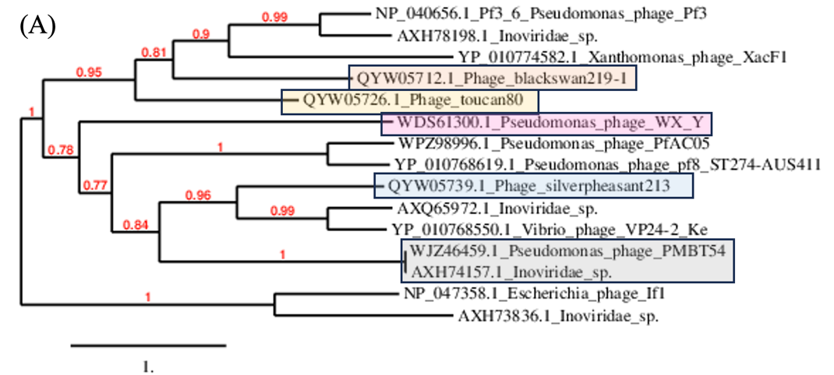
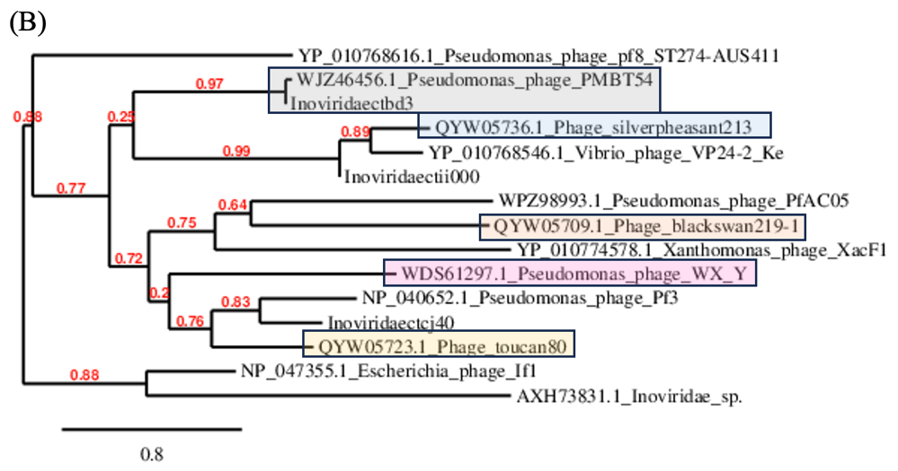
 | GenBank Access. No. | Genome length (nt) | Mol% G+C | No. CDS | DNA (% seq. Ident) | Proteome (No. of homologous proteins; E<10⁻³) | Zot | CoaB
Shewanella phage Dolos | OP867012.1 | 6761 | 38.4 | 11 | 100 | 11 | 100 | 100
Inoviridae sp. isolate ctce6 | MH617040.1 | 7769 | 40.2 | 7 | 27.9 | 3 | 62.8 | 44.7
Inoviridae sp. isolate ctcf138 | MH649005.1 | 6362 | 36.6 | 11 | 24.9 | 6 | 56.7 | 68.1
Inoviridae sp. isolate ctca11 | MH617673.1 | 6136 | 33.8 | 7 | 9.5 | 4 | 44.2 | 55.8
Inoviridae sp. isolate ctcg13 | MH617363.1 | 6312 | 31.6 | 7 | 6.6 | 3 | 46.0 | 45.8
Vibrio phage Vaf1 | OP297622.1 | 10,004 | 44.9 | 13 | 8.4 | 2 | 4.6 | 0
Vibrio phage pre-CTX | KP972569.1 | 6722 | 47.1 | 7 | 8.7 | 3 | 10.6 | 0
Table 6. New genus Serpentivirus (member of the genus is highlighted in green) and new species Serpentivirus dolos (strain in bold, highlighted in green) compared with selected most closely related phages

 | GenBank Access. No. | Genome length (nt) | Mol% G+C | No. CDS | DNA (% seq. Ident) | Proteome (No. of homologous proteins; E<10⁻³) | Zot | CoaB
Inoviridae sp. isolate ctce6 | MH617040.1 | 7769 | 40.2 | 7 | 100 | 7 | 100 | 100
Inoviridae sp. isolate ctcf138 | MH649005.1 | 6362 | 36.6 | 11 | 16.8 | 3 | 63.7 | 62.2
Inoviridae sp. isolate ctca11 | MH617673.1 | 6136 | 33.8 | 7 | 8.1 | 3 | 44.3 | 55.1
Inoviridae sp. isolate ctcg13 | MH617363.1 | 6312 | 31.6 | 7 | 5.8 | 3 | 44.3 | 61.5
Table 7. New genus Scytalavirus (member of the genus is highlighted in blue) and new species Scytalavirus 6 (strain in bold, highlighted in blue) compared with selected most closely related phages

Table 8. New genus Senectutivirus (member of the genus is highlighted in light green) and new species Senectutivirus 138 (strain in bold, highlighted in light green) compared with selected most closely related phages
 | GenBank Access. No. | Genome length (nt) | Mol% G+C | No. CDS | DNA (% seq. Ident) | Proteome (No. of homologous proteins; E<10⁻³) | Zot | CoaB
Inoviridae sp. isolate ctcf138 | MH649005.1 | 6362 | 36.6 | 11 | 100 | 11 | 100 | 100
Inoviridae sp. isolate ctce6 | MH617040.1 | 7769 | 40.2 | 7 | 22.4 | 3 | 62.4 | 58.1
Enterobacteria If1 | NC_001954.1 | 8454 | 43.7 | 10 | 3.2 | 2 | 11.8 | 0
Inoviridae sp. isolate ctcg13 | MH617363.1 | 6312 | 31.6 | 7 | 3.8 | 3 | 40.3 | 50.7
Inoviridae sp. isolate ctca11 | MH617673.1 | 6136 | 33.8 | 7 | 2.5 | 4 | 41.2 | 50.7
Shewanella phage Dolos | OP867012.1 | 6761 | 51.4 | 12 | 14.9 | 6 | 56.1 | 51.5
Vibrio phage Vaf1 | OP297622.1 | 10,004 | 44.9 | 13 | 0 | 0 | 4.9 | 0
Vibrio phage pre-CTX | KP972569.1 | 6722 | 47.1 | 7 | 0 | 1 | 8.8 | 0

Table 9. New species Femenvirus 11 and Femenvirus 13 (strain in bold, highlighted in light blue) and the new genus Femenvirus (member of the genus is highlighted in light blue) compared with selected most closely related phages
 | GenBank Access. No. | Genome length (nt) | Mol% G+C | No. CDS | DNA (% seq. Ident) | Proteome (No. of homologous proteins; E<10⁻³) | Zot | CoaB
Inoviridae sp. isolate ctca11 | MH617673.1 | 6136 | 33.8 | 7 | 100 | 7 | 100 | 100
Inoviridae sp. isolate ctcg13 | MH617363.1 | 6312 | 31.6 | 7 | 68.3 | 7 | 81.0 | 69.4
Shewanella phage Dolos | OP867012.1 | 6761 | 51.4 | 12 | 3.6 | 4 | 43.7 | 33.3
Inoviridae sp. isolate ctce6 | MH617040.1 | 7769 | 40.2 | 7 | 2.4 | 3 | 42.9 | 50
Inoviridae sp. isolate ctcf138 | MH649005.1 | 6362 | 36.6 | 11 | 2.5 | 4 | 41.5 | 44.6
Vibrio phage Vaf1 | OP297622.1 | 10,004 | 44.9 | 13 | 0 | 1 | 4.3 | 0
Vibrio phage pre-CTX | KP972569.1 | 6722 | 47.1 | 7 | 0 | 0 | 7.9 | 0

Table 10. New genus Vittavirus (member of the genus is highlighted in light red) and new species Vittavirus Vaf1 (strain in bold, highlighted in light red) compared with selected most closely related phages
 | GenBank Access. No. | Genome length (nt) | Mol% G+C | No. CDS | DNA (% seq. Ident) | Proteome (No. of homologous proteins; E<10⁻³) | Zot | CoaB
Vibrio phage Vaf1 | OP297622.1 | 10,004 | 44.9 | 13 | 100 | 13 | 100 | 100
Vibrio phage VFJ | NC_021562.1 | 8555 | 44.3 | 12 | 23.6 | 9 | 62.8 | 34.2
Shewanella phage Dolos | OP867012.1 | 6761 | 51.4 | 12 | 10.3 | 2 | 4.6 | 0
Vibrio phage pre-CTX | KP972569.1 | 6722 | 47.1 | 7 | 10.8 | 2 | 0 | 0
Vibrio phage Vf12 | NC_005949.1 | 7965 | 45.7 | 7 | 10.0 | 1 | 0 | 0
Vibrio phage K04M1_VK04M1 | CP017895.1 | 7079 | 46.1 | 11 | 7.8 | 2 | 0 | 0

Figure 2. Phylogenetic relationships of members of new genera Serpentivirus (dark green), Scytalavirus (blue), Senectutivirus (light green), Femenvirus (light blue) and Vittavirus (light red) based on amino-acid sequence of assembly protein (A) and major coat protein (B).

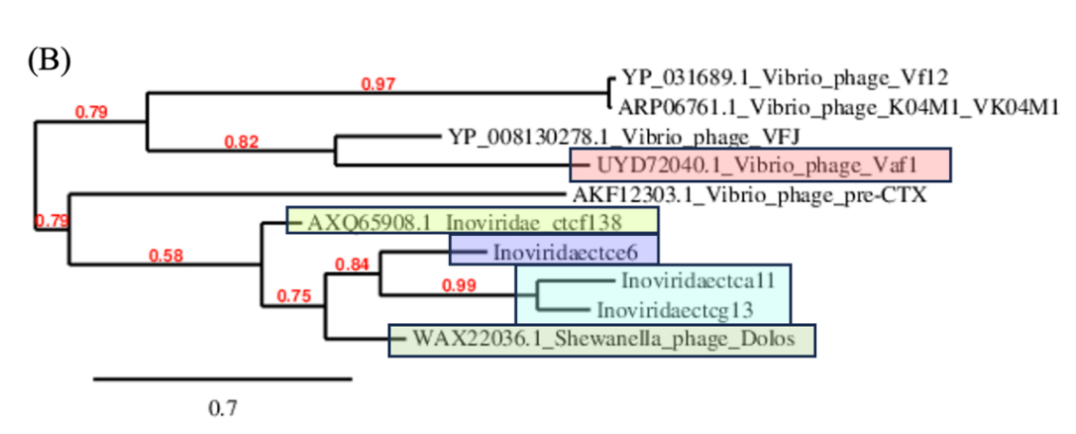
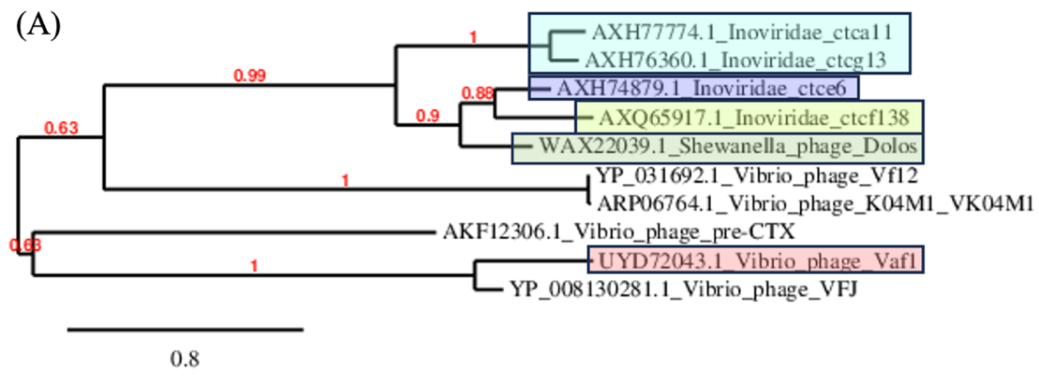

Table 11. New genus Amentovirus (member of the genus is highlighted in violet) and new species Amentovirus 10, Amentovirus 42 and Amentovirus 39 (strain in bold, highlighted in violet) compared with selected most closely related phages
 | GenBank Access. No. | Genome length (nt) | Mol% G+C | No. CDS | DNA (% seq. Ident) | Proteome (No. of homologous proteins; E<10⁻³) | Zot | CoaB
Inoviridae sp. isolate ctbh10 | MH593836.1 | 5166 | 37.7 | 5 | 100 | 5 | 100 | 100
Inoviridae sp. isolate ctcf42 | MH617172.1 | 4949 | 37.8 | 5 | 80.7 | 5 | 95.2 | 100
Inoviridae sp. isolate ctda39 | MH617090.1 | 5096 | 37.7 | 5 | 70.5 | 5 | 92.3 | 100
Inoviridae sp. isolate ctcj20 | MH617306.1 | 6009 | 38.8 | 7 | 1.7 | 3 | 92.3 | 0
Escherichia virus M13 | NC_003287 | 6407 | 40.7 | 10 | 0.8 | 2 | 25.6 | 0

Table 12. New genus Fasceasvirus (member of the genus is highlighted in green) and new species Fasceasvirus 1, Fasceasvirus 25 and Fasceasvirus 39 (strain in bold, highlighted in green) compared with selected most closely related phages
 | GenBank Access. No. | Genome length (nt) | Mol% G+C | No. CDS | DNA (% seq. Ident) | Proteome (No. of homologous proteins; E<10⁻³) | Zot | CoaB
Inoviridae sp. isolate ctcf1 | MH616765.1 | 5826 | 39.5 | 6 | 100 | 6 | 100 | 100
Inoviridae sp. isolate ctjd25 | MH617190.1 | 5705 | 40.8 | 6 | 63.4 | 5 | 89.9 | 55.6
Inoviridae sp. isolate ctgd30 | MH616730.1 | 5370 | 40.6 | 8 | 34.7 | 4 | 70.0 | 78.8
Inoviridae sp. isolate ctbf24 | MH617675.1 | 5913 | 35.6 | 7 | 1.8 | 3 | 17.3 | 0
Inoviridae sp. isolate ctci24 | MH617072.1 | 5723 | 40 | 8 | 3.2 | 4 | 27.3 | 0
Enterobacteria phage Ike | NC_002014 | 6883 | 40.5 | 10 | 0.8 | 1 | 3.1 | 0

Table 13. New genus Adiligaturavirus (member of the genus is highlighted in yellow-green) and new species Adiligaturavirus 24 (strain in bold, highlighted in yellow-green) compared with selected most closely related phages
 | GenBank Access. No. | Genome length (nt) | Mol% G+C | No. CDS | DNA (% seq. Ident) | Proteome (No. of homologous proteins; E<10⁻³) | Zot | CoaB
Inoviridae sp. isolate ctbf24 | MH617675.1 | 5913 | 35.6 | 7 | 100 | 7 | 100 | 100
Inoviridae sp. isolate ctce6 | MH617507.1 | 6275 | 35.2 | 6 | 12.5 | 4 | 28.4 | 18.6
Inoviridae sp. isolate ctgd30 | MH616730.1 | 5370 | 40.6 | 8 | 10.0 | 5 | 14.9 | 0
Inoviridae sp. isolate ctcg21 | MH617060.1 | 5991 | 36.9 | 7 | 10.4 | 5 | 18.7 | 18.9
Escherichia virus M13 | NC_003287 | 6407 | 40.7 | 10 | 7.0 | 1 | 5.0 | 0

Table 14. New genus Antiavirus (member of the genus is highlighted in gray) and new species Antiavirus 20 (strain in bold, highlighted in gray) compared with selected most closely related phages
 | GenBank Access. No. | Genome length (nt) | Mol% G+C | No. CDS | DNA (% seq. Ident) | Proteome (No. of homologous proteins; E<10⁻³) | Zot | CoaB
Inoviridae sp. isolate ctcj20 | MH617306.1 | 6009 | 38.8 | 7 | 100 | 7 | 100 | 100
Inoviridae sp. isolate ctci24 | MH617072.1 | 5723 | 40 | 8 | 31.8 | 6 | 36.1 | 27.8
Inoviridae sp. isolate ctcg21 | MH617060.1 | 5991 | 36.9 | 7 | 10.4 | 4 | 18.3 | 27.8
Inoviridae sp. isolate ctjd25 | MH617190.1 | 5913 | 35.6 | 7 | 2.2 | 3 | 19.3 | 0

Table 15. New genus Aclydivirus (member of the genus is highlighted in red) and new species Aclydivirus 6 (strain in bold, highlighted in red) compared with selected most closely related phages
 | GenBank Access. No. | Genome length (nt) | Mol% G+C | No. CDS | DNA (% seq. Ident) | Proteome (No. of homologous proteins; E<10⁻³) | Zot | CoaB
Inoviridae sp. isolate ctce6 | MH617507.1 | 6275 | 35.2 | 6 | 100 | 6 | 100 | 100
Inoviridae sp. isolate ctfi19 | MH617224.1 | 6043 | 32.7 | 6 | 26.0 | 3 | 18.8 | 20.2
Inoviridae sp. isolate ctcg21 | MH617060.1 | 5991 | 36.9 | 7 | 10.5 | 4 | 31.5 | 23.1
Inoviridae sp. isolate ctbf24 | MH617675.1 | 5913 | 35.6 | 7 | 11.0 | 4 | 29.6 | 24.2

Figure 3. Phylogenetic relationships of members of new genera Amentovirus (violet), Fasceasvirus (green), Adiligaturavirus (yellow green), Antiavirus (gray), and Aclydivirus (red) based on amino-acid sequence of assembly protein (A) and major coat protein (B).

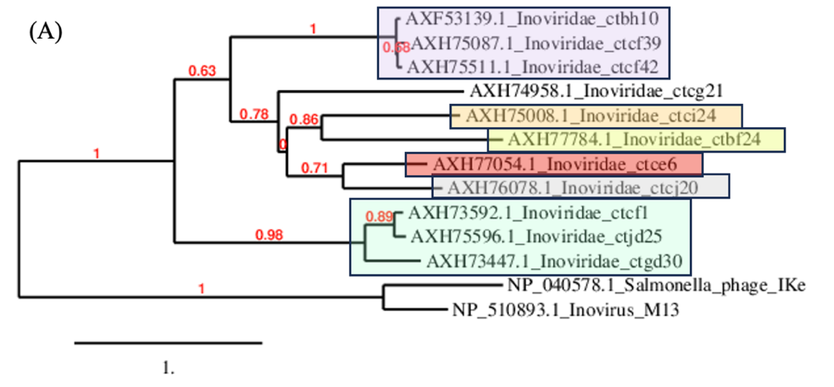
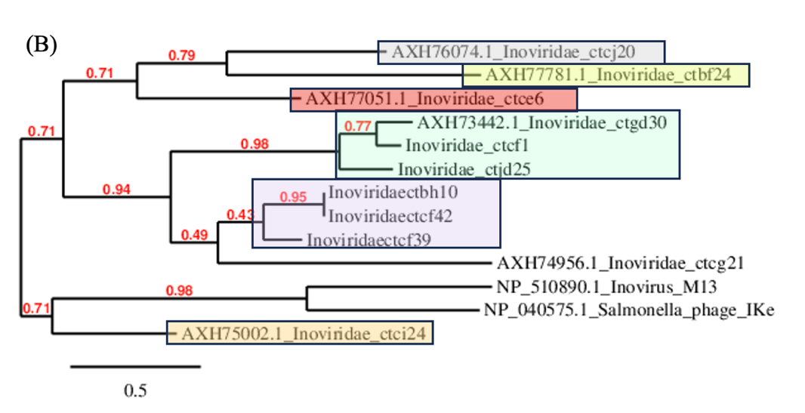
Table 16. New genus Strophivirus (member of the genus is highlighted in brown) and new species Strophivirus 33, Strophivirus 31, Strophivirus 32, Strophivirus 36, Strophivirus 37 and Strophivirus 34 (strain in bold, highlighted in brown) compared with selected most closely related phages
 | GenBank Access. No. | Genome length (nt) | Mol% G+C | No. CDS | DNA (% seq. Ident) | Proteome (No. of homologous proteins; E<10⁻³) | Zot | CoaB
Inoviridae sp. isolate ctdf33 | MH616872.1 | 5181 | 44.5 | 10 | 100 | 10 | 100 | 100
Inoviridae sp. isolate ctbh31 | MH616838.1 | 5257 | 43.4 | 6 | 51.6 | 6 | 90.4 | 93
Inoviridae sp. isolate ctch32 | MH617618.1 | 5205 | 45.4 | 7 | 84.6 | 7 | 98.0 | 100
Inoviridae sp. isolate ctbi36 | MH617298.1 | 5178 | 44.3 | 8 | 82.4 | 8 | 96.7 | 100
Inoviridae sp. isolate ctcc37 | MH617717.1 | 5180 | 44.8 | 9 | 85.0 | 9 | 97.7 | 97.6
Inoviridae sp. isolate ctcj34 | MH617011.1 | 5175 | 44.4 | 8 | 84.9 | 8 | 97.7 | 97.6
Inoviridae sp. isolate cted44 | MH617219.1 | 4926 | 44.7 | 7 | 51.0 | 7 | 59.0 | 17.1
Inoviridae sp. isolate ctcj40 | MH617768.1 | 5095 | 44.5 | 10 | 36.0 | 7 | 60 | 36.1
Inoviridae sp. isolate ctda43 | MH617492.1 | 4948 | 45.5 | 5 | 6.2 | 2 | 51.6 | 43.6
Inoviridae sp. isolate ctda12 | MH617343.1 | 6346 | 38 | 7 | 12.7 | 3 | 56.0 | 52.3
Inoviridae sp. isolate ctcf41 | MH616641.1 | 5080 | 38 | 8 | 10.1 | 4 | 63.8 | 53.5
Inoviridae sp. isolate ctbh45 | MH617617.1 | 4815 | 39 | 7 | 14.5 | 4 | 62.5 | 53.4
Ralstonia phage RSCq | OR088903.1 | 7480 | 61.9 | 11 | 0 | 3 | 24.8 | 0
Pseudomonas phage Pf3 | NC_001418 | 5833 | 45.4 | 10 | 6.3 | 3 | 64.0 | 55.8

Table 17. New genus Maeandervirus (member of the genus is highlighted in orange) and new species Maeandervirus 44 and Maeandervirus 40 (strain in bold, highlighted in orange) compared with selected most closely related phages
 | GenBank Access. No. | Genome length (nt) | Mol% G+C | No. CDS | DNA (% seq. Ident) | Proteome (No. of homologous proteins; E<10⁻³) | Zot | CoaB
Inoviridae sp. isolate cted44 | MH617219.1 | 4926 | 44.7 | 7 | 100 | 7 | 100 | 100
Inoviridae sp. isolate ctcj40 | MH617768.1 | 5095 | 44.5 | 10 | 63.4 | 7 | 95.4 | 95.5
Inoviridae sp. isolate ctda43 | MH617492.1 | 4948 | 45.5 | 5 | 4.8 | 2 | 48.7 | 29.4
Inoviridae sp. isolate ctda12 | MH617343.1 | 6346 | 38 | 7 | 4.8 | 3 | 42.4 | 50
Inoviridae sp. isolate ctcf41 | MH616641.1 | 5080 | 38 | 8 | 6.7 | 4 | 53.3 | 42.9
Inoviridae sp. isolate ctbh45 | MH617617.1 | 4815 | 39 | 7 | 6.6 | 4 | 57.0 | 36.1
Ralstonia phage RSCq | OR088903.1 | 7480 | 61.9 | 11 | 0 | 2 | 24.5 | 0
Pseudomonas phage Pf3 | NC_001418 | 5833 | 45.4 | 10 | 5.5 | 3 | 55.8 | 0

Table 18. New genus Semitavirus (member of the genus is highlighted in blue) and new species Semitavirus 43 (strain in bold, highlighted in blue) compared with selected most closely related phages
 | GenBank Access. No. | Genome length (nt) | Mol% G+C | No. CDS | DNA (% seq. Ident) | Proteome (No. of homologous proteins; E<10⁻³) | Zot | CoaB
Inoviridae sp. isolate ctda43 | MH617492.1 | 4948 | 45.5 | 5 | 100 | 5 | 100 | 100
Pseudomonas phage Pf3 | NC_001418 | 5833 | 45.4 | 9 | 19.9 | 3 | 0 | 49.8
Inoviridae sp. isolate ctch32 | MH617618.1 | 5205 | 45.4 | 7 | 8.5 | 2 | 0 | 52.3
Inoviridae sp. isolate ctbh45 | MH617617.1 | 4815 | 39 | 7 | 7.0 | 2 | 0 | 65.9

Table 19. New genus Itinerivirus (member of the genus is highlighted in violet) and new species Itinerivirus 12 (strain in bold, highlighted in violet) compared with selected most closely related phages
 | GenBank Access. No. | Genome length (nt) | Mol% G+C | No. CDS | DNA (% seq. Ident) | Proteome (No. of homologous proteins; E<10⁻³) | Zot | CoaB
Inoviridae sp. isolate ctda12 | MH617343.1 | 6346 | 38 | 7 | 100 | 7 | 100 | 100
Inoviridae sp. isolate ctcf41 | MH616641.1 | 5080 | 38 | 8 | 5.4 | 3 | 53.1 | 56.8
Inoviridae sp. isolate ctbh45 | MH617617.1 | 4815 | 39 | 7 | 6.1 | 3 | 52.7 | 54.1
Ralstonia phage RSCq | OR088903.1 | 7480 | 61.9 | 11 | 0 | 3 | 24.5 | 0
Pseudomonas phage Pf3 | NC_001418 | 5833 | 45.4 | 10 | 0 | 3 | 51.6 | 47.1

Table 20. New genus Actovirus (member of the genus is highlighted in dark green) and two new species Actovirus 45 and Actovirus 41 (strain in bold, highlighted in dark green) compared with selected most closely related phages
 | GenBank Access. No. | Genome length (nt) | Mol% G+C | No. CDS | DNA (% seq. Ident) | Proteome (No. of homologous proteins; E<10⁻³) | Zot | CoaB
Inoviridae sp. isolate ctbh45 | MH617617.1 | 4815 | 39 | 7 | 100 | 7 | 100.0 | 100
Inoviridae sp. isolate ctcf41 | MH616641.1 | 5080 | 38 | 7 | 53.5 | 6 | 69.1 | 79.4
Pseudomonas phage Pf3 | NC_001418 | 5833 | 45.4 | 10 | 9.3 | 4 | 0 | 70.5
Inoviridae sp. isolate ctcc37 | MH617717.1 | 5180 | 44.8 | 9 | 8.7 | 4 | 62.8 | 50.1

Figure 4. Phylogenetic relationships of members of new genera Strophivirus (brown), Maeander (orange), Semitavirus (blue), Itinerivirus (violet), Actovirus (dark green), and Pubesvirus (green) based on amino-acid sequence of assembly protein (A) and major coat protein (B).
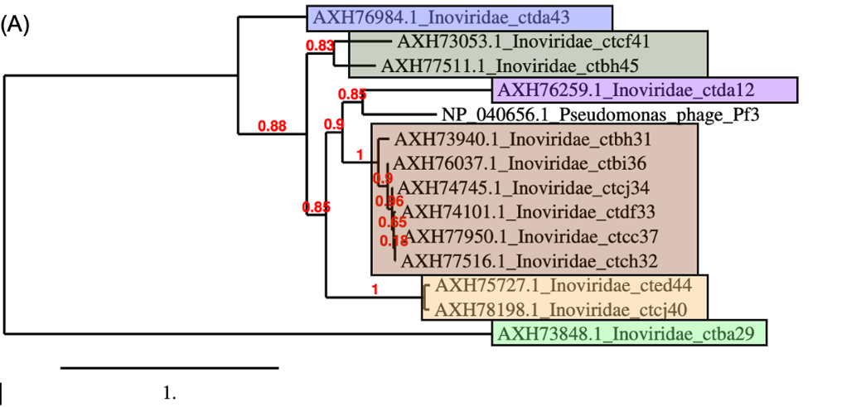
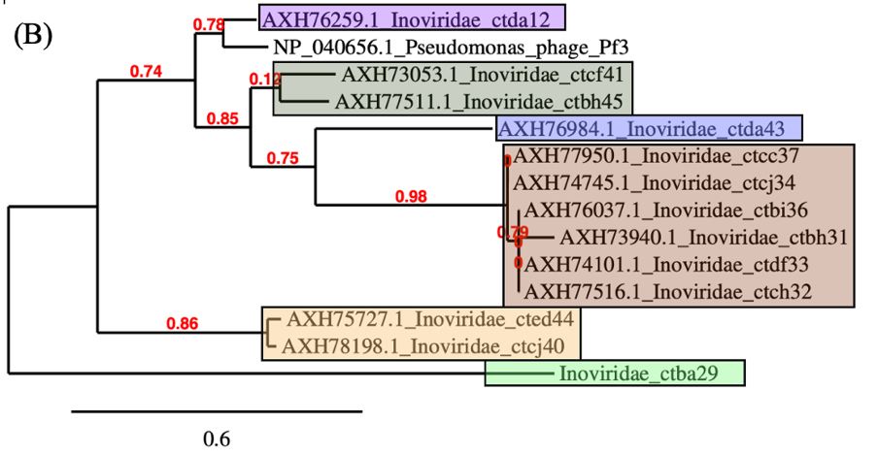
Table 21. New genus Aspidivirus (member of the genus is highlighted in neon green) and new species Aspidivirus 14 (strain in bold, highlighted in neon green) compared with selected most closely related phages
 | GenBank Access. No. | Genome length (nt) | Mol% G+C | No. CDS | DNA (% seq. Ident) | Proteome (No. of homologous proteins; E<10⁻³) | Zot | CoaB
Inoviridae sp. isolate ctbf14 | MH617742.1 | 6115 | 31.8 | 10 | 100 | 10 | 100 | 100
Inoviridae sp. isolate ctfi19 | MH617224.1 | 6043 | 32.7 | 6 | 49.6 | 4 | 84.6 | 76.9
Inoviridae sp. isolate ctba17 | MH617467.1 | 6062 | 35.1 | 9 | 48.8 | 8 | 43.1 | 59.5
Inoviridae sp. isolate ctcg5 | MH617262.1 | 6789 | 35.6 | 7 | 1.5 | 3 | 26.1 | 0
Inoviridae sp. isolate ctge7 | MH616675.1 | 7265 | 37.3 | 7 | 1.5 | 2 | 30.6 | 0
Enterobacteria phage M13 | NC_003287 | 6407 | 40.7 | 10 | 0 | 1 | 0 | 0
Enterobacteria phage Ike | NC_002014 | 6883 | 40.5 | 10 | 0 | 1 | 2.8 | 0

Table 22. New genus Galbavirus (member of the genus is highlighted in neon pink) and new species Galbavirus 17 (strain in bold, highlighted in neon pink) compared with selected most closely related phages
 | GenBank Access. No. | Genome length (nt) | Mol% G+C | No. CDS | DNA (% seq. Ident) | Proteome (No. of homologous proteins; E<10⁻³) | Zot | CoaB
Inoviridae sp. isolate ctba17 | MH617467.1 | 6062 | 35.1 | 9 | 100 | 9 | 100 | 100
Inoviridae sp. isolate ctbf14 | MH617742.1 | 6115 | 31.8 | 10 | 48.8 | 8 | 43.1 | 59.5
Enterobacteria phage M13 | NC_003287 | 6407 | 40.7 | 10 | 0 | 2 | 3.1 | 0
Enterobacteria phage Ike | NC_002014 | 6883 | 40.5 | 10 | 0 | 2 | 7.5 | 0

Figure 5. Phylogenetic relationships of members of new genera Aspidivirus (neon green) and Galbavirus (neon pink) based on amino-acid sequence of assembly protein (A) and major coat protein (B).
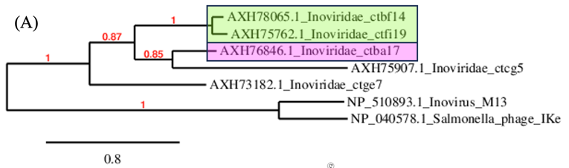
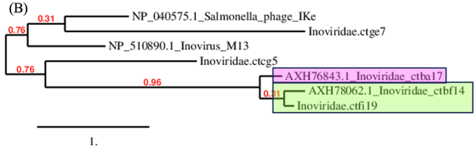

Table 23. New species Reticulivirus 11 (strain in bold, highlighted in yellow) and the new genus Reticulivirus (member of the genus is highlighted in yellow) compared with selected most closely related phages
 | GenBank Access. No. | Genome length (nt) | Mol% G+C | No. CDS | DNA (% seq. Ident) | Proteome (No. of homologous proteins; E<10⁻³) | Zot | CoaB
Inoviridae sp. isolate ctcb11 | MH617645.1 | 6372 | 38.2 | 6 | 100 | 6 | 100 | 100
Shewanella phage Dolos | OP867012.1 | 8146 | 38.4 | 12 | 2.0 | 2 | 32.1 | 24.6
Inoviridae sp. isolate ctca11 | MH617673.1 | 6136 | 33.8 | 7 | 1.4 | 3 | 29.4 | 27.8

Figure 6. Phylogenetic relationships of members of new genus Reticulivirus (yellow) and other related viruses, based on amino-acid sequence of assembly protein (A) and major coat protein (B).

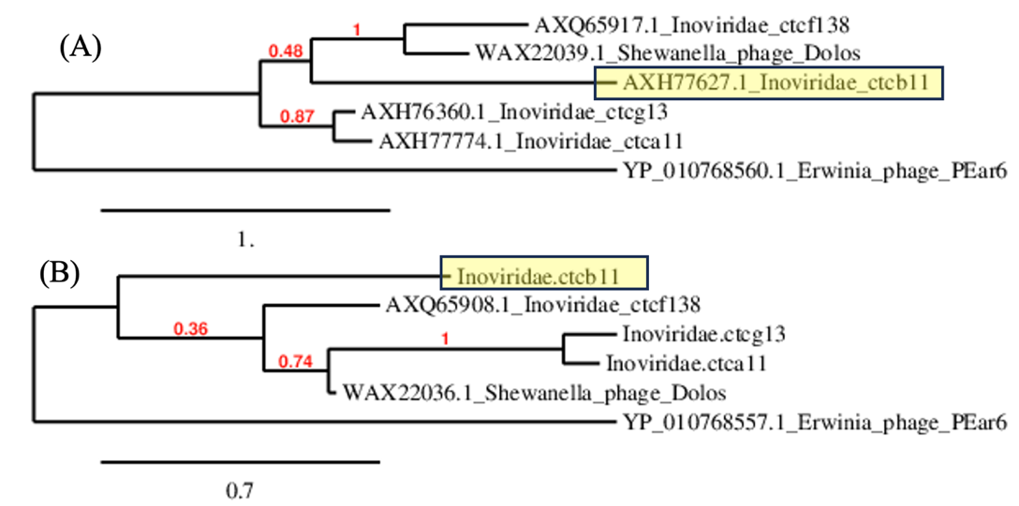

Table 24. New genus Pubesvirus (member of the genus is highlighted in dark gray) and new species Pubesvirus 29 (strain in bold, highlighted in dark gray) compared with selected most closely related phages
 | GenBank Access. No. | Genome length (nt) | Mol% G+C | No. CDS | DNA (% seq. Ident) | Proteome (No. of homologous proteins; E<10⁻³) | Zot | CoaB
Inoviridae sp. isolate ctba29 | MH616818.1 | 5419 | 36.2 | 5 | 100 | 5 | 100 | 100
Inoviridae sp. isolate ctce6 | MH617507.1 | 6275 | 35.2 | 6 | 1.4 | 4 | 15.9 | 22.7
Inoviridae sp. isolate ctbd37 | MH617622.1 | 5821 | 37.5 | 5 | 0 | 1 | 39.8 | 54.6
Vibrio phage VP24-2_Ke | NC_073750.1 | 7180 | 42.5 | 13 | 0 | 1 | 35.6 | 52.3

Table 25. New genus Prolivirus (member of the genus is highlighted in olive green) and new species Prolivirus 37 (strain in bold, highlighted in olive green) compared with selected most closely related phages
 | GenBank Access. No. | Genome length (nt) | Mol% G+C | No. CDS | DNA (% seq. Ident) | Proteome (No. of homologous proteins; E<10⁻³) | Zot | CoaB
Inoviridae sp. isolate ctbd37 | MH617622.1 | 5821 | 37.5 | 5 | 100 | 5 | 100 | 100
Inoviridae sp. isolate ctii000 | MH649021.1 | 7006 | 40.3 | 12 | 52.5 | 4 | 30.3 | 65.9
Inoviridae sp. isolate ctcb147 | MH649151.1 | 5999 | 36.7 | 7 | 30.0 | 3 | 4.5 | 0
Vibrio phage VP24-2_Ke | NC_073750.1 | 7180 | 42.5 | 13 | 0 | 5 | 31.0 | 56.8

Table 26. New genus Plantarivirus (member of the genus is highlighted in brown) and new species and Plantarivirus 147 (strain in bold, highlighted in brown) compared with selected most closely related phages
 | GenBank Access. No. | Genome length (nt) | Mol% G+C | No. CDS | DNA (% seq. Ident) | Proteome (No. of homologous proteins; E<10⁻³) | Zot | CoaB
Inoviridae sp. isolate ctcb147 | MH649151.1 | 5999 | 36.7 | 7 | 100 | 7 | 100 | 100
Inoviridae sp. isolate ctbd37 | MH617622.1 | 5821 | 37.5 | 5 | 29.6 | 3 | 8.0 | 0
Inoviridae sp. isolate ctii000 | MH649021.1 | 7006 | 40.3 | 12 | 0 | 2 | 10.4 | 0

Table 27. New genus Propagovirus (member of the genus is highlighted in pink) and new species Propagovirus nuni (strain in bold, highlighted in pink) and the compared with selected most closely related phage
 | GenBank Access. No. | Genome length (nt) | Mol% G+C | No. CDS | DNA (% seq. Ident) | Proteome (No. of homologous proteins; E<10⁻³) | Zot | CoaB
Inoviridae sp. isolate ctii000 | MH649021.1 | 7006 | 40.3 | 12 | 100 | 12 | 100 | 100
Vibrio phage VP24-2_Ke | NC_073750.1 | 7180 | 42.5 | 13 | 15.2 | 7 | 53.0 | 70.5

Figure 7. Phylogenetic relationships of members of new genera Pubesvirus (gray), Prolivirus (dark blue), Plantarivirus (brown) and Propagovirus (pink) based on amino-acid sequence of assembly protein (A) and major coat protein (B).
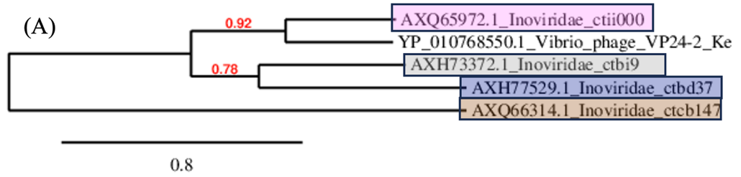
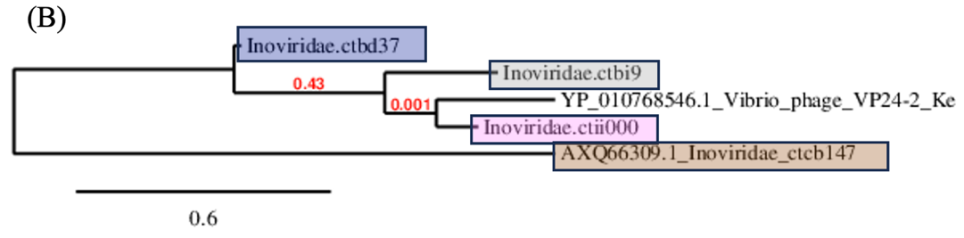

Table 28. New genus Sarmentivirus (member of the genus is highlighted in dark blue) and new species Sarmentivirus 25 (strain in bold, highlighted in dark blue) compared with selected most closely related phages
 | GenBank Access. No. | Genome length (nt) | Mol% G+C | No. CDS | DNA (% seq. Ident) | Proteome (No. of homologous proteins; E<10⁻³) | Zot | CoaB
Inoviridae sp. isolate ctbd25 | MH616843.1 | 5901 | 41.0 | 8 | 100 | 8 | 100 | 100
Enterobacteria phage M13 | NC_003287.2 | 6407 | 40.7 | 10 | 4.1 | 5 | 29.6 | 21.3
Enterobacteria phage I2-2 | NC_001332.1 | 6744 | 42.7 | 9 | 3.5 | 4 | 17.9 | 27.7
Shewanella phage Dolos | OP867012.1 | 8146 | 38.4 | 12 | 2.1 | 1 | 7.4 | 0

Figure 8. Phylogenetic relationships of member of new genus Sarmentivirus (dark blue) and other related members of family Inoviridae, based on amino-acid sequence of assembly protein (A) and major coat protein (B).
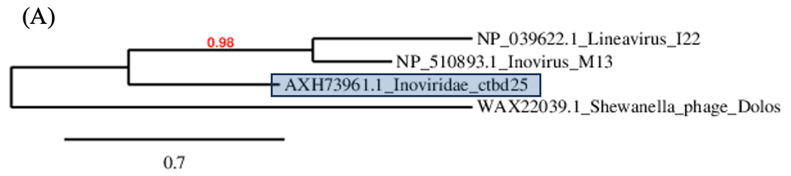
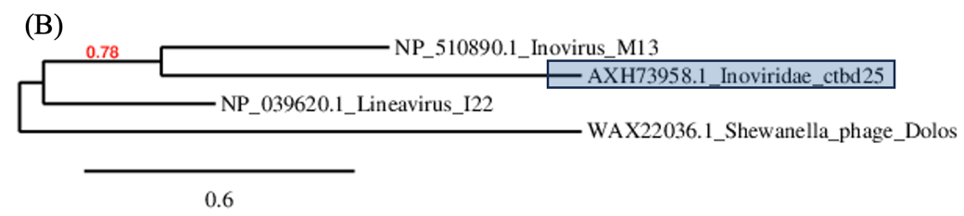
Table 29. New genus Acontivirus (member of the genus is highlighted in orange) and new species Acontivirus 21 (strain in bold, highlighted in orange) compared with selected most closely related phages
 | GenBank Access. No. | Genome length (nt) | Mol% G+C | No. CDS | DNA (% seq. Ident) | Proteome (No. of homologous proteins; E<10⁻³) | Zot | CoaB
Inoviridae sp. isolate ctcg21 | MH617060.1 | 5991 | 36.9 | 7 | 100 | 7 | 100 | 100
Inoviridae sp. isolate ctce6 | MH617507.1 | 6275 | 35.2 | 6 | 10.5 | 4 | 10.5 | 0
Inoviridae sp. isolate ctbf24 | MH617675.1 | 5913 | 35.6 | 7 | 10.6 | 5 | 21.1 | 21.1
Inoviridae sp. isolate ctba17 | MH617467.1 | 6062 | 35.1 | 9 | 2.9 | 3 | 14.7 | 16.6

Table 30. New genus Abaestuovirus (member of the genus is highlighted in blue) and new species Abaestuovirus 8 (strain in bold, highlighted in blue) compared with selected most closely related phages
 | GenBank Access. No. | Genome length (nt) | Mol% G+C | No. CDS | DNA (% seq. Ident) | Proteome (No. of homologous proteins; E<10⁻³) | Zot | CoaB
Inoviridae sp. isolate ctbh8 | MH617292.1 | 6223 | 35.4 | 6 | 100 | 6 | 100 | 100
Inoviridae sp. isolate ctcg21 | MH617060.1 | 5991 | 36.9 | 7 | 9.7 | 3 | 33.1 | 23.3
Inoviridae sp. isolate ctce6 | MH617507.1 | 6275 | 35.2 | 6 | 4.1 | 2 | 14.9 | 18.3
Inoviridae sp. isolate ctba17 | MH617467.1 | 6062 | 35.1 | 9 | 2.7 | 2 | 34.8 | 24.3

Figure 9. Phylogenetic relationships of members of new genera Acontivirus (orange) and Abaestuovirus (blue) based on amino-acid sequence of assembly protein (A) and major coat protein (B).

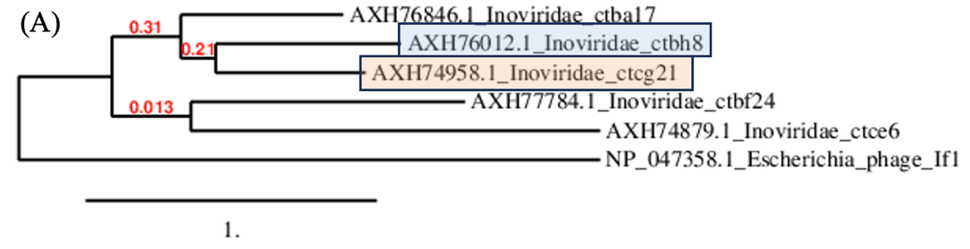
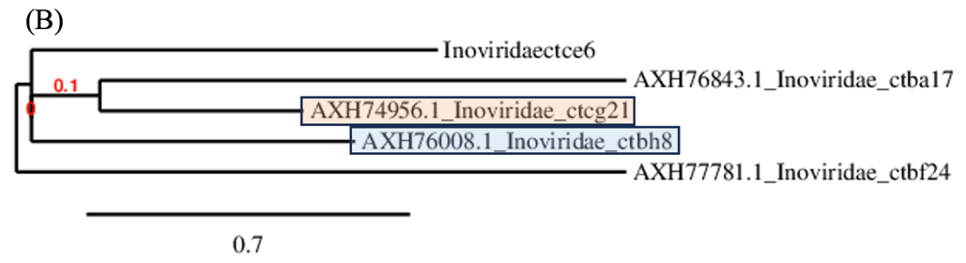
Table 31. New genus Xiphivirus (member of the genus is highlighted in light violet) and new species Xiphivirus 2 (strain in bold, highlighted in light violet) compared with selected most closely related phages
 | GenBank Access. No. | Genome length (nt) | Mol% G+C | No. CDS | DNA (% seq. Ident) | Proteome (No. of homologous proteins; E<10⁻³) | Zot | CoaB
Inoviridae sp. isolate ctcf2 | MH617445.1 | 7256 | 64.1 | 16 | 100 | 16 | 100 | 100
Stenotrophomonas phage PSH1 | NC_010429.1 | 6867 | 61.1 | 7 | 21.8 | 4 | 54.2 | 0
Stenotrophomonas phage phiSMA6 | NC_043029.1 | 7648 | 62.6 | 10 | 4.6 | 5 | 34.2 | 0
Xanthomonas phage XaF13 | NC_062737.1 | 7045 | 60.3 | 14 | 2.2 | 3 | 31.6 | 0

Table 32. New genus Catenatiovirus (member of the genus is highlighted in orange) and new species Catenatiovirus 32 (strain in bold, highlighted in orange) compared with selected most closely related phages
 | GenBank Access. No. | Genome length (nt) | Mol% G+C | No. CDS | DNA (% seq. Ident) | Proteome (No. of homologous proteins; E<10⁻³) | Zot | CoaB
Inoviridae sp. ctBZ32 | MN582099.1 | 4924 | 66 | 8 | 100 | 8 | 100 | 100
Stenotrophomonas phage phiSMA6 | NC_043029.1 | 7648 | 62.6 | 10 | 8.5 | 1 | 28.8 | 10.9

Table 33. New species Staminivirus 6 (strain in bold, highlighted in green) compared with another member of the genus (highlighted in green)
 | GenBank Access. No. | Genome length (nt) | Mol% G+C | No. CDS | DNA (% seq. Ident) | Proteome (No. of homologous proteins; E<10⁻³) | Zot | CoaB
Inoviridae sp. isolate ctda6 | MH552488.1 | 6561 | 61.5 | 11 | 100 | 11 | 100 | 100
Stenotrophomonas phage phiSMA9 | NC_007189.1 | 6907 | 62.4 | 7 | 50.7 | 7 | 82.1 | 71.3
Stenotrophomonas phage phiSHP2 | NC_015586.1 | 5819 | 61.5 | 9 | 45.6 | 6 | 16.6 | 0
Stenotrophomonas phage PSH1 | NC_010429.1 | 6867 | 61.1 | 7 | 24.9 | 5 | 2.6 | 0

Figure 10. Phylogenetic relationships of member of Staminivirus (green) and new genera Xiphivirus (violet), Catenatiovirus (orange), other related members of family Inoviridae, based on amino-acid sequence of assembly protein (A) and major coat protein (B).

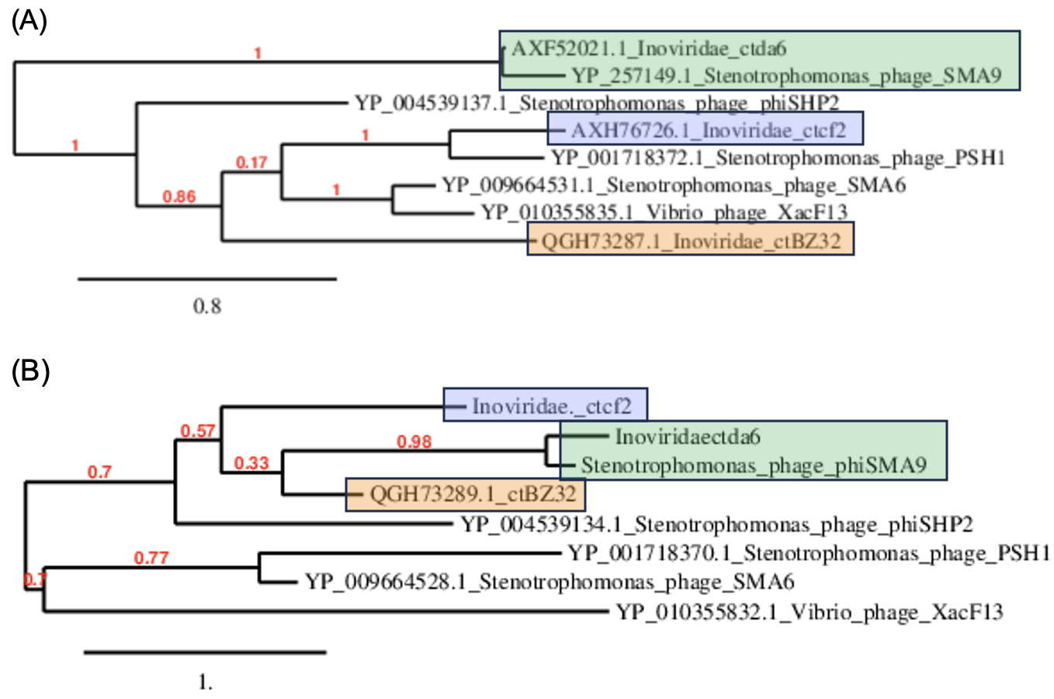
Table 34. New genus Circumitovirus (member of the genus is highlighted in dark red) and new species Circumitovirus 48 (strain in bold, highlighted in dark red) compared with selected most closely related phages
 | GenBank Access. No. | Genome length (nt) | Mol% G+C | No. CDS | DNA (% seq. Ident) | Proteome (No. of homologous proteins; E<10⁻³) | Zot | CoaB
Inoviridae sp. isolate ctbi48 | MH617564.1 | 4533 | 44 | 9 | 100 | 9 | 100 | 100
Erwinia phage PEar6 | NC_073751.1 | 6608 | 41.7 | 11 | 1.5 | 4 | 30.5 | 22.3
Vibrio phage fs2 | NC_001956.1 | 8651 | 44.5 | 9 | 2.1 | 3 | 33.6 | 23.7
Enterobacteria phage Ike | NC_002014 | 6883 | 40.5 | 10 | 1.5 | 4 | 30.2 | 34.3
Vibrio phage Vaf1 | OP297622.1 | 10,004 | 44.9 | 13 | 0 | 3 | 30.0 | 35.2
Escherichia phage M13 | NC_003287 | 6407 | 40.7 | 10 | 1.5 | 3 | 26.4 | 25.1

Figure 11. Phylogenetic relationships of members of new genera Circumitovirus (blue) and Catervavirus (red) based on amino-acid sequence of assembly protein (A) and major coat protein (B).

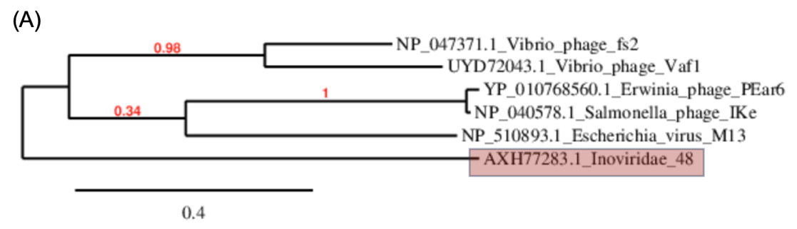

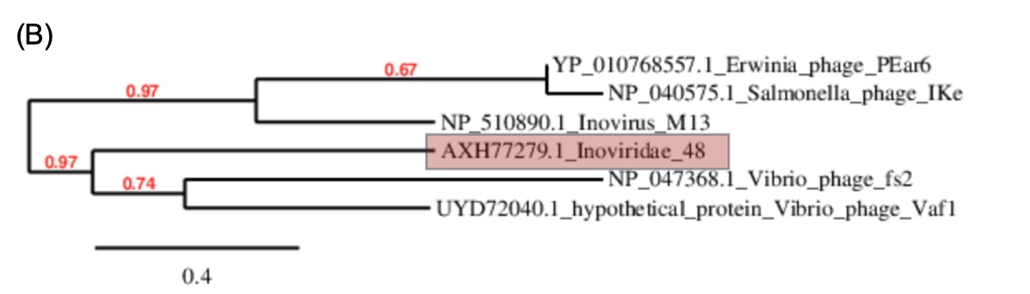

Table 35. New species Viscerivirus 525 (strain in bold, highlighted in black) and the new genus Viscerivirus (member of the genus is highlighted in black) compared with selected most closely related phages
 | GenBank Access. No. | Genome length (nt) | Mol% G+C | No. CDS | DNA (% seq. Ident) | Proteome (No. of homologous proteins; E<10⁻³) | Zot | CoaB
Inoviridae sp. isolate ctbf525 | MH616815.1 | 5715 | 50.8 | 9 | 100 | 9 | 100 | 100
Inoviridae sp. isolate ctcf 138 | MH649005.1 | 6362 | 36.6 | 11 | 2.8 | 1 | 0 | 0
Enterobacteria phage If1 | NC_001954.1 | 8454 | 43.7 | 10 | 2.9 | 2 | 31.1 | 17.6
Alteromonas phage phiAFP1 | OP433453.1 | 5986 | 40.3 | 8 | 1.5 | 2 | 0 | 0

Figure 12. Phylogenetic relationships of member of new genus Viscerivirus (black) and other related members of family Inoviridae, based on amino-acid sequence of assembly protein (A) and major coat protein (B).

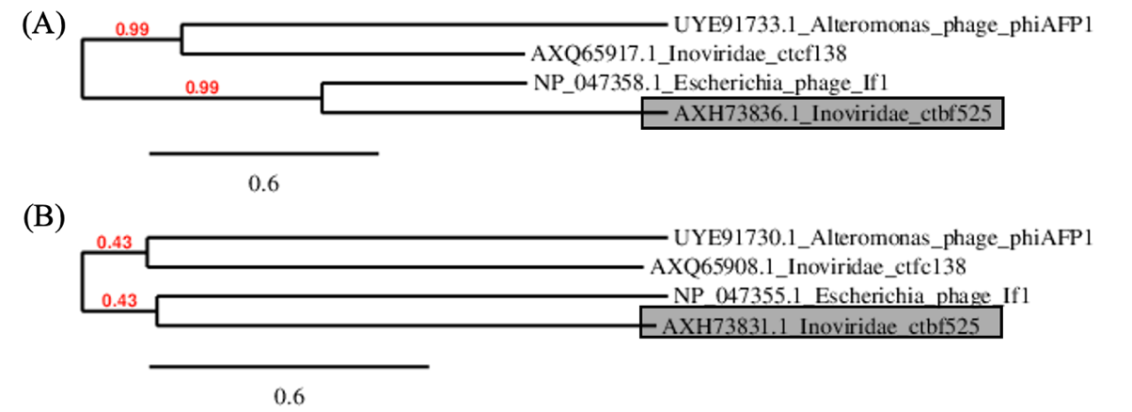
Table 36. The new species Thomixvirus zuza (strain shown in bold and highlighted in grey-blue) was compared with another species of the same genus (Thomixvirus OH3), two representatives of another genus in family Paulinoviridae, and a peripherally related member of the family Inoviridae (Enterobacteria phage If1).
 | GenBank Access. No. | Genome length (nt) | Mol% G+C | No. CDS | DNA (% seq. Ident) | Proteome (No. of homologous proteins; E<10⁻³) | Zot | CoaB
Thermus phage Zuza8 | PP554188.1 | 6773 | 60.0 | 9 | 100 | 9 | 100 | 100
Thermus phage OH3 | NC_045425 | 5688 | 58 | 8 | 53.1 | 8 | 82.2 | 64.7
Propionobacterium phage B5 | NC_003460 | 5804 | 64.3 | 10 | 0 | 1 | 16.5 | 0
Propionobacterium phage Philemon | PP693361.1 | 6312 | 31.6 | 7 | 0 | 1 | 16.3 | 0
Enterobacteria phage If1 | NC_001954.1 | 8454 | 43.7 | 10 | 0 | 0 | 5.2 | 0

Figure 13. Phylogenetic relationships of member of new species Thomixvirus zuza (gray-blue) and other related members of family Paulinoviridae, based on amino-acid sequence of assembly protein (A) and major coat protein (B).
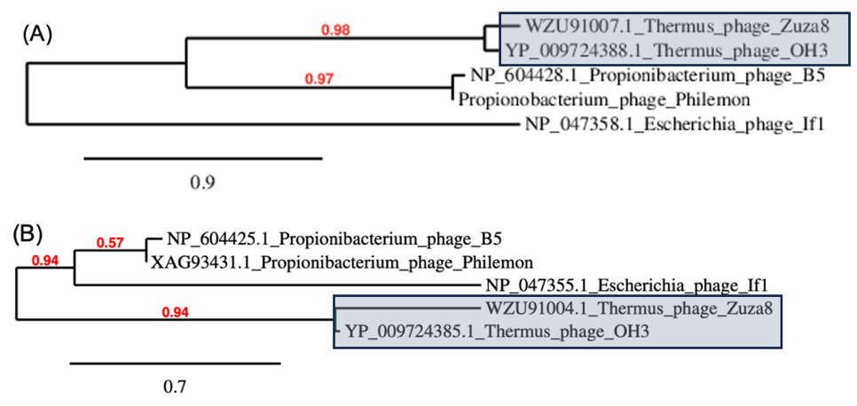
Figure 14. The phylogeny was inferred based on amino acid sequences of assembly protein (morphogenesis protein; Zot) using the Maximum Likelihood method and Jones-Taylor-Thornton (1992) model [4] of amino acid substitutions and the tree with the highest log likelihood (-61.371.22) is shown. The percentage of replicate trees in which the associated taxa clustered together (200 replicates) is shown next to the branches [5]. The initial tree for the heuristic search was selected by choosing the tree with the superior log-likelihood between a Neighbor-Joining (NJ) tree [6] and a Maximum Parsimony (MP) tree. The NJ tree was generated using a matrix of pairwise distances computed using the Jones-Taylor-Thornton (1992) model [4]. The MP tree had the shortest length among 10 MP tree searches; each performed with a randomly generated starting tree. The analytical procedure encompassed 107 amino acid sequences with 852 positions in the final dataset. Evolutionary analyses were conducted in MEGA12 [7] utilizing up to 3 parallel computing threads. In the phylogenetic tree, amino acid sequences from newly identified strains and established species and/or genera are highlighted with boxes and shown in distinct colors (as in the detailed comparative analysis). For clarity, sequences from previously known species are not individually labelled, and branches belonging to the same genus are collapsed unless they contain a newly proposed species, in which case the full branching structure is retained.
