

The International Committee on Taxonomy of Viruses

Taxonomy Proposal Form, 2024

**Part 1a: Details of taxonomy proposals**

|  |  |  |  |
| --- | --- | --- | --- |
| **Title:** | Create a new family, *Casidaviridae*, for a group of *Arthrobacter-Microbacterium* phages (Class: *Caudoviricetes*) |  | |
| **Code assigned:** | 2024.005B | |

|  |  |  |  |
| --- | --- | --- | --- |
| **Author(s), affiliation and email address(es):** | | | |
| **Name** | **Affiliation** | **Email address** | **Corresponding author(s)** X |
| Kurtböke, I | University of the Sunshine Coast, Australia | ikurtbok@usc.edu.au |  |
| Moraru C | Carl von Ossietzky Universität Oldenburg, Germany | liliana.cristina.moraru@uol.de |  |
| Tolstoy I | National Center for Biotechnology Information, MD, USA | tolstoy@ncbi.nlm.nih.gov |  |
| Kropinski AM | University of Guelph, Ontario, Canada [AMK] | Phage.Canada@gmail.com | **x** |

**Part 1b: Taxonomy Proposal Submission**

|  |  |  |  |
| --- | --- | --- | --- |
| **ICTV Subcommittee:** | | | |
| Animal DNA Viruses and Retroviruses |  | Bacterial viruses | **x** |
| Animal minus-strand and dsRNA viruses |  | Fungal and protist viruses |  |
| Animal positive-strand RNA viruses |  | Plant viruses |  |
| Archaeal viruses |  | General - |  |

|  |
| --- |
| **List the ICTV Study Group(s) that have seen or have been involved in creating this proposal:** |
| Actinophages Study group |

|  |  |  |  |
| --- | --- | --- | --- |
| **Optional – complete only if formally voted on by an ICTV Study Group:** | | | |
| **Study Group** | **Number of members** | | |
| **Votes in support** | **Votes against** | **No vote** |
|  |  |  |  |
|  |  |  |  |

|  |  |
| --- | --- |
| **Submission date:** | 20/05/2024 |

**Part 1c: Feedback from ICTV Executive Committee (EC) meeting**

|  |  |
| --- | --- |
| **Executive Committee Meeting Decision code:** | **X** |
| A – Accept |  |
| Ac – Accept subject to revision by relevant subcommittee chair. No further vote required |  |
| U – Accept without revision but with re-evaluation and email vote by the EC |  |
| Uc – Accept subject to revision and re-evaluation and email vote by the EC | **X** |
| Ud – Deferred to the next EC meeting, with an invitation to revise based on EC comments |  |
| J - Reject |  |
| W - Withdrawn |  |

|  |
| --- |
| **Comments from the Executive Committee:** |
| The genus *Manhattenvirus* is not monophyletic by core genome phylogeny and probably needs splitting. Consider revising the genus names *Honkvirus* and *Vroomvirus* |

**Part 1d: Revised Taxonomy Proposal Submission**

|  |
| --- |
| **Response of proposer:** |
| We also dislike *Honkvirus* but generally we name genera after the name given to the individual isolate. The name *Vroomvirus* was changed to *Hilgardvirus*, since “Vroom” leads to confusion with *Mycobacterium* phage Vroom. Exemplars of the genus *Manhattenvirus* are all temperate bacteriophages which The Actinobacteriophage Database has grouped into Subcluster AZ1. We have found that the 70% cutoff for membership in a genus does not work satisfactorily with temperate phages. We propose to re-examine *Manhattenvirus* in the future following the isolation of additional member species |

|  |  |
| --- | --- |
| **Revision date:** | 30/09/2024 |

**Part 3:** **TAXONOMIC PROPOSAL**

|  |
| --- |
| **Name of accompanying Excel module:** |
| 2024.005B.A.v2.Casidaviridae_nf.xlsx |

|  |  |  |  |
| --- | --- | --- | --- |
| **Taxonomic changes proposed:** | | | |
| Establish new taxon | **x** | Split taxon |  |
| Abolish taxon |  | Merge taxon |  |
| Move taxon |  | Promote taxon |  |
| Rename taxon |  | Demote taxon |  |
| Move and rename |  |  |  |

|  |  |  |
| --- | --- | --- |
| **Is any taxon name used here derived from that of a living person:** | | **N** |
| **Taxon name** | **Person from whom the name is derived** | **Attached X** |
|  |  |  |
|  |  |  |
|  |  |  |

|  |
| --- |
| **Abstract of Taxonomy Proposal:** |
| *Taxonomic rank(s) affected*:  Realm *Duplodnaviria*, kingdom *Heunggongvirae*, phylum *Uroviricota*, class *Caudoviricetes*  *Description of current taxonomy*:  At present the following taxa exist as floating genera in the order *Caudoviricetes:*  *Zetavirus, Baileybluvirus, Yangvirus, Manhattanvirus* and *Liebevirus*  *Proposed* *taxonomic change(s):*   1. To create a new genus, *Gardenstatevirus*, with two species 2. To create a new genus, *Percivalvirus*, with two species 3. To create a new single species genus *Mabodamacavirus* 4. To create a new genus, *Barnstormervirus* with two species 5. To create a new single species genus *Honkvirus* 6. To create a new single species genus *Cenunavirus* 7. To create a new species in *Baileybluvirus* 8. To create seven new species in the genus *Yangvirus* 9. To create two new species in the genus *Manhattanvirus* 10. To create a new single species genus, *Emotionvirus* 11. To create a new single species genus, *Hilgardvirus* 12. To create a new single species genus, *Swepdovirus* 13. To create one new species in the genus *Liebevirus* 14. To create a new family, *Casidaviridae*   *Justification*:  We propose the creation of a new family, *Casidaviridae*,after examination of 21 bacteriophages related to the genera *Zetavirus, Baileybluvirus, Yangvirus, Manhattanvirus* and *Liebevirus* on the basis of nucleotide sequence similarity, tblastx distances and core gene phylogeny. |

|  |
| --- |
| **Text of Taxonomy proposal:** |
| *Taxonomic rank(s) affected*: Species, Genus and Family  *Description of current taxonomy*:  Currently phages of this type are recognized in five genera: *Baileybluvirus, Liebevirus, Manhattanvirus, Yangvirus* and *Zetavirus;* largely temperate siphophages with cohesive 3’- termini infecting *Arthrobacter* and *Microbacterium* species.  *Proposed* *taxonomic change(s)*:   1. To create a new genus, *Gardenstatevirus*, with two species 2. To create a new genus, *Percivalvirus*, with two species 3. To create a new single species genus *Mabodamacavirus* 4. To create a new genus, *Barnstormervirus* with two species 5. To create a new single species genus *Honkvirus* 6. To create a new single species genus *Cenunavirus* 7. To create a new species in *Baileybluvirus* 8. To create seven new species in the genus *Yangvirus* 9. To create two new species in the genus *Manhattanvirus* 10. To create a new single species genus, *Emotionvirus* 11. To create a new single species genus, *Hilgardvirus* 12. To create a new single species genus, *Swepdovirus* 13. To create one new species in the genus *Liebevirus* 14. To create a new family, *Casidaviridae*   *Demarcation criteria:*  **Species demarcation criteria:** Two phages are assigned to the same species if their genomes are more than 95% identical over their genome length for isolates.  These values can be calculated by a number of tools, such as BLASTn [1,2] – usually calculated using intergenomic distance calculator VIRIDIC [3].  **Genus demarcation criteria:** In search for criteria that create cohesive and distinct genera that are reproducible and monophyletic, the Bacterial Viruses Subcommittee has established 70% nucleotide identity of the genome length as the cut-off for genera. Genus-level groupings should always be monophyletic in the signature genes, as tested with a phylogenetic tree. [10]  **Subfamily demarcation criteria:** Subfamilies are to be created when two or more genera are related below the family level. In practical terms, this usually means that they share a low degree of sequence similarity (usually about 40-50%) and that the genera form a clade in a marker tree phylogeny. [10]  **Family demarcation criteria:** The family is represented by a cohesive and monophyletic group in the main predicted proteome-based clustering tools (VirClust, ViPTree, GRAViTy dendrogram, vConTACT2 network). Members of the family share a significant number of orthologous genes (the number will depend on the genome sizes and number of coding sequences of members of the family). [10]  *Justification*:  We propose the creation of a new family, *Casidaviridae*,after examination of 21 bacteriophages related to the genera *Zetavirus, Baileybluvirus, Yangvirus, Manhattanvirus* and *Liebevirus* on the basis of nucleotide sequence similarity, tblastx distances and core gene phylogeny. |
|  |

|  |
| --- |
| **References:** |
| 1. Sayers EW, Beck J, Bolton EE, Bourexis D, Brister JR, Canese K, Comeau DC, Funk K, Kim S, Klimke W, Marchler-Bauer A, Landrum M, Lathrop S, Lu Z, Madden TL, O'Leary N, Phan L, Rangwala SH, Schneider VA, Skripchenko Y, Wang J, Ye J, Trawick BW, Pruitt KD, Sherry ST. Database resources of the National Center for Biotechnology Information. Nucleic Acids Res. 2021 Jan 8;49(D1):D10-D17. doi: 10.1093/nar/gkaa892. PMID: 33095870  2. O'Leary NA, Wright MW, Brister JR, Ciufo S, Haddad D, McVeigh R, et al. Reference sequence (RefSeq) database at NCBI: current status, taxonomic expansion, and functional annotation. Nucleic Acids Res. 2016;44(D1):D733-45. doi: 10.1093/nar/gkv1189. PMID: 26553804.  3. Moraru C, Varsani A, Kropinski AM. VIRIDIC-A Novel Tool to Calculate the Intergenomic Similarities of Prokaryote-Infecting Viruses. Viruses. 2020 Nov 6;12(11):1268. doi: 10.3390/v12111268. PMID: 33172115; PMCID: PMC7694805. http://kronos.icbm.uni-oldenburg.de/viridic/  4. Nishimura Y, Yoshida T, Kuronishi M, Uehara H, Ogata H, Goto S. ViPTree: the viral proteomic tree server. Bioinformatics. 2017; 33(15):2379-2380. doi:10.1093/bioinformatics/btx157. PubMed PMID: 28379287. https://www.genome.jp/viptree/  5. Rohwer F, Edwards R. The Phage Proteomic Tree: a genome-based taxonomy for phage. J Bacteriol. 2002 Aug;184(16):4529-35. PubMed PMID: 12142423  6. Turner D, Reynolds D, Seto D, Mahadevan P. CoreGenes3.5: a webserver for the determination of core genes from sets of viral and small bacterial genomes. BMC Res Notes. 2013;6:140. doi: 10.1186/1756-0500-6-140. PMID: 23566564.  7. Davis P, Seto D, Mahadevan P. CoreGenes5.0: An Updated User-Friendly Webserver for the Determination of Core Genes from Sets of Viral and Bacterial Genomes. Viruses. 2022 Nov 16;14(11):2534. doi: 10.3390/v14112534. PMID: 36423143; PMCID: PMC9693508.  8. Dereeper A, Guignon V, Blanc G, Audic S, Buffet S, Chevenet F, Dufayard JF, Guindon S, Lefort V, Lescot M, Claverie JM, Gascuel O. Phylogeny.fr: robust phylogenetic analysis for the non-specialist. Nucleic Acids Res. 2008;36(Web Server issue):W465-9. doi: 10.1093/nar/gkn180. Epub 2008 Apr 19. PMID: 18424797.  9. Anisimova M, Gascuel O. Approximate likelihood-ratio test for branches: A fast, accurate, and powerful alternative. Syst Biol. 2006;55(4):539-52. PMID: 16785212. DOI: 10.1080/10635150600755453.  10. Turner D, Kropinski AM, Adriaenssens EM. A Roadmap for Genome-Based Phage Taxonomy. Viruses. 2021 Mar 18;13(3):506. doi: 10.3390/v13030506. PMID: 33803862; PMCID: PMC8003253.  11. Bin Jang H, Bolduc B, Zablocki O, Kuhn JH, Roux S, Adriaenssens EM, Brister JR, Kropinski AM, Krupovic M, Lavigne R, Turner D, Sullivan MB. Taxonomic assignment of uncultivated prokaryotic virus genomes is enabled by gene-sharing networks. Nat Biotechnol. 2019 Jun;37(6):632-639. doi: 10.1038/s41587-019-0100-8. Epub 2019 May 6. PMID: 31061483.  12. Bolduc B, Jang HB, Doulcier G, You ZQ, Roux S, Sullivan MB. vConTACT: an iVirus tool to classify double-stranded DNA viruses that infect Archaea and Bacteria. PeerJ. 2017 May 3;5:e3243. doi: 10.7717/peerj.3243. PMID: 28480138; PMCID: PMC5419219.  13. Moraru C. VirClust-A Tool for Hierarchical Clustering, Core Protein Detection and Annotation of (Prokaryotic) Viruses. Viruses. 2023 Apr 19;15(4):1007. doi: 10.3390/v15041007. PMID: 37112988; PMCID: PMC10143988.  14. Letunic I, Bork P. Interactive Tree Of Life (iTOL): an online tool for phylogenetic tree display and annotation. Bioinformatics. 2007 Jan 1;23(1):127-8. doi: 10.1093/bioinformatics/btl529. Epub 2006 Oct 18. PMID: 17050570.  15. Zhou T, Xu K, Zhao F, Liu W, Li L, Hua Z, Zhou X. itol.toolkit accelerates working with iTOL (Interactive Tree of Life) by an automated generation of annotation files. Bioinformatics. 2023 Jun 1;39(6):btad339. doi: 10.1093/bioinformatics/btad339. PMID: 37225402; PMCID: PMC10243930.  16. Nguyen LT, Schmidt HA, von Haeseler A, and Minh BQ (2015) IQ-TREE: A fast and effective stochastic algorithm for estimating maximum likelihood phylogenies. Molecular Biology and Evolution, 32:268-274. <https://doi.org/10.1093/molbev/msu300>  17. Hoang DT, Chernomor O, von Haeseler A, Minh BQ, Vinh LS (2018) UFBoot2: Improving the ultrafast bootstrap approximation. Molecular Biology and Evolution, 35:518–522. <https://doi.org/10.1093/molbev/msx281>  18. Kalyaanamoorthy S, Minh BQ, Wong TKF, von Haeseler A, and Jermiin JS (2017) ModelFinder: Fast Model Selection for Accurate Phylogenetic Estimates, Nature Methods, 14:587–589. <https://doi.org/10.1038/nmeth.4285> |

|  |
| --- |
| **Tables, Figures:** |

Figure 1. VIRIDIC heat map of a portion of the members of this family: VIRIDIC (Virus Intergenomic Distance Calculator; VIRIDIC (Virus Intergenomic Distance Calculator; [3]; http://rhea.icbm.uni-oldenburg.de/VIRIDIC/) computes pairwise intergenomic distances/similarities amongst phage genomes. Data values which are bordered in black correspond to strains. Abbreviations: phg = phage; Arth = *Arthrobacter*; Micr = *Microbacterium*. The yellow highlighted accession numbers and phage names in Column A represent ICTV-recognized species. the complete VIRIDIC heatmap is provided as supplementary material.

Conclusions: There are several major clades, but the question raised is whether the *Armstrongvirus* group is sufficiently closely related to the *Yangvirus* group to be considered in the same family.

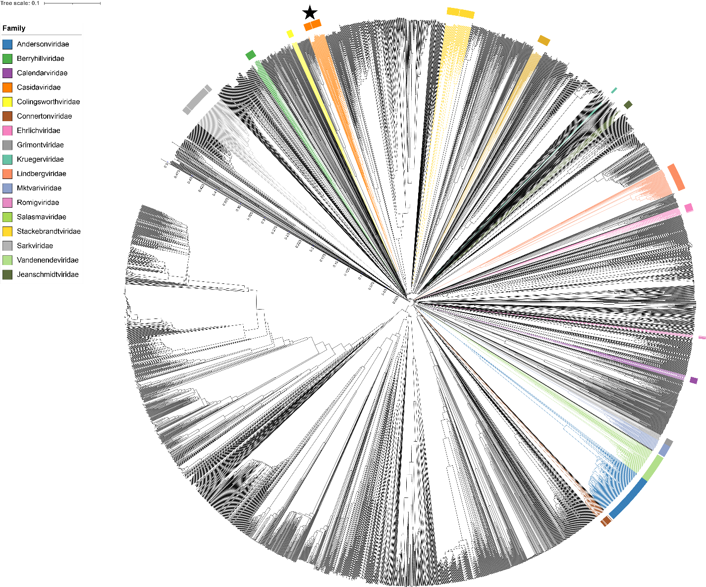

Figure 2. ViPTree [4] analysis Proteomic tree of 4,408 bacterial viruses with proposed viral families labeled by the coloured ring. The *Casidaviridae* are marked with a star symbol. The hierarchical tree was created using ViPTreeGen (version 1.1.2) [4] and annotated using iToL [15-16]. The tree is based on a dissimilarity matrix generated by pairwise tBLASTx scores between each of the genomes.

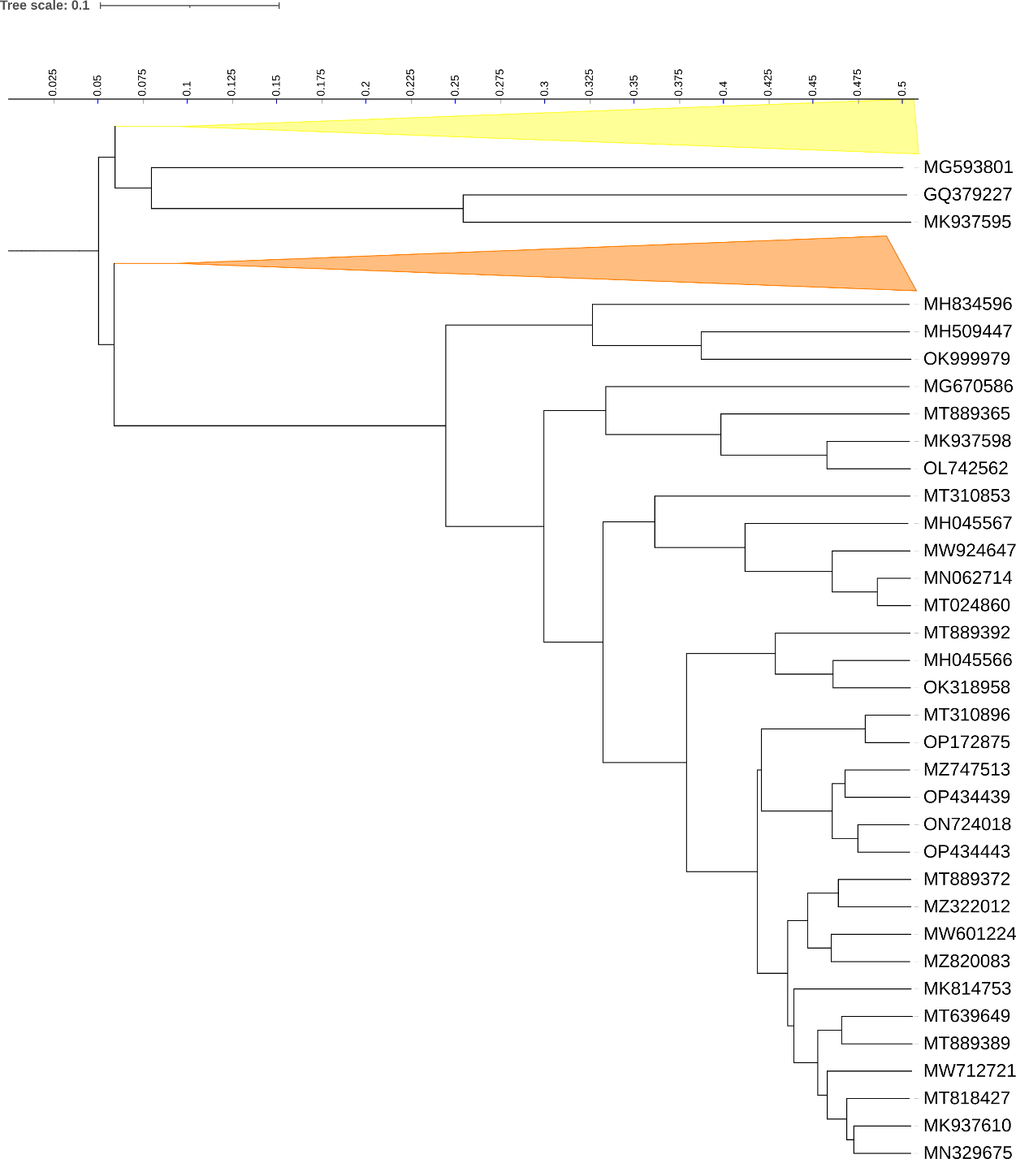

Figure 3. ViPTree [4] hierarchical tree pruned to show the proposed *Colingsworthviridae* alonside neighbouring clades. The proposed families *Colingsworthviridae* (yellow) and *Casidaviridae* (orange) are shown as collapsed clades.



Figure 4. VirClust protein heatmap of the *Yangvirus* group: at the first level, proteins are grouped based on their reciprocal BLASTP similarities into protein clusters, or PCs. At the second level, PCs are grouped based on their Hidden Markov Model (HMM) similarities into protein superclusters, or PSCs. AT the third, still experimental level, PSCs are grouped based on their HMM similarities into protein super-superclusters, or PSSC [13].

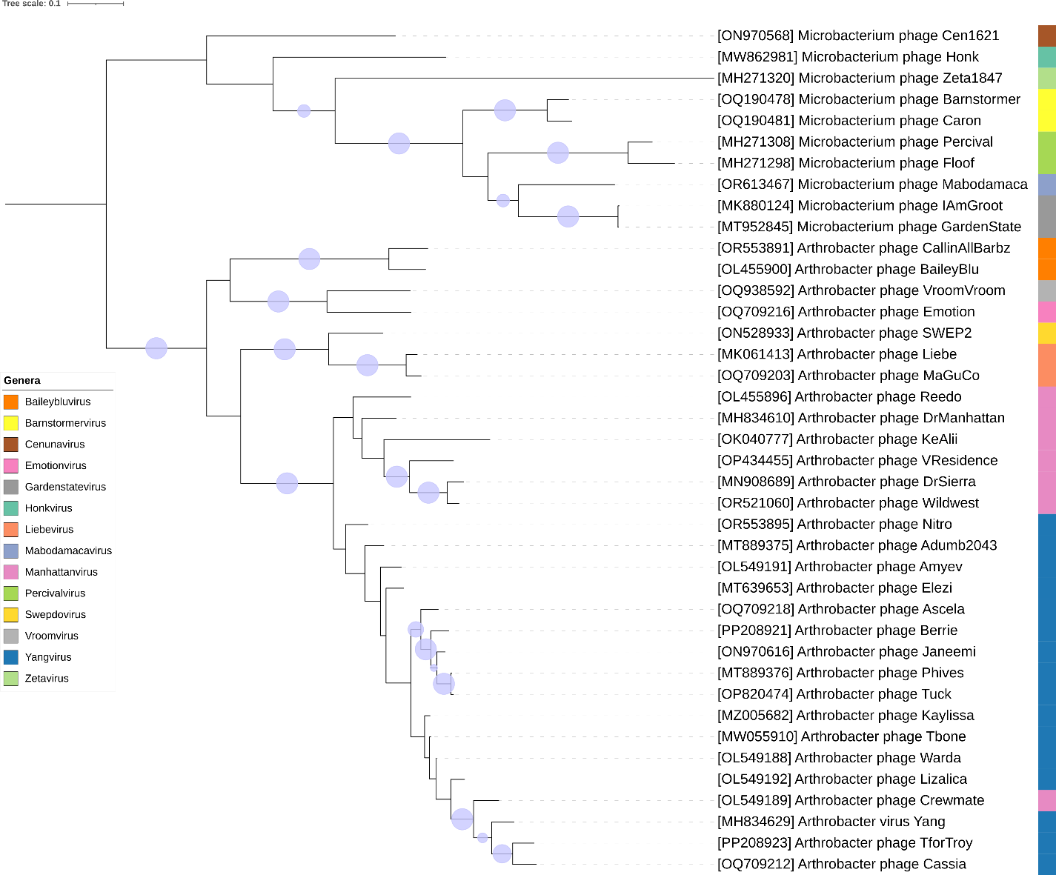

Figure 5. Core genome phylogeny of the proposed *Casidaviridae* family of bacterial viruses. A partitioned protein ML phylogeny was created from 6 genes present in all species of the proposed family. Alignments were performed using MAFFT in e-insi mode and trimmed using trimAl with a gap threshold of 0.5. The tree was calculated using IQ-Tree2 with 1000 ultrafast (UF) bootstrap replicates and SH-Alrt tests with -m TEST to optimise models for each alignment. The tree is rooted at the midpoint and UF bootstrap support ≥ 95% are shown. The coloured strips indicate proposed genera and subfamilies.

Table 1. Signature genes in the proposed *Casidaviridae* family of bacterial viruses. Genes were identified by clustering with MMSeqs2, with thresholds of 35% sequence similarity and 50% coverage.

|  |  |  |  |
| --- | --- | --- | --- |
| **protein cluster** | **No. of genomes (14 total)** | **Percentage of genomes present in protein cluster** | **Predicted gene function** |
| 1 | 40 | 100% | exonuclease |
| 2 | 40 | 100% | deoxynucleoside monophosphate kinase |
| 3 | 40 | 100% | LAGLIDADG endonuclease |
| 4 | 40 | 100% | hypothetical protein |
| 5 | 40 | 100% | recombination directionality factor |
| 6 | 40 | 100% | DNA polymerase |
| 7 | 39 | 97.50% | DNA primase |
| 8 | 39 | 97.50% | Holliday junction resolvase |
| 9 | 39 | 97.50% | hypothetical protein |

**Proposals Data:**

1. **To create a new genus, *Gardenstatevirus*, with two species**
2. **To create a new genus, *Percivalvirus*, with two species**
3. **To create a new single species genus *Mabodamacavirus***
4. **To** **create a new genus, *Barnstormervirus* with two species**
5. **To** **create a new single species genus *Honkvirus***
6. **To create a new single species genus *Cenunavirus***
7. **To** **create a new species in *Baileybluvirus***
8. **To create seven new species in the genus *Yangvirus***
9. **To create two new species in the genus *Manhattanvirus***
10. **To create a new single species genus, *Emotionvirus***
11. **To create a new single species genus, *Hilgardvirus***
12. **To create a new single species genus, *Swepdovirus***
13. **To** **create one new species in the genus *Liebevirus***
14. **To** **create a new family, *Casidaviridae***

**Taxonomic Proposals:**

1. **To create a new genus, *Gardenstatevirus*, with two species**

**Origin of the name of this taxon:** This taxon was named after a virus of its type *Microbacterium* phage GardenState

**Historical aspects:** *Microbacterium* siphophage GardenState was isolated from soil from New Jersey by Paulina Onisko using *Microbacterium* sp. ISAT203as the host at James Madison University, Cranford, NJ. It is temperate and was isolated as part of the Science Education Alliance-Phage Hunters Advancing Genomics and Evolutionary Science program. Phage GardenState is a member of the EH cluster as defined by The Actinobacteriophage Database and possesses 11 nt 3' Sticky Overhangs (CGGGGAGGCAT).

**Genomic characterization:**

|  |  |  |  |  |  |  |
| --- | --- | --- | --- | --- | --- | --- |
| Phage name | INSDC | Size (kb) | %GC | Protein | Overall % DNA sequence identity (*) | Overall % homologous proteins (**) |
| *Microbacterium* phage GardenState | MT952845.1 | 45.4 | 70.0 | 76 | 100 | 100 |
| *Microbacterium* phage IAmGroot | MK880124.2 | 45.6 | 70.0 | 75 | 93.8 | 96.0 |
|  |  |  |  |  |  |  |

**(*) determined using VIRIDIC [3]**

**(**) determined using CoreGenes 3.5 [6]**

**Electron micrograph:** N/A

1. **To create a new genus, *Percivalvirus*, with two species**

**Origin of the name of this taxon:** This taxon was named after a virus of its type *Microbacterium* phage Percival

**Historical aspects:** *Microbacterium* siphophage Percival was isolated from soil from Cabot, PA USA by Johnathon Schiebel (University of Pittsburgh) using *Microbacterium foliorum* NRRL B-24224as the host at James Madison University, Cranford, NJ. It is temperate and was isolated as part of the Phage Hunters Integrating Research and Education program. Phage Percival is a member of the EH cluster as defined by The Actinobacteriophage Database and possesses 11 nt 3' Sticky Overhangs (CGGGGAGGCAT).

**Genomic characterization:**

|  |  |  |  |  |  |  |
| --- | --- | --- | --- | --- | --- | --- |
| Phage name | INSDC | Size (kb) | %G+C | Protein | Overall % DNA sequence identity (*) | Overall % homologous proteins (**) |
| *Microbacterium* phage Percival | MH271308.1 | 47.4 | 69.6 | 74 | 100 | 100 |
| *Microbacterium* phage Floof | MH271298.1 | 48.5 | 69.0 | 80 | 69.1 | 81.1 |
|  |  |  |  |  |  |  |

**(*) determined using VIRIDIC [3]**

**(**) determined using CoreGenes 3.5 [6]**



**Electron micrograph:** Electron micrographs of negatively stained *Microbacterium* phage Percival (<https://phagesdb.org/phages/Percival/>). Limited permission was granted by The Actinobacteriophages Database (<https://phagesdb.org/>), funded by the Howard Hughes Medical Institute, to use this electron micrograph for this taxonomy proposal; it cannot be reused without permission of The Actinobacteriophages Database.

1. **To create a new single species genus *Mabodamacavirus***

**Origin of the name of this taxon:** This taxon was named after the first virus of its type *Microbacterium* phage Mabodamaca

**Historical aspects:** *Microbacterium* phage Mabodamaca was isolated from soil by Edwin Vazquez (University of Puerto Rico at Cayey) using *Microbacterium foliorum* NRRL B-24224 as the host. It is temperate and was isolated as part of the Science Education Alliance-Phage Hunters Advancing Genomics and Evolutionary Science program. Phage Mabodamaca is a member of the EH cluster as defined by The Actinobacteriophage Database and possesses 11 nt 3' Sticky Overhangs (CGGGGAGGCAT).

**Genomic characterization:**

|  |  |  |  |  |  |  |
| --- | --- | --- | --- | --- | --- | --- |
| Phage name | INSDC | Size (kb) | %G+C | Protein | Overall % DNA sequence identity (*) | Overall % homologous proteins (**) |
| *Microbacterium* phage Mabodamaca | OR613467.1 | 49.0 | 69.8 | 73 | 100 | 100 |

**Electron micrograph:** N/A

1. **To create a new genus, *Barnstormervirus* with two species**

**Origin of the name of this taxon:** This taxon was named after the first virus of its type *Microbacterium* phage Barnstormer

**Historical aspects:** *Microbacterium* phage Barnstormer was isolated from soil from Edinburg , VA, by Timothy Joseph Edelman using *Microbacterium* sp. ISAT203as the host at James Madison University. It is temperate and was isolated as part of the Science Education Alliance-Phage Hunters Advancing Genomics and Evolutionary Science program. Phage Barnstormer is a member of the EH cluster as defined by The Actinobacteriophage Database and possesses 11 nt 3' Sticky Overhangs (CGGGGAGGCAT).

**Genomic characterization:**

|  |  |  |  |  |  |  |
| --- | --- | --- | --- | --- | --- | --- |
| Phage name | INSDC | Size (kb) | %G+C | Protein | Overall % DNA sequence identity (*) | Overall % homologous proteins (**) |
| *Microbacterium* phage Barnstormer | OQ190478.1 | 46.9 | 69.5 | 77 | 100 | 100 |
| *Microbacterium* phage Caron | OQ190481.1 | 47.7 | 70.1 | 80 | 80.5 | 87.0 |
|  |  |  |  |  |  |  |

**(*) determined using VIRIDIC [3]**

**(**) determined using CoreGenes 3.5 [6]**

**Electron micrograph:** N/A

1. **To create a new single species genus *Honkvirus***

**Origin of the name of this taxon:** This taxon was named after the first virus of its type *Microbacterium* phage Honk

**Historical aspects:** *Microbacterium* phage Honk was isolated from soil from New Jersey by Megan Ulbrich using *Microbacterium foliorum* NRRL B-24224 as the host at University of Pittsburgh. It is temperate and was isolated as part of the Science Education Alliance-Phage Hunters Advancing Genomics and Evolutionary Science program. Phage Honk is a member of the EH cluster as defined by The Actinobacteriophage Database and possesses 11 nt 3' Sticky Overhangs (CGAAGCGGCAT).

**Genomic characterization:**

|  |  |  |  |  |  |  |
| --- | --- | --- | --- | --- | --- | --- |
| Phage name | INSDC | Size (kb) | %G+C | Protein | Overall % DNA sequence identity (*) | Overall % homologous proteins (**) |
| *Microbacterium* phage Honk | MW862981.1 | 50.2 | 70.3 | 82 | 100 | 100 |

**Electron micrograph:** N/A

1. **To create a new single species genus *Cenunavirus***

**Origin of the name of this taxon:** This taxon was named after the first virus of its type *Microbacterium* phage Cen1621

**Historical aspects:** *Microbacterium* phage Cen1621 was isolated from soil by Ketsy M. Torres-Arroyo using *Microbacterium foliorum* NRRL B-24224 as the host at the University of Puerto Rico at Cayey. It is temperate and was isolated as part of the Science Education Alliance-Phage Hunters Advancing Genomics and Evolutionary Science program. Phage Cen1621 is a member of the EH cluster as defined by The Actinobacteriophage Database and possesses 11 nt 3' Sticky Overhangs (CGAGGCGGCAT).

**Genomic characterization:**

|  |  |  |  |  |  |  |
| --- | --- | --- | --- | --- | --- | --- |
| Phage name | INSDC | Size (kb) | %G+C | Protein | Overall % DNA sequence identity (*) | Overall % homologous proteins (**) |
| *Microbacterium* phage Cen1621 | ON970568.1 | 49.4 | 70.7 | 75 | 100 | 100 |

**Electron micrograph:** N/A

1. **To create a new species in *Baileybluvirus***

**Origin of the name of this taxon:** N/A

**Historical aspects:** The genus *Baileybluevirus* was established through Taxonomy Proposal 2022.011B.Baileybluevirus_ng

**Genomic characterization:**

|  |  |  |  |  |  |
| --- | --- | --- | --- | --- | --- |
| Phage name | INSDC | Size (kb) | Protein | Overall % DNA sequence identity (*) | Overall % homologous proteins (**) |
| *Arthrobacter* phage BaileyBlu | OL455900.1 | 40.4 | 61 | 100 | 100 |
| *Arthrobacter* phage CallinAllBarbz | OR553891.1 | 41.2 | 62 | 78.8 | 91.8 |

**(*) determined using VIRIDIC [3]**

**(**) determined using CoreGenes 3.5 [6]**

**Electron micrograph:** N/A

1. **To create seven new species in the genus *Yangvirus***

**Origin of the name of this taxon:** N/A

**Historical aspects:** The genus *Yangvirus* was created through Taxonomy Proposal 2019.093B

**Genomic characterization:**

|  |  |  |  |  |  |
| --- | --- | --- | --- | --- | --- |
| Phage name | INSDC | Size (kb) | Protein | Overall % DNA sequence identity (*) | Overall % homologous proteins (**) |
| *Arthrobacter* phage Yang | MH834629.1 | 43.2 | 68 | 100 | 100 |
| *Arthrobacter* phage Janeemi | ON970616.1 | 43.9 | 69 | 69.8 | 79.4 |
| *Arthrobacter* phage Tuck | OP820474.1 | 44.0 | 69 | 67.9 | 82.3 |
| *Arthrobacter* phage Berrie | PP208921.1 | 43.8 | 69 | 70.6 | 77.9 |
| *Arthrobacter* phage Ascela | OQ709218.1 | 44.2 | 71 | 73.9 | 83.8 |
| *Arthrobacter* phage Cassia | OQ709212.1 | 44.3 | 69 | 83.0 | 88.2 |
| *Arthrobacter* phage TforTroy | PP208923.1 | 43.7 | 69 | 82.4 | 86.8 |
| *Arthrobacter* phage Nitro | OR553895.1 | 44.4 | 70 | 71.6 | 86.8 |

**(*) determined using VIRIDIC [3]**

**(**) determined using CoreGenes 3.5 [6]**

**Electron micrograph:** N/A

1. **To create two new species in the genus *Manhattanvirus***

**Origin of the name of this taxon:** N/A

**Historical aspects:** The genus *Manhattanvirus* was created through Taxonomy Proposal 2022.010B.Azeevirinae_nsf. These are temperate phages belonging to

**Genomic characterization:**

|  |  |  |  |  |  |
| --- | --- | --- | --- | --- | --- |
| Phage name | INSDC | Size (kb) | Protein | Overall % DNA sequence identity (*) | Overall % homologous proteins (**) |
| *Arthrobacter* phage DrManhattan | MH834610.1 | 42.6 | 72 | 100 | 100 |
| *Arthrobacter* phage VResidence | OP434455.1 | 42.2 | 70 | 63.8 | 77.8 |
| *Arthrobacter* phage Wildwest | OR521060.1 | 43.7 | 65 | 66.4 | 77.8 |
|  |  |  |  |  |  |

**(*) determined using VIRIDIC [3]**

**(**) determined using CoreGenes 3.5 [6]**

**Electron micrograph:** N/A

1. **To create a new single species genus, *Emotionvirus***

**Origin of the name of this taxon:** This taxon was named after the first virus of its type *Arthrobacter* phage Emotion

**Historical aspects:** *Microbacterium* phage Emotion was isolated from soil from Lakewood, CA USA by Dominic Garza and Michelle Zorawik using *Arthrobacter sulfureus* ATCC 19098as the host at University of California, Los Angeles. It is temperate and was isolated as part of the Science Education Alliance-Phage Hunters Advancing Genomics and Evolutionary Science program. Phage Emotion is a member of the AZ cluster/AZ4 subcluster as defined by The Actinobacteriophage Database and possesses 11 nt 3' Sticky Overhangs (CGAAGCGGCAT). While it lacks an integrase all other members of the AZ Cluster have one.

**Genomic characterization:**

|  |  |  |  |  |  |
| --- | --- | --- | --- | --- | --- |
| Phage name | INSDC | Size (kb) | Protein | Overall % DNA sequence identity (*) | Overall % homologous proteins (**) |
| *Arthrobacter* phage Emotion | OQ709216.1 | 45.1 | 73 | 100 | 100 |

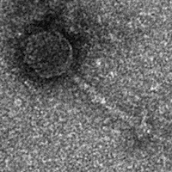

**Electron micrograph:** Electron micrographs of negatively stained *Arthrobacter phage Emotion* (<https://phagesdb.org/phages/Emotion/>). Limited permission was granted by The Actinobacteriophages Database (<https://phagesdb.org/>), funded by the Howard Hughes Medical Institute, to use this electron micrograph for this taxonomy proposal; it cannot be reused without permission of The Actinobacteriophages Database.

1. **To create a new single species genus, *Hilgardvirus***

**Origin of the name of this taxon:** This taxon was named after the ring road (Hilgard Ave) around the UCLA campus where the first virus of its type *Arthrobacter* phage VroomVroom was isolated

**Historical aspects:** *Arthrobacter phage VroomVroom* was isolated from soil from Los Angeles, CA US by Dominic Garza using *Arthrobacter sulfureus* ATCC 19098as the host at the University of California, Los Angeles. It is temperate and was isolated as part of the Science Education Alliance-Phage Hunters Advancing Genomics and Evolutionary Science program. Phage VroomVroom is a member of the AZ Cluster/Subcluster AZ4 as defined by The Actinobacteriophage Database and possesses 11 nt 3' Sticky Overhangs (CGAACTGGCAT). Unlike the majority of Cluster AZ members, VroomVroom does not have an identifiable integrase gene.

**Genomic characterization:**

|  |  |  |  |  |  |  |
| --- | --- | --- | --- | --- | --- | --- |
| Phage name | INSDC | Size (kb) | %G+C | Protein | Overall % DNA sequence identity (*) | Overall % homologous proteins (**) |
| *Arthrobacter* phage VroomVroom | OQ938592.1 | 43.2 | 66.9 | 66 | 100 | 100 |

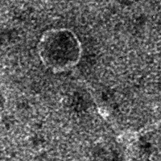

**Electron micrograph:** Electron micrographs of negatively stained *Arthrobacter* phage VroomVroom (<https://phagesdb.org/phages/VroomVroom/>). Limited permission was granted by The Actinobacteriophages Database (<https://phagesdb.org/>), funded by the Howard Hughes Medical Institute, to use this electron micrograph for this taxonomy proposal; it cannot be reused without permission of The Actinobacteriophages Database.

**L. To create a new single species genus, *Swepdovirus***

**Origin of the name of this taxon:** This taxon was named after the first virus of its type *Arthrobacter* phage SWEP2

**Historical aspects:** *Arthrobacter* phage SWEP2 was isolated from soil from New Jersey by C. Ruan (College of Land Science and Technology, China Agricultural University,

Beijing, China) using A*rthrobacter* sp. 5Bas the host.

**Genomic characterization:**

|  |  |  |  |  |  |
| --- | --- | --- | --- | --- | --- |
| Phage name | INSDC | Size (kb) | Protein | Overall % DNA sequence identity (*) | Overall % homologous proteins (**) |
| *Arthrobacter* phage SWEP2 | ON528933.2 | 43.4 | 64 | 100 | 100 |

**Electron micrograph:** N/A

1. **To create one new species in the genus *Liebevirus***

**Origin of the name of this taxon:** N/A.

**Historical aspects:** The genus *Liebevirus* was created through Taxonomy Proposal 2019.093B

**Genomic characterization:**

|  |  |  |  |  |  |
| --- | --- | --- | --- | --- | --- |
| Phage name | INSDC | Size (kb) | Protein | Overall % DNA sequence identity (*) | Overall % homologous proteins (**) |
| Arthrobacter phage Liebe | MK061413.1 | 45.8 | 69 | 100 | 100 |
| *Arthrobacter* phage MaGuCo | OQ709203.1 | 43.9 | 63 | 87.1 | 84.1 |
|  |  |  |  |  |  |

**(*) determined using VIRIDIC [3]**

**(**) determined using CoreGenes 3.5 [6]**

**Electron micrograph:** N/A

1. **To create a new family, *Casidaviridae***

**Origin of the name of this taxon:** This taxon is named in honour of American industrial microbiologist Lester E. Casida Jr. (b. 1928, Columbia, Mo.; d. 2017, State College, PA). “Earl received B.S., M.S., and Ph.D. degrees in Bacteriology from the University of Wisconsin. He was a Research Scientist for Pabst Laboratories, Abbott Laboratories, and Pfizer. At Pfizer, he developed and patented the first commercial fermentation for the production of the amino acid, L-lysine. Subsequently, he was a Professor of Microbiology at the Pennsylvania State University for 36 years. He taught and did research in the fields of Industrial Microbiology and Microbial Ecology, and wrote a textbook on Industrial Microbiology that is still widely used today.”

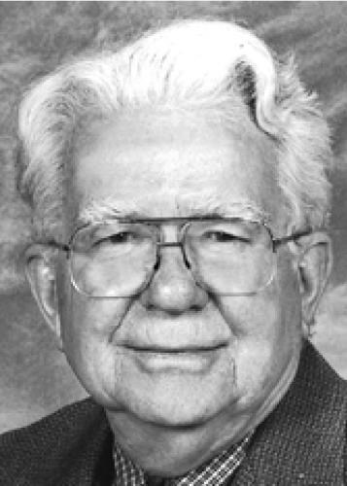

**(Photo copied from** [**https://www.legacy.com/us/obituaries/centredaily/name/lester-casida-obituary?id=7756461**](https://www.legacy.com/us/obituaries/centredaily/name/lester-casida-obituary?id=7756461)**)**

**Rationale:** This group of temperate phages together with the genus *Zetavirus*, share ≥7.9% DNA sequence similarity and 6 homologous proteins and therefore fulfil the criteria which we have established for recognizing a new family.