

The International Committee on Taxonomy of Viruses

Taxonomy Proposal Form, 2024

**Part 1a: Details of taxonomy proposals**

|  |  |  |
| --- | --- | --- |
| **Title:** | Create *Emaravirus clematis* as a new species in the genus *Emaravirus,* family *Fimoviridae* | |
| **Code assigned:** | 2024.001P.A.v1.Fimoviridae_1nsp |

|  |  |  |  |
| --- | --- | --- | --- |
| **Author(s), affiliation and email address(es):** | | | |
| **Name** | **Affiliation** | **Email address** | **Corresponding author(s)** X |
| **Yang C** | Liaoning Key Lab. of Urban Integrated Pest Management and Ecological Security, Shenyang University, Dadong, Shenyang, Liaoning 110044, China] | xueyang27@126.com |  |
| **An W** | Liaoning Key Lab. of Urban Integrated Pest Management and Ecological Security, Shenyang University, Dadong, Shenyang, Liaoning 110044, China] | [1690141602@qq.com](mailto:1690141602@qq.com) |  |
| **Li C** | Liaoning Key Lab. of Urban Integrated Pest Management and Ecological Security, Shenyang University, Dadong, Shenyang, Liaoning 110044, China] | 784154979@qq.com |  |
| **Zhang S** | Guangxi Citrus Breeding and Cultivation Technology Innovation Center, Guangxi Academy of Specialty Crops, Guilin 541004, China | [qq371260@email.swu.edu.cn](mailto:qq371260@email.swu.edu.cn) |  |
| **Cao M** | National Citrus Engineering and Technology Research Center, Citrus Research Institute, Southwest University, Beibei, Chongqing 400712, China | caomengji@cric.cn |  |
| **Digiaro M** | CIHEAM, Istituto Agronomico Mediterraneo of Bari, Via Ceglie 9, 70010 Valenzano (BA), Italy | digiaro@iamb.it | X |
| **Elbeaino T** | CIHEAM, Istituto Agronomico Mediterraneo of Bari, Via Ceglie 9, 70010 Valenzano (BA), Italy | elbeaino@iamb.it |  |
| **Kubota K** | Institute for Plant Protection, NARO 2-1-18, Kannondai, Tsukuba, Ibaraki 305-8666, Japan | kubotak@affrc.go.jp |  |
| **Ochoa Corona FM** | Oklahoma State University, Institute for Biosecurity & Microbial Forensics, 127 NRC Stillwater, OK 74078 | ochoaco@okstate.edu |  |
| **von Bargen S** | Humboldt-Universität zu Berlin, Unter den Linden 6, 10099 Berlin, Germany | susanne.von.bargen@agrar.hu-berlin.de |  |

**Part 1b: Taxonomy Proposal Submission**

|  |  |  |  |
| --- | --- | --- | --- |
| **ICTV Subcommittee:** | | | |
| Animal DNA Viruses and Retroviruses |  | Bacterial viruses |  |
| Animal minus-strand and dsRNA viruses |  | Fungal and protist viruses |  |
| Animal positive-strand RNA viruses |  | Plant viruses | **X** |
| Archaeal viruses |  | General - |  |

|  |
| --- |
| **List the ICTV Study Group(s) that have seen or have been involved in creating this proposal:** |
| *Fimoviridae* Study Group |

|  |  |  |  |
| --- | --- | --- | --- |
| **Optional – complete only if formally voted on by an ICTV Study Group:** | | | |
| **Study Group** | **Number of members** | | |
| **Votes in support** | **Votes against** | **No vote** |
|  |  |  |  |
|  |  |  |  |

|  |  |
| --- | --- |
| **Submission date:** | 30/04/2024 |

**Part 1c: Feedback from ICTV Executive Committee (EC) meeting**

|  |  |
| --- | --- |
| **Executive Committee Meeting Decision code:** | **X** |
| A – Accept |  |
| Ac – Accept subject to revision by relevant subcommittee chair. No further vote required | **X** |
| U – Accept without revision but with re-evaluation and email vote by the EC |  |
| Uc – Accept subject to revision and re-evaluation and email vote by the EC |  |
| Ud – Deferred to the next EC meeting, with an invitation to revise based on EC comments |  |
| J - Reject |  |
| W - Withdrawn |  |

|  |
| --- |
| **Comments from the Executive Committee:** |
| E-mail addresses should be provided for all authors. |

**Part 1d: Revised Taxonomy Proposal Submission**

|  |
| --- |
| **Response of proposer:** |
|  |

|  |  |
| --- | --- |
| **Revision date:** | 16/09/2024 |

**Part 3:** **TAXONOMIC PROPOSAL**

|  |
| --- |
| **Name of accompanying Excel module:** |
| 2024.001P.A.v1.Fimoviridae_1nsp.xlsx |

|  |  |  |  |
| --- | --- | --- | --- |
| **Taxonomic changes proposed:** | | | |
| Establish new taxon | **X** | Split taxon |  |
| Abolish taxon |  | Merge taxon |  |
| Move taxon |  | Promote taxon |  |
| Rename taxon |  | Demote taxon |  |
| Move and rename |  |

|  |  |  |
| --- | --- | --- |
| **Is any taxon name used here derived from that of a living person:** | | **N** |
| **Taxon name** | **Person from whom the name is derived** | **Attached X** |
|  |  |  |
|  |  |  |
|  |  |  |

|  |
| --- |
| **Abstract of Taxonomy Proposal:** |
| The creation of the new species *Emaravirus clematis* in the genus *Emaravirus*, family *Fimoviridae,* is proposed to accommodate Clematis yellow mottle-associated virus (CYMaV), identified in China on *Clematis brevicaudata* DC, as its exemplar virus isolate. The new species consists of five segmented, linear, single-stranded (ss), negative-sense RNA genomes (of which two RNA3s encode the nucleocapsid protein), fully sequenced, which show features common to homologous RNAs of other known emaravirus species, but from which it differs significantly in nucleotide and amino acid sequences. |

|  |
| --- |
| * **Text of Taxonomy proposal:** |
| Clematis yellow mottle-associated virus (CYMaV) has been recently identified in *Clematis brevicaudata* (Queen of Climbing) in China and its genome has been completely sequenced (Yang *et al*., 2024). CYMaV possesses all molecular and biological features to be considered as a new member of the genus *Emaravirus*, which currently comprises the following viruses: Actinidia chlorotic ringspot-associated virus (AcCRaV), Actinidia virus 2 (AcV2), Arceuthobium sichuanense-associated virus 1 (ArSaV1), ash shoestring-associated virus (AsaV), aspen mosaic-associated virus (AsMaV), blackberry leaf mottle-associated virus (BLMaV), Camellia japonica-associated virus 1 (CjaV1), Camellia japonica-associated virus 2 (CjaV2), chrysanthemum mosaic-associated virus (ChMaV), common oak ringspot virus (CORaV), European mountain ash ringspot-associated virus (EMARaV), fig mosaic virus (FMV), High Plains wheat mosaic virus (HPWMoV), Japanese star anise ringspot-associated virus (JSARaV), jujube yellow mottle-associated virus (JYMaV), lilac chlorotic ringspot-associated virus (LiCRaV), maple mottle-associated virus (MaMaV), karaka Õkahu purepure virus (KOPV), palo verde broom virus (PVBV), pear chlorotic leaf spot-associated virus (PCLSaV), Perilla mosaic virus (PerMV), pigeonpea sterility mosaic virus 1 (PPSMV1), pigeonpea sterility mosaic virus 2 (PPSMV2), Pistacia virus B (PiVB), raspberry leaf blotch virus (RLBV), redbud yellow ringspot-associated virus (RYRSaV), rose rosette virus (RRV), ti ringspot-associated virus (TiRSaV), and Vitis emaravirus (VEV) (Digiaro *et al.,* 2024; Elbeaino *et al*., 2018; Mielke and Muehlbach 2007; <https://ictv.global/report/chapter/fimoviridae/fimoviridae>). The RNA-dependent RNA polymerase (RdRp), glycoprotein precursor (GP), nucleocapsid (NP), and p4 (MP) proteins show different levels of sequence identity with ortholog proteins of other emaraviruses.  **Virus properties**   1. Genome: resembles that of members of the genus *Emaravirus.* It is composed of five segments of negative-sense, ssRNA. RNA-1: 6,591 nt, RNA-2: 1,982 nt, RNA3a: 1301 nt, RNA-3b: 1,397 nt, and RNA-4: 1,192 nt (Figure 1) (in order from RNA-1 to RNA-4, accession numbers are: OP807964– OP807968) (Yang *et al*., 2024). Each monocistronic segment encodes a single protein translated from the complementary strand (Figure 1). Untranslated regions (UTRs) at the 3’ and 5’ termini of all RNA segments extended from 17 to 87 nt and 88 to 454 nt, respectively. 2. Virus-encoded proteins: RNA-dependent RNA-polymerase (RdRp) (p1): 252,8 kDa; putative glycoprotein precursor (GP) (p2): 68.6 kDa; putative nucleocapsid protein (NP) (p3a and p3b): 32.3 and 32.2 kDa, respectively; putative movement protein (MP) (p4): 33.7 kDa (Figure 1). 3. Phylogenetic relationships: RdRp, GP, NC, and MP proteins of CYMaV consistently segregated with those of Karaka Õkahu purepure virus (KOPV) and formed a cluster (group III) with the emaraviruses chrysanthemum mosaic-associated virus, Callicarpa mosaic-associated virus1, and pear chlorotic leaf spot-associated virus (Figure 2). The highest aa identities of the CYMaV proteins were with those of KOPV, i.e., 60.2% for p1, 44.4% for p2, 46.9% for p3, and 61.1% for p4. 4. Transmission: No observations and specific trials were carried out. 5. Natural host range: *Clematis brevicaudata* DC. 6. Particle morphology: Transmission electron microscopy observation of negatively stained samples from *C. brevicaudata* revealed spherical virus-like particles (VLPs) approximately 100 nm in diameter.   The detected identities fulfilling the demarcation criteria for species in the genus [aa sequence of relevant gene products of RNA1 (RdRp), RNA2 (GP), RNA3 (NP), and RNA4 (MP) differing by more than 20%], and the genome organization typical of emaraviruses clearly indicate that CYMaV represents a new species in the genus *Emaravirus*. Therefore, the creation of the new viral species *Emaravirus clematis* within the genus *Emaravirus*, which contains CYMaV isolate DWTXL as the exemplar isolate, is proposed. |

|  |
| --- |
| **References:** |
| Digiaro M, Elbeaino T., Kubota K, Ochoa FM, von Bargen S (2024) ICTV Virus Taxonomy Profile: *Fimoviridae* 2023, *J Gen Virol* (in press)  Elbeaino T, Digiaro M, Mielke-Ehret N, Muehlbach HP, Martelli GP and ICTV Report Consortium (2018) ICTV Virus Taxonomy Profile: *Fimoviridae*. *J Gen Virol* 99(11):1478-1479. PMID: 30204080, DOI: [10.1099/jgv.0.001143](https://doi.org/10.1099/jgv.0.001143)  Mielke N, Muehlbach HP (2007) A novel, multipartite, negative-strand RNA virus is associated with the ringspot disease of European mountain ash (*Sorbus aucuparia* L.). *J Gen Virol* 88:1337–1346. PMID: 17374780. DOI 10.1099/vir.0.82715-0  Yang C, An W, Li C, Zhang S, Cao M (2024) Detection and characterization of a putative emaravirus infecting *Clematis brevicaudata* DC. in China. *Arch Virol* 169:10 [DOI: 10.1007/s00705-023-05945-w](https://doi.org/10.1007/s00705-023-05945-w)  <https://ictv.global/report/chapter/fimoviridae/fimoviridae> |

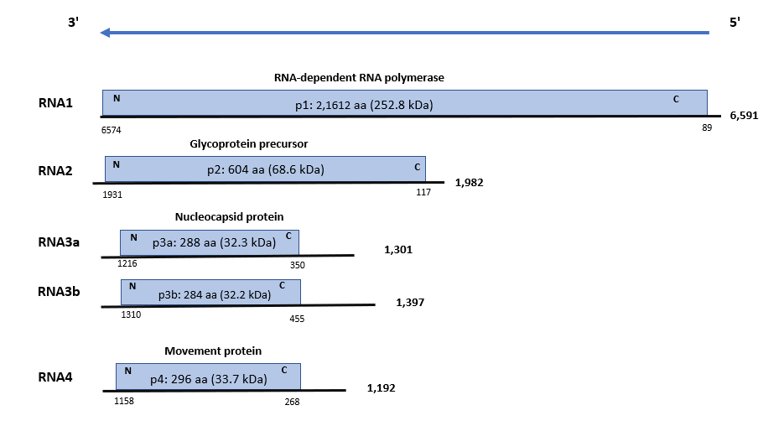

**Figure 1.** Genome organization of Clematis yellow mottle-associated virus (CYMaV). Colored boxes represent the protein-encoding region (ORF) for each RNA. The length of RNAs, the putative protein product for each ORF, function (if known), and estimated molecular mass are provided. The genomic RNAs are not drawn to scale.

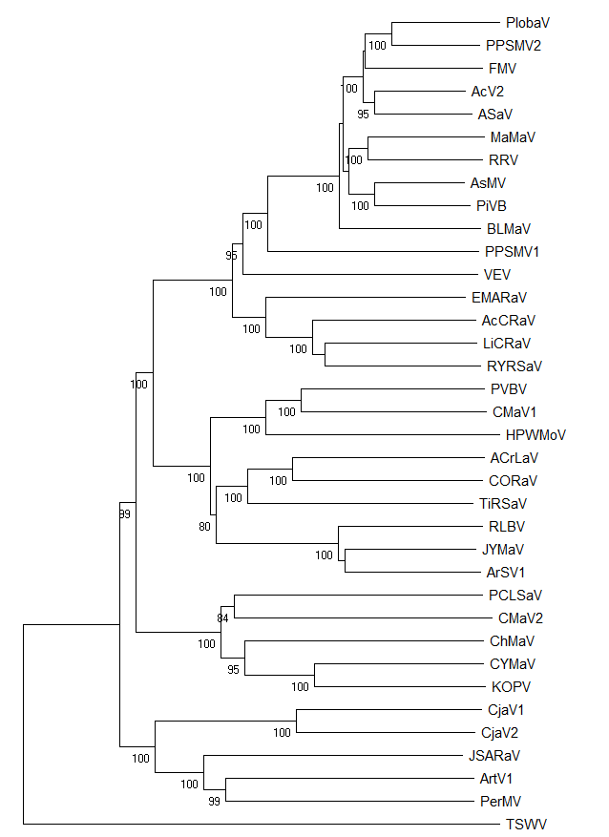

**I**

**II**

**III**

**IV**



**Figure 2. A** phylogenetic tree is constructed with amino acid sequences encoded by RNA1 (RdRp) of recognized emaraviruses and corresponding tentative species (indicated by a red square). Alignment was obtained using ClustalW and analyzed using the Neighbor-Joining method, with 1000 bootstrap replicates. The percentage of replicate trees where the associated taxa clustered together in the bootstrap is shown next to the branches (when >80%). Tomato spotted wilt virus (TSWV, AIY28466), an orthotospovirus of the family *Tospoviridae*, was used as an outgroup species. Actinidia chlorotic ringspot-associated virus (AcCRaV, YP_009507925), Actinidia virus 2 (AcV2, YP_010088071), ailanthus crinkle leaf-associated virus (ACrLaV, WCL16047), Arceuthobium sichuanense virus 1 (ArSV1, YP_010840857), Artemisia virus 1 (ArtV1, USL90372), ash shoestring-associated virus (ASaV, CAG9003603), aspen mosaic-associated virus (AsMaV, YP_010840587 ), blackberry leaf mottle associated virus (BLMaV, YP_010839677), Callicarpa mosaic-associated virus 1 (CMaV1, WGG93561), Callicarpa mosaic-associated virus 2 (CMaV2, WGG93565), Camellia japonica-associated virus 1 (CjaV1, YP_010840109), Camellia japonica-associated virus 2 (CjaV2, YP_010840122), chrysanthemum mosaic-associated virus (ChMaV, YP_010840376), **Clematis yellow mottle-associated virus (CYMaV, WIM36821)** (indicated by a blue star), common oak ringspot-associated virus (CORaV, YP_010840591), European mountain ash ringspot-associated virus (EMARaV, YP_003104764), fig mosaic virus (FMV, YP_009237269 ), High Plains wheat mosaic virus (HPWMoV, YP_009237277), Japanese star anise ringspot-associated virus (JSARaV, YP_010840873), jujube yellow mottle-associated virus (JYMaV, YP_010840071), karaka Õkahu purepure emaravirus (KOPV, YP_010840842), lilac chlorotic ringspot-associated virus (LiCRaV, YP_010840135), maple mottle-associated virus (MaMaV, YP_010840395), palo verde broom virus (PVBV, YP_010840059), pear chlorotic leaf spot-associated virus (PCLSaV, YP_010840088), Perilla mosaic virus (PerMV, YP_010840051), pigeonpea sterility mosaic virus 1 (PPSMV1, YP_009237282), pigeonpea sterility mosaic virus 2 (PPSMV2, YP_009268863), Pistacia virus B (PiVB, YP_010839662), Pueraria lobata-associated virus (PlobaV, UQV97405), raspberry leaf blotch virus (RLBV, YP_009237274 ), redbud yellow ringspot-associated virus (RYRSaV, YP_009508083), rose rosette virus (RRV, YP_004327589), ti ringspot-associated virus (TiRSaV, YP_010088065), and Vitis emaravirus (VEV, LC604727).