Setting CouchDB Development Environment

1. Download and install **couchapp-1.0.0-win.zip** from here <https://github.com/couchapp/couchapp/downloads>

Unzip and run the executable.

To deploy (push) the changes open cmd from YOU_COCONUT_REPOSITORY\app folder and run the command:

**couchapp push dev**

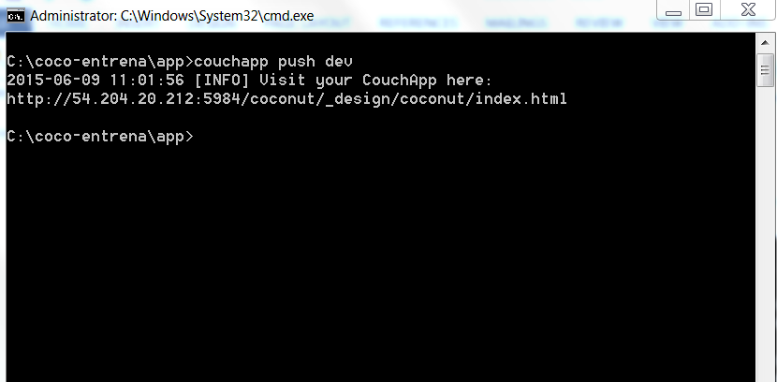

**Note:** to push code to prod type “couchapp push prod”.

1. Install coffescript transpalier to compile coffescript to javascript.

Install nodejs from <https://nodejs.org/>.

Run “npm install -g coffee-script” from the command prompt. This will install coffeescript transpiler.

From Intellij I have the following setup for coffeescript plugin: