Tramon
  - An exploration of this Iavan town

History
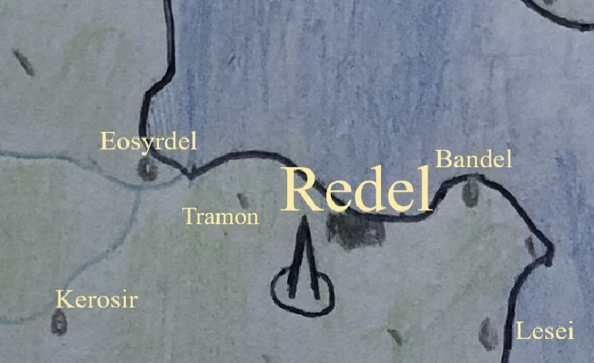
Tramon was founded around -6000 as a tavern on the road from Redel and Eosyrdel, although at this time both Tramon and Redel went by different names. These town’s modern names came about during the 1700s, with Tramon’s name being a sudden change, perhaps named after a notable, and Redel’s name changing more slowly in the eye of the public as the Spire became a prominent feature of the city’s atmosphere. Before these name changes, Redel was known as Miavthdel, and Tramon was known as Seiveakutle. It’s probably a good thing that these old-fashioned names have been left in the past.
Not much is known about the tavern due to how old it is, but in the town’s tales, the family became wealthy enough to invest in other forms of industry, creating Tramon’s artisan centre. The first documents of the town come about during the Dolom Republic, where the first remaining documents of the town were written. The modern town retains two dolomite buildings that were likely built during the Dolom Republic’s dolomite construction boom.
Of course, during the end of the Dolomite republic in the 1700s the appearance of the Spire occurred, and simultaneously it seems the town of Seiveakutle became known as Tramon, or Tramonten as the documents refer to it as for the next 200 years. After this period, the Dolom republic fell, making way for the old-fashioned feudal nations that propagated from their birthplace in Terlaye. Documentation of their townsmen isn’t the main goal of those feudal societies, but it is known that Tramon experienced stagnant growth in its population over this time, as when population censuses were took again during the Eresonian Empire in the 2200s, the population had only grown by hundreds.
As with most cities and towns under the Eresonian Empire, growth was plenty, especially for towns on Lake Daini. Although Tramon isn’t on the lake, Redel and Eosyrdel certainly were, and both of those towns experienced massive booms in population and maritime industry, as the Eresonian empire gobbled up the iconic Barogateli lake. The Empire also brought a great revolution in the way cities were built, and the centre of Tramon was reconstructed by eager new guilds. After this initial boom in expansion and production, the town of Tramon joint the rest of Ereso in a more slow and gradual growth. Organised living spaces were built during this time, although part-by-part these types of living spaces were still planned as a whole by the Eresonian Empire.
The Civil War of the Eresonian Empire in 2461 hit like a hammer against the rock structures of Ereso. Existing close to the imperial core of Mouvasir, Tramon, and the entirety of the Iavan Coast was in the hands of the Constitutionals. Traimon suffered levels of destruction usual for towns of its size during this time, but most notably is the location of the Battle for Tramon, where a naval invasion led by one of the Empire’s most prized generals landed and was intercepted by an army garrisoned at Redel, before it could make way to occupy Tramon. The battle lasted 24 days.
Tramon would receive relative rest for the next three centuries, apart from the frequent drafting that the crumbling Eresonian Empire’s army required from its citizens. The Dictatorship of the Dead hadn’t much effect on Tramon either: all of the superconduit’s attacks were targeted further southeast, hitting Lesei the worst. Out of fear, the dead of Tramon were cremated, unearthing the graves of thousands of decomposing bodies. The next majour event wouldn’t touch Tramon’s trade and tranquility either, as the Constitutional Purge by the Absolute Emperor of Ereso, Toreza Sasket.
During the times of the Second Eresonian Empire and the Reign of the Pri-Conners

