Background
Every life started somehow, and people are defined by their experiences. Your character, too, is a life, and is also defined by their experiences. Wastelife the Tabletop Roleplaying Game is set in the setting of Wastelife, and you can be very creative with your backstory.
This section exists to guide the player into making a backstory that blends well with the world of Wastelife. In general, when you make your character you think of their backstory. Backstory changes a few aspects of your character such as what languages they know.

Regions
Wastelife TTTRPG is set on the twin continents of Barogate and Anula, both of which consist of regions. Regions have a native species or subspecies, which speaks a certain language that if you were in that region for long enough, your character will know. Below is a reference map for all the regions, followed by descriptions and languages.
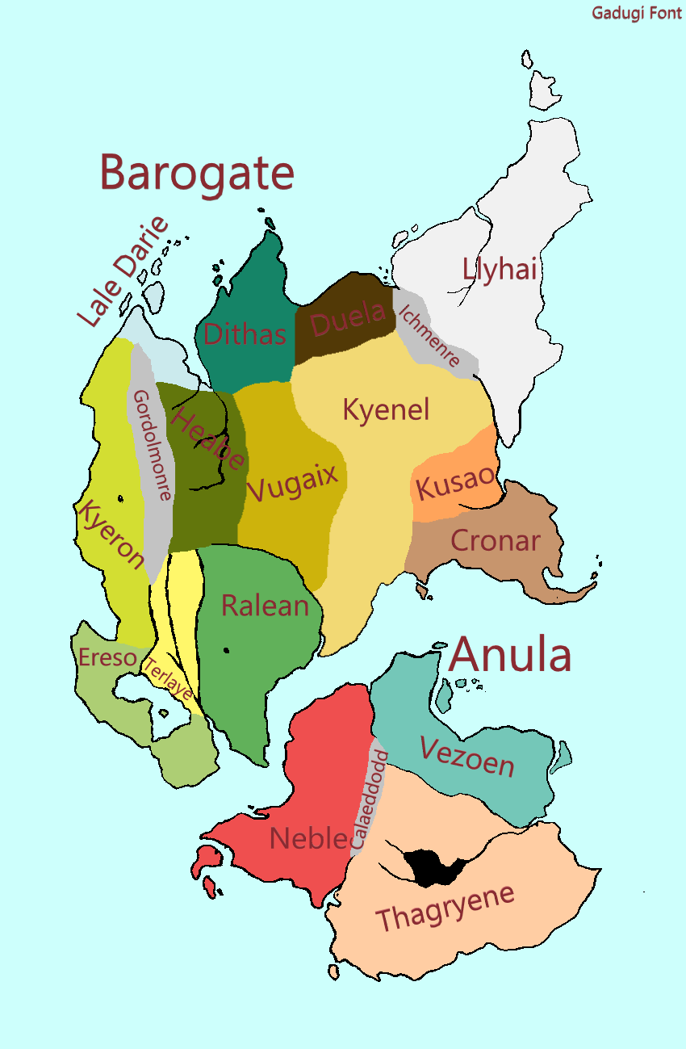

Ereso
Ereso is the land of the Kaemuz. Ereso is a very geographically diverse region, with hilly plains across most of the land with hills on the mid-western coast and mountains on the north-western coast. Its shape is defined by the lake Daini. It also has a sub-region in the South, the odd peninsula of Vania, with a mountain range stretching across it diagonally from northeast to south west. Vania is its own nation, with the nation controlling the rest of Ereso being called Eresonia. Ereso’s language is Eresonian.

Terlaye
Terlaye is the land of the Danmuz. It is a warm place full of rivers and hills which guide those rivers to the great city of Nater’s End. Terlaye doesn’t have much geographical distinction between parts of it. Terlaye’s language is Danmuzan, and because it has been conquered by the Empire of Ralean, it also has the language Empiric.

Ralean
Ralean is the land of the Lemuz. It has three distinct geographic regions. The north is hilly, almost mountainous in many parts. The centre is full of rivers that flow from the mountains into the sea and the south is dominated by a forest. Northern Ralean and much of central Ralean are controlled by the Empire of Ralean, while the south is in revolt and host to several new and often extreme natiosn. Ralean’s language is Empiric.

Kyeron
Kyeron is the land of the Ximuz, and is a rainforest. It gets steep closer to the Gordolmonre region. It is controlled by a nation consisting of several clans, which often fight between each other. Kyeron is notable for being the only place to follow a religion. Kyeron’s language is Prophetic.

Lale Darie
Properly Gazi Lale Darie, this region is the land of the Domuz. It has three subregions: Gazi, Lale, and Darie. Gazi is a collection of small islands in the northmost areas, Lale are the four largest islands closer to the mainland, and Darie is the huge stretch of mainland. It is controlled by the Republic of Domuz, which also manages several colonies in other regions. Lale Darie’s language is Seaspeak and Daran. Daran is more commonly spoken in Lale.

Cronar
Cronar is the land of the Korongan. It is a large tract of semi-arid land where water seeps in from the coast. It is the last of the “living regions”, often only distinguished by not being the Wastes. Cronar is controlled by a myriad of Korongan warlords. Its language is Ataken.

The Heabe
The Heabe is the land of the Ens. It is a steppe conquering the lands east of Gordolmonre, where the rivers flow eastwards after rain gets stuck in the mountains. A great and wide river dominates the land. Several temporary Ens settlements exist here as well as the Muz towns of Hegrel, the Cosbon Complex, and Camp Hess. It is divided among the Aredvic Riders, who are chariot-faring nomads. The language of the Ens is Garas, the language of the Aredvics and the two latter towns is Aredvic Shaiou, and the language of Hegrel is Hegrel Shaiou.

Dithas
Dithas is the land of the Dimad, although many Domuz also live in the region. It is a mushroom forest with many normal trees scattered around, although many of their bark is covered in fungi. The Dimad here speak Common Vuga, while the most common Domuz language is Daran..

Vugaix
Vugaix is a fully-blown mushroom forest with many gaps in some places called an “oasis”, where the sun reaches the floor. It is home to several communities of Mad, each of which has their own type of Vuga language. Also in the region is the city of Nasarch, centred around the only area in the region where the underground rock comes close enough to the surface to be mined. It is a huge iron mine, and often considered the capitol of the Wastes. Its language is Nasarch Shaiou.

Kyenel
Kyenel is a desert. There’s a few ancient silver structures here, maybe a Phax or two. A couple Difmuz roam the place, each have their own spin on the Shaiou language.

Kusao
Kusao is the land of the Phax. It is a region of canyons, with the little water there is accessible via wells. The Phax are an often overlooked civilised folk, with a central government. They can speak using their Krykis language, and they have a completely separate written language called Anaylethen.

Duela
Duela is a swamp land inhabited by the rare Fall. Their language is Fallet. A good few Difmuz also live in this region, who all speak the same Duela Shaiou.

Llyhai
Llyhai is a gigantic Ashland made in the wake of Hidoiad. It is the most dangerous land possibly anywhere. Still, a couple Difmuz have managed to settle while albeit being constantly attacked. There’s even a Domuz colony. Each Difmuz speaks their own version of Shaiou.

Neble
Neble is the land of the Nebdos, but also land to the Ews. It has five major factions on its soil, so is therefore quite a complex region. There is the Empire of Plains in the north, the Western Neble Imperium, Codia, Carehope, and the Grand City of Brwrd. Each of which you would have to ask someone to know any more about. The unique language in Neble is Barhkent, a language spoken by the Codews. All Dos speak Caukee.

Vezoen
Vezoen is the land of the Nidos. It is a flat and forested land in the east, and a rough land in the west. The west is often called Roughwalk. Both sides have their own nations, and Roughwalk speaks their own language of the same name, Roughwalk.

Thagryene
Thagryene is the land of the Nudos and the Akiiogan, in a unique arrangement. It is a flat or hilly land, depending on where you are, and the south-western coast speaks Resbayan.

