Modelling dengue vaccination strategies in Singapore

Introduction:
We use a dengue transmission model which explicitly incorporates age of human population, serotypes of dengue virus, and number of infections to study the long-term disease dynamics in Singapore. The model divides the whole population into several classes, called compartments, based on different factors like health statuses, infecting serotypes, number of infections, vaccination status, etc. and keeps track of the number of individuals in each of the compartments over time (see Figure 1 for simplified representation of compartments). Since dengue is a vector-borne disease, we also explicitly incorporate the adult mosquito population into the model (not shown in Figure 1).

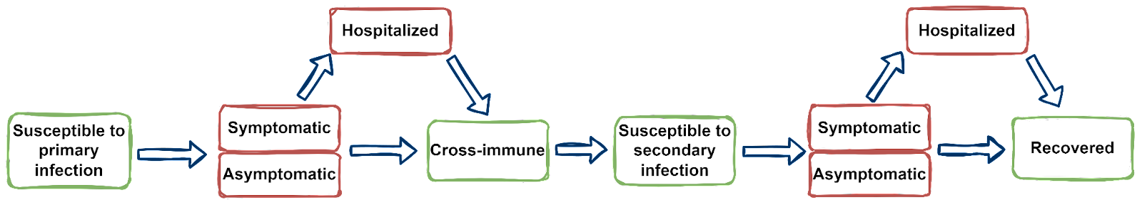
Figure 1: The simplified flowchart of the model showing the disease progression over time through different compartments. Vector compartments are not shown here.
Human demography:
Studies (Cummings et al., 2009; Wagner et al., 2020; Huang et al., 2022; Colón-González et al., 2023) showed that human demography plays an important role in dengue disease dynamics, and since we are interested in studying the long-term impact of vaccination, we consider human demography into the model. We consider the population from 0 years to 90+ years with an age bracket of 1 year. We use the historical demography related information like birth rate, age-specific mortality rate from (Singapore Population, 2024). Additionally, for future projection , we will use the population trend from (World Population Prospects, no date).

Pre-exposure history:
Based on the rarity of third and fourth infections (Endy et al., 2007), we make the assumption that individuals acquired complete protection from dengue infection after secondary infection (Cummings et al., 2005; Recker et al., 2009). Since the seroprevalence data contains no information on pre-exposure history, we have reconstructed the age-specific number of exposures using catalytic model (Muench, 1959; Quan et al., 2018) under certain assumptions (see Figure 2, using the data from sero-survey done in 2013 in Singapore). We see a significant change in the number of pre-exposures in the age group of around 40 years and older (see Figure 2, blue curve).
We also see that the force-of-infection (foi) shows a decreasing trend (see Figure 3). The model estimate of current foi is approximately 1%.
We are currently updating this to serotype specific immunity, using modelling and serotype specific serological data (Low et al., 2015).
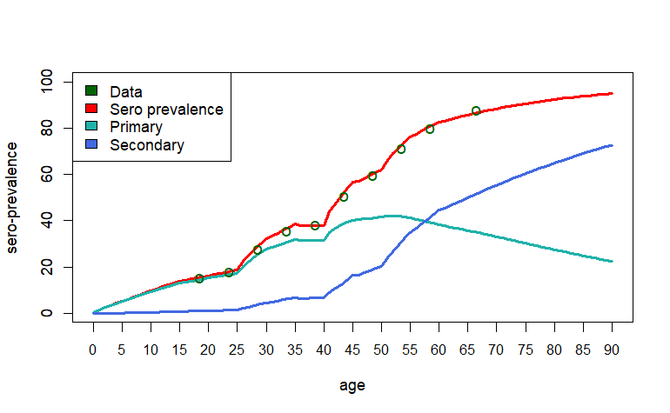
Figure 2: Age-specific infection history estimated from sero-survey done in 2013 in Singapore. Here “Data” refers to the fraction of people with at least one exposure, “Primary” (from modelling) refers to fraction of people with only one exposure, and “secondary” (from modelling) refers to fraction of people with two or more exposures in a particular age.

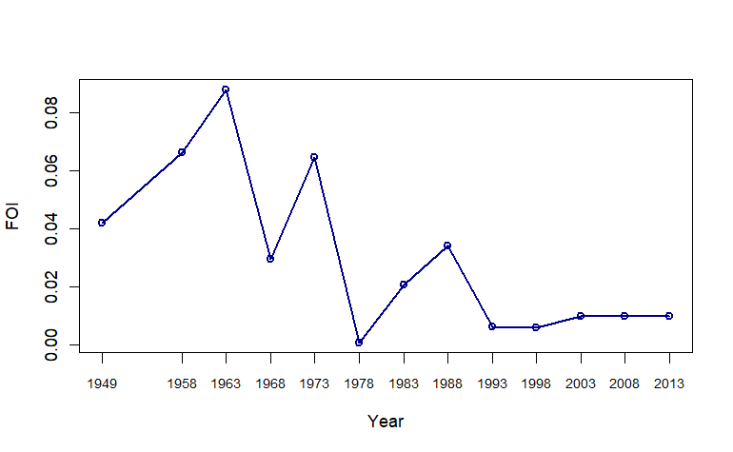
Figure 3: Time evolution of force-of-infection (foi), shows a decreasing trend over time.

Disease transmission
Here we explicitly model human-mosquito-human cycle of transmission. As dengue infection can result in a range of severity of disease (Ten Bosch et al., 2018), we consider asymptomatic, symptomatic, and severe outcomes (DHF, DSS) of the disease. With further breakdown possible for the cost effectiveness modelling, and as data becomes available. We consider antibody-dependent-enhancement (ADE) in disease severity as increased rate of hospitalization for secondary infection. We assume that after primary infection individuals acquire permanent homologous immunity, and temporary heterologous immunity. For both Primary and secondary infection, a certain proportion of infections would require hospitalization. The information on rate of hospitalization has been taken from (Ang et al., 2019). We follow a similar trend in hospitalization rate in our model.

For human to mosquito transmission, we assume both symptomatic and asymptomatic individual can transmit the disease where the infectiousness of asymptomatic individuals is higher than that of symptomatic individuals (Duong et al., 2015). However, we will perform sensitivity analysis on this assumption as some of the previous studies (Ferguson et al., 2016) have assumed the completely opposite scenario, i.e. symptomatic individuals are more infectious than asymptomatic individuals.

Estimation of model parameter
We are currently working on the estimation of the unknown model parameters, for example age-specific symptomatic infection rate, and disease transmission rate, etc. using a Bayesian inference framework. For this we are using age-specific reported dengue cases data from 2001 – 2020 (see Figure 3), and the data of relative contribution of four serotypes in reported dengue cases from the year 1994 to 2022 (see Figure 4).
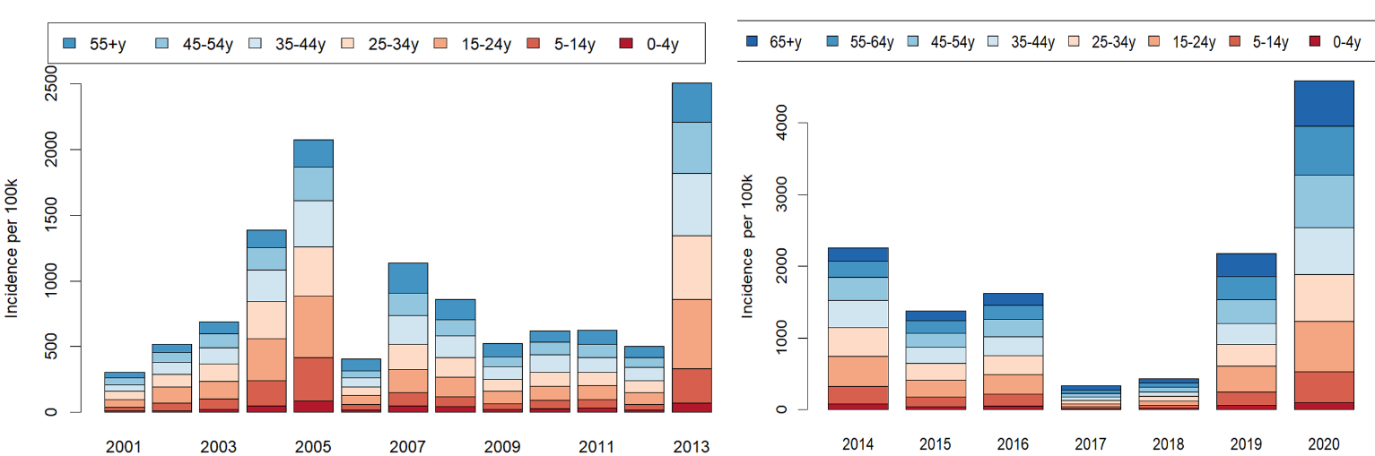
Figure 3: Age specific reported dengue incidence per 100k population in Singapore from 2001 to 2020.
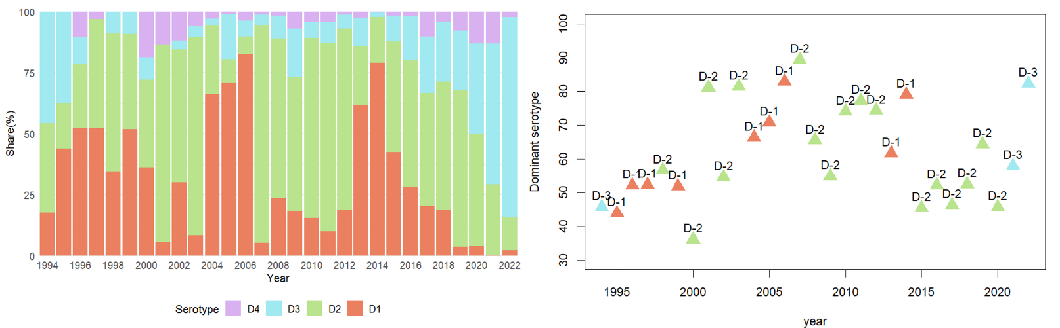
Figure 4: Contribution of four serotypes in reported dengue cases in Singapore since 1994 and the corresponding dominant serotype in each year. DENV-II seems to be the most dominating one, DENV-I, reemerges almost every 4-5 years, and remains dominating for the next 2-3 years. In recent times, the dominance of DENV-III has been observed.

Model schematic with vaccination
The vaccination is introduced to both sero-negative (Susceptible), and sero-positive (Cross-immune, one previous dengue exposure, and more than one previous dengue exposure) individuals. The flow of different compartments of the model in the presence of vaccination has been visualized in Figure 6.

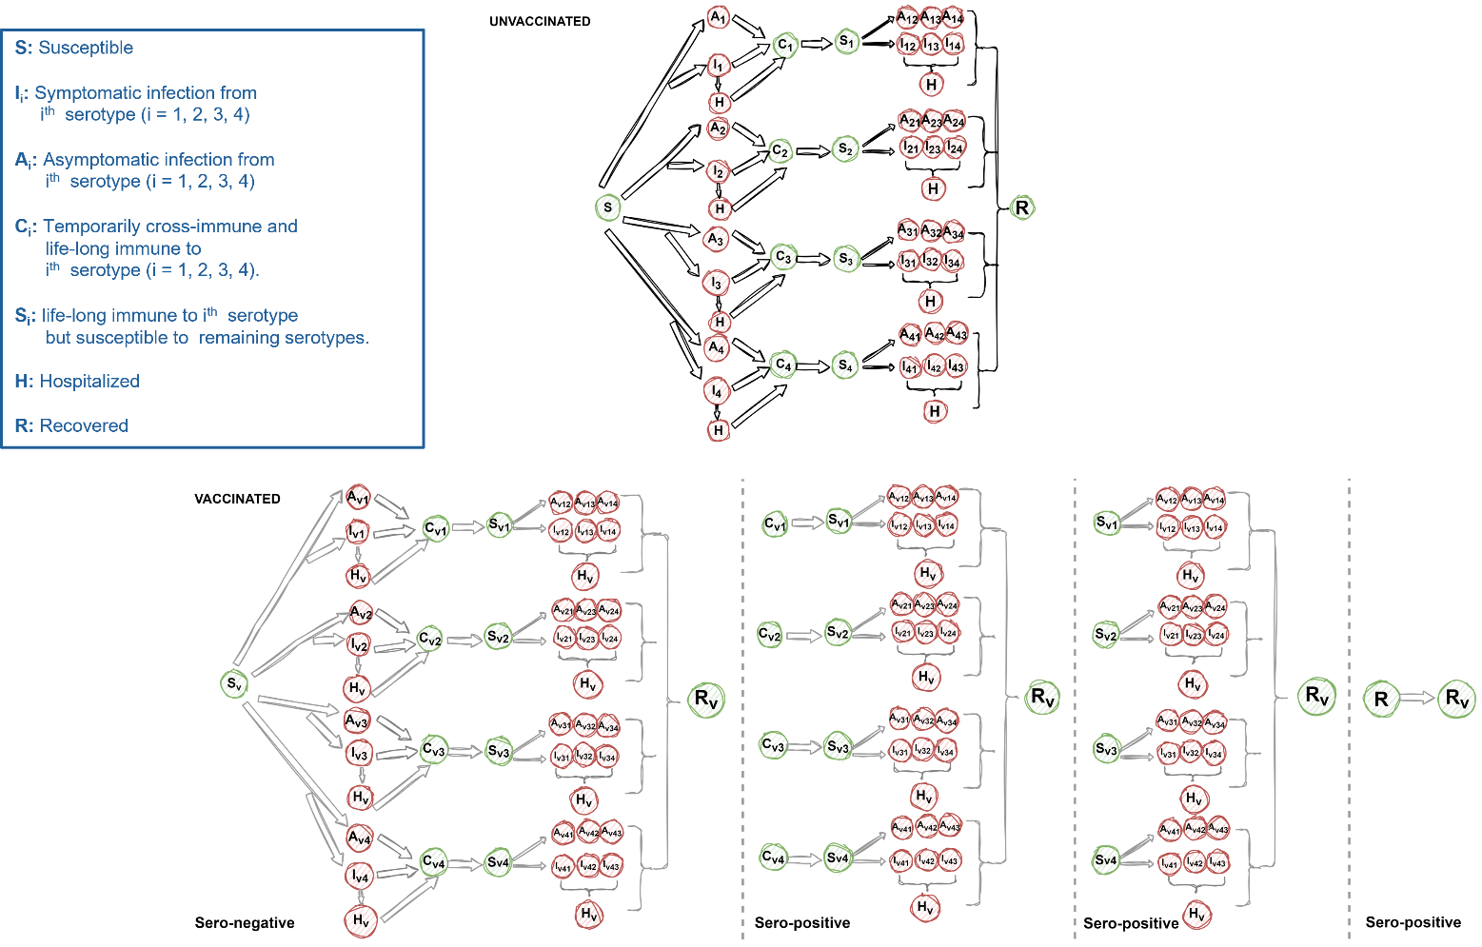
Figure 4: Model schematic with vaccination.

List of parameters:
We summarize the description of the parameters used in the model below:

Parameters | Description | Value | Source | Remarks
$$Λ^{h}$$ | Human birth rate | Around 7.9 per 1000 residents in 2022 | (Singapore Population, 2024) | Over the time the birth rate showed a decreasing trend
$$μ$$ | Human mortality rate | Age-specific values | (Singapore Population, 2024)
$$ρ_{1}$$ | Proportion of symptomatic primary infection | Age specific |  | Need to estimate from age-stratified case notification data.
$$ρ_{2}$$ | Proportion of symptomatic secondary infection | Age specific |  | Need to estimate from age-stratified case notification data
$$ξ_{1}$$ | Proportion of symptomatic primary infection require hospitalization | 0.30 | (Ang et al., 2019) | During 2003 – 2005, the rate was more than 88%. However, over time it has been reduced. In 2017, it became, 35.9%.
$$ξ_{2}$$ | Proportion of symptomatic secondary infection require hospitalization |  |  | Need to make some assumption based on the fact the secondary infection is more severe than primary infection
$$χ$$ | Relative infectiousness of asymptomatic compared to symptomatic | 2 | (Duong et al., 2015) | We will run sensitivity analysis to see the impact of this assumption
$$\frac{1}{γ}$$ | Infectious period of human | 4 days | (Murgue et al., 2000)
$$\frac{1}{α}$$ | Duration of heterologous protection from infection n | 1 year | (Anderson et al., 2014) | To be varied in sensitivity analysis
$$b$$ | Mosquito biting rate | Will be parametrized from the estimate of FOI
$$β^{m}$$ | Per bite probability of transmission from infected mosquito to human | Will be parametrized from the estimate of FOI
$$β^{h}$$ | Per bite probability of transmission from infected human  to mosquito | Will be parametrized from the estimate of FOI
$$\frac{1}{σ_{m}}$$ | Mean extrinsic incubation period | 10 days | (Whitmire et al., 1987; Salazar et al., 2007)
$$Λ^{m}$$ | Recruitment rate of mosquito | Adjusted according to total human population
$$μ^{m}$$ | Adult mosquito mortality rate | 0.1 per day |  | Need to consider the current mosquito control effort in Singapore

Vaccination:
With this baseline model, we will then incorporate vaccination scenarios. We will explore the effectiveness of three main vaccines: (i) Dengvaxia, (ii) Qdenga, and (iii) Butantan-DV (Phase-3 trial is on-going). Below are the parameters we are currently using for the vaccines: Dengvaxia and Qdenga, but we will consider the vaccine Butanatan-DV in a similar fashion, once the trial data is available.
We incorporate the impact of vaccination into the model through 3 vaccine efficacy related parameters:
- Efficacy against infection
- Efficacy against symptomatic infection, and
- Efficacy against hospitalization.
Below we summarize the vaccine efficacy for both the vaccines.

Dengvaxia
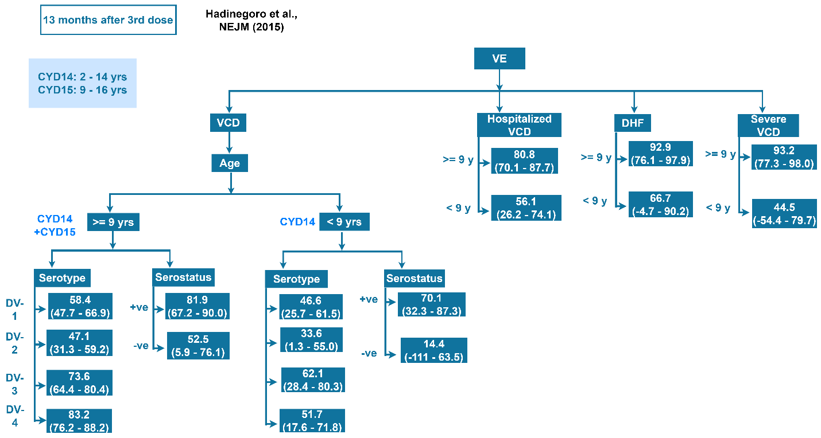
Figure 5: Vaccine efficacy of Dengvaxia

Qdenga
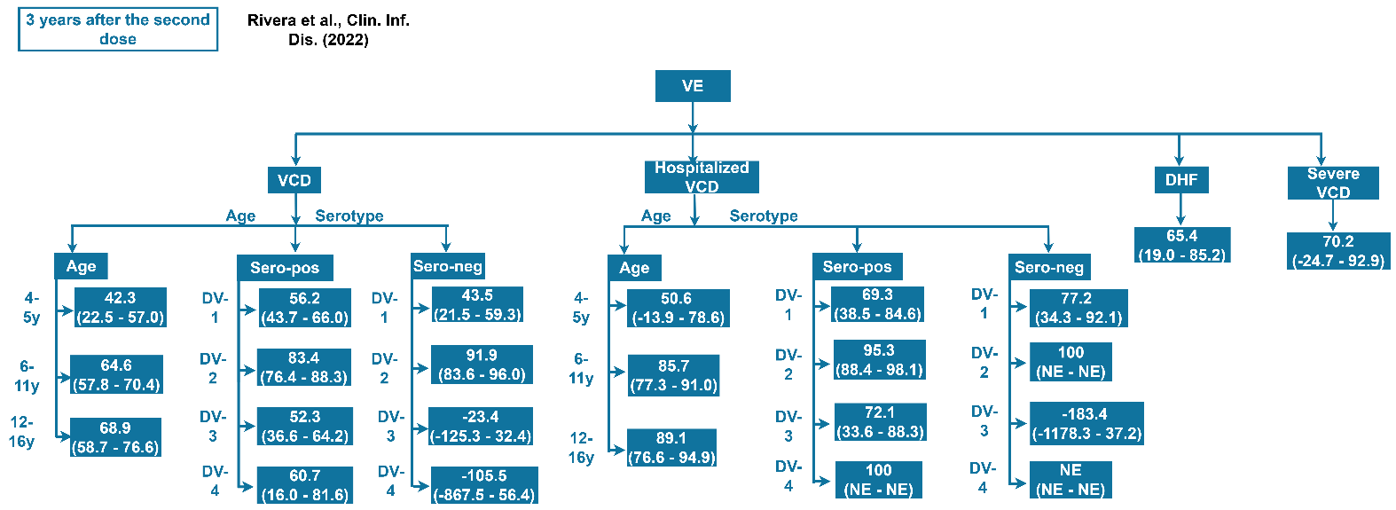
Figure 6: Vaccine efficacy of Qdenga.

Vaccination scenarios:
Using the vaccine efficacy related parameter, we will create different scenario based on the following:
- Vaccine coverage
- Targeted age-group
- Number of vaccine dose and frequency of vaccination depending on the waning of immunity derived from vaccines.
We will further study the combined effect of vaccination and ongoing vector control effort in Singapore.

References:
Anderson, K.B. et al. (2014) ‘A Shorter Time Interval Between First and Second Dengue Infections Is Associated With Protection From Clinical Illness in a School-based Cohort in Thailand’, The Journal of Infectious Diseases, 209(3), pp. 360–368. Available at: https://doi.org/10.1093/infdis/jit436.
Ang, L.W. et al. (2019) ‘A 15-year review of dengue hospitalizations in Singapore: Reducing admissions without adverse consequences, 2003 to 2017’, PLOS Neglected Tropical Diseases. Edited by B. Althouse, 13(5), p. e0007389. Available at: https://doi.org/10.1371/journal.pntd.0007389.
Colón-González, F.J. et al. (2023) ‘Projecting the future incidence and burden of dengue in Southeast Asia’, Nature Communications, 14(1), p. 5439. Available at: https://doi.org/10.1038/s41467-023-41017-y.
Cummings, D.A.T. et al. (2005) ‘Dynamic effects of antibody-dependent enhancement on the fitness of viruses’, Proceedings of the National Academy of Sciences, 102(42), pp. 15259–15264. Available at: https://doi.org/10.1073/pnas.0507320102.
Cummings, D.A.T. et al. (2009) ‘The Impact of the Demographic Transition on Dengue in Thailand: Insights from a Statistical Analysis and Mathematical Modeling’, PLoS Medicine. Edited by J. Farrar, 6(9), p. e1000139. Available at: https://doi.org/10.1371/journal.pmed.1000139.
Duong, V. et al. (2015) ‘Asymptomatic humans transmit dengue virus to mosquitoes’, Proceedings of the National Academy of Sciences, 112(47), pp. 14688–14693. Available at: https://doi.org/10.1073/pnas.1508114112.
Endy, T.P. et al. (2007) ‘Analysis of Repeat Hospital Admissions for Dengue to Estimate the Frequency of Third or Fourth Dengue Infections Resulting in Admissions and Dengue Hemorrhagic Fever, and Serotype Sequences’, The American Journal of Tropical Medicine and Hygiene, 77(5), pp. 910–913. Available at: https://doi.org/10.4269/ajtmh.2007.77.910.
Ferguson, N.M. et al. (2016) ‘Benefits and risks of the Sanofi-Pasteur dengue vaccine: Modeling optimal deployment’, Science, 353(6303), pp. 1033–1036. Available at: https://doi.org/10.1126/science.aaf9590.
Flasche, S. et al. (2016) ‘The Long-Term Safety, Public Health Impact, and Cost-Effectiveness of Routine Vaccination with a Recombinant, Live-Attenuated Dengue Vaccine (Dengvaxia): A Model Comparison Study’, PLOS Medicine. Edited by L. Von Seidlein, 13(11), p. e1002181. Available at: https://doi.org/10.1371/journal.pmed.1002181.
Huang, A.T. et al. (2022) ‘Assessing the role of multiple mechanisms increasing the age of dengue cases in Thailand’, Proceedings of the National Academy of Sciences, 119(20), p. e2115790119. Available at: https://doi.org/10.1073/pnas.2115790119.
Low, S.-L. et al. (2015) ‘Dengue Seroprevalence of Healthy Adults in Singapore: Serosurvey Among Blood Donors, 2009’, The American Journal of Tropical Medicine and Hygiene, 93(1), pp. 40–45. Available at: https://doi.org/10.4269/ajtmh.14-0671.
Muench, H. (1959) Catalytic Models in Epidemiology: Harvard University Press. Available at: https://doi.org/10.4159/harvard.9780674428928.
Murgue, B. et al. (2000) ‘Prospective study of the duration and magnitude of viraemia in children hospitalised during the 1996-1997 dengue-2 outbreak in French Polynesia’, Journal of Medical Virology, 60(4), pp. 432–438. Available at: https://doi.org/10.1002/(SICI)1096-9071(200004)60:4<432::AID-JMV11>3.0.CO;2-7.
Quan, T.M. et al. (2018) ‘Evidence of previous but not current transmission of chikungunya virus in southern and central Vietnam: Results from a systematic review and a seroprevalence study in four locations’, PLOS Neglected Tropical Diseases. Edited by B. Althouse, 12(2), p. e0006246. Available at: https://doi.org/10.1371/journal.pntd.0006246.
Recker, M. et al. (2009) ‘Immunological serotype interactions and their effect on the epidemiological pattern of dengue’, Proceedings of the Royal Society B: Biological Sciences, 276(1667), pp. 2541–2548. Available at: https://doi.org/10.1098/rspb.2009.0331.
Salazar, M.I. et al. (2007) ‘Dengue virus type 2: replication and tropisms in orally infected Aedes aegypti mosquitoes’, BMC Microbiology, 7(1), p. 9. Available at: https://doi.org/10.1186/1471-2180-7-9.
Singapore Population (2024). Available at: http://www.singstat.gov.sg/modules/infographics/population (Accessed: 4 March 2024).
Ten Bosch, Q.A. et al. (2018) ‘Contributions from the silent majority dominate dengue virus transmission’, PLOS Pathogens. Edited by N.M. Ferguson, 14(5), p. e1006965. Available at: https://doi.org/10.1371/journal.ppat.1006965.
Wagner, C.E. et al. (2020) ‘Climatological, virological and sociological drivers of current and projected dengue fever outbreak dynamics in Sri Lanka’, Journal of The Royal Society Interface, 17(167), p. 20200075. Available at: https://doi.org/10.1098/rsif.2020.0075.
Whitmire, R.E. et al. (1987) ‘Effect of Temperature on the Vector Efficiency of Aedes aegypti for Dengue 2 Virus’, The American Journal of Tropical Medicine and Hygiene, 36(1), pp. 143–152. Available at: https://doi.org/10.4269/ajtmh.1987.36.143.
World Population Prospects (no date). Available at: https://population.un.org/wpp/Graphs/DemographicProfiles/Line/702 (Accessed: 4 March 2024).

Appendix:
Mathematical form of the model
$$\frac{dS^{a}}{dt}=Λ^{h}-\left(\sum_{i=1}^{4}{λ_{i}^{m}}+μ^{ha}\right)S^{a}+a_{+}S^{a-1}-a_{-}S^{a}-pS^{a},$$
$\frac{dI_{i}^{a}}{dt}=ρ_{1}λ_{i}^{m}S^{a}-\left(ξ_{1}+γ_{1}+μ^{ha}\right)I_{i}^{a}+a_{+}I_{i}^{a-1}-a_{-}I_{i}^{a},$
$$\frac{dA_{i}^{a}}{dt}=\left(1-ρ_{1}\right)λ_{i}^{m}S^{a}-\left(γ_{1}+μ^{ha}\right)A_{i}^{a}+a_{+}A_{i}^{a-1}-a_{-}A_{i}^{a},$$
$$\frac{dC_{i}^{a}}{dt}=γ_{1}\left(I_{i}^{a}+A_{i}^{a}\right)-\left(α+μ^{ha}\right)C_{i}^{a}+a_{+}C_{i}^{a-1}-a_{-}C_{i}^{a}-pC_{i}^{a},$$
$$\frac{dS_{i}^{a}}{dt}=αC_{i}^{a}-\left(\sum_{j≠i}{λ_{j}^{ma}}+μ^{ha}\right)S_{i}^{a}+a_{+}S_{i}^{a-1}-a_{-}S_{i}^{a}-pS_{i}^{a},$$
$$\frac{dI_{ij}^{a}}{dt}=ρ_{2}λ_{j}^{ma}S_{i}^{a}-\left(γ_{2}+ξ_{2}+μ^{ha}\right)I_{ij}^{a}+a_{+}I_{ij}^{a-1}-a_{-}I_{ij}^{a},$$
$$\frac{dA_{ij}^{a}}{dt}=\left(1-ρ_{2}\right)λ_{j}^{ma}S_{i}^{a}-\left(γ_{2}+μ^{ha}\right)A_{ij}^{a}+a_{+}A_{i}^{a-1}-a_{-}A_{i}^{a},$$
$$\frac{dH^{a}}{dt}=ξ_{1\sum_{i}{I_{i}^{a}}}+ξ_{2}\sum_{i,j}{I_{ij}^{a}}-\left(γ_{2}+μ^{ha}\right)H^{a}+a_{+}H^{a-1}-a_{-}H^{a},$$
$$\frac{dR^{a}}{dt}=γ_{2\sum_{i,j}{\left(I_{ij}^{a}+A_{ij}^{a}\right)}}+γ_{2}H^{a}-μ^{ha}R^{a}-pR^{a}+a_{+}R^{a-1}-a_{-}R^{a},$$
$$\frac{dS^{m}}{dt}=Λ^{m}-\left(\sum_{i=1}^{4}{λ_{i}^{h}}+μ^{m}\right)S^{m},$$
$$\frac{dE_{i}^{m}}{dt}=λ_{i}^{h}-\left(σ^{m}+μ^{m}\right)E_{i}^{m},$$
$$\frac{dI_{i}^{m}}{dt}=σ^{m}E_{i}^{m}-μ^{m}I_{i}^{m},$$
$$\frac{dS_{v}^{a}}{dt}=pS^{a}-\left(\sum_{i=1}^{4}{\left(1-ϵ_{ia}^{\text{inf-}}\right)λ_{i}^{m}}+μ^{ha}\right)S_{v}^{a}+a_{+}S_{v}^{a-1}-a_{-}S_{v}^{a},$$
$$\frac{dI_{vi}^{a}}{dt}=ρ_{1}\left(1-ϵ_{ia}^{\text{symp-}}\right)\left(1-ϵ_{ia}^{\text{inf-}}\right)λ_{i}^{m}S_{v}^{a}-\left(γ_{1}^{v}+ξ_{1}\left(1-ϵ_{ia}^{\text{hosp-}}\right)+μ^{ha}\right)I_{vi}^{a}+a_{+}I_{vi}^{a-1}-a_{-}I_{vi}^{a},$$
$$\frac{dA_{vi}^{a}}{dt}=\left(1-ρ_{1}\left(1-ϵ_{ia}^{\text{symp-}}\right)\right)\left(1-ϵ_{ia}^{\text{inf-}}\right)λ_{i}^{m}S_{v}^{a}-\left(γ_{1}^{v}+μ^{ha}\right)A_{vi}+a_{+}A_{vi}^{a-1}-a_{-}A_{vi}^{a},$$
$$\frac{dC_{vi}^{a}}{dt}=pC_{i}^{a}+γ_{1}^{v}\left(I_{vi}^{a}+A_{vi}^{a}\right)-\left(α^{v}+μ^{ha}\right)C_{vi}^{a}+a_{+}C_{vi}^{a-1}-a_{-}C_{vi}^{a},$$
$$\frac{dS_{vi}^{a}}{dt}=pS_{i}^{a}+α^{v}C_{vi}^{a}-\left(\sum_{j≠i}{\left(1-ϵ_{ja}^{\text{inf+}}\right)λ_{j}^{m}}+μ^{ha}\right)S_{vi}^{a}+a_{+}S_{vi}^{a-1}-a_{-}S_{vi}^{a},$$
$$\frac{dI_{vij}^{a}}{dt}=ρ_{2}\left(1-ϵ_{ja}^{\text{symp+}}\right)\left(1-ϵ_{ja}^{\text{inf+}}\right)λ_{j}^{m}S_{vi}^{a}-\left(γ_{2}^{v}+ξ_{2}\left(1-ϵ_{ja}^{hosp+}\right)\&+\&μ^{ha}\right)I_{vij}^{a}+a_{+}I_{vij}^{a-1}-a_{-}I_{vij}^{a},$$
$$\frac{dA_{vij}^{a}}{dt}=\left(1-ρ_{2}\left(1-ϵ_{ja}^{\text{symp+}}\right)\left(1-ϵ_{ja}^{\text{inf+}}\right)\right)λ_{j}^{m}S_{vi}^{a}-\left(γ_{2}^{v}+μ^{ha}\right)A_{vij}^{a}+a_{+}A_{vij}^{a-1}-a_{-}A_{vij}^{a},$$
$$\frac{dH_{v}^{a}}{dt}=ξ_{1\sum_{j}{\left(1-ϵ_{ja}^{hosp-}\right)I_{vj}^{a}}}+ξ_{2\sum_{i,j}{\left(1-ϵ_{ja}^{hosp+}\right)I_{vij}^{a}}}-\left(γ_{2}^{v}+μ^{ha}\right)H_{v}^{a}+a_{+}H_{v}^{a-1}-a_{-}H_{v}^{a},$$

$$\frac{dR_{v}^{a}}{dt}=pR^{a}+γ_{2}^{v\sum_{i,j}{\left(I_{vij}^{a}+A_{vij}^{a}\right)}}+γ_{2}^{v}H_{v}^{a}-μ^{ha}R_{v}^{a}+a_{+}R_{v}^{a-1}-a_{-}R_{v}^{a},$$

