Notes of efficacy calculation on modelling:

How did I calculate the efficacy over time?
I have used the used the trial data from the following 5 studies:
Source | Timeline | Remark
Biswal et al., NEJM, 2019 | For 1-12 months | Calculated VE for 1-12 months
Biswal et al., Lancet, 2020 | Up to 18 months post vaccination | Calculated VE for 13-18 Months
Lopez-Medina et al., J. Inf. Dis., 2020 | Up to 24 months post vaccination | Calculated VE for 19-24 months
Rivera et al., Clin. Inf. Dis., 2022 | For 25-36 months | Calculated VE for 25-36 months
Tricou et al., Lancet, 2024 | For 37-48 months and 37-54 months | Calculated VE for 37-48 months and for 49-54 months

Note that these studies reported VE estimates mainly for (i) Safety set population, and (ii) Per-protocol population. Also, the formula for calculating VE is not uniform in these study. For example, in Biswal et al., NEJM, 2019, they used the formula, VE = 1- Relative risk, whereas in the subsequent they did not use the formula, instead it seems (Not clearly mentioned in the studies though!) they modified the formula incorporating “Person-year at risk”, etc.
Since per-protocol are those who completed the trial, I only focused on this population. I mainly collated four quantities:
- Cases in TAK-003
- Participants in TAK-003
- Cases in Placebo
- Participants in Placebo
Note that the participants both in TAK-003, and Placebo did not remain exactly same over the time, but the differences are very little.

After gathering, these four quantities, I have calculated VE just using the simple formula at these 6 time points,
VE = 100*(1 – Relative Risk (RR)),
Where RR is defined as the ratio of attack rate in TAK-003 group and Placebo group.
So, this calculation of VE might not match with estimates provided in these studies as they used different formulae.
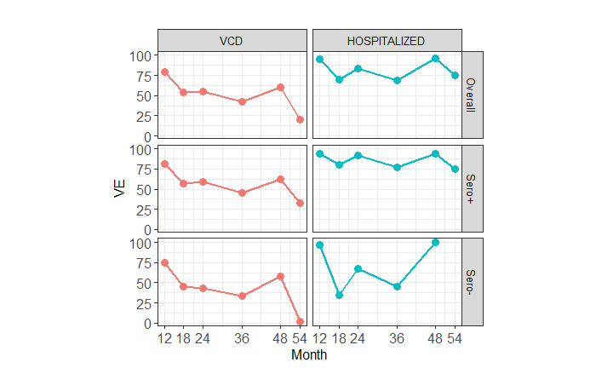
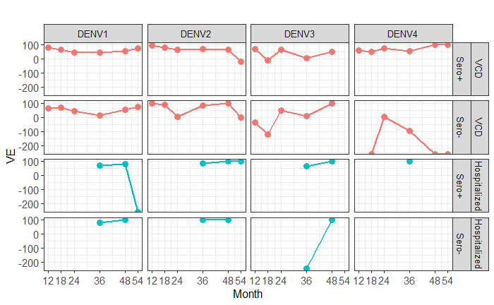
Note that serotype-stratified VE, mainly for Hospitalized are not available.
The figure below shows the number of cases over time in both Vaccine and Placebo groups.
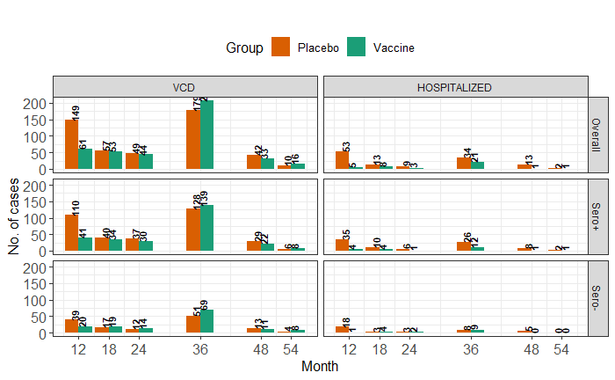
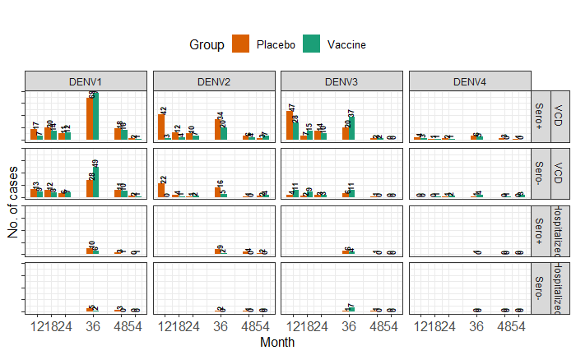

Which VE estimates have been used so far in the transmission model?
The cumulative efficacy up to 54 months for Safety set from Tricou et al., Lancet, 2024, have been used and assumed it remains same over the time. The estimates are serotype and sero-status stratified both for VCD and hospitalization.

How to incorporate waning of VE?
“Is this issue how to model or how to parameterize? The figures don’t show the numbers of events in each group as far as I can tell, but it looks like perhaps there is a dip at the 54 months. Simplest would be the same VE up until this point then a lower after that so we only need two subgroups in the vaccinated. That should be fairly straight forward to model but let me know if not. We aren’t then dealing with longer term waning, so if we can get three time since vaccination groups then that would be helpful for sensitivity around this.”

Looking at the VE estimates over time (Figure 1), it seems there is a decreasing trend in VE for VCD, but for hospitalized it not that clearly visible. If we look at the serotype stratified estimates (Figure 2), it is getting difficult to conclude that there was a reduction in VE over time.

Just for the reference, in HITAP meeting, Prof. Neil showed the estimates of VE over time (stratified wrt to serotype and serostatus), using a survival model. Here the decreasing trend is clearly visible (see the screenshot below). Consequently, these estimates have been used in the transmission model, and created some scenarios: VE decays with this rate for next few years and then stops decaying.
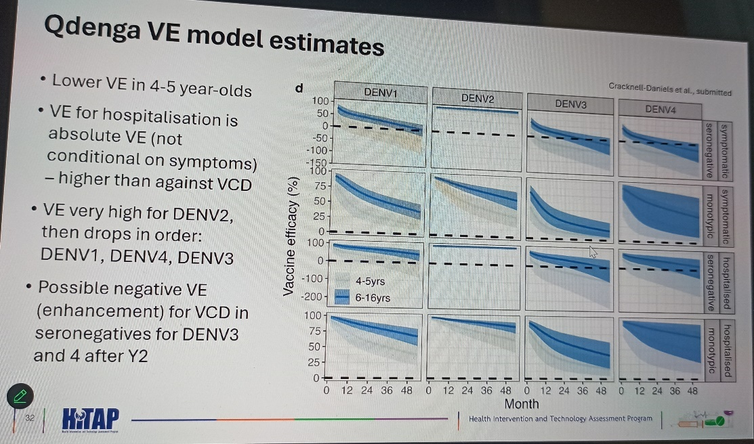

Parametrization:
- However, in our case, for simplicity if we assume that VE remains same until 54 months, then we need to somehow justify our assumption.
- If we can justify that, the next task is, which VE estimate to consider as baseline? The cumulative VE up to 54 months reported for Safety set in Tricou et al, Lancet, 2024 (the same estimate I have used in the analysis so far)? Or we can calculate the VE up to 54 months from per-protocol population using the simple formula, VE = 1 – Relative Risk?
- We can then create scenarios based on the rate of decay and time point after which it stops decaying.

Modelling:
To adapt waning of VE in the transmission model, I am considering
- one compartment for tracking the 54 months since vaccination with baseline VE (no decay),
- then they will transferred to the compartments where there will be decay in VE with a specific rate up to “y” years.
- Finally, they will move to the compartment where there won’t be any decay on VE.
