We consider several scenarios based on the following uncertainties:
- Vaccine efficacy scenarios
We consider serotype and serostatus stratified VE estimates.
Since the VE estimates have been reported in different phases of the trial, and they seem variable, we also explicitly incorporate these estimates into model. However, due to low number of events and targeting different end points, the following issues have been observed (see Figure 1 and Figure 2):
- Some of VE estimates have been reported to be 100 (replaced with immediate next or previous value where VE estimate is not equal to 100, in the analysis).
- Even though the points are positive, the confidence interval is very wide. In some of the reported estimates, the lower bound of the interval goes even less than -150.
- Some of the estimates are missing (see Figure 2, specifically VE against hospitalization).

- Lower bound of negative VE estimates: Since most of the point estimates (if available) of VE estimates are reported to be positive, but the confidence interval is wide and covers large negative values (for example see VE against VCD among sero-negative due to DENV-II in Figure 2. Therefore, we can restrict the lower bound of the negative confidence interval but the upper bound remains same as the raw VE estimate. We set the lower bound to -100, -50-25 and 0.
- Replacement of missing VE estimates: Most of the VE estimates are not available for hospitalized (all for serotypes and both serostatuses) and against VCD due DENV-III and DENV-IV among seronegative (see Figure 2). In this case we can consider the VE estimate against any serotype (see Figure 1) as a reference point. Additionally, we can consider some optimistic and pessimistic scenarios based on whether the interval covers negative estimates or only positive and zero estimates.
- Rate and duration of decline in VE: We can consider r% reduction in VE estimates obtained at month 54 and continue forward simulation with that estimate. We can also make this more general by assuming a decline in VE with a constant rate for y years and then stabilized.
- VE against infection: So far, we have considered no efficacy against infection. However, different level of protection against infection can introduced to see how it can help increasing the impact against VCD and/or hospitalization.
- Transmission scenarios
Dominant serotype: Since variability in VE estimates against different serotypes have been reported, we create scenarios based on dominant serotype. This is modelled by introducing imported cases infected with a particular serotype.
Future wolbachia impact: This is modelled as a reduction in biting rate of mosquitoes.
- Vaccine coverage and targeted age-groups:
For vaccine coverage we consider three different situation low coverage (20%), medium coverage (50%), and high coverage (80%). In this regard, we can provide whether impact increases linearly with the vaccine coverage.
The targeted age-groups are chosen from 0 – 84 years with an age-bracket of 5 years (therefore 17 age-groups). We also include childhood vaccination 6-18, 18-60 and over 50, 60 and 70s.
Across scenarios we consider the following outcome metrics:
- Percentage of cases averted after y years
- Fully Vaccinated Persons (FVP) needed to avert 1 VCD/Hospitalization
- Age-group wise impact while targeting a particular age-groups for vaccination,
- Comparison of impact among vaccinated and non-vaccinated

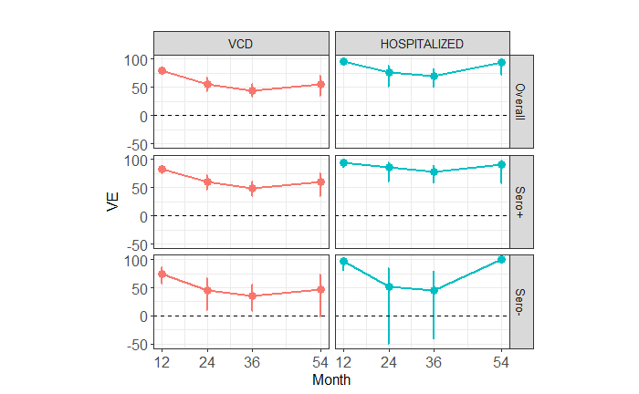
Figure 1: The VE estimates against any serotype from the vaccine trial data. The circle represents the VE and the bar represents the 95% confidence interval.
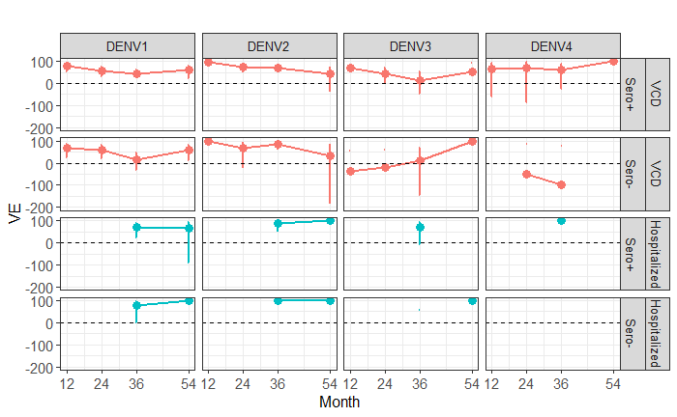
Figure 2: The VE estimate, stratified with serotypes from the vaccine trial. The circle represents the VE and the bar represents the 95% confidence interval.

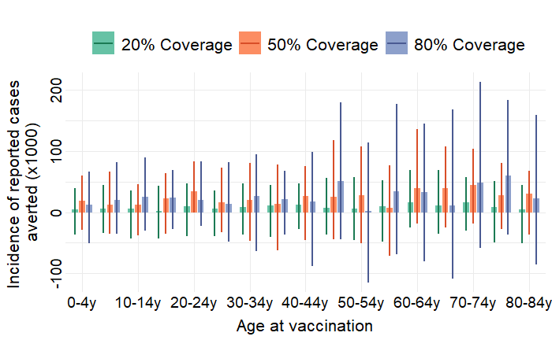
Figure 3: Impact of vaccination impact with lower bound of negative VE estimates restricted at -100.

