We use catalytic model and follow the methodology described in (Quan et al., 2018; Cox et al., 2022). We have used binomial likelihood for estimating force of infection (FOI) $\left(λ\right),$and since we have the sero-prevalence data aggregated for an age-brackets, we adapted the same method as in (Quan et al., 2018) to calculate the average foi for each age bracket.
The main aim is to use the model estimates of sero-prevalence for each age group and use this as initial conditions (Susceptible ($S_{0}$), exposed to 1-infection ($S_{0}^{i},i=1,2,3,4$), exposed to 2 or more infections ($R_{0}$)) in the dengue transmission model.
Description of Catalytic model:
Before going to use, Catalytic model, let’s first look at the mathematical expression which will be of interest while estimating the force of infection.
The fraction of people who remain susceptible (0-infection) in age group $a$, during year $X$, is given by:
$$s_{a,X}=exp\left(-\sum_{i=0}^{a}{\sum_{k=1}^{4}{λ_{X-i}^{k}}}\right)$$
( 1 )
Since, so far we do not have any information on serotype from sero-survey (except 2009- sero-survey, but not quite straight forward to use as do not have access to raw-data), we assume that the force of infection is time not serotype-specific, i.e. $λ_{k}=λ\left(k=1,2,3,4\right)$, then the equation becomes
$$s_{a,X}=exp\left(-4\sum_{i=0}^{a}{λ_{X-i}}\right)$$
( 2)
Now the fraction of people who experienced at least one infection is given by,
$$π_{a,X}=1-s_{a,X}$$
( 3)
The fraction of people who has experienced only one infection is given by,
$$ϕ_{a,X}=4\left(1-exp\left(-\sum_{i=0}^{a}{λ_{X-i}}\right)\right)exp\left(-3\sum_{i=0}^{a}{λ_{X-i}}\right)$$
( 4)

Finally, the fraction of people who has experienced more than one infection is given by,
$$α_{a,X}=1-s_{a,X}-ϕ_{a,X}$$
( 5)
Data
We have the sero-prevalence data obtained from sero-surveys done in 2013, 2017 in Singapore. We have the number of participants and number of sero-positives for the age group 16-71(2013), and 16-74(2017).
We choose the sero-survey done in 2013. The same approach can be adopted for the sero-survey done in 2017. The age group distribution in 2013-sero-survey was: "16-20y", "21-25y", "26-30y", "31-35y", "36-40y", "41-45y", "46-50y", "51-55y", "56-60y", "60+y". The data has been grabbed from the supplementary of previous study (Tan et al., 2019).
The average annual force-of-infection in respective periods 2008-2013, 2003-2007, ..., 1953-1957 are denoted by $λ^{p}$, $p=1,2,…,12$. $λ^{13}$ represents the average annual FOI estimated for the year 1922-1952. The estimate FOI is shown in Figure 1.
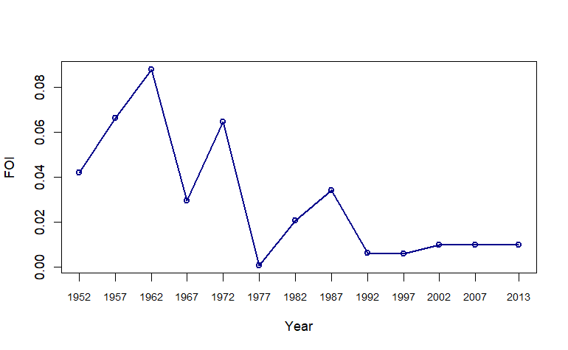
Figure 1: Estimates of FOI from 2013 sero-survey. The estimate for an interval is shown for the endpoint of that interval. For example the estimate shown at 2013 is the estiate of the average annual estimate for the time interval 2008-2013.

The model fit (time varying foi) with age-specific sero-prevalence data is presented in Figure 2.

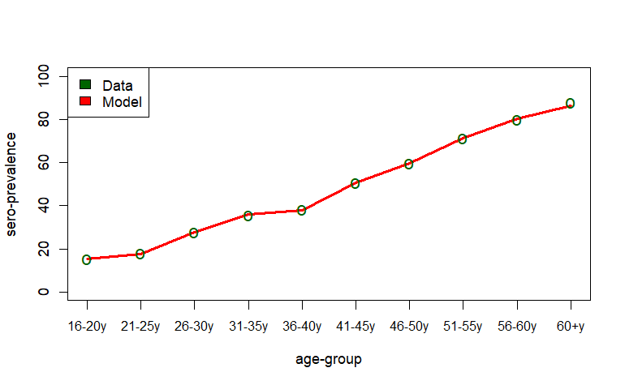
Figure 2: Model fit with age-specific sero-prevalence data done in 2013.

Reconstruction of pre-exposure history:
Next, for each age group, we reconstructed the fraction of individual who have experienced exactly 1-infection ($ϕ_{a,X}$ in Eq. 4), and 2-or more infection ($α_{a,X}$ in Eq. 5) (see Figure 3).
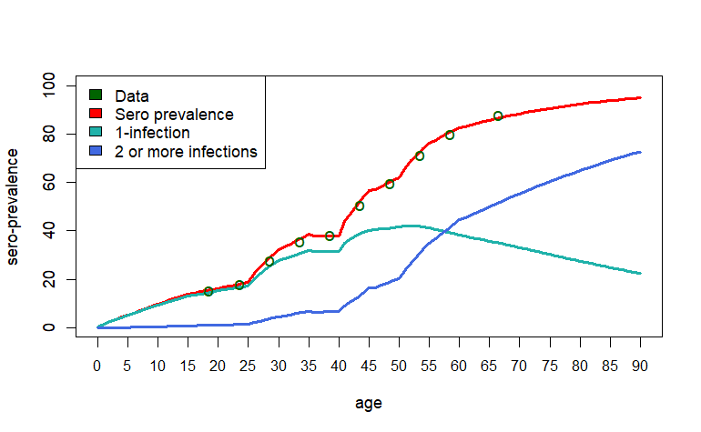
Figure 3: Reconstruction of pre-exposure history.
Reconstruction of $R_{0}$:
We used the following formula (Ferguson, Donnelly and Anderson, 1999) for calculating $R_{0}$ from the estimate of FOI ($λ$):
$$R_{0}=\frac{1+\frac{dλ}{dt}/σλ\left(t\right)}{1-\int_{0}^{∞}{f\left(a^{'}\right)π\left(a^{'},t\right)da^{'}}}$$
Where, $f\left(a\right)$ is the proportion of the population of age $a$ (from demographic data in Singapore), $π\left(a,t\right)$ is the proportion of sero-positive at age a & time t, and $σ$is the rate of loss of infectiousness ($\frac{1}{4}day^{-1}$).
This gives the estimate of $R_{0}$ in the year 2013 as 1.81 (see Figure 4).
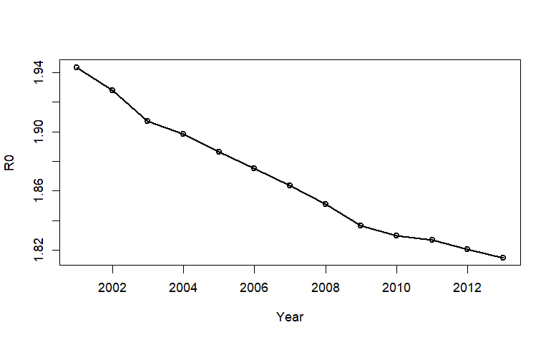
Figure 4: Reconstruction of basic reproduction number.
The mathematical expression for serotype-specific $R_{0}^{i}$, derived from the transmission model, using the model parameters as follows:

$$R_{0}^{i}=\sqrt{\frac{ρ_{1}b^{2}β_{i}^{m}β^{h}σ^{m}λ^{m}μ}{\left(σ^{m}+μ^{m}\right)μ^{m^{2}}λ^{h}\left(γ_{1}+μ+ξ_{1}\right)}+\frac{χ\left(1-ρ_{1}\right)b^{2}β_{i}^{m}β^{h}σ^{m}λ^{m}μ}{\left(σ^{m}+μ^{m}\right)μ^{m^{2}}λ^{h}\left(γ_{1}+μ+ξ_{1}\right)}}$$
( 6)

Fixing all the other transmission related parameters (i.e, $β_{i}^{m},b$) and $Λ^{m}$, we adjust the parameter $β^{h}$, so that $R_{0}$ becomes 1.81.
Output from transmission model:
Now we use all parameters values listed in Table 1, and demographic information from the data.
We use the initial conditions:
- Sero-negative ($s_{a,X}$ from Catalytic model estimate)
- Exposed to only one infection ($ϕ_{a,X}$ from Catalytic model estimate). We assumed the same for all the serotypes, i.e we divide the estimate by 4 to get the same estimate for all four serotypes.
- Exposed to two or more infection ($α_{a,X}$ from Catalytic model estimate)
- For initial seeding we assume that infection starts due to the presence of mosquitoes infected with different serotypes.
We check that with all these estimates and fixed parameter values, the transmission model can generate annual FOI in the subsequent times (2013 onwards) estimated from Catalytic model. We see that transmission model generates ~1% annual infections (see Figure 5).
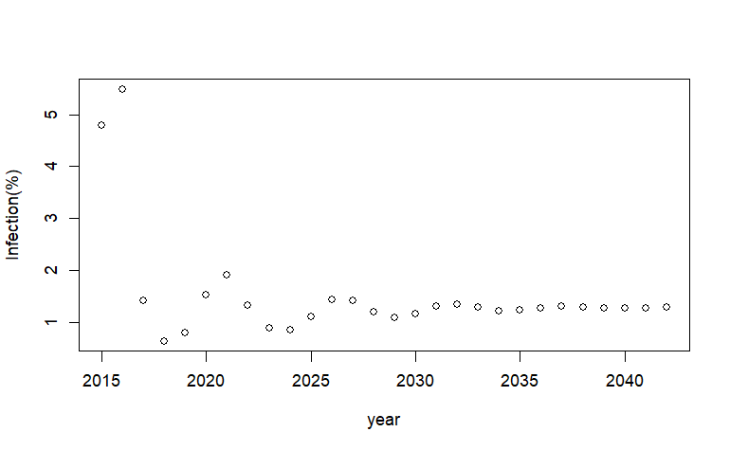
Figure 5: Annual infection.

Next, we plot the model output for annual reported cases assuming all the symptomatic infections had been reported (see Figure 6). We will incorporate under-reporting and estimate the related parameters in a more formal way.
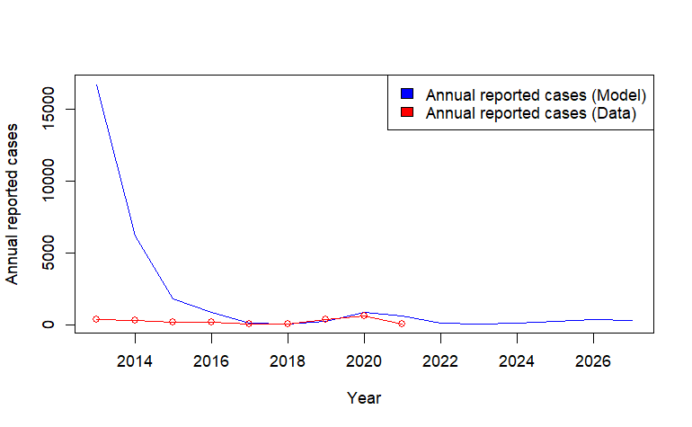
Figure 6: Annual reported cases.
Sero-prevalence:
We plot the model generated annual sero-prevalence for each age group in 3 different years: 2013, 2014, and 2028.
We consider only the compartments:
- Recovered from one serotype but susceptible to the remaining serotypes ($S_{i}^{a}\left(t\right)$)
- Recovered from secondary infection ($R^{a}\left(t\right)$).
We did not consider the Cross-immune compartment ($C_{i}^{a}\left(t\right)$), as eventually the individuals in this compartment move to the compartments: $S_{i}^{a},R^{a}.$

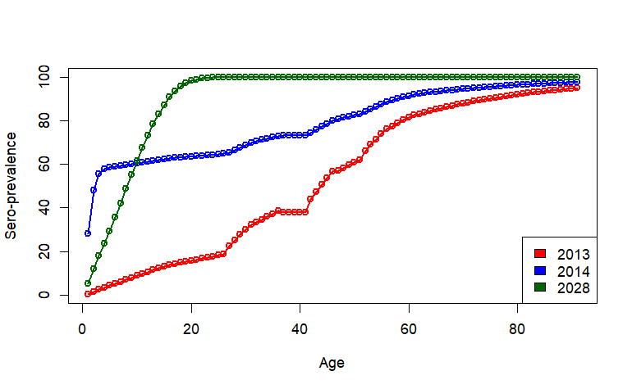
Figure 7: Age-specific sero-prevalence.
Serotype dominance:
We fixed the serotype specific reproduction number to be same, but choose initially infected mosquitoes with different serotypes to be different.
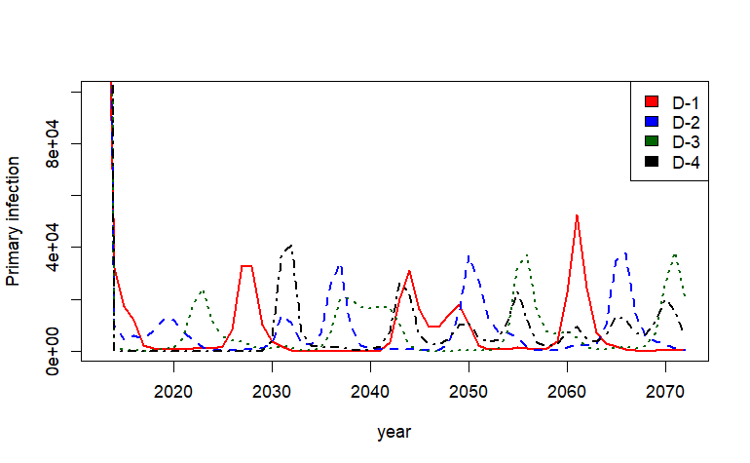
Figure 8: Serotype specific primary infection.
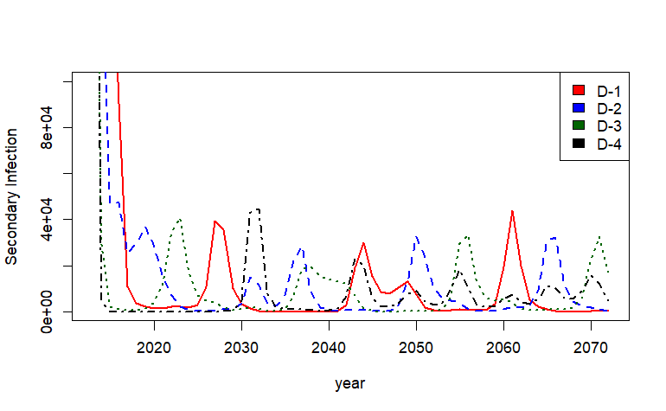
Figure 9: Serotype specific secondary infection.

Ongoing:

- Model’s ability to produce serotype dominance in subsequent years, even if sero-specific basic reproduction numbers are same.
- Considering the parameter: Proportion of symptomatic infection ($ρ_{1}$) as age-dependent and try to estimate these using age-stratified reported cases data. We will make some assumption on the ratio of primary and secondary symptomatic infections and calculate the parameter values of $ρ_{2}.$

Model parameters:

Next to do (From meeting on 09.04.24)
- Find out $β$ so that model will be able to produce FOI approximately 0.01, and the model generated age-specific sero-prevalence looks closer to real data.
I have tuned the parameter $β_{m}^{i}$ in such a way that model generates FOI approximately 0.01. The value of $β_{m}^{i}$= [0.195, 0.215, 0.08, 0.05].
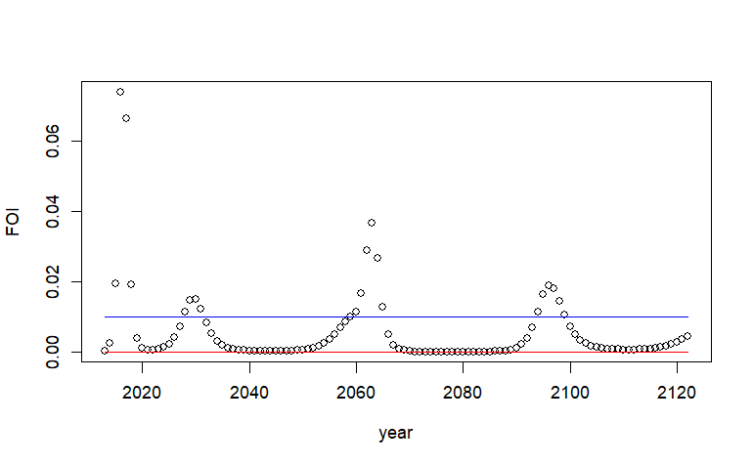
Age-specific sero-prevalence for some time-points are given below.
The model estimates have improved quite a lot from previous estimates and also the sero-prevalence estimates look better, but there is definitely room for improvement.
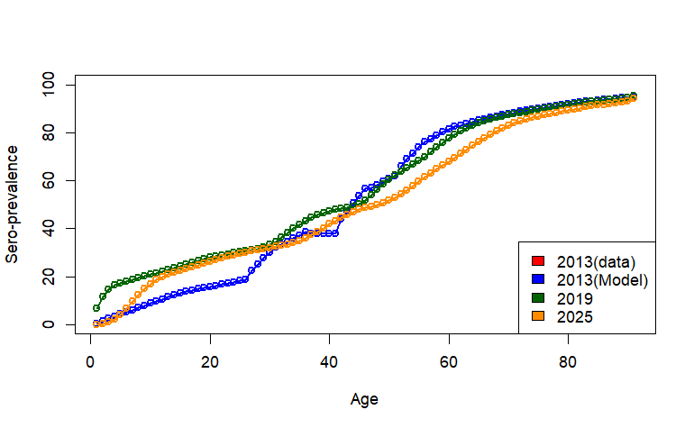
Some more figures answering your comments:
How low is the foi in the low years?
The zoomed-in figure is below. The blue line is the FOI=0.01, and the red line is the FOI=0.

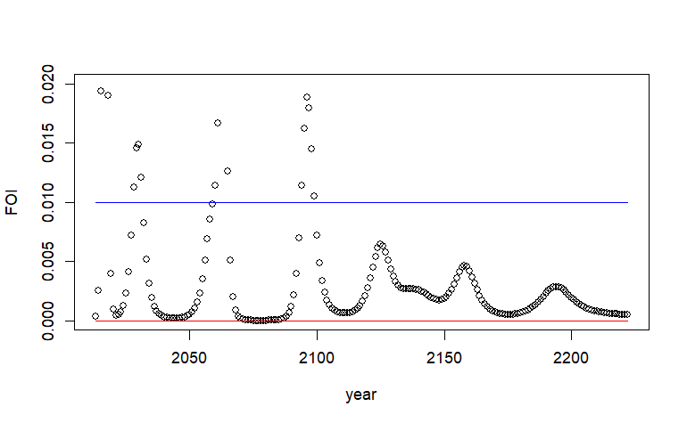
Annual infection (%)
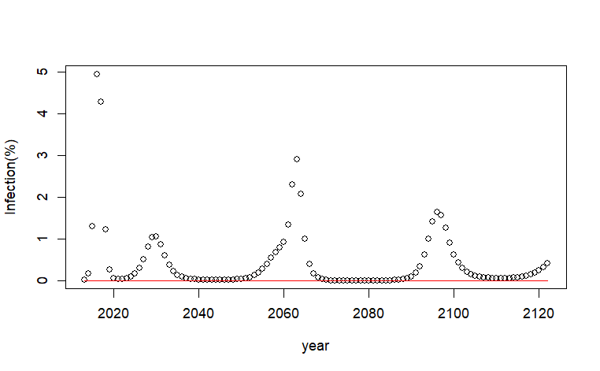

Wondering if the cycles are a bit far apart?
True. Model produced longer epidemic cycle. Dengue cases in Singapore exhibits a 5 to 6 year epidemic cycle (Rajarethinam et al., 2018). Refining the $β_{m}$ could reduce the epidemic cycle. I am working on this.
And what do the cases look like?
Here, we consider, proportion of symptomatic primary infection, $ρ_{1}$=0.1, and proportion of symptomatic secondary infection, $ρ_{2}$ = 0.3, and without any reporting error. However, we will formally model the reporting rate using Poisson or Negative Binomial distribution.
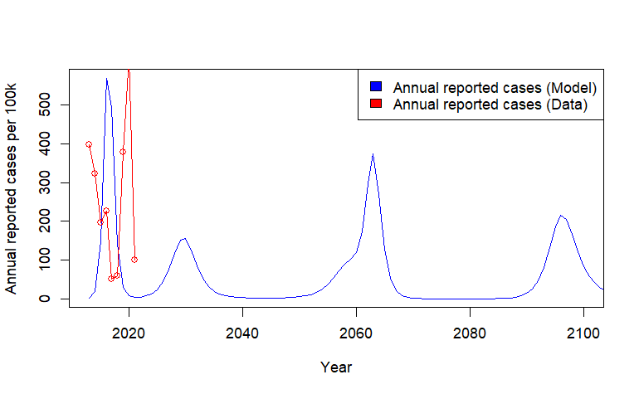

Serotype-wise annual primary and secondary infection:
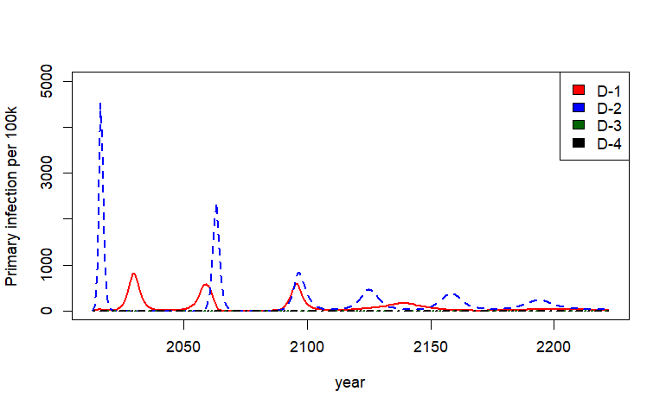
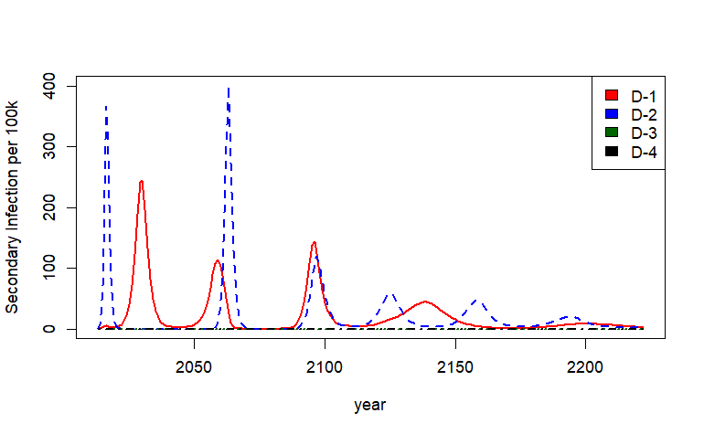

Below is the improvement in the model generated infection so far.
I also keep the corresponding age-specific sero-prevalence.
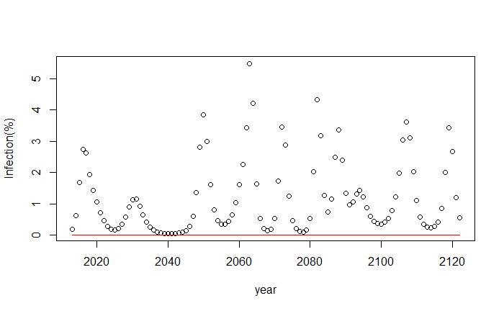
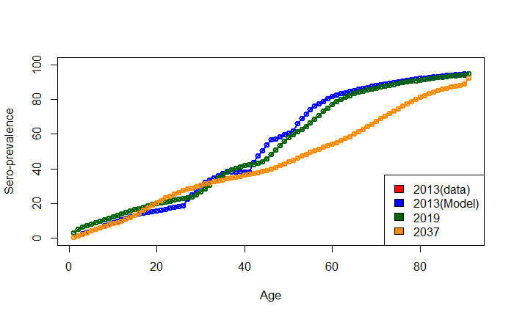

- Run the model without cross-protection and study the cyclic dominance of serotypes. Read theoretical studies from PNAS, Interface, etc. regarding this.

- Try to match with number of exposures in different age-groups, from 2009 sero-survey data

Comparison of model generated reported cases (aggregated over age) over time with reported cases data.

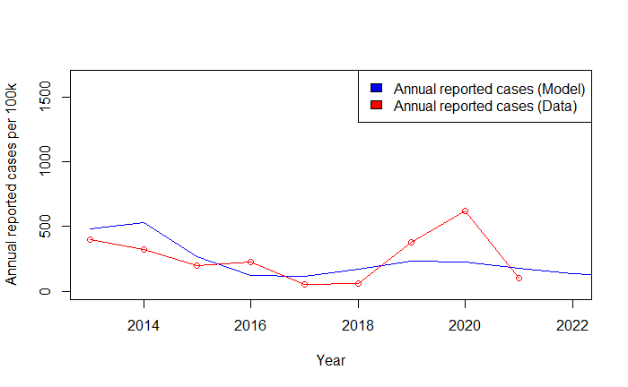
The comparison of model and data for age-specific reported cases. Note that here I did not consider the proportion of symptomatic infection to be age-specific. As a result, the fit for younger age-group is worse than that of olde age groups.

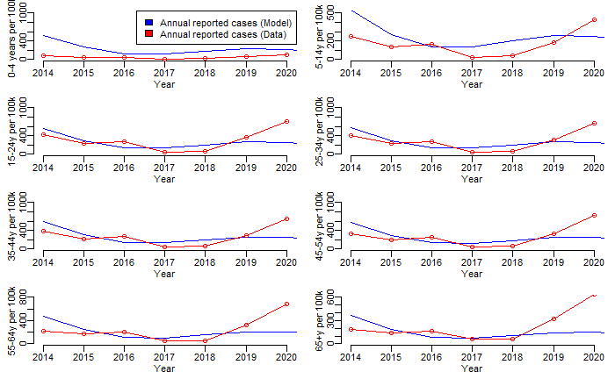
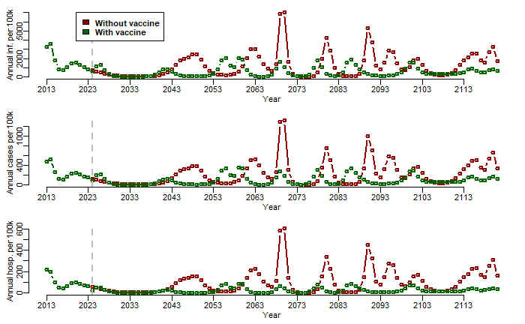
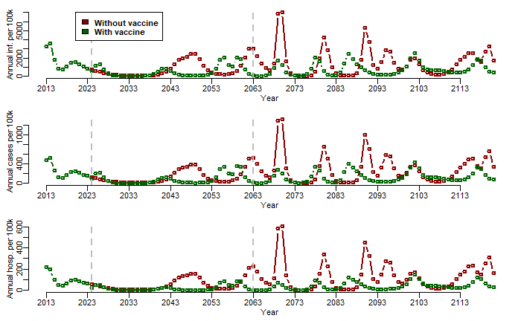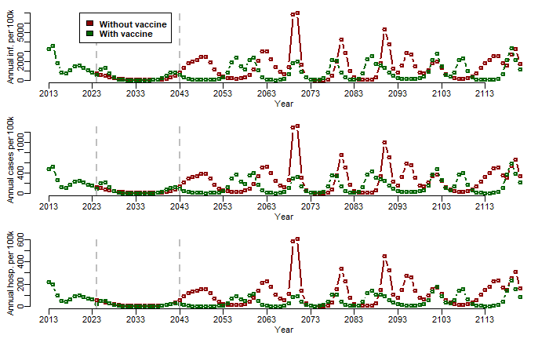

Model Fitting with age-specific reported cases data

Here, we estimate the fractions of primary infection which are reported as symptomatic.
We consider 8 parameters which are age dependent.
We keep the fractions of secondary infection which are reported as symptomatic fixed to avoid the correlated estimates of the model parameters. For now, we assume these fractions are 2 times higher than the fractions corresponding to primary infection.

Prior: Uniform
Likelihood: Poisson

In the figure below, gray lines are the annual age-specific incidence of reported cases per 100k from 2014 – 2020, and the blue line is the model fit.

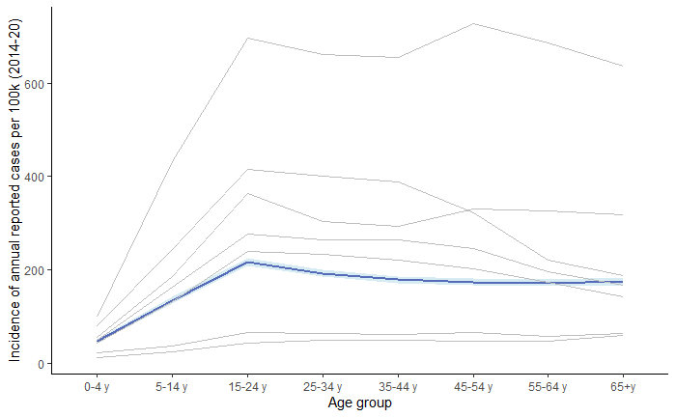

#####

- Could you plot the range of incidences from the model too (each year would be good).

The gray is the data from 2024-2020. The dark blue lines are the model generated means (also from 2014 -2020) and the shaded regions are the corresponding uncertainties.

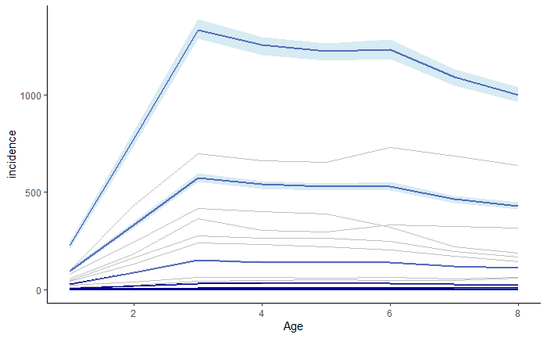

- I wonder if you could try introducing DENV 3 in at some point and see what happens?

Now both DENV 3 and DENV 4 have been introduced into the model. For DENV -4, both the transmission rate and the initial seeding is kept very low compared to the other three, so that infection due to DENV-4 could be seen in future.

The modified fitting is provided in the reply to next comment.

- Maybe I missed it, but did you have the number of cases by age? You mentioned the symptomatic rate didn’t vary by age. Did reporting? What are your plans for the symptomatic rate by age?

In the model, we consider two parameters:
- Fraction of symptomatic cases from primary infection $ρ_{1}$
- Fraction of symptomatic cases from secondary infection $ρ_{2}$
Initial thought was to incorporate another extra parameter, reporting rate when fitting with reported annual incidence of dengue cases. But to make it simple and avoid correlation and other typical issue, I reinterpret the parameters $ρ_{1}$ and $ρ_{2}$
as the Fraction of reported symptomatic cases from primary and secondary infection respectively.

Further, I extend the parameters $ρ_{1}$ and $ρ_{2}$ to be age-specific since we have the age-specific reported annual incidence of dengue cases data. Therefore, we consider 8 different values corresponding to 8 different age-groups both for $ρ_{1}$
and $ρ_{2}$ as follows:

$ρ_{1}^{a}$, $a=$ 0 - 4 y, 5 - 14 y, 15 - 24 y, 25 - 34 y, 35 – 44 y, 45 – 54 y, 55 – 64 y, 65+ y
$ρ_{2}^{a}$, $a=$ 0 - 4 y, 5 - 14 y, 15 - 24 y, 25 - 34 y, 35 – 44 y, 45 – 54 y, 55 – 64 y, 65+ y

To avoid correlation between estimates of $ρ_{1}^{a}$ and $ρ_{2}^{a}$, we assume that
$ρ_{1}^{a}=0.5*ρ_{2}^{a}$ and only estimated $ρ_{2}^{a}$ by fitting the model to annual age-specific incidence of reported dengue cases from 2014-2020.

Note that, even though the model output has been fitted to the annual age-specific reported cases data from 2014 -2020, the figure for model fitting has been shown as the average of reported cases from 2014 – 2020 for each age group. It has two reasons:
- Easier visualization, otherwise, 8 separate figures corresponding to 8 age-groups are required to visualize the fit.
- The individual fit for each age-group does not look that good. The figures attached below.

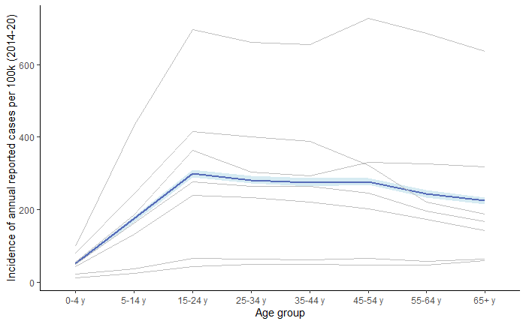
Here is the trace plot of MCMC chain and pairwise correlation plot.

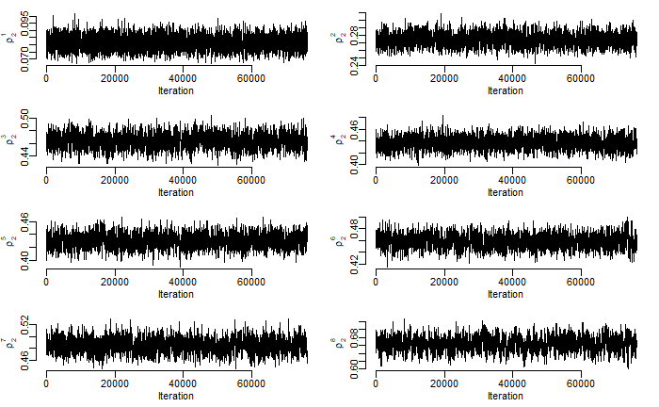
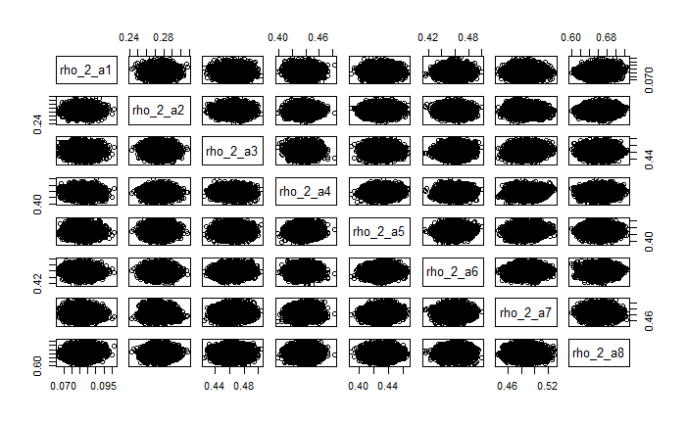

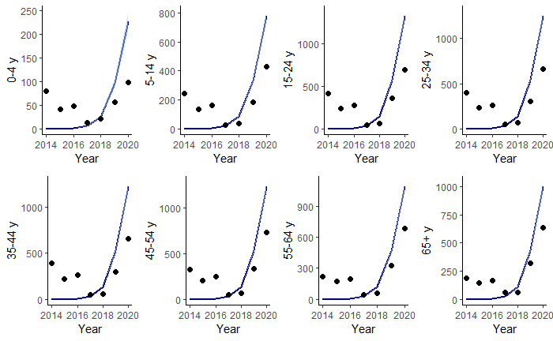

- What are the characteristics of the vaccine put in?
So far I have used overall efficacy of Qdenga against VCD and Hospitalization both for sero-positive and sero-negative. The efficacy parameter I have used so far is given below.

My plan is to create various vaccination scenarios using these overall efficacies first. Then will start incorporating serortype specific efficacy.

Vaccine scenario:
Vaccine to 6-16 years age old, the current recommended age-group for Qdenga. For 3 annual vaccine coverage scenarios: 5%, 20%, and 50%.

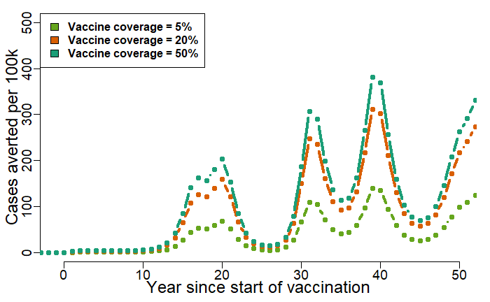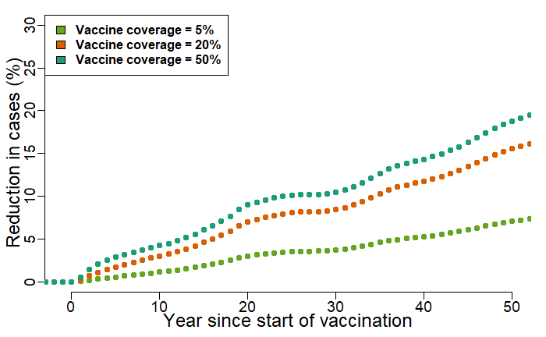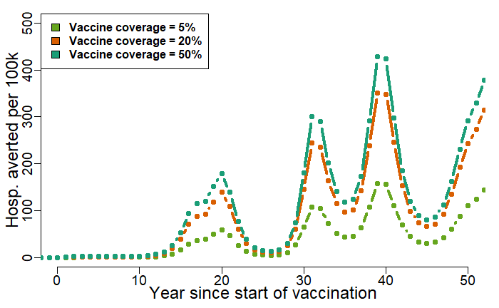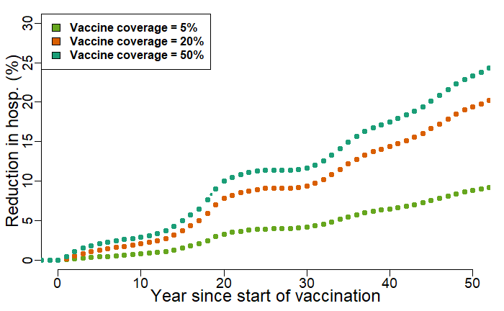

Direct effect & Indirect effect

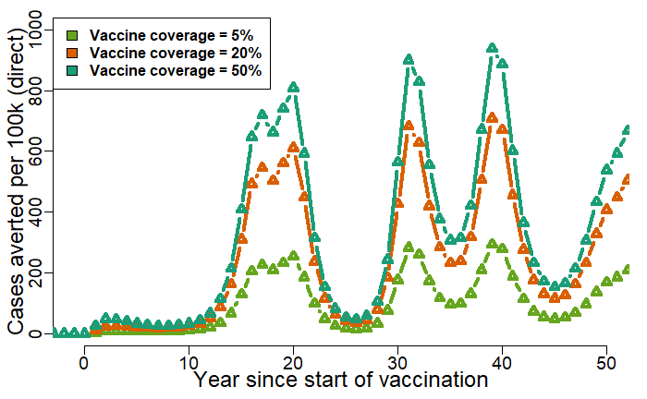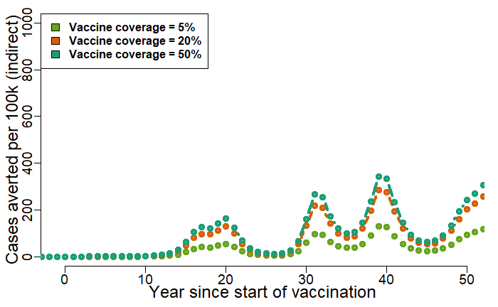
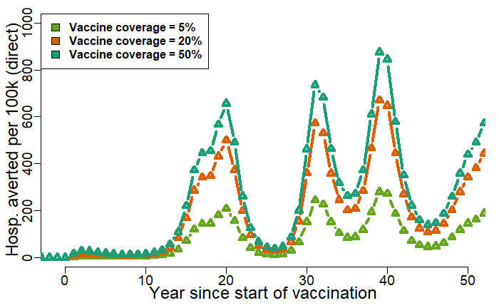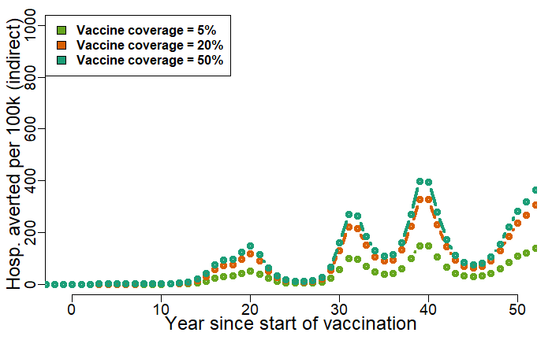

Age-targeted vaccination

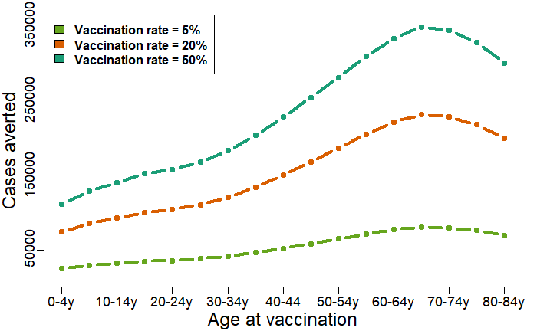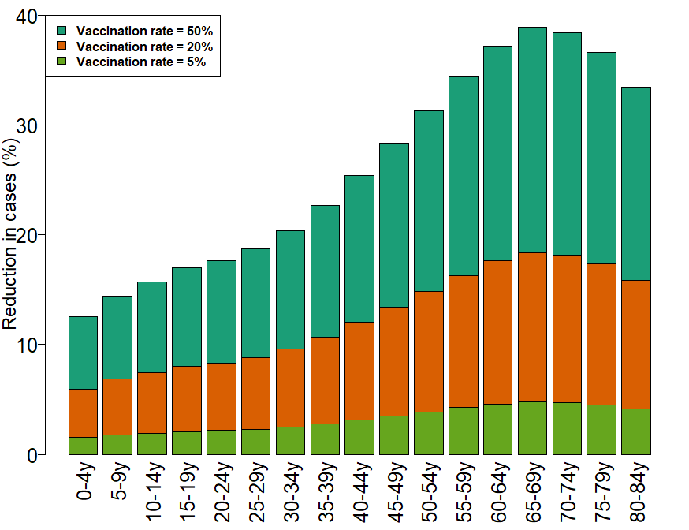
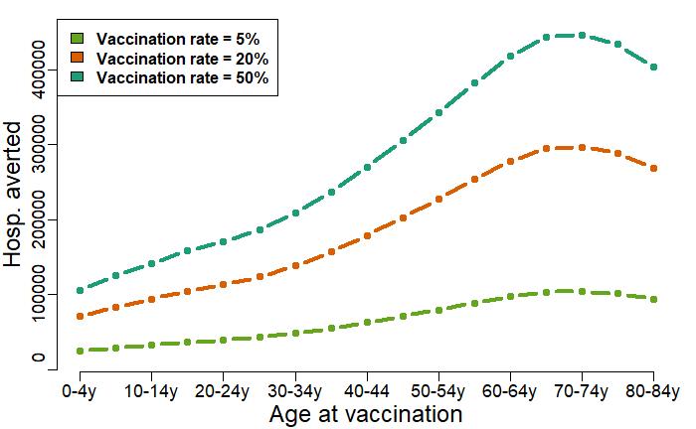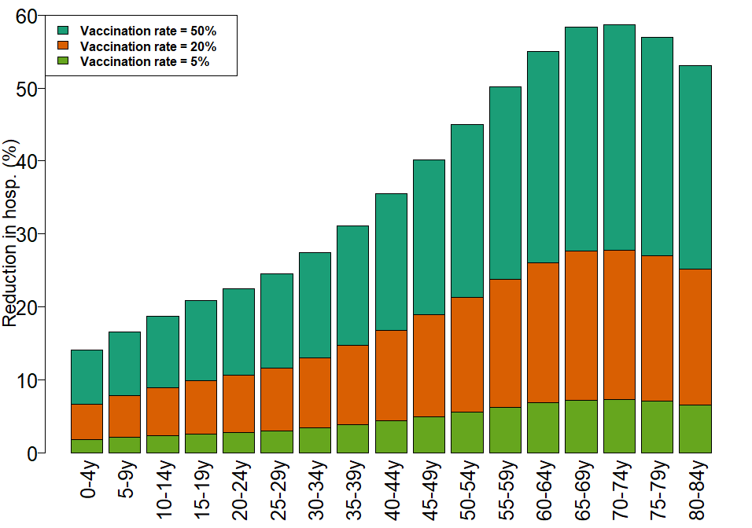

Table parameters:
Parameters | Description | Value | Source | Remarks
$$Λ^{h}$$ | Human birth rate | Crude birth rate * Total population  (Time dependent) | (Singapore Population, 2024)  Reported as births per 1000 population in a year  For projection: World Population Prospects (WPP) | From this raw data first calculate per capita birth rate simply dividing 1000 and make it daily rate (by dividing it 365) then multiply it with total population.  For, future data, we use the “medium” projection of birth rate from world population prospects (WPP)
$$μ$$ | Human mortality rate | Time dependent | (Singapore Population, 2024) | Followed same approach as in Birth rate.
$$ρ_{1}$$ | Proportion of infection to be reported (primary infection). It can be interpreted as the combination of proportion symptomatic infection and reporting rate. Related to this, the asymptomatic compartment (we can rename it!) should be described as the compartment that contains both asymptomatic and unreported infections | Age-specific. For 8 different age-groups:  0 - 4 y, 5 - 14 y,  15 - 24 y, 25 - 34 y, 35 – 44 y, 45 – 54 y, 55 – 64 y, 65+ y |  | Estimated from age-stratified annual case notification data from 2013-2020.
$$ρ_{2}$$ | Proportion of infection to be reported (Secondary) | $2*ρ_{1}$ (Assumed to avoid correlated parameter estimate)
$$ξ_{1}$$ | Proportion of primary infection require hospitalization | $$\frac{1}{4}ξ_{2}$$  (Assumed primary symptomatic infections are 75% less likely to be hospitalized following (Ferguson et al., 2016))
$$ξ_{2}$$ | Proportion of secondary infection require hospitalization | 0.30  (Not age-specific) | (Ang et al., 2019) | During 2003 – 2005, the rate was more than 88%. However, over time it has been reduced. In 2017, it became 35.9%. However, this study did not specify if the hospitalization is due to primary or secondary infection.
$$\frac{1}{γ}$$ | Infectious period of human | 4 days | (Murgue et al., 2000)
$$\frac{1}{α}$$ | Duration of heterologous protection from infection n | 1 year | (Anderson et al., 2014) | To be varied in sensitivity analysis
$$b$$ | Mosquito biting rate | 15 | Assumed
$$β^{h}$$ | Per bite probability of transmission from infected human to mosquitoes | 0.2 | Assumed
$$β^{m}$$ | Per bite probability of transmission from infected mosquitoes  to human | 0.166 (DENV-I)  0.176 (DENV-II)  0.152 (DENV-III)  0.144 (DENV-IV) | Calibrated to FOI estimate with b and $β^{h} kept fixed as above$
$$\frac{1}{σ_{m}}$$ | Mean extrinsic incubation period | 10 days | (Whitmire et al., 1987; Salazar et al., 2007)
$$Λ^{m}$$ | Recruitment rate of mosquito | $μ^{m}$*Total Mosquito pop. | Assumed constant mosquito population over time. Also, initial susceptible mosquito (so as the total mosquito pop.) population is assumed to be 1% of initial total human population as Aedes House Index is reported to be around 1% since 1990s (Ho et al., 2023)
$$μ^{m}$$ | Adult mosquito mortality rate | 0.1 per day | (Sheppard et al., 1969; Ferguson et al., 2016)

Table: Vaccine efficacy (not sero-specific)
VE against (Overall) | Sero+ | Sero-
VCD | 64.2  (58.4 – 69.2) | 53.5  (41.6 – 62.9)
Hospitalization | 85.9  (78·7 - 90·7) | 79.3  (63·5 to 88·2)

Table: Vaccine efficacy (sero-specific)

VE against (Overall) | Serotype | Sero+ | Sero-
VCD | DENV-I | 56·1  (44·6 - 65·2) | 45·4  (26·1 - 59·7)
VCD | DENV-II | 80·4  (73·1 - 85·7) | 88·1  (78·6 - 93·3)
VCD | DENV-III | 52·3  (36·7 - 64·0) | –15·5  (–108·2 - 35·9)
VCD | DENV-IV | 70·6  (39·9 - 85·6) | –105·6  (–628·7 - 42·0)
Hospitalization | DENV-I | 66·8  (37·4 - 82·3 | 78·4  (43·9 to 91·7)
Hospitalization | DENV-II | 95·8  (89·6 - 98·3) | 100·0  (NE)
Hospitalization | DENV-III | 74·0  (38·6 - 89·0) | –87·9  (–573·4 to 47·6)
Hospitalization | DENV-IV | 100·0  (NE) | 100·0  (NE)

List of things to do: (12.07.24)
- Time until impact/impact on the different age groups.. (did some progress but need to think about the how to present it more compact way)
- Vaccination numbers/rate right coverage… (Done)
- Uncertainty in the estimated parameters (ongoing)
- Incorporate serotype specific efficacy (incorporated already)
- Scenarios based on serotype dominance (need to discuss)
- More description on parameter/data (Done)
- Comparison to vaccinated people (Same as point 1)
- Then waning (Ongoing)

- Vaccination numbers/rate right coverage…

First let’s look at the previous version of the model where I had incorporated vaccination coverage as just a vaccination rate (which does not capture the vaccination coverage).
For example, if dengue Naïve population in age-group a, (denoted as $S_{all}^{a}$) is being vaccinated then there would be a transfer from $S_{all}^{a}$ to vaccinated compartment ($S_{all}^{v,a}$) as $vac_{rate}S_{all}^{a}$, where, $vac_{rate}$ is the rate of vaccination.
I have now defined the vaccination defined vaccination coverage (or coverage of a targeted age-group). It is defined as the fraction of vaccinated population in a particular age group $i$, ($\frac{N_{v}^{i}\left(t\right)}{N_{i}\left(t\right)}$).
Now to keep the vaccinated population in a particular age-group constant over time, we have derived the expression for number of people to be vaccinated per time ($v_{rate}$), as follows:
For age-group 1,
$$v_{rate}^{1}=\frac{Λ^{h}NN_{1}^{v}}{N_{1}}$$
For the remaining age-groups ($i=2,3,…,n$),
$$v_{rate}^{i}=\frac{a_{i-1}\left(N_{i-1}N_{i}^{v}-N_{i}N_{i-1}^{v}\right)}{N_{i}}$$
Now, since there are 4 eligible compartments for vaccination, we assume that these compartments are selected randomly for vaccination. Therefore, for these compartments ($X_{i}\left(t\right)$, where $X=S_{all},C,S,R$), the expression of $v_{rate}^{i}$ become as follows:
$$v_{rate}^{i}=v_{rate}^{i}\frac{X_{i}}{\sum_{X}{X_{i}}}$$

We consider 3 different vaccination coverage scenarios: low-25%, medium-50%, and high-70%. Also we consider 17 different age-groups as targeted age-groups for vaccination. The age-groups are: 0-4y, 5-9y, 10-14y, 15-19y, 20-24y, 25-29y, 30-34y, 35-39y, 40-44y, 45-49y, 50-54y, 55-59y, 60-64y, 65-69y, 70-74y, 75-79y, 80-84y.
For each of the targeted age-group, we calculate the following quantity:
- Averted annual incidence of reported dengue cases per 100k population
$$ϕ_{reported}^{coverage}=\frac{N_{reported}^{coverage=0}-N_{reported}^{coverage=v}}{N_{reported}^{coverage=0}}$$

In the following figures, the dashed gray vertical line indicates the start of vaccination.

Same quantity can be defined for hospitalization (follows similar trend), but here we only show the results for reported cases.

The results below are for serotype-specific efficacy
However we will consider two other scenarios based on vaccine efficacy:
- Overall vaccine efficacy (same efficacy against all 4 serotypes)
- Serotype-specific efficacy, with negative efficacy replaced with zero.

Averted reported cases per 100k:
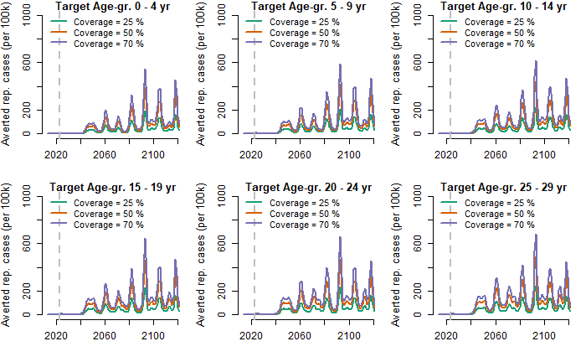
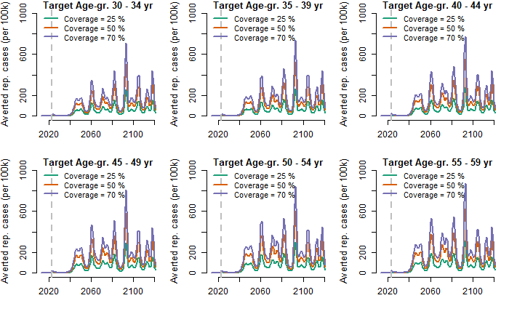
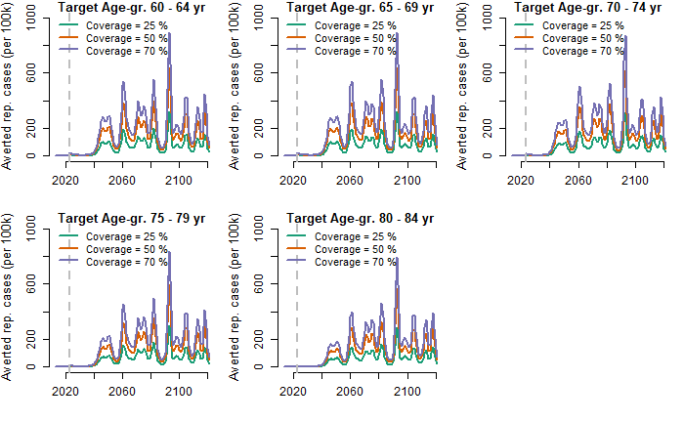
Relative reduction of reported cases
We consider relative reduction (RR) in incidence of reported cases and hospitalization as the measure of impact. The relative reduction is defined as the percentage of reduction compared to the baseline (without vaccination strategies):
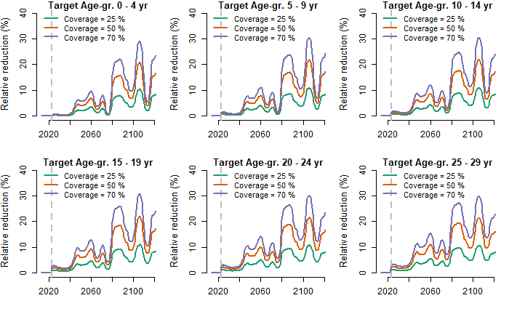
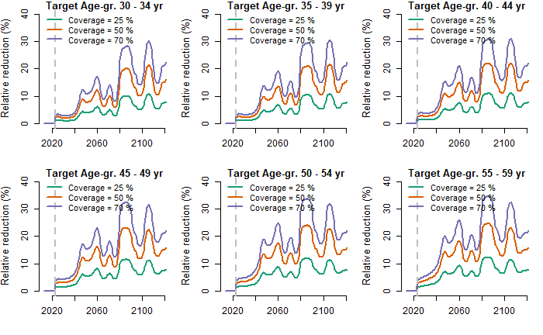
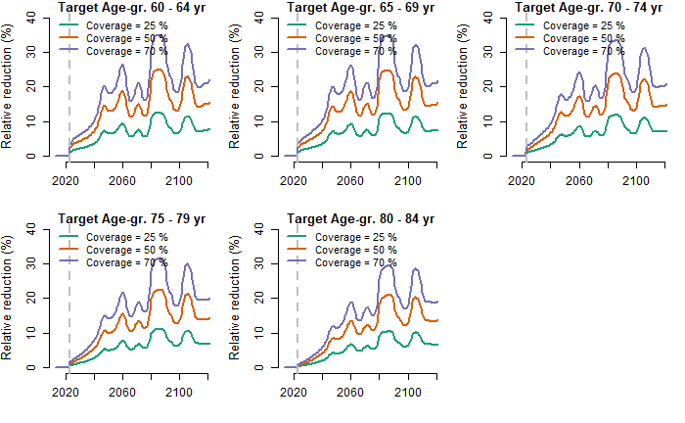

- Time until impact/impact on the different age groups..
(Still figuring out how best to define impact in this case, so that a clear temporal trend visible. The following analysis is for “overall efficacy scenario”, where the temporal trend is somewhat visible, but for “sero-stratified” scenario this kind of trend is not visible)
We consider relative reduction (RR) in incidence of reported cases and hospitalization as the measure of impact. The relative reduction is defined as the percentage of reduction compared to the baseline (without vaccination strategies) as before:
First, we plot the how do RRs look like for different age-targeted vaccination strategies.
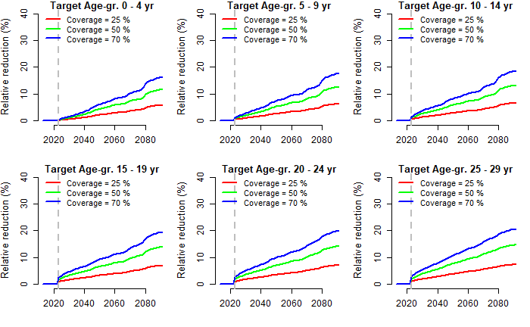
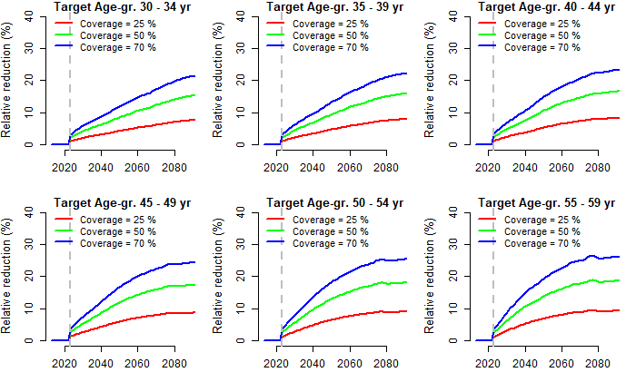
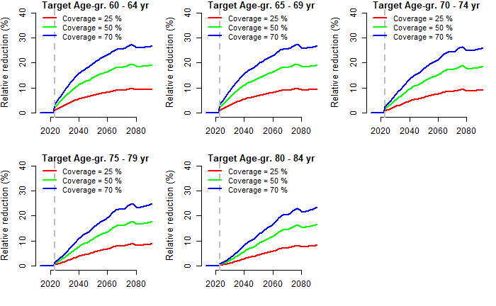
Next, we estimate the time since vaccination to reach a given impact i.e., given relative reduction.
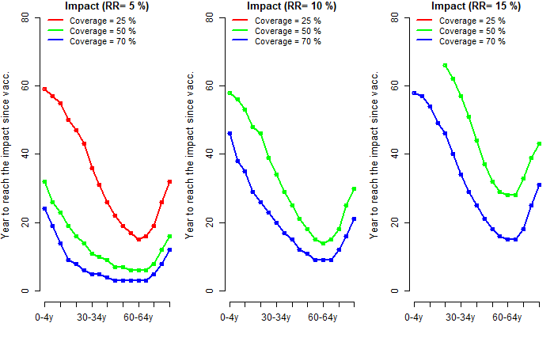

Note that, in the last two subfigures () the estimate corresponding to 25% coverage is not visible, because the given impact (i.e. targeted relative reduction) is not achievable with this low coverage.
Effectiveness
Now we consider following 3 vaccine efficacy scenarios:
- Overall vaccine efficacy (not serotype stratified)
- Serotype stratified vaccine efficacy but replaced negative efficacy with zero
- Serotype stratified vaccine efficacy along with negative efficacy

Below we compare the effectiveness between these 3 vaccine efficacy scenarios for different age-group targeted vaccination. The effectiveness is defined as follows:
$$Effectiveness=100*\left(1-\frac{p_{reported,vaccinated}}{p_{reported,unvaccinated}}\right)$$

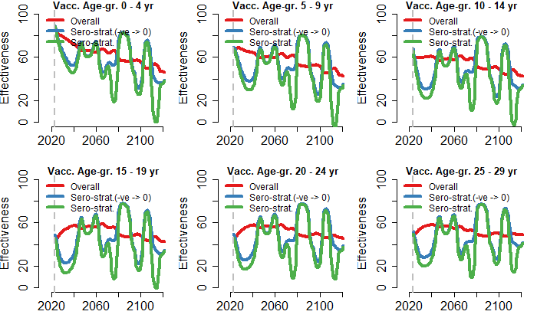
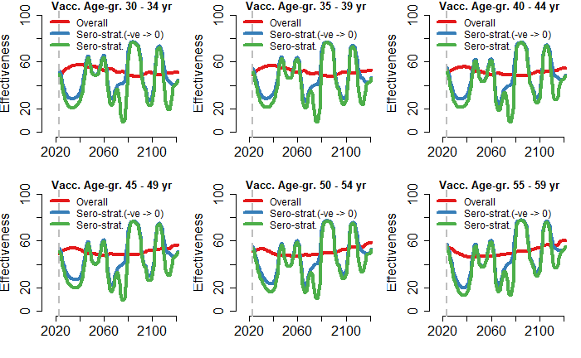
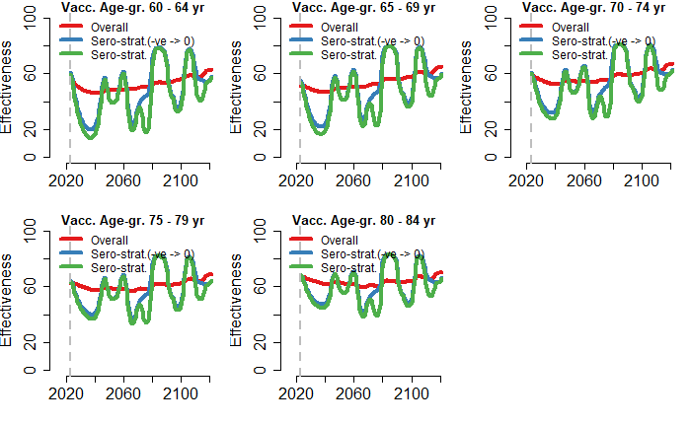

Now, we choose specific age-group and for sero-specific efficacy, and zoom into the impact on different age-groups separately, we see that if we vaccinate younger age-groups, we can have negative effectiveness (may be due more seronegative in this age-group, for which efficacy is negative), whereas vaccinating older-age group can avoid such negative impact (i.e., effectiveness)
Remark: (NOT so sure how to visualize it, for now just looking at effectiveness over time for different age groups)
For example, if we vaccinate individuals in 5-9 year age group, and track effectiveness for each of the age-group, we can see negative effectiveness until age group 20-24yr.

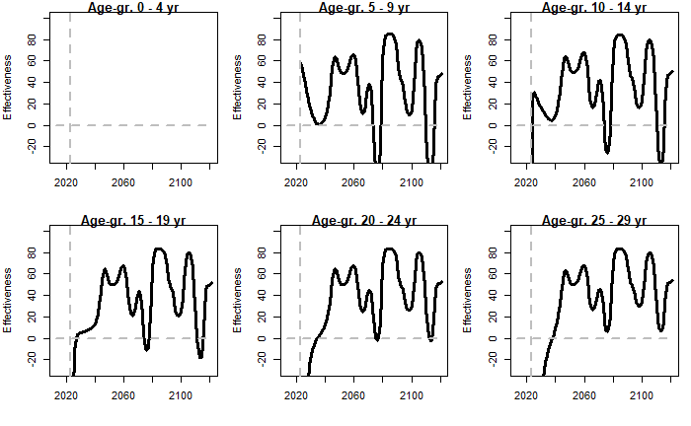
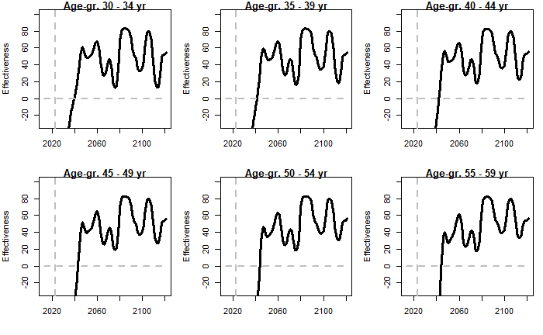
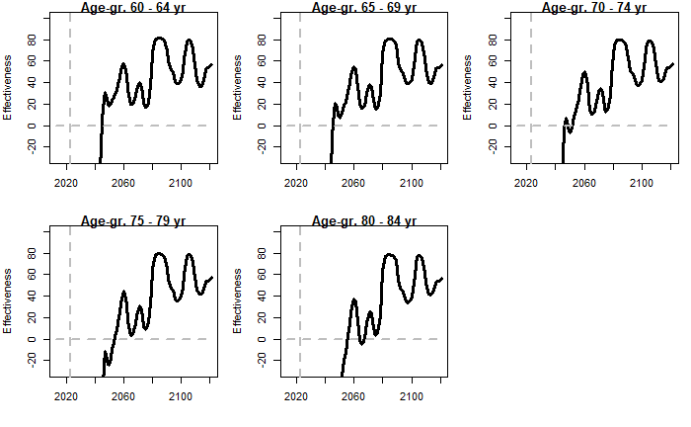

Now if we target older age group for example, 40-44yrs, we can see the following impact:
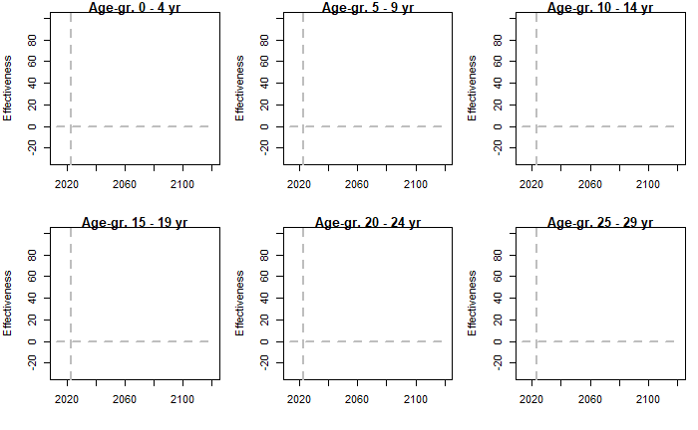
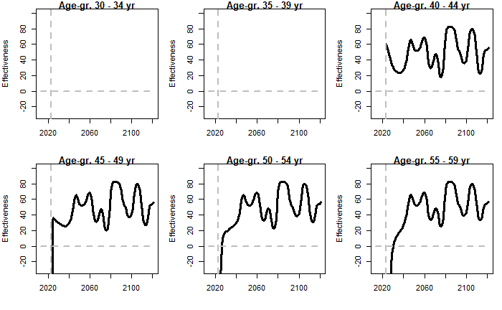
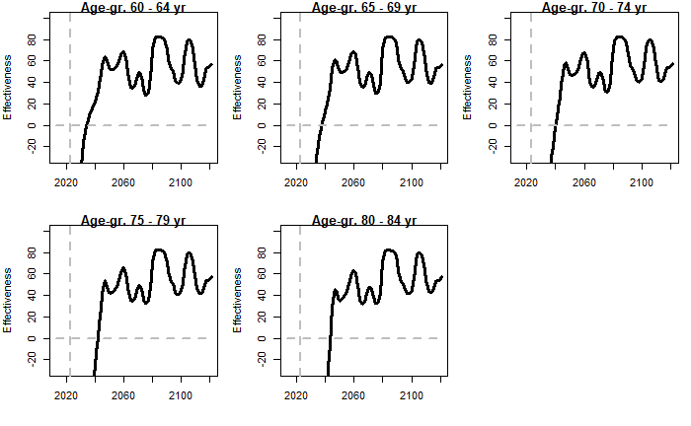

For more comparison, we consider vaccine coverage 70% and calculate relative reduction in reported case aggregating over 50 years since start of vaccination, for each of the vaccine efficacy scenario.
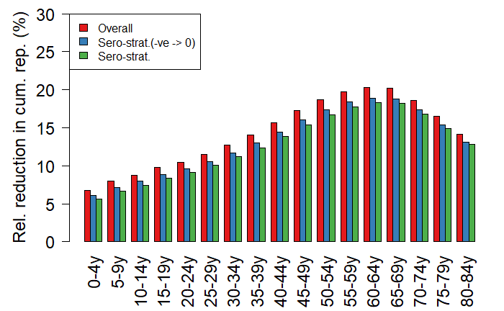
FVP per reported cases averted
Fully vaccinated person needed to avert one reported case.
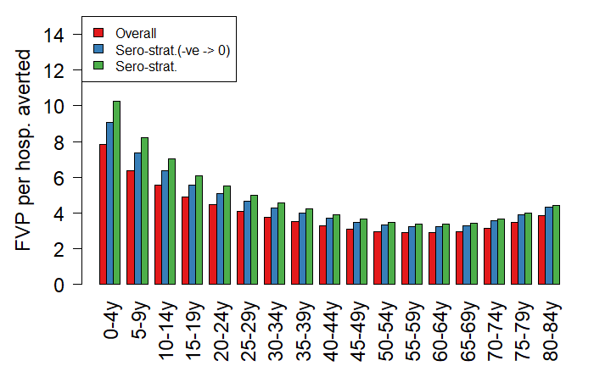

Notes of efficacy calculation on modelling:

How did I calculate the efficacy over time?
I have used the used the trial data from the following 5 studies:
Source | Timeline | Remark
Biswal et al., NEJM, 2019 | For 1-12 months | Calculated VE for 1-12 months
Biswal et al., Lancet, 2020 | Up to 18 months post vaccination | Calculated VE for 13-18 Months
Lopez-Medina et al., J. Inf. Dis., 2020 | Up to 24 months post vaccination | Calculated VE for 19-24 months
Rivera et al., Clin. Inf. Dis., 2022 | For 25-36 months | Calculated VE for 25-36 months
Tricou et al., Lancet, 2024 | For 37-48 months and 37-54 months | Calculated VE for 37-48 months and for 49-54 months

Note that these studies reported VE estimates mainly for (i) Safety set population, and (ii) Per-protocol population. Also, the formula for calculating VE is not uniform in these study. For example, in Biswal et al., NEJM, 2019, they used the formula, VE = 1- Relative risk, whereas in the subsequent they did not use the formula, instead it seems (Not clearly mentioned in the studies though!) they modified the formula incorporating “Person-year at risk”, etc.
Since per-protocol are those who completed the trial, I only focused on this population. I mainly collated four quantities:
- Cases in TAK-003
- Participants in TAK-003
- Cases in Placebo
- Participants in Placebo
Note that the participants both in TAK-003, and Placebo did not remain exactly same over the time, but the differences are very little.

After gathering, these four quantities, I have calculated VE just using the simple formula at these 6 time points,
VE = 100*(1 – Relative Risk (RR)),
Where RR is defined as the ratio of attack rate in TAK-003 group and Placebo group.
So, this calculation of VE might not match with estimates provided in these studies as they used different formulae.
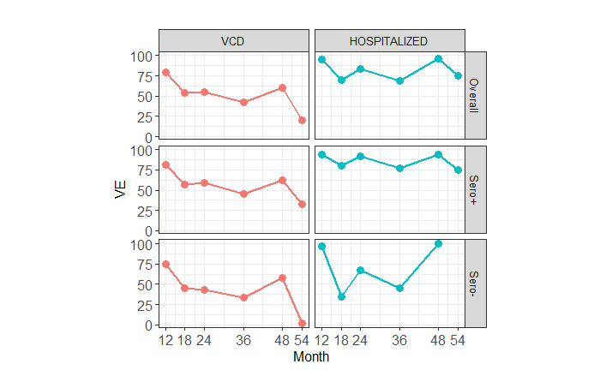
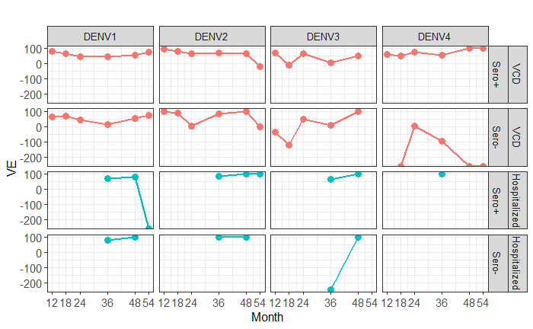
Note that serotype-stratified VE, mainly for Hospitalized are not available.
The figure below shows the number of cases over time in both Vaccine and Placebo groups.
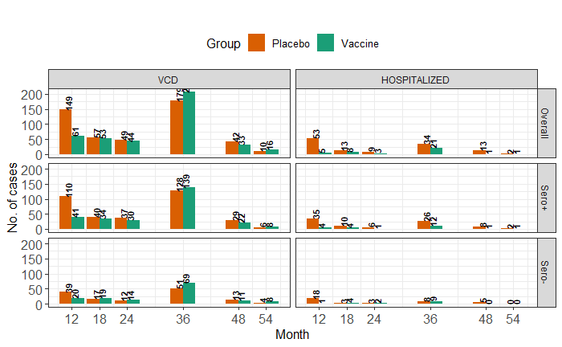
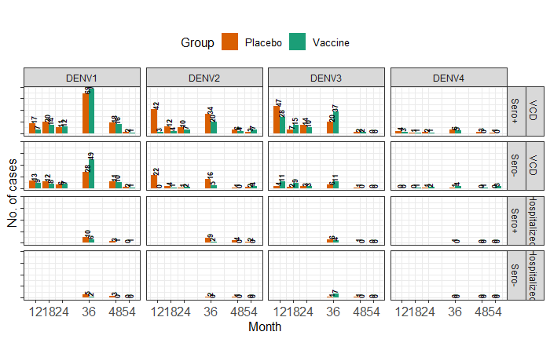

Which VE estimates have been used so far in the transmission model?
The cumulative efficacy up to 54 months for Safety set from Tricou et al., Lancet, 2024, have been used and assumed it remains same over the time. The estimates are serotype and sero-status stratified both for VCD and hospitalization.

How to incorporate waning of VE?
“Is this issue how to model or how to parameterize? The figures don’t show the numbers of events in each group as far as I can tell, but it looks like perhaps there is a dip at the 54 months. Simplest would be the same VE up until this point then a lower after that so we only need two subgroups in the vaccinated. That should be fairly straight forward to model but let me know if not. We aren’t then dealing with longer term waning, so if we can get three time since vaccination groups then that would be helpful for sensitivity around this.”

Looking at the VE estimates over time (Figure 1), it seems there is a decreasing trend in VE for VCD, but for hospitalized it not that clearly visible. If we look at the serotype stratified estimates (Figure 2), it is getting difficult to conclude that there was a reduction in VE over time.

Just for the reference, in HITAP meeting, Prof. Neil showed the estimates of VE over time (stratified wrt to serotype and serostatus), using a survival model. Here the decreasing trend is clearly visible (see the screenshot below). Consequently, these estimates have been used in the transmission model, and created some scenarios: VE decays with this rate for next few years and then stops decaying.
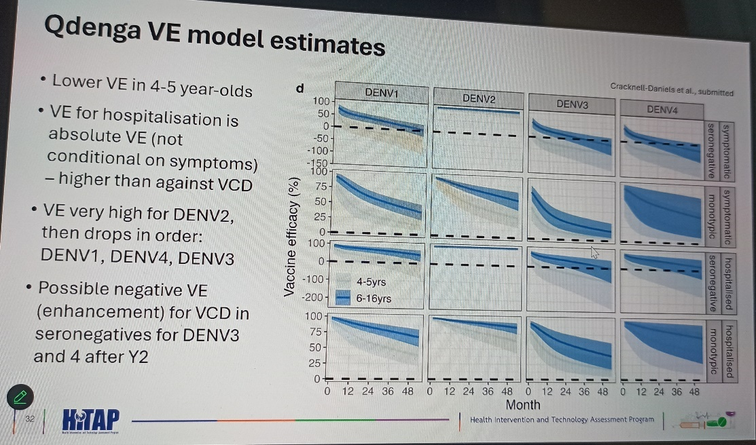

Parametrization:
- However, in our case, for simplicity if we assume that VE remains same until 54 months, then we need to somehow justify our assumption.
- If we can justify that, the next task is, which VE estimate to consider as baseline? The cumulative VE up to 54 months reported for Safety set in Tricou et al, Lancet, 2024 (the same estimate I have used in the analysis so far)? Or we can calculate the VE up to 54 months from per-protocol population using the simple formula, VE = 1 – Relative Risk?
- We can then create scenarios based on the rate of decay and time point after which it stops decaying.

Modelling:
To adapt waning of VE in the transmission model, I am considering
- one compartment for tracking the 54 months since vaccination with baseline VE (no decay),
- then they will transferred to the compartments where there will be decay in VE with a specific rate up to “y” years.
- Finally, they will move to the compartment where there won’t be any decay on VE.
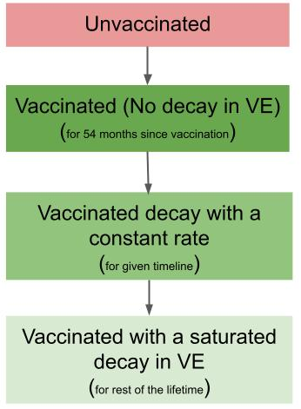

Latest Outputs from the model

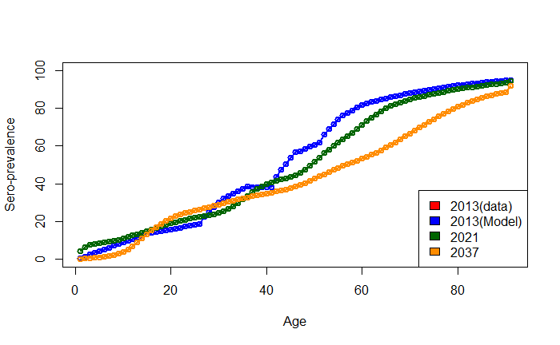
Serotype-specific annual infection (Primary and Secondary separately)
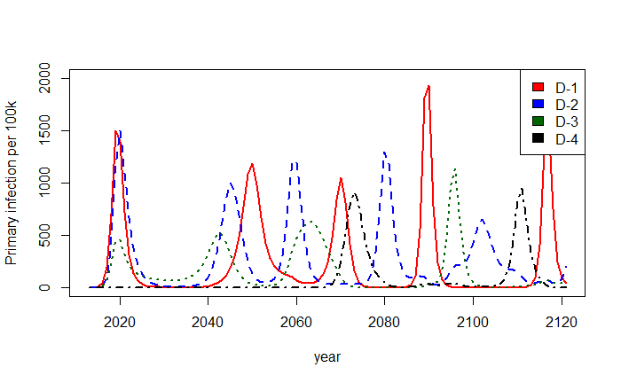
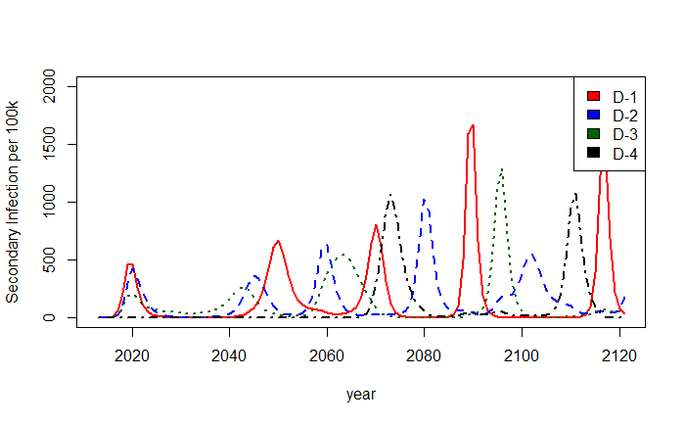

Possible sources of uncertainties:
- Uncertainty of estimated parameters
- Vaccine efficacy
- Timing of vaccination introduction

References:

Anderson, K.B. et al. (2014) ‘A Shorter Time Interval Between First and Second Dengue Infections Is Associated With Protection From Clinical Illness in a School-based Cohort in Thailand’, The Journal of Infectious Diseases, 209(3), pp. 360–368. Available at: https://doi.org/10.1093/infdis/jit436.
Ang, L.W. et al. (2019) ‘A 15-year review of dengue hospitalizations in Singapore: Reducing admissions without adverse consequences, 2003 to 2017’, PLOS Neglected Tropical Diseases. Edited by B. Althouse, 13(5), p. e0007389. Available at: https://doi.org/10.1371/journal.pntd.0007389.
Cox, V. et al. (2022) ‘Estimating dengue transmission intensity from serological data: A comparative analysis using mixture and catalytic models’, PLOS Neglected Tropical Diseases. Edited by J.T. Wu, 16(7), p. e0010592. Available at: https://doi.org/10.1371/journal.pntd.0010592.
Ferguson, N.M. et al. (2016) ‘Benefits and risks of the Sanofi-Pasteur dengue vaccine: Modeling optimal deployment’, Science, 353(6303), pp. 1033–1036. Available at: https://doi.org/10.1126/science.aaf9590.
Ferguson, N.M., Donnelly, C.A. and Anderson, Roy M. (1999) ‘Transmission dynamics and epidemiology of dengue: insights from age–stratified sero–prevalence surveys’, Philosophical Transactions of the Royal Society of London. Series B: Biological Sciences. Edited by R. M. Anderson, 354(1384), pp. 757–768. Available at: https://doi.org/10.1098/rstb.1999.0428.
Flasche, S. et al. (2016) ‘The Long-Term Safety, Public Health Impact, and Cost-Effectiveness of Routine Vaccination with a Recombinant, Live-Attenuated Dengue Vaccine (Dengvaxia): A Model Comparison Study’, PLOS Medicine. Edited by L. Von Seidlein, 13(11), p. e1002181. Available at: https://doi.org/10.1371/journal.pmed.1002181.
Ho, S.H. et al. (2023) ‘Singapore’s 5 decades of dengue prevention and control—Implications for global dengue control’, PLOS Neglected Tropical Diseases. Edited by D.J. Gubler, 17(6), p. e0011400. Available at: https://doi.org/10.1371/journal.pntd.0011400.
Murgue, B. et al. (2000) ‘Prospective study of the duration and magnitude of viraemia in children hospitalised during the 1996-1997 dengue-2 outbreak in French Polynesia’, Journal of Medical Virology, 60(4), pp. 432–438. Available at: https://doi.org/10.1002/(SICI)1096-9071(200004)60:4<432::AID-JMV11>3.0.CO;2-7.
Quan, T.M. et al. (2018) ‘Evidence of previous but not current transmission of chikungunya virus in southern and central Vietnam: Results from a systematic review and a seroprevalence study in four locations’, PLOS Neglected Tropical Diseases. Edited by B. Althouse, 12(2), p. e0006246. Available at: https://doi.org/10.1371/journal.pntd.0006246.
Rajarethinam, J. et al. (2018) ‘Dengue in Singapore from 2004 to 2016: Cyclical Epidemic Patterns Dominated by Serotypes 1 and 2’, The American Journal of Tropical Medicine and Hygiene, 99(1), pp. 204–210. Available at: https://doi.org/10.4269/ajtmh.17-0819.
Salazar, M.I. et al. (2007) ‘Dengue virus type 2: replication and tropisms in orally infected Aedes aegypti mosquitoes’, BMC Microbiology, 7(1), p. 9. Available at: https://doi.org/10.1186/1471-2180-7-9.
Sheppard, P.M. et al. (1969) ‘The Dynamics of an Adult Population of Aedes aegypti in Relation to Dengue Haemorrhagic Fever in Bangkok’, The Journal of Animal Ecology, 38(3), p. 661. Available at: https://doi.org/10.2307/3042.
Singapore Population (2024). Available at: http://www.singstat.gov.sg/modules/infographics/population (Accessed: 4 March 2024).
Tan, L.K. et al. (2019) ‘Force of Infection and True Infection Rate of Dengue in Singapore: Implications for Dengue Control and Management’, American Journal of Epidemiology, 188(8), pp. 1529–1538. Available at: https://doi.org/10.1093/aje/kwz110.
Whitmire, R.E. et al. (1987) ‘Effect of Temperature on the Vector Efficiency of Aedes aegypti for Dengue 2 Virus’, The American Journal of Tropical Medicine and Hygiene, 36(1), pp. 143–152. Available at: https://doi.org/10.4269/ajtmh.1987.36.143.

