Modelling dengue vaccination strategies in Singapore

Author¹, Author^{1,2*}

Affiliations:
¹Saw Swee Hock School of Public Health, National University of Singapore
²National University Health System, Singapore

Abstract
Dengue virus, with all four serotypes in cocirculation, has created significant epidemiologic and economic burdens in Singapore. Despite the implementation of several integrated vector control programs, the magnitude and frequency of periodic dengue outbreaks have increased over the last few decades. This highlights the inadequacy of existing control strategies in preventing dengue outbreaks in Singapore. In this context, vaccination has emerged as a promising approach to enhance population immunity and could complement ongoing vector control measures.
In this study, we develop an age-stratified, multi-serotype, compartmental-based dengue transmission model to evaluate the potential impact of different vaccination strategies on dengue transmission dynamics in Singapore. The baseline transmission model is calibrated using available data on age-specific dengue seroprevalence and reported incidence of cases from Singapore in a Bayesian framework. We incorporate the serotype- and baseline serostatus-specific efficacy of the commercially available dengue vaccine Qdenga, based on clinical trial data from dengue-endemic regions of Asia and Latin America. Several scenarios related to vaccination coverage, targeted age groups, and waning vaccine efficacy are designed to assess the impact of vaccination on symptomatic disease and hospitalization using various metrics. Our model predicts that vaccination has an overall positive population-level impact under variable vaccination efficacy against serostatus and serotypes. In assessing the optimal age group for vaccination, we show that targeting older age groups could be more beneficial than targeting younger age groups in terms of averting reported dengue incidence and hospitalization over a 50-year post-vaccination period. Moreover, vaccinating older age groups can also avoid individual-level negative impacts.
The results of this study provide valuable insights for policymakers and public health authorities in Singapore on designing evidence-based optimal vaccination strategies to reduce the burden of dengue in the country. The findings underscore the necessity of a comprehensive approach to dengue control, integrating targeted vaccination strategies with vector control measures for efficient disease management.
Key words: Dengue, Vaccination, Qdenga, Singapore, Transmission modelling

Introduction
Dengue fever, a mosquito-borne viral infection caused by the dengue virus, poses a significant global health burden. An estimated 390 million dengue infections occur annually, with over half the global population at risk, predominantly in tropical and subtropical regions. The burden is particularly acute in Southeast Asia, which consistently reports high incidence rates and severe dengue outbreaks. Within this region, Singapore stands out not only due to its high dengue incidence rates but also for its unique urban landscape, extensive public health infrastructure, and vector control programs.
Globally, dengue’s burden has increased exponentially over the past few decades due to urbanization, globalization, and climate change, which enhance mosquito breeding conditions. Dengue’s epidemiology is complex, driven by four virus serotypes (DENV1–4), each contributing to varying degrees of disease severity and immunity. The Force of Infection (FOI), which measures the rate at which susceptible individuals acquire infection, is crucial for understanding dengue transmission dynamics. Despite successful vector control efforts, Singapore has seen an increasing trend in dengue cases over the years.
Singapore’s urbanized environment, dense population, and sophisticated health infrastructure create a unique landscape for dengue transmission. Despite aggressive mosquito control measures and public health interventions, the country continues to face periodic dengue outbreaks. The hot and humid climate, coupled with a mobile and interconnected population, fosters conditions conducive to the proliferation of the primary dengue vector, Aedes aegypti. Singapore's health surveillance system is robust, enabling early detection and response, yet the complexities of multi-serotype transmission and immunity dynamics make control challenging.
The development of dengue vaccines has been an active area of research, with the first licensed dengue vaccine, CYD-TDV (Dengvaxia), marking a significant milestone. However, CYD-TDV’s safety and efficacy vary across serotypes and depend on prior dengue exposure, limiting its use to individuals with evidence of previous infection. Other vaccines, such as TAK-003 (developed by Takeda), have shown promising results in clinical trials, offering broader protection against dengue regardless of prior exposure. In addition, several other vaccine candidates are in various stages of development, each contributing to the evolving landscape of dengue prevention strategies.
Given the unique epidemiology of dengue in Singapore and the continued threat of outbreaks despite effective vector control programs, vaccination represents a critical component of the country’s long-term strategy to reduce dengue incidence. The introduction of a suitable vaccine could help mitigate the burden of the disease, particularly in high-risk populations. In Singapore, where the population has heterogeneous exposure to dengue, identifying an appropriate vaccination strategy requires careful consideration of factors such as age, prior exposure, and the local FOI. Vaccination, when combined with existing vector control efforts, could significantly reduce the number of severe dengue cases and hospitalizations, alleviating both public health and economic burdens.
This study presents the first modeling effort to evaluate the potential impact of dengue vaccination in Singapore. By incorporating local epidemiological data, serotype-specific FOI estimates, and vaccine efficacy data, this model provides insights into the effectiveness of vaccination strategies tailored to Singapore's unique context. It aims to offer evidence-based guidance for policymakers on the potential benefits and limitations of introducing dengue vaccination into the national immunization program.

Methods

Transmission model
We developed a deterministic, multi-serotype, age-stratified compartmental transmission model that includes both human and adult mosquito population explicitly. Humans are assumed to be born susceptible and can get primary infection from one of the four dengue serotypes: DENV-I, DENV-II, DENV-III, DENV-IV. Upon recovery from primary infection, they acquired permanent protection against homologous infection and transient cross-protection against heterologous infection. Once the duration of cross-protection stage is over, individuals become susceptible to secondary infection by all the serotypes other than their primary infection causing serotypes. Based on the rarity of third and fourth infections (Endy et al., 2007), we make the assumption that individuals acquired complete protection from dengue infection after secondary infection (Cummings et al., 2005; Recker et al., 2009). We assume that the fraction of dengue infection to be reported as cases depends both on age and order of infection (i.e., primary or secondary). We also assume that the secondary infection is more likely to be reported than the primary infection. Regarding hospitalization, we considered antibody-dependent enhancement in disease severity and assumed that that the fraction of reported cases due to secondary infection that requires hospitalization is higher than that of reported cases due to primary infection.
The mosquito population is assumed to be constant over time. Mosquitoes become infected upon feeding on humans infected with a specific serotype. Due to short life span they remain infected for the rest of their life.
The vaccination is introduced among the individuals in a targeted age groups in four different compartments: (i) individuals who have never experience dengue infection, (ii) individuals who had one previous exposure but currently are cross-protected, (iii) individuals who had one previous exposure but now susceptible to infection from remaining serotypes, and (iv) individuals who had two previous exposures. We consider three different vaccine efficacy parameters: (i) efficacy against dengue infection, (ii) efficacy against Virologically Confirmed Dengue (VCD), and (iii) efficacy against hospitalization. The vaccine efficacy estimates from vaccine trial showed variability mainly with respect to baseline serostatus of vaccinated individuals, serotype, and time since completion of vaccination (we name it as “stage” after vaccination). Therefore, we consider the vaccine efficacy to be stratified by baseline serostatus, serotype and stage. However, due to unavailability of the evidence of efficacy of Qdenga against infection, we consider the vaccine efficacy against infection only to be stratified by baseline serostatus and stage.
The mathematical equations describing the model, description of variables and parameters are presented in Supplementary.
Model calibration:
We consider only Singaporean citizen and permanent resident (PR) and group them into 91 age groups: 0 to 89 years with 1 year age bracket and 90 years & above. The data for birth and death rate for the period 2013 to 2021 are taken from (“Singapore Population,” 2024). The projection of birth rate and death rates for 2022 onwards are taken from World population prospects (add ref.).
We use a time varying catalytic model on the age-specific seroprevalence data from the sero-survey conducted in 2013 in Singapore (add ref.) to estimate the proportion of individuals who had exactly one infection, at least one infection, and two or more infections in each age group. These estimates have been used to calculate the corresponding initial conditions of the model. The average annual force of infection estimated using the catalytic model is around 0.01 (see Figure S1). We set the disease transmission related parameters in such a way that the model approximately generates the estimated annual force of infection (see Table S2 for parameter values).
We calibrated the model to the data on age-stratified annual incidence of dengue cases per 100,000 population (Singaporean citizen and PR) during 2013 to 2020, collected from MOH, Singapore ( add .ref). The data were reported for the following 8 age groups: 0-4 years, 5-14 years, 15-24 years, 25-34 years, 35-44 years, 45-54 years, 55-64 years, and 65+ years. We use a Bayesian framework implanted using “odin” library in R to fit our model and estimated 8 age-specific fractions of secondary infection reported to as cases. We use Poisson likelihood and choose uniform priors ($U\left[0,1\right]$) for all the estimated parameters. The model fitting is presented in Figure S#. Also, the estimated parameters values are presented in Table S# and the trace plot of the MCMC chain is presented in Figure S#.
To evaluate the impact of vaccine, for each scenario we randomly draw 100 samples from the posterior distribution of the estimated parameters and from intervals of VE estimates.
For VE estimates, we transform the

Conditional Vaccine efficacy:

Results

Discussion:

Supplementary Material

Mathematical form of the transmission model
$$\frac{dS^{a}}{dt}=Λ^{h}-\left(\sum_{i=1}^{4}{λ_{i}^{m}}+μ^{h}\right)S^{a}+a_{+}S^{a-1}-a_{-}S^{a}-pS^{a},$$
$$\frac{dI_{i}^{a}}{dt}=λ_{i}^{m}S^{a}-\left(γ_{1}+μ^{h}\right)I_{i}^{a}+a_{+}I_{i}^{a-1}-a_{-}I_{i}^{a},$$
$$\frac{dC_{i}^{a}}{dt}=γ_{1}I_{i}^{a}-\left(α+μ^{h}\right)C_{i}^{a}+a_{+}C_{i}^{a}-a_{-}C_{i}^{a}–pC_{i}^{a},$$
$$\frac{dS_{i}^{a}}{dt}=αC_{i}^{a}-\left(\sum_{j≠i}{λ_{j}^{m}}+μ^{h}\right)S_{i}^{a}+a_{+}S_{i}^{a-1}-a_{-}S_{i}^{a}-pS_{i}^{a},$$
$$\frac{dI_{ij}^{a}}{dt}=λ_{j}^{m}S_{i}^{a}-\left(γ_{2}+μ^{h}\right)I_{ij}^{a}+a_{+}I_{ij}^{a-1}-a_{-}I_{ij}^{a},$$
$$\frac{dR^{a}}{dt}=γ_{2}\sum_{i,j}{I_{ij}^{a}}-μ^{h}R^{a}+a_{+}R^{a-1}-a_{-}R^{a}-pR^{a},$$
$$\frac{dS^{m}}{dt}=Λ^{m}-\left(\sum_{i=1}^{4}{λ_{i}^{h}}+μ^{m}\right)S^{m},$$
$$\frac{dE_{i}^{m}}{dt}=λ_{i}^{h}S^{m}-\left(σ^{m}+μ^{m}\right)E_{i}^{m},$$
$$\frac{dI_{i}^{m}}{dt}=σ^{m}E_{i}^{m}-μ^{m}I_{i}^{m},$$
$$\frac{dS_{v}^{sa}}{dt}=pS^{a}–\left(1-ϵ_{s}^{inf-}\right)\left(\sum_{i=1}^{4}{λ_{i}^{m}}+μ^{h}\right)S_{v}^{sa}+a_{+}S_{v}^{sa-1}–a_{-}S_{v}^{sa}+s_{+}S_{v}^{s-1a}-s_{-}S_{v}^{sa},$$
$$\frac{dI_{vi}^{sa}}{dt}=\left(1-ϵ_{s}^{inf-}\right)λ_{i}^{m}S_{v}^{sa}-\left(γ_{1}+μ^{h}\right)I_{vi}^{sa}+a_{+}I_{vi}^{sa-1}-a_{-}I_{vi}^{sa}+s_{+}I_{vi}^{s-1a}-s_{-}I_{vi}^{sa},$$
$$\frac{dC_{vi}^{sa}}{dt}=pC_{i}^{a}+γ_{1}I_{vi}^{sa}-\left(α+μ^{h}\right)C_{vi}^{sa}+a_{+}C_{vi}^{sa-1}-a_{-}C_{vi}^{sa}+s_{+}C_{vi}^{s-1a}-s_{-}C_{vi}^{sa},$$
$$\frac{dS_{vi}^{sa}}{dt}=pS_{i}^{a}+αC_{vi}^{sa}-\left(1-ϵ_{s}^{inf+}\right)\left(\sum_{j≠i}{λ_{j}^{m}}+μ^{h}\right)S_{vi}^{sa}+a_{+}S_{vi}^{sa-1}-a_{-}S_{vi}^{sa}+s_{+}S_{vi}^{s-1a}-s_{-}S_{vi}^{sa},$$
$$\frac{dI_{vij}^{sa}}{dt}=\left(1-ϵ_{s}^{inf+}\right)λ_{j}^{m}S_{vi}^{sa}-\left(γ_{2}+μ^{h}\right)I_{vij}^{sa}+a_{+}I_{vij}^{sa-1}-a_{-}I_{vij}^{sa}+s_{+}I_{vij}^{s-1a}-s_{-}I_{vij}^{sa},$$
$$\frac{R_{v}^{sa}}{dt}=pR^{a}+γ_{2}\sum_{i,j}{I_{vij}^{sa}}-μ^{h}R_{v}^{sa}+a_{+}R_{v}^{sa-1}-a_{-}R_{v}^{sa}+s_{+}R_{v}^{s-1a}-s_{-}R_{v}^{sa},$$
The force of infection on human due to serotype i, is given by
$$λ_{i}^{m}=\frac{bβ_{i}^{m}I_{i}^{m}}{N}$$
The force of infection on mosquito from human infected with serotype i, is given by
$$λ_{i}^{h}=\frac{bβ_{i}^{h}\left(\sum_{a}{I_{i}^{a}}+\sum_{a,j\left(j≠i\right)}{I_{ji}^{a}}+\sum_{a}{I_{vi}^{a}}+\sum_{a,j\left(j≠i\right)}{I_{vji}^{a}}\right)}{N}$$
The incidence of infection of age a at time t due to serotype i is given by,
$$Inf_{i}^{a}\left(t\right)=λ_{i}^{m}S^{a}+\sum_{j\left(≠i\right)}{λ_{j}^{m}}S_{i}^{a}+\sum_{s}{\left(1-ϵ_{s}^{inf-}\right)λ_{i}^{m}S_{v}^{sa}}+\sum_{s,j\left(≠=i\right)}{\left(1-ϵ_{s}^{inf+}\right)λ_{j}^{m}S_{vi}^{sa}}$$

The incidence of reported cases of age at time t due to serotype i is given by,
$$Rep_{i}^{a}\left(t\right)=ρ_{1}^{a}λ_{i}^{m}S^{a}+ρ_{2}^{a}\sum_{j\left(≠i\right)}{λ_{j}^{m}}S_{i}^{a}+ρ_{1}^{a}\sum_{s}{\left(1-ϵ_{si}^{vcd-}\right)\left(1-ϵ_{s}^{inf-}\right)λ_{i}^{m}S_{v}^{sa}}+ρ_{2}^{a}\sum_{s,j\left(≠=i\right)}{\left(1-ϵ_{si}^{vcd+}\right)\left(1-ϵ_{s}^{inf+}\right)λ_{j}^{m}S_{vi}^{sa}}$$

$$Rep_\{i\}^\{a\}(t) = ρ_\{1\}^\{a\} λ_\{i\}^\{m\}S^\{a\} + ρ_\{2\}^\{a\} ∑_\{j(≠i)\} λ_\{j\}^\{m\}S_\{i\}^\{a\} + ρ_\{1\}^\{a\} ∑_\{s\} (1- ϵ_\{si\}^\{vcd - ∣inf-\})$$

The incidence of hospitalization of age a at time t due to serotype i is given by,
$$Hosp_{i}^{a}\left(t\right)=ξ_{1}ρ_{1}^{a}λ_{i}^{m}S^{a}+ξ_{2}ρ_{2}^{a}\sum_{j\left(≠i\right)}{λ_{j}^{m}}S_{i}^{a}+ξ_{1}ρ_{1}^{a}\sum_{s}{\left(1-ϵ_{si}^{hosp-}\right)\left(1-ϵ_{si}^{vcd-}\right)\left(1-ϵ_{s}^{inf-}\right)λ_{i}^{m}}S_{v}^{sa}+ξ_{2}ρ_{2}^{a}\sum_{s,j\left(≠=i\right)}{\left(1-ϵ_{si}^{hosp+}\right)\left(1-ϵ_{si}^{vcd+}\right)\left(1-ϵ_{s}^{inf+}\right)λ_{j}^{m}}S_{vi}^{sa}$$

Symbol | Description
$$S^{a}\left(t\right)$$ | Number of people of age a at time t, who are susceptible to infection from any serotype
$$I_{i}^{a}\left(t\right)$$ | Number of people of age a at time t, who are infected with serotype i (primary infection)
$$C_{i}^{a}\left(t\right)$$ | Number of people of age a at time t who are immune to infection from serotype i, and temporarily protected against heterologous infection
$$S_{i}^{a}\left(t\right)$$ | Number of people of age a at time t who are immune to infection from serotype i but remain susceptible to infection from other serotypes
$$I_{ij}^{a}\left(t\right)$$ | Number of people of age a at time t who are immune to infection from serotype i, but infected with serotype j ($≠i)$ (secondary infection)
$$R^{a}\left(t\right)$$ | Number of people of age a at time t who are recovered from secondary infection
$$S_{v}^{sa}\left(t\right)$$ | Number of vaccinated people of age a, in stage s at time t, who are susceptible to infection from any serotype
$$I_{vi}^{sa}\left(t\right)$$ | Number of vaccinated people of age a in stage s at time t, who are infected with serotype i (primary infection)
$$C_{vi}^{sa}\left(t\right)$$ | Number of vaccinated people of age a in stage s at time t who are immune to infection from serotype i, and temporarily protected against heterologous infection
$$S_{vi}^{sa}\left(t\right)$$ | Number of vaccinated people of age a in stage s at time t who are immune to infection from serotype i but remain susceptible to infection from other serotypes
$$I_{vij}^{sa}\left(t\right)$$ | Number of vaccinated people of age a in stage s at time t who are immune to infection from serotype i, but infected with serotype j ($≠i)$ (secondary infection)
$$R_{v}^{sa}\left(t\right)$$ | Number of vaccinated people of age a in stage s at time t who are recovered from secondary infection
$$S^{m}\left(t\right)$$ | Number of uninfected adult female mosquitoes at time t
$$E_{i}^{m}\left(t\right)$$ | Number of adult female mosquitoes at time t in incubation period infected with serotype i
$$I_{i}^{m}\left(t\right)$$ | Number of infectious adult female mosquitoes infected with serotype i
Table S1: The description of the state variables used in the model.

Parameters | Description | Value | Source | Remarks
$$Λ^{h}$$ | Human birth rate | Crude birth rate * Total population  (Time dependent) | (“Singapore Population,” 2024)  Reported as births per 1000 population in a year  For projection: World Population Prospects (WPP) | From this raw data first calculate per capita birth rate simply dividing 1000 and make it daily rate (by dividing it 365) then multiply it with total population.  For, future data, we use the “medium” projection of birth rate from world population prospects (WPP)
$$μ^{h}$$ | Human mortality rate | Time dependent | (“Singapore Population,” 2024) | Followed same approach as in Birth rate.
$$ρ_{1}$$ | Proportion of primary infection to be reported | $$\frac{1}{2}ρ_{2}$$ | Assumed
$$ρ_{2}$$ | Proportion of secondary infection to be reported | Age-specific. For 8 different age-groups:  0 - 4 y, 5 - 14 y,  15 - 24 y, 25 - 34 y, 35 – 44 y, 45 – 54 y, 55 – 64 y, 65+ y | Estimated from age-stratified annual case notification data from 2013-2020
$$ξ_{1}$$ | Proportion of primary infection require hospitalization | $$\frac{1}{4}ξ_{2}$$  (Assumed primary symptomatic infections are 75% less likely to be hospitalized following (Ferguson et al., 2016))
$$ξ_{2}$$ | Proportion of secondary infection require hospitalization | 0.30 | (Ang et al., 2019) | During 2003 – 2005, the rate was more than 88%. However, over time it has been reduced. In 2017, it became 35.9%. However, this study did not specify if the hospitalization is due to primary or secondary infection.
$$\frac{1}{γ}$$ | Infectious period of human | 4 days | (Murgue et al., 2000)
$$\frac{1}{α}$$ | Duration of heterologous protection from infection | 1 year | (Anderson et al., 2014)
$$b$$ | Mosquito biting rate | 15 | Assumed
$$β_{i}^{h}$$ | Per bite probability of transmission from infected human to mosquitoes | 0.2 | Assumed
$$β_{i}^{m}$$ | Per bite probability of transmission from infected mosquitoes  to human | 0.166 (DENV-I)  0.176 (DENV-II)  0.152 (DENV-III)  0.144 (DENV-IV) | Calibrated to FOI estimate with b and $β_{i}^{h}$ kept fixed as above
$$\frac{1}{σ^{m}}$$ | Mean extrinsic incubation period | 10 days | (Salazar et al., 2007; Whitmire et al., 1987)
$$Λ^{m}$$ | Recruitment rate of mosquito | $μ^{m}$*Total Mosquito pop. | Assumed constant mosquito population over time. Also, initial susceptible mosquito (so as the total mosquito pop.) population is assumed to be 1% of initial total human population as Aedes House Index is reported to be around 1% since 1990s (Ho et al., 2023)
$$μ^{m}$$ | Adult mosquito mortality rate | 0.1 per day | (Ferguson et al., 2016; Sheppard et al., 1969)
$$a_{+}$$ | Rate at which individuals enter age group a from age group a-1 | $\frac{1}{365}$ per day for a = 2,3,…,91,  and 0 for a =1
$$a_{-}$$ | Rate at which individuals leaves age group a and enters age group a+1 | $\frac{1}{365}$ per day for a = 1,3,…,90,  and 0 for a =91
$$s_{+}$$ | Rate at which vaccinated individuals enter vaccination stage s from vaccination stage s-1 | $$\left(0,\frac{1}{30×12},\frac{1}{30×12},\frac{1}{30×12}\right)$$  per day
$$s_{-}$$ | Rate at which vaccinated individuals leave vaccination stage s and enter vaccination stage s+1 | $$\left(\frac{1}{30×12},\frac{1}{30×12},\frac{1}{30×12},0\right)$$  per day  per day
$$p$$ | Vaccination coverage | 0.2, 0.5, 0.8
$$ϵ_{s}^{\text{inf+}}$$ | Efficacy of vaccine against infection among baseline seropositive individuals in vaccination stage s
$$ϵ_{s}^{\text{inf}-}$$ | Efficacy of vaccine against infection among baseline seronegative individuals in vaccination stage s
$$ϵ_{si}^{vcd+∣inf+}$$ | Efficacy of vaccine against VCD due to serotype I, among baseline seropositive individuals in vaccination stage s | Calculated from Table S3 using the formula describe in Methods section
$$ϵ_{si}^{vcd-∣inf-}$$ | Efficacy of vaccine against VCD due to serotype I, among baseline seronegative individuals in vaccination stage s | See Table S3
$$ϵ_{si}^{hosp+∣vcd+}$$ | Efficacy of vaccine against hospitalization due to serotype i, among baseline seropositive individuals in vaccination stage s | See Table S4
$$ϵ_{si}^{hosp-∣vcd-}$$ | Efficacy of vaccine against hospitalization due to serotype i, among baseline seronegative individuals in vaccination stage s | See Table S4
Table S2: Model parameters used in the transmission model.

Baseline serostatus
Time  (months) | Seropositive |  |  |  | Seronegative
Time  (months) | D-I | D-II | D-III | D-IV | D-I | D-II | D-III | D-IV
0-12 | 79.8  (51.3 – 91.6) | 96.5  (88.8 – 98.9) | 71.4  (54.3 – 82.1) | 63.8  (-61.8 – 91.9) | 67.2  (23.2 - 86) | 100  (-) | -38.7  (-335.7 – 55.8) | -
13-24 | 59.1  (31.1 – 75.7) | 75.5  (49.5 – 88.1) | 44.9  (1.5 – 69.1) | 69  (-85.8 – 94.8) | 60.7  (22.1 – 80.2) | 70.5  (-23.4 - 93) | -18.5  (-236.2 – 58.3) | -47.6  (-1319.1 – 84.6)
25-36 | 45.4  (24.5 – 60.6) | 72.1  (51.6 - 84) | 15.2  (-46.1 – 50.8) | 61.9  (-24.9 – 88.4) | 17.2  (-31.8 – 47.9) | 84.9  (58.7 – 94.5) | 9.5  (-144.7 – 66.5) | -99  (-1680.3 – 77.8)
37-54 | 59.6  (22.8 – 78.8) | 42.6  (-38.7 – 76.2) | 52.4  (-238.3 – 93.3) | 100  (-) | 60.2  (11.1 – 82.2) | 35.7  (-187.3 – 85.6) | 100  (-) | -
Table S3: VE estimates against VCD stratified by baseline serostatus, serotype, and stage.

Baseline serostatus
Time  (months) | Seropositive |  |  |  | Seronegative
Time  (months) | D-I | D-II | D-III | D-IV | D-I | D-II | D-III | D-IV
0-12 | - | - | - | - | - | - | - | -
13-24 | - | - | - | - | - | - | - | -
25-36 | 71.6  (21.7 – 89.7) | 89.4  (51.1 – 97.7) | 69.6  (-7.9 – 91.4) | 100  (-) | 80.6  (-0.1 – 96.2) | 100  (-) | -246.6  (-2716.1 -57.3) | -
37-54 | 68.2  (-90.2 – 94.7) | 100  (-) | - | - | 100  (-) | 100  (-) | 100  (-) | -
Table S4: VE estimates against hospitalization stratified by baseline serostatus, serotype, and stage.

Time  (months) | VCD |  |  | Hospitalization
Time  (months) | Overall | Seropositive | Seronegative | Overall | Seropositive | Seronegative
0-12 | 80.2  (73.3 – 85.3) | 82.2  (74.5 – 87.6) | 74.9  (57 – 85.4) | 95.4  (88.4 – 98.2) | 94.4  (84.4 - 98) | 97.2  (79.1 – 99.6)
13-24 | 56.2  (42.3 – 66.8) | 60.3  (44.7 – 71.5) | 45.3  (9.9 – 66.8) | 76.1  (50.8 – 88.4) | 85.2  (59.6 – 94.6) | 51.4  (-50.7 – 84.3)
25-36 | 44.7  (32.5 – 54.7) | 48.3  (34.2 – 59.3) | 35.5  (7.3 – 55.1) | 70.8  (49.6 - 83) | 78.4  (57.1 – 89.1) | 45  (-42.6 – 78.8)
37-54 | 55.7  (34.5 - 70) | 59.6  (34.2 – 75.2) | 46.9  (-2.1 – 72.4) | 93.7  (72.4 – 98.6) | 90.4  (56.4 – 97.9) | 100  (-)
Table S5: VE estimates against VCD and hospitalization due to any serotype, stratified by baseline serostatus, and stage.

Parameter | Estimated value  Median (95% Credible Interval)
$$ρ_{2}^{0-4y}$$ | 0.074 (0.081- 0.089)
$$ρ_{2}^{5-14y}$$ | 0.261 (0.274 - 0.287)
$$ρ_{2}^{15-24y}$$ | 0.447 (0.464 - 0.481)
$$ρ_{2}^{25-34y}$$ | 0.421 (0.437- 0.453)
$$ρ_{2}^{35-44y}$$ | 0.414 (0.430 - 0.447)
$$ρ_{2}^{45-54y}$$ | 0.440 (0.458 - 0.475)
$$ρ_{2}^{55-64y}$$ | 0.465 (0.484 - 0.505)
$$ρ_{2}^{65+y}$$ | 0.636 (0.663 - 0.692)
Table S6: Estimated value of age-specific fraction of secondary infection to be reported.
Estimation of annual force of infection:
The fraction of people who remain susceptible (0-infection) in age group $a$, during year $X$, is given by:
$$s_{a,X}=exp\left(-\sum_{i=0}^{a}{\sum_{k=1}^{4}{λ_{X-i}^{k}}}\right)$$
( 1 )
Since, so far we do not have any information on serotype from sero-survey (except 2009- sero-survey, but not quite straight forward to use as do not have access to raw-data), we assume that the force of infection is time not serotype-specific, i.e. $λ_{k}=λ\left(k=1,2,3,4\right)$, then the equation becomes
$$s_{a,X}=exp\left(-4\sum_{i=0}^{a}{λ_{X-i}}\right)$$
( 2)
Now the fraction of people who experienced at least one infection is given by,
$$π_{a,X}=1-s_{a,X}$$
( 3)
The fraction of people who has experienced only one infection is given by,
$$ϕ_{a,X}=4\left(1-exp\left(-\sum_{i=0}^{a}{λ_{X-i}}\right)\right)exp\left(-3\sum_{i=0}^{a}{λ_{X-i}}\right)$$
( 4)

Finally, the fraction of people who has experienced more than one infection is given by,
$$α_{a,X}=1-s_{a,X}-ϕ_{a,X}$$
( 5)
Data
We have the sero-prevalence data obtained from sero-surveys done in 2013, 2017 in Singapore. We have the number of participants and number of sero-positives for the age group 16-71(2013), and 16-74(2017).
We choose the sero-survey done in 2013. The same approach can be adopted for the sero-survey done in 2017. The age group distribution in 2013-sero-survey was: "16-20y", "21-25y", "26-30y", "31-35y", "36-40y", "41-45y", "46-50y", "51-55y", "56-60y", "60+y". The data has been grabbed from the supplementary of previous study (Tan et al., 2019).
The average annual force-of-infection in respective periods 2008-2013, 2003-2007, ..., 1953-1957 are denoted by $λ^{p}$, $p=1,2,…,12$. $λ^{13}$ represents the average annual FOI estimated for the year 1922-1952. The estimate FOI is shown in Figure 1.
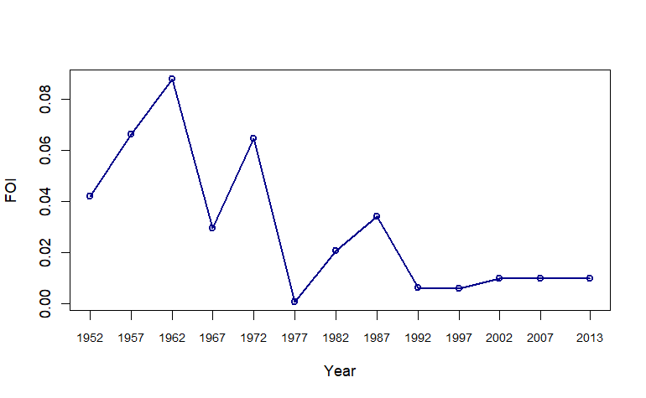
Figure S1: Estimates of FOI from 2013 sero-survey. The estimate for an interval is shown for the endpoint of that interval. For example the estimate shown at 2013 is the estiate of the average annual estimate for the time interval 2008-2013.

The model fit (time varying foi) with age-specific sero-prevalence data is presented in Figure 2.

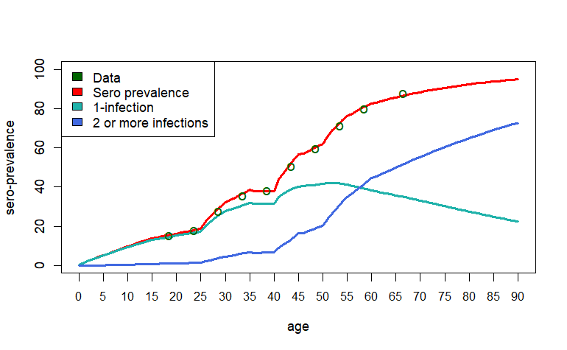
Figure S2: Reconstruction of pre-exposure history.

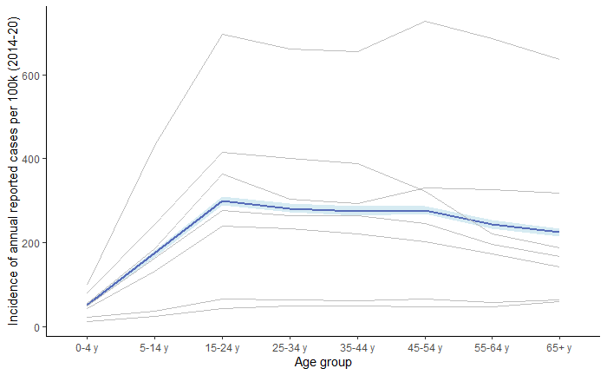

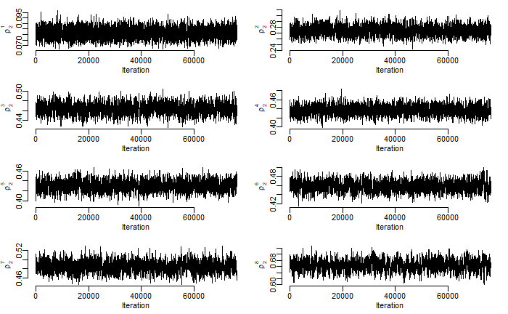

References:

Anderson, K.B., Gibbons, R.V., Cummings, D.A.T., Nisalak, A., Green, S., Libraty, D.H., Jarman, R.G., Srikiatkhachorn, A., Mammen, M.P., Darunee, B., Yoon, I.-K., Endy, T.P., 2014. A Shorter Time Interval Between First and Second Dengue Infections Is Associated With Protection From Clinical Illness in a School-based Cohort in Thailand. J. Infect. Dis. 209, 360–368. https://doi.org/10.1093/infdis/jit436
Ang, L.W., Thein, T.-L., Ng, Y., Boudville, I.C., Chia, P.Y., Lee, V.J.M., Leo, Y.-S., 2019. A 15-year review of dengue hospitalizations in Singapore: Reducing admissions without adverse consequences, 2003 to 2017. PLoS Negl. Trop. Dis. 13, e0007389. https://doi.org/10.1371/journal.pntd.0007389
Cummings, D.A.T., Schwartz, I.B., Billings, L., Shaw, L.B., Burke, D.S., 2005. Dynamic effects of antibody-dependent enhancement on the fitness of viruses. Proc. Natl. Acad. Sci. 102, 15259–15264. https://doi.org/10.1073/pnas.0507320102
Endy, T.P., Srikiatkhachorn, A., Jarman, R.G., Mammen, M.P., Vaughn, D.W., Kalanarooj, S., Nisalak, A., Gibbons, R.V., 2007. Analysis of Repeat Hospital Admissions for Dengue to Estimate the Frequency of Third or Fourth Dengue Infections Resulting in Admissions and Dengue Hemorrhagic Fever, and Serotype Sequences. Am. J. Trop. Med. Hyg. 77, 910–913. https://doi.org/10.4269/ajtmh.2007.77.910
Ferguson, N.M., Rodríguez-Barraquer, I., Dorigatti, I., Mier-y-Teran-Romero, L., Laydon, D.J., Cummings, D.A.T., 2016. Benefits and risks of the Sanofi-Pasteur dengue vaccine: Modeling optimal deployment. Science 353, 1033–1036. https://doi.org/10.1126/science.aaf9590
Flasche, S., Jit, M., Rodríguez-Barraquer, I., Coudeville, L., Recker, M., Koelle, K., Milne, G., Hladish, T.J., Perkins, T.A., Cummings, D.A.T., Dorigatti, I., Laydon, D.J., España, G., Kelso, J., Longini, I., Lourenco, J., Pearson, C.A.B., Reiner, R.C., Mier-y-Terán-Romero, L., Vannice, K., Ferguson, N., 2016. The Long-Term Safety, Public Health Impact, and Cost-Effectiveness of Routine Vaccination with a Recombinant, Live-Attenuated Dengue Vaccine (Dengvaxia): A Model Comparison Study. PLOS Med. 13, e1002181. https://doi.org/10.1371/journal.pmed.1002181
Ho, S.H., Lim, J.T., Ong, J., Hapuarachchi, H.C., Sim, S., Ng, L.C., 2023. Singapore’s 5 decades of dengue prevention and control—Implications for global dengue control. PLoS Negl. Trop. Dis. 17, e0011400. https://doi.org/10.1371/journal.pntd.0011400
Murgue, B., Roche, C., Chungue, E., Deparis, X., 2000. Prospective study of the duration and magnitude of viraemia in children hospitalised during the 1996-1997 dengue-2 outbreak in French Polynesia. J. Med. Virol. 60, 432–438. https://doi.org/10.1002/(SICI)1096-9071(200004)60:4<432::AID-JMV11>3.0.CO;2-7
Recker, M., Blyuss, K.B., Simmons, C.P., Hien, T.T., Wills, B., Farrar, J., Gupta, S., 2009. Immunological serotype interactions and their effect on the epidemiological pattern of dengue. Proc. R. Soc. B Biol. Sci. 276, 2541–2548. https://doi.org/10.1098/rspb.2009.0331
Salazar, M.I., Richardson, J.H., Sánchez-Vargas, I., Olson, K.E., Beaty, B.J., 2007. Dengue virus type 2: replication and tropisms in orally infected Aedes aegypti mosquitoes. BMC Microbiol. 7, 9. https://doi.org/10.1186/1471-2180-7-9
Sheppard, P.M., Macdonald, W.W., Tonn, R.J., Grab, B., 1969. The Dynamics of an Adult Population of Aedes aegypti in Relation to Dengue Haemorrhagic Fever in Bangkok. J. Anim. Ecol. 38, 661. https://doi.org/10.2307/3042
Singapore Population [WWW Document], 2024. URL http://www.singstat.gov.sg/modules/infographics/population (accessed 3.4.24).
Whitmire, R.E., Burke, D.S., Nisalak, A., Harrison, B.A., Watts, D.M., 1987. Effect of Temperature on the Vector Efficiency of Aedes aegypti for Dengue 2 Virus. Am. J. Trop. Med. Hyg. 36, 143–152. https://doi.org/10.4269/ajtmh.1987.36.143

