**COURSEWORK SUBMISSION FORM**

|  |  |  |  |
| --- | --- | --- | --- |
| **STUDENT USE** | | **STAFF USE** | |
| Module Name | Introduction to Information and Web Technologies | First Marker’s  (acts as signature) |  |
| Module Code | 3BUIS001C | Second Marker’s  (acts as signature) |  |
| Lecturer Name | Abduvosid Malikov  Olga Yugay | Agreed Mark |  |
| UoW Student IDs |  | **For Registrar’s office use only (hard copy submission)** | |
| WIUT Student IDs | 00010443 |
| Deadline date | 2nd of April, 2020 |
| Assignment Type | 🗌Group ☑Individual |

**SUBMISSION INSTRUCTIONS**

**COURSEWORKS *must* be submitted in *both* HARD COPY (to the Registrar’s Office) *and* ELECTRONIC unless instructed otherwise.**

For hardcopy submission instructions refer to: [http://intranet.wiut.uz/Shared%20Documents/Forms/AllItems.aspx](http://charlotte.wiut.uz:36765/Shared%20Documents/Forms/AllItems.aspx) - Coursework hard copy submission instructions.doc

For online submission instructions refer to: [http://intranet.wiut.uz/Shared%20Documents/Forms/AllItems.aspx](http://charlotte.wiut.uz:36765/Shared%20Documents/Forms/AllItems.aspx) - Coursework online submission instructions.doc

|  |
| --- |
| **MARKERS FEEDBACK (Continued on the next page)** |

Word count: 1256

Table of Contents

Description of main competitor's website………………………………………………………..3

Competitors ebsite evoluation…………………………………………………………………….4

Description of company I chose…………………………………………………………………..7

Summary…………………………………………………………………………………………7

Reference list…………………………………………………………………………………….8

Description of main competitor's website

This article describes the website of the main competitors of Still Young, which I chose to create the website. The competitor's website I selected belongs to one of the largest clothing stores in Uzbekistan. Website name Podiumitalia.uz and link address https://podiumitalia.uz/eng/ The website is owned by a boutique where clothes of the most popular brands of the world are sold. The oﬃcial Podium Italia website can be called an online catalog of fashion brands. Here users of website can ﬁnd small, informative and interesting articles about world-class clothing companies. The targeted audience of this company is vast. The catalogs show that Podium Italia stores have clothes for any gender and style. Age category from adolescents to middle-aged people. The site has 6 sections, such as "about the company", "catalog", "brands", "news", "contacts", "vacancies". In the section about the company, a small description of the company is described and photos of the store are presented. The brands section contains major global brands whose collections are sold in the Podium Italia boutique. The catalog section contains information about the new collections of these brands with photos straight from the catwalks. Each season, this section is updated in connection with the advent of new collections of clothing. A fashion news program is also available on the site. For example, for those who want to make a purchase, but do not know about current trends, there is a special news section. Also in the same section users of website can easily learn about various events from the company Podium Italia (about discounts, sales, forums and so on).

Competitors website evoluation.

Any website should have easy navigation. If the intricate transitions begin to disorient the visitor of website and prevent him from ﬁnding the necessary information, the user will prefer the competitors' website.  Therefore, it is important to have thoughtful navigation on the site.  There are three good navigation practices on the Podium Italia website.

1. Language navigation. This type of navigation is used for audiences who speak different languages. Three languages are popular in Uzbekistan: Uzbek, Russian and English. Therefore, on the Podium Italia website visitors can see this feature, which is not available in many other sites of local companies. (Lei Xu, Baowen Xu 2003)

2. Website menu. The website menu is located horizontally so that the user can safely see all the sectors immediately by accessing the web page. This method of Podium Italia website is well located in handheld devices too, like a smartphone. The menu in smartphones is hidden by a button at the top of the left side of the screen, so that it is convenient for a user with a small screen to distinguish sectors on the site. (Lei Xu, Baowen Xu 2003)

3. Thematic navigation. This type of navigation is very convenient for those who want to be informed about various news or events held in the company.  The Podium Italia website has a photo gallery where the user can go through the link under each photo to an article with thematic photos. This function helps the users to ﬁnd an interesting article for themself and follow the link to the full description of the article. (Lei Xu, Baowen Xu 2003)

Despite the convenient features and beautiful site design, there are several bad practices in oﬃcial Podium Italia website.

1. Lack of map. Since Podium Italia is a clothing store where customers come to buy goods, it would be nice to have a map on the site. The user can quickly navigate the map and ﬁnd the address of the store. But such a function is not available on the web page.

For this case, it is recommended to have a link to a map with the geolocation of brand stores in the "contacts" sector.

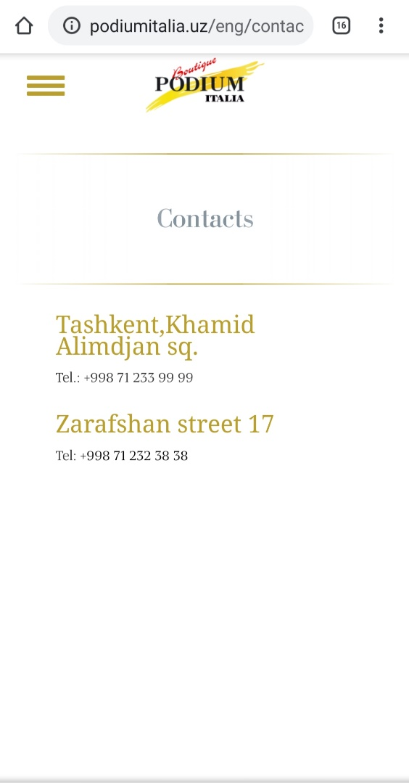

2. Incomprehensible information on the product account. The company’s website has a “brands” sector, where more than thirty brand names are represented. By clicking on the brand name, a little information about this brand appears on the website, but there is no information on whether these products are available in Podium Italia stores or not. Similarly, in other sectors there is no information about products that are sold in company boutiques. It is extremely inconvenient for customers to get an idea about the quality, price of the goods.

For this case, it is recommended to include in the menu the categories of clothes and their prices, which are available in boutiques of the company.

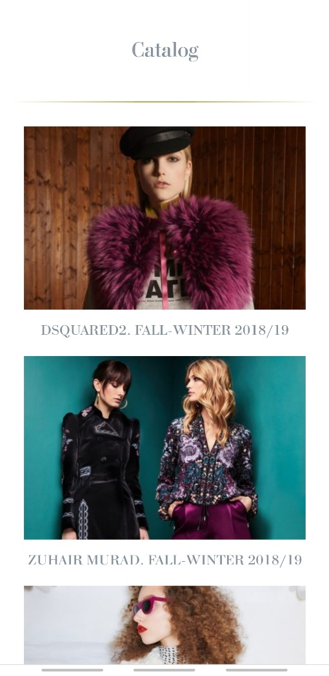

3. Footer. The footer usually records the addresses of links to social networks and the phone number of the company. Unfortunately, on the Podium Italia website, footer for smartphone users is extremely inconvenient. The page link in the Instagram application is very close to the page link in the Facebook application. Moreover, the footer phone number does not have a link to direct access to the phone call, which means the website user must separately dial the company number for the call. (Claire R McInerney, Nora J Bird 2006).

For such a case, it is recommended to insert direct access to the call into the phone number. It is also necessary to increase the distance between links to oﬃcial pages on social networks.

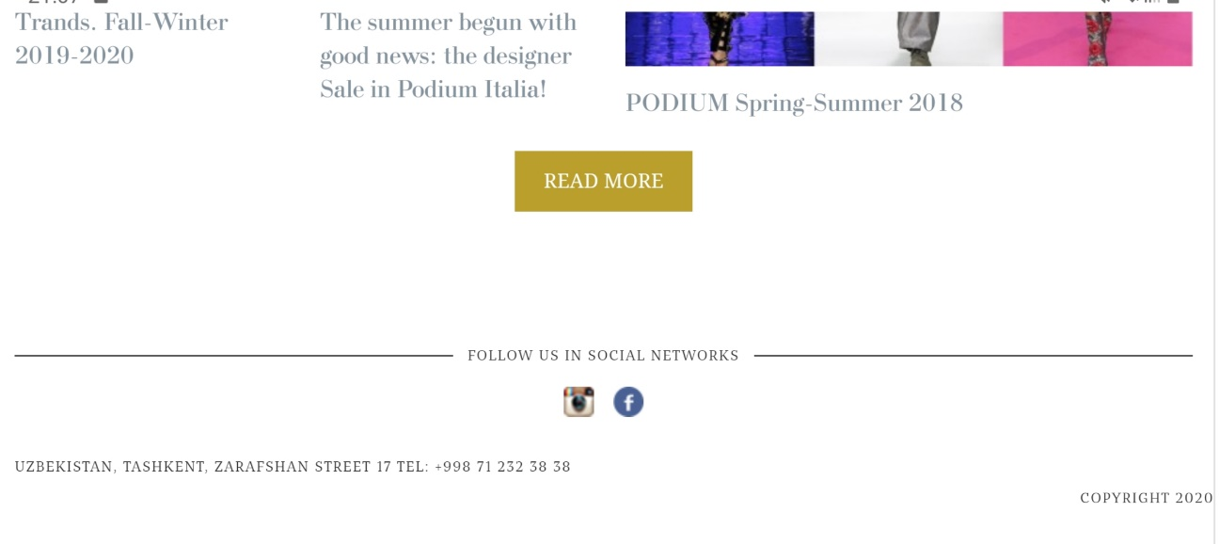

Description of company I chose

The company "Still Young" that I chose is one of the most popular clothing stores in Uzbekistan. According to the oﬃcial website of Still Young (stillyoung.uz/), most of the store’s target audience are women and girls, sometimes it maybe men who want to give a present to their female relatives, buying company's products. On the oﬃcial page of Still Young company in the Instagram application, it is indicated that the company has ﬁve branches throughout the country, three of which are located in Tashkent city. Regarding similar companies, the competition of the company is huge, as the audience of users is large. The direct competitors of this company are Podium Italia (whose website I reviewed above), Selﬁe Viva, Cherry Shop Uz and others.

Summary

Having studied the website of both companies (Still Young company for which I created the website and the oﬃcial website of Podium Italia), I wrote a short conclusion to my research.

Both companies have beautiful and easy-to-use website designs. The same and inaccuracies. Despite its popularity in the country, Podium Italia does not have direct access to product views on the site pages. As for the Still Young website, I can note that the oﬃcial website displays products and their prices. Also on the site you can make an online order and delivery of goods to your home. The good practices of both webpages consist in a well-composed navigation menu, with which you can easily navigate company sites.

Reference List:

By Lei Xu, Baowen Xu, Zbenqiang Chen, Huowang Chen Year: 2003 Container:IEEE Xplore Page: 301–306 DOI:10.1109/FTDCS.2003.1204351 URL: https://ieeexplore.ieee.org/ abstract/document/1204351

By Claire R. McInerney, Nora J. Bird Year: 2007 Container:Proceedings of the American Society for Information Science and Technology Volume: 43 Issue: 1 Page: 1-12 DOI:10.1002/meet. 14504301288

By Anon Year: 2020Container: Fbcdn.net URL: https://scontent.fala5-1.fna.fbcdn.net/ v/t1.0-9/56276036_809966706044697_1709548991290540032_o.png? _nc_cat=110&_nc_sid=85a577&_nc_ohc=jx97F_gs2TsAX8GxglZ&_nc_ht=scontent.fala5-1.fna& oh=47c37e12a12172783d52f61549f980f2&oe=5EAB22E7

By Anon Container:Instagram URL: https://www.instagram.com/p/B91IbTqFfWB/? igshid=1crjd72rtcb4m

By Anon Container:Instagram URL: https://www.instagram.com/p/B9loSIulmTL/? igshid=xc2yi2bkxgva

By Anon Container:Instagram URL: https://www.instagram.com/p/B9lrKPAF9SU/? igshid=12r47t0arnqh1

By Anon Container:Instagram URL: https://www.instagram.com/p/B8P2cZ4l_58/? igshid=vi8lmsqfmtau

By Anon Container:Instagram URL: https://www.instagram.com/p/B76MvEAFjEg/? igshid=1m3wazo18whys