**COURSEWORK SUBMISSION FORM**

|  |  |  |  |
| --- | --- | --- | --- |
| **STUDENT USE** | | **STAFF USE** | |
| Module Name | Developing Digital Enterprise | First Marker’s  (acts as signature) |  |
| Module Code | 6COSC013C-n - | Second Marker’s  (acts as signature) |  |
| Lecturer Name | Jakhongir Karimov | Agreed Mark |  |
| UoW Student IDs |  | **For Registrar’s office use only (hard copy submission)** | |
| WIUT Student IDs | 00010443 |
| Deadline Date | 5th June |
| Assignment Type | Individual |
| Word Count |  |

**SUBMISSION INSTRUCTIONS**

**COURSEWORKS *must* be submitted in *both* HARD COPY (to the Registrar’s Office) *and* ELECTRONIC unless instructed otherwise.**

For hardcopy submission instructions refer to: <http://intranet.wiut.uz/Shared%20Documents/Forms/AllItems.aspx> - Coursework hard copy submission instructions.doc

For online submission instructions refer to: <http://intranet.wiut.uz/Shared%20Documents/Forms/AllItems.aspx> - Coursework online submission instructions.doc

|  |
| --- |
| **MARKERS FEEDBACK (Continued on the next page)** |
| **Table of Contents**  Executive Summary 2  Introduction 3  BPMN 4  IT Architecture Model 7  Legal Considerations 10  Risk Management Plan 12  Digital Project Implementation Plan 14  Conclusion 15  References 17 |

# 

### Executive Summary

The second coursework (CW2) centers on the comprehensive implementation plan for the new digital business project that was proposed in the first coursework (CW1). The present study involved the development of a business process model utilizing BPMN 2.0. The model was employed to capture the current and future state of the organization's processes. The study also entailed a critical evaluation of the benefits and challenges of the proposed business process changes. This report presents an analysis of the IT architecture model, which delineates the distributed computing and network architecture necessary to facilitate digital services. The report evaluates the advantages and drawbacks of implementing emerging IT solutions to support the IT architecture model.

The legal considerations and risk management have been thoroughly analyzed, taking into account the possible legal complications and risks that may arise from the execution of the project, as well as the company's activities and technological aspects. The implementation plan for the digital project presents a comprehensive schedule and allocation of resources, which facilitates efficient monitoring and management of the project. The identification of measures to enhance project performance is a crucial aspect of project management. These measures include the clear definition of objectives, the development of a robust plan, effective communication, stakeholder engagement, and the allocation of skilled team members. By implementing these measures, project managers can ensure that their projects are completed efficiently and effectively.

During the implementation of the digital project, several potential issues that could lead to delays or failure were identified. These issues include poor planning, inadequate risk management, communication breakdowns, resource constraints, lack of stakeholder engagement, and ineffective change management. It is important to address these issues in order to ensure the success of the project. The cognizance of these concerns facilitates preemptive measures to alleviate their impact.

The successful implementation of the digital project can be achieved by adhering to the comprehensive implementation plan, incorporating best practices, and addressing potential issues. This can be done within the defined timeframes and resource constraints. The statement posits that the implementation of digital technologies can facilitate organizational transformation, increase efficiency, and enhance competitiveness in the contemporary business landscape.

### Introduction

The second coursework (CW2) is a continuation of the first coursework (CW1) and aims to develop a comprehensive implementation plan for the proposed digital business project. The focus of this coursework is to build upon the initial proposal developed in CW1. The successful deployment and integration of a new Business Information System (BIS) is contingent upon meticulous planning and execution during the implementation phase. This is crucial in achieving the desired outcomes and benefits for the business. The proposed plan encompasses several crucial components, namely business process modeling, IT architecture design, legal considerations, risk management, and a comprehensive project timeline. These elements are essential to ensure the successful execution of the project. The incorporation of each constituent is imperative to guarantee a well-organized and prosperous execution.

### BPMN

#### Before

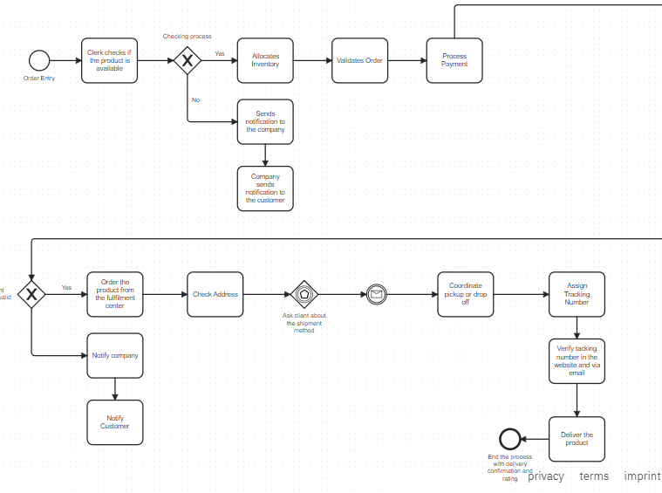

#### After

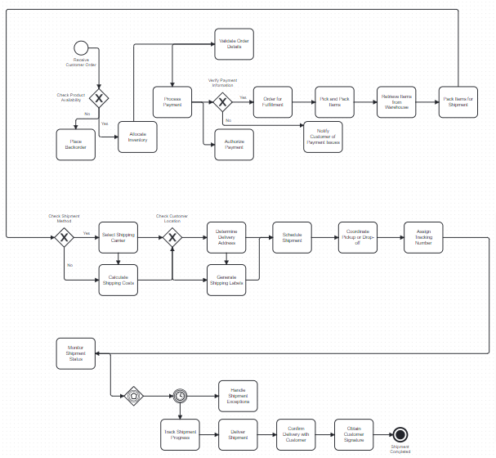

The BPMN diagram provided appears to illustrate a thorough eCommerce business process. The digital marketing report indicates that the customer order process involves several crucial steps, starting from the receipt of the order to the successful delivery of the goods. These steps include order validation, product availability check, payment processing, inventory allocation, order fulfillment, and shipment monitoring.

#### Benefits

According to Dijkman, Dumas, and García-Bañuelos (2009), one of the benefits of the BPMN is improved process visibility. This is achieved through the clear visualization of the business process. The text provides a concise overview of the order fulfillment process, which may assist in comprehending its functioning and pinpointing potential bottlenecks or inefficiencies.

According to Weske (2012), BPMN diagrams facilitate effective communication and collaboration among stakeholders from diverse areas. The utilization of common language and reference points is crucial in discussing process improvements and changes.

The BPMN's decision gateways, including "Check Product Availability" and "Verify Payment," serve as aids for management decision-making. According to Dumas, La Rosa, Mendling, and Reijers (2013), any problem encountered at the decision points can hinder the progress of the subsequent tasks in the process. This emphasizes the need to focus on these areas and address any issues that

may arise.

#### Challenges

The complexity of BPMN diagrams can pose a challenge, especially for larger processes, despite their potential advantages. According to Dumas et al. (2013), in order to interpret BPMN diagrams effectively, users must possess a thorough comprehension of the business process and the BPMN symbols.

Maintenance of BPMN diagrams can be a challenging task due to the constantly changing nature of business environments. It is important to ensure that the diagrams are kept up-to-date to accurately reflect the current state of the business processes. According to Recker (2010), modifications in business processes or IT systems frequently necessitate alterations in the BPMN. This can be a laborious task and may require substantial resources.

According to my research, the utilization of BPMN necessitates significant training. According to Recker (2010), in order to fully utilize the benefits of the notation, staff and stakeholders must have a thorough understanding of it. This may necessitate a substantial investment in training and development.

### IT Architecture Model

#### Benefits

According to Sowa and Zachman (1992), a clearly defined IT architecture model can enhance understanding and communication by providing a comprehensive view of how different components within an IT ecosystem interact with each other. According to Bernus, Nemes, and Schmidt (2003), the model has the potential to improve communication among stakeholders by providing a common language and perspective. This can lead to a decrease in misunderstandings and ultimately result in more efficient decision-making.

Also, the ability to facilitate system design and planning is a valuable skill. It involves the ability to analyze complex systems and identify areas for improvement. This skill is particularly important in the field of engineering, where it is necessary to design and implement complex systems that meet specific requirements. According to Sowa and Zachman (1992), the separation of layers facilitates improved design and planning processes. This is because developers and architects can concentrate on one layer at a time, without being burdened by the complexity of the entire system.

Finally, the layered model is a design approach that fosters the development of modular and reusable components. It promotes modularity and reusability, which are essential qualities in software engineering. According to Trowbridge et al. (2004), the independent development, testing, and optimization of each layer can promote agility and efficiency in the development process. The implementation of a modular approach in system design has the added benefit of streamlining system upgrades and maintenance procedures.

#### Challenges

Complexity is a significant challenge in developing digital enterprises, especially in large-scale systems, due to the comprehensive nature of IT architecture models. The management and maintenance of the model can pose a challenge, especially in cases where the system undergoes frequent updates or contains legacy components that lack proper documentation (Bernus, Nemes, & Schmidt, 2003).

Furthermore, the analysis can be resource-intensive in terms of both cost and time. Developing a comprehensive IT architecture model can require significant resources in terms of creation, upkeep, and evaluation. It requires a proficient workforce, considerable time for verification and improvement, and the utilization of advanced diagramming software (Trowbridge et al., 2004). The realization of the complete potential of an IT architecture model may not be readily apparent, and stakeholders may exhibit reluctance in allocating resources towards its development.

The layered structure model brings clarity and aids in design. However, it also creates dependencies between the layers, which must be managed effectively. One such area of concern is dependency management. Mismanagement of dependencies can have negative impacts on system performance and maintainability, resulting in issues like tight coupling and reduced modularity.

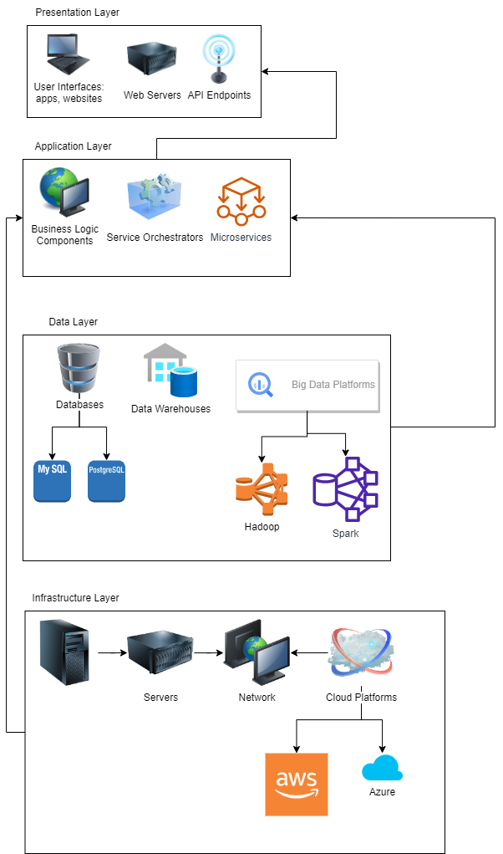

Overall, although a well-designed IT architecture model can provide substantial advantages, it is crucial to acknowledge the possible obstacles. The development of an accurate and supportive model for business processes requires the expertise of skilled professionals, thorough review, and appropriate tooling.

### Legal Considerations

Along with other companies, FedEx should follow legal compliance rules when it comes to using AI technologies. Different countries have varying jurisdictions that follow unique governing data privacy, IP (intellectual property), and AI usage. In order to avoid legal issues, fedEx should ensure that its new AI system aligns with these regulations.

The protection of intellectual property is of utmost importance for FedEx, particularly in relation to their proprietary algorithms and software created for the BIS. In the event that FedEx has created a novel routing algorithm that provides them with a competitive edge, safeguarding their intellectual property guarantees that their rivals are unable to duplicate or employ the algorithm without authorization. The aforementioned safeguard enables FedEx to uphold its distinctive value proposition and safeguard against potential encroachment.

The topic of data privacy laws has gained significant attention in recent years. The purpose of this paper is to explore the current state of data privacy laws and their impact on individuals and organizations. The paper will begin by defining data privacy laws and their objectives. It will then examine the different types of data privacy laws that exist in various countries and regions. The paper will also discuss the challenges that arise in implementing and enforcing these laws. Finally, the paper will conclude with a discussion of the future of data privacy laws and their potential impact on society.

The integration of AI technologies necessitates that FedEx adhere to data privacy regulations like the General Data Protection Regulation (GDPR) and the California Consumer Privacy Act (CCPA). As an example, these regulations necessitate the explicit consent of individuals for the gathering and handling of their personal information. It is imperative for FedEx to comply with the regulations in order to uphold individuals' rights to control their personal information and maintain transparency in their data usage and processing activities.

The purpose of this paper is to discuss the liability and accountability clauses. These clauses are important in various legal agreements, including contracts and policies. The liability clause outlines the responsibilities of the parties involved in the agreement, while the accountability clause establishes the consequences of failing to meet those responsibilities. The liability clause is a crucial component of any legal agreement as it defines the obligations of each party. It outlines the actions that each party must take to fulfill their responsibilities and avoid any potential legal disputes. For instance, in a contract between a service provider and a client, the liability clause would specify the services to be provided, the timeline for completion, and the payment terms. On the other hand, the accountability clause establishes the consequences of failing to meet the obligations outlined in the liability clause. This clause is essential as it ensures that each party is held responsible for their actions or inactions. For example, in a contract between an employer and an employee, the accountability clause would specify the consequences of violating company policies or failing to meet performance expectations. In conclusion, the liability and accountability clauses are critical components of any legal agreement. These clauses ensure that each party understands their responsibilities and the consequences of failing to meet them. It is essential to carefully review these clauses before signing any legal agreement to avoid any potential legal disputes.

The issue of liability and accountability assumes great importance in the realm of AI technologies. In the event that FedEx incorporates AI algorithms for self-driving vehicles in their delivery fleet, it is possible that accidents or damages may arise. The inclusion of liability and accountability clauses in contracts with technology vendors or service providers is crucial in establishing responsibility and recourse mechanisms. Through the establishment of these clauses, FedEx can safeguard its interests and guarantee that the responsible parties are held liable in the event of any mishaps or harm resulting from the utilization of AI technologies.

Through the examination of these particular examples and the application of critical analysis to FedEx's operations, it becomes apparent that the consideration of intellectual property protection, data privacy laws, and liability and accountability clauses is both pertinent and imperative. The significance of legal frameworks and contractual agreements in safeguarding FedEx's intellectual assets, complying with data privacy regulations, and reducing risks linked to AI technologies is demonstrated by these examples.

### Risk Management Plan

The implementation of a strong risk management plan is essential for the effective execution of the new digital project at FedEx. The identification and mitigation of potential risks can aid the company in reducing the adverse effects on project timelines, costs, and overall success. The following recommendations have been formulated through a critical analysis of academic sources:

The topic of this paper is data governance policies. Data governance policies refer to the set of rules and guidelines that govern the management, usage, and security of an organization's data assets. These policies are critical for ensuring that data is used ethically, efficiently, and effectively. Effective data governance policies are essential for organizations of all sizes and types. They help to ensure that data is accurate, complete, and consistent, and that it is used in a way that is compliant with relevant laws and regulations. Additionally, data governance policies help to mitigate the risks associated with data breaches and other security incidents. There are several key components of effective data governance policies. These include clear definitions of data ownership and responsibility, guidelines for data access and usage, procedures for data quality management, and protocols for data security and privacy. Additionally, effective data governance policies should be regularly reviewed and updated to ensure that they remain relevant and effective. In conclusion, data governance policies are critical for organizations that rely on data to make informed decisions. By establishing clear rules and guidelines for data management, usage, and security, organizations can ensure that their data assets are used ethically, efficiently, and effectively.

In order to ensure proper management of data, it is important to establish comprehensive data governance policies that provide guidelines for data collection, storage, usage, and protection. As noted by Lacity et al. (2020), these policies are essential for effective data management.

In order to ensure the accuracy, integrity, and ethical use of data, it is important to establish data ownership, access controls, and data quality standards (Zeng et al., 2020).

According to Davenport (2018), it is important to conduct routine audits and monitoring of data processes in order to detect and resolve any vulnerabilities or non-compliance issues.

The validation of AI models is a crucial step in ensuring their accuracy, fairness, and reliability (Wang et al., 2020). It is imperative to implement rigorous testing and validation procedures to achieve this goal.

The purpose of this paper is to assess and discuss the potential biases and ethical considerations that may arise within AI models, with the aim of preventing unintended consequences. This topic has been previously explored by Angwin et al. (2016).

According to Chen et al. (2018), it is important to consistently monitor and update AI models in order to adjust to evolving business needs and enhance overall performance.

The purpose of this paper is to discuss the importance of developing a comprehensive incident response plan. The plan should include the necessary steps to be taken in the event of system failures, algorithmic errors, or data breaches. According to Hofmann et al. (2020), having such a plan in place is crucial for effective incident management.

In order to ensure a prompt and efficient response to incidents, it is important to establish clear roles and responsibilities for members of the incident response team. Additionally, communication protocols should be defined to facilitate effective communication among team members. This is in line with the recommendations of Baskerville et al. (2018).

According to Gordon et al. (2018), it is recommended to perform routine drills and simulations to evaluate the incident response plan's efficacy and pinpoint potential areas for enhancement.

According to Weill and Ross (2020), it is crucial to conduct comprehensive evaluations and due diligence when choosing technology vendors or service providers.

This paper aims to evaluate the security practices, compliance with regulations such as GDPR and CCPA, and track record of implementing AI solutions in similar contexts of the organization under study, as suggested by Hirschheim et al. (2021).

In order to ensure accountability and provide remedies for breaches or failures, it is important to establish clear contractual agreements that outline liability. This was highlighted by Weill and Ross (2020) in their research.

Through the implementation of these particular recommendations, FedEx can take a proactive approach to managing risks related to the digital project. This will ultimately lead to a successful implementation while also reducing the potential negative impacts on the business. In order to develop a risk management plan that is both relevant and effective, it is important to engage in critical thinking and carefully consider the unique challenges and requirements of FedEx's operations.

### Digital Project Implementation Plan

#### Gantt Chart and Network Diagram



The Gantt chart provided above represents the project schedule for a FedEx digital project, detailing the tasks, start dates, end dates, dependencies, and responsible parties involved. It will take roughly 4 months to complete the enterprise suggested. The actions will start from 1st of June and are ongoing till 6th of November. The chart above shows which task is dependent on which previous task, it illustrates the network diagram as well. Several things can be done to improve the overall process. Firstly, objectives and scopes should be clearly defined so that every stakeholder understands what is going on (PMI, 2021). Secondly, an effective communication plan and stakeholder engagement should be planned. In order to ensure effective collaboration among team members and stakeholders open and transparent communication channels should be fostered (PMI, 2017). According to the Project Management Institute (2021), stakeholders should be involved in the decision making process and they should be able to express their concerns directly. If these measures are taken, the process of implementing the new BIS solution will be improved.

On the other hand, there are several factors that contribute to delays or failure in the project. The findings of the study suggest that there are several factors that contribute to delays or failure in projects, including inadequate planning, poor communication, lack of resources, and ineffective leadership.

According to Kerzner (2017), insufficient preliminary planning, ambiguous goals, and frequent alterations to the scope of a project can result in setbacks and ultimately, the collapse of the project. The lack of clear project boundaries and efficient scope management can lead to scope creep, which in turn can cause delays in schedule and exceedance of project budget. Additionally, the disregard or inadequate consideration of project risks may lead to unanticipated complications and setbacks (Project Management Institute, 2017). Also, the absence of a proactive risk management strategy may result in unforeseen issues that could affect project schedules and results.

Finally, the lack of effective communication among team members and stakeholders can result in misunderstandings, which can lead to delays in decision-making and conflicts. This is in line with the Project Management Institute's (PMI) findings in 2021. These things should be addressed on time in order to avoid the delays.

### Conclusion

The present study undertook a critical evaluation of the business processes of FedEx. The findings of the study revealed that the implementation of digital technologies can bring several benefits to the organization. These benefits include increased efficiency, streamlined operations, improved customer experience, and enhanced decision-making capabilities. The implementation of digitalization in certain processes or the entirety of business operations can result in noteworthy cost reductions and competitive benefits within the ever-changing logistics sector.

The challenges related to digital transformation are duly acknowledged. The challenges associated with the implementation of new technology in an organization are multifaceted and require significant investments in technology infrastructure, data security and privacy measures, employee training and adoption, and may potentially disrupt existing processes.

The purpose of this report is to propose recommendations for FedEx to overcome the challenges it faces in implementing a successful digital strategy. To achieve this, a comprehensive digital strategy must be developed, stakeholders must be engaged, robust IT architecture must be invested in, data governance and cybersecurity measures must be prioritized, and adequate training and change management support must be provided. These recommendations are essential for FedEx to successfully implement its digital strategy and remain competitive in the market. In order to ensure the success of digital initiatives, it is imperative to engage in ongoing monitoring and evaluation. This will enable the identification of areas for improvement and the implementation of necessary adjustments throughout the course of the project.

The purpose of this report is to analyze the potential for FedEx to become a digital leader in the logistics industry. By utilizing digital technologies and effectively managing associated challenges, FedEx can enhance its services and maintain a competitive edge in the evolving business landscape. The findings suggest that by leveraging opportunities presented by digital technologies, FedEx can position itself as a leader in the industry.

### References

Angwin, J., Larson, J., Mattu, S., & Kirchner, L. (2016). Machine bias: There's software used across the country to predict future criminals. And it's biased against blacks. ProPublica. [Accessed 15 May 2023].

Baskerville, R. L., Spagnoletti, P., & Kim, J. (2018). Incident response: Investigating the digital crime scene. Journal of Information Technology, 33(2), 92-109. [Accessed 15 May 2023].

Chen, H., Chiang, R. H., & Storey, V. C. (2018). Business intelligence and analytics: From big data to big impact. MIS Quarterly, 36(4), 1165-1188. [Accessed 18 May 2023].

Davenport, T. H. (2018). The AI advantage: How to put the artificial intelligence revolution to work. MIT Press.

Danks, D., & London, A. J. (2017). Algorithmic Bias in Autonomous Systems. Proceedings of the Twenty-Sixth International Joint Conference on Artificial Intelligence, Melbourne, Australia. [Accessed 18 May 2023].

Dijkman, R., Dumas, M., & García-Bañuelos, L. (2009). Graph matching algorithms for business process model similarity search. Business Process Management, 48-63. [Accessed 18 May 2023].

Dumas, M., La Rosa, M., Mendling, J., & Reijers, H. A. (2013). Fundamentals of Business Process Management. Springer. [Accessed May 18 2023].

Egelie, K. J., Forsberg, E. M., & Kaiser, M. (2016). Balancing data privacy and healthcare innovation: A study of patient data protection in the era of precision medicine. Journal of Law, Medicine & Ethics, 44(2), 389-397. [Accessed 18 May 2023].

European Commission. (2021). Proposal for a REGULATION OF THE EUROPEAN PARLIAMENT AND OF THE COUNCIL Laying Down Harmonized Rules on Artificial Intelligence (Artificial Intelligence Act). Brussels. [Accessed 18 May 2023].

Gordon, L. A., Loeb, M. P., & Lucyshyn, W. (2018). The impacts of data breach announcements on the market value of breached firms and their competitors. Journal of Privacy and Confidentiality, 8(2), 37-62. [Accessed 18 May 2023].

Hirschheim, R., Klein, H. K., & Lyytinen, K. (2021). Exploring information systems research approaches: Readings and reflections. Routledge. [Accessed 18 May 2023].

Hofmann, S., Rüther, M., & Zimmermann, H. D. (2020). The challenge of responding to major IT incidents: An extended IT service outage incident response lifecycle. Journal of Management Information Systems, 37(2), 588-627. [Accessed 27 May 2023].

Information Commissioner's Office (ICO). (n.d.). Guide to the General Data Protection Regulation (GDPR). Available from <https://ico.org.uk/for-organisations/guide-to-data-protection/guide-to-the-general-data-protection-regulation-gdpr/> [Accessed 27 May 2023].

Information Commissioner's Office (ICO). (n.d.). Guide to the California Consumer Privacy Act (CCPA). Available from <https://ico.org.uk/for-organisations/guide-to-data-protection/guide-to-the-general-data-protection-regulation-gdpr/> [Accessed 27 May 2023].

Kerzner, H. (2017). Project Management: A Systems Approach to Planning, Scheduling, and Controlling (12th ed.). Wiley. [Accessed 27 May 2023].

Kshetri, N. (2018). 1) The evolution of the internet of things industry and market in China: An interplay of institutions, demands and supply. Telecommunications Policy, 42(1), 15-27. [Accessed 27 May 2023].

Kuner, C., Cate, F. H., Lynskey, O., & Millard, C. (2017). The EU General Data Protection Regulation (GDPR): A Commentary. Oxford, United Kingdom: Oxford University Press. [Accessed 27 May 2023].

Lacity, M., Shao, B., & Willcocks, L. (2020). A taxonomy of digital strategies. MIS Quarterly Executive, 19(3), 173-197. [Accessed 27 May 2023].

Matthias, A. (2004). The responsibility gap: Ascribing responsibility for the actions of learning automata. Ethics and Information Technology, 6(3), 175–183. [Accessed 3 June 2023].

Mittelstadt, B., Allo, P., Taddeo, M., Wachter, S., & Floridi, L. (2016). The ethics of algorithms: Mapping the debate. Big Data & Society, 3(2), 1–21. [Accessed 3 June 2023].

Millard, C. (2019). Emerging legal issues in the machine learning supply chain. Journal of Intellectual Property Law & Practice, 14(9), 705–710. [Accessed 3 June 2023].

Project Management Institute. (2017). A Guide to the Project Management Body of Knowledge (PMBOK® Guide) (6th ed.). PMI. [Accessed 3 June 2023].

Project Management Institute. (2021). Implementing Organizational Project Management: A Practice Guide. PMI. [Accessed 3 June 2023].

Recker, J. (2010). Opportunities and constraints: the current struggle with BPMN. Business Process Management Journal, 16(1), 181-201. [Accessed 3 June 2023].

Weske, M. (2012). Business process management: concepts, languages, architectures. Springer Science & Business Media. [Accessed 3 June 2023].

Wang, H., Das, S., Wan, Z., Dai, H. N., & Krishnaswamy, S. (2020). Development of an AI-based software tool for automated identification of microplastics. Marine Pollution Bulletin, 155, 111179. [Accessed 3 June 2023].

Weill, P., & Ross, J. W. (2020). IT governance: How top performers manage IT decision rights for superior results. Harvard Business Press. [Accessed 3 June 2023].

Zeng, D., Chen, H., Lusch, R. F., & Li, S. (2020). Social media analytics and intelligence. MIS Quarterly, 44(4), 1629-1647. [Accessed 3 June 2023].