**COURSEWORK SUBMISSION FORM**

|  |  |  |  |
| --- | --- | --- | --- |
| **STUDENT USE** | | **STAFF USE** | |
| Module Name | Information Systems Management | First Marker’s  (acts as signature) |  |
| Module Code | 5BUIS011C-n | Second Marker’s  (acts as signature) |  |
| Lecturer Name | Daryoush Alimohammadi | Agreed Mark |  |
| UoW Student IDs |  | **For Registrar’s office use only (hard copy submission)** | |
| WIUT Student IDs | 00010443 |
| Deadline Date | 14.04.2022 |
| Assignment Type | Group ☑ Individual |
| Word Count |  |

**SUBMISSION INSTRUCTIONS**

**COURSEWORKS *must* be submitted in *both* HARD COPY (to the Registrar’s Office) *and* ELECTRONIC unless instructed otherwise.**

For hardcopy submission instructions refer to: <http://intranet.wiut.uz/Shared%20Documents/Forms/AllItems.aspx> - Coursework hard copy submission instructions.doc

For online submission instructions refer to: <http://intranet.wiut.uz/Shared%20Documents/Forms/AllItems.aspx> - Coursework online submission instructions.doc

|  |
| --- |
| **MARKERS FEEDBACK (Continued on the next page)** |
| **Table of contest**  1. Introduction  2. Designing a business model for providing services:  - How they manage BPM, BMM, BOM, and BRM in their BM?  - How good is their BM?  3. Conclusion |

# 

**Introduction**

For this research I chose Coca-Cola Ichimligi Uzbekiston Ltd. The company of food industry that produces soft drinks. The company has largely become a pioneer in Uzbekistan. For example, they are the first to deliver their products to customers on their own trucks. They also tripled large-scale events, forums and competitions for their audience.

The company is the representative of the international company Coca-Cola in the USA. Therefore, many aspects of the business are established with the business plan of the original company. This enables Coca-Cola Ichimligi Uzbekiston Ltd. stand out among other companies, has a more developed management and this allows them to maintain leadership in the territory of Uzbekistan.

**Designing a business model for providing services**

After formulating a business idea at the infancy stage, organizations begin to develop a business model. As mentioned above, the business idea for Coca-Cola Ichimligi Uzbekiston Ltd. was a ready point in starting a business, since the company is a subsidiary. But the business model had to be rebuilt. Since consumers, conditions, place of residence, etc., the branch of the company in Uzbekistan could differ from the company in the USA.

The business model is used to describe the basic principles of creation, development and successful operation of the organization and contains a description of the way in which a young enterprise will achieve revenue generation and sustainable profits over a long period of time.

For example, for the marketing campaign of Coca-Cola Ichimligi Uzbekiston Ltd. organization is very strong. A lot of work has been done in this part of the business model.

Unlike a business idea, a business model is a deeper level of consideration for the operation of a new enterprise. And therefore, it includes not only the problem of the consumer that the product solves, but also covers the strategic positioning of the company, describes the groups of consumers and stakeholders, the distinctive properties of the product and service, through which the best solution to this problem will be achieved, in comparison with existing analogues, distribution channels etc.

An analysis of the company for each item is below.

And so, there are two types of brand positioning: center and differential. We are dealing with the leader of products in our field Coca-Cola Ichimligi Uzbekiston Ltd. among other drinks, so the company undoubtedly adheres to the center positioning, that is, it is defined as a typical example of this product category. In most product categories, the first brand to appear - the "pioneer" or, more precisely, the first successful brand - occupies a key position in the product category, since it largely determines the product category itself. For example, often even in Uzbekistan, any drinks with the taste of cola are called "Coca-Cola".

Coca-Cola Ichimligi Uzbekiston Ltd. now adheres to a policy of market segmentation, developing new products specifically to meet the wishes of specific consumer groups. The company also has a growing portfolio of non-carbonated soft drinks that is helping to expand its consumer base.

One of the main interfaces in the business model of providing services, which decisively affects the entire structure of relationships between the subjects of the model, is the interface "service provider - the end customer of services".

The generalized business model for providing the services of an interface is determined in the process of drawing up the corresponding service agreement that regulates the levels of service provision (or service levels). The Coca-Cola Company in Uzbekistan retails its products to grocery stores. But you can also make a purchase online, through various social networks. The Coca-Cola Company actively uses telegram bots to sell goods.

**BPM (business process management)**

A large place in the company's activities is occupied by various projects - from advertising campaigns to the installation of billboards. Many diverse and heterogeneous projects require constant monitoring. The solution that Coca-Cola implemented is a classic example of implementing project management through processes:

Project initiation. Initiates any projects related to the activities of the enterprise

Project correction. Allows to make changes to open projects. As part of the process, project participants can be redefined, the deadlines for the execution of the project itself, as well as its stages and works, can be changed.

Project cancellation. Cancels open projects, interrupting assigned tasks associated with this project.

Project completion. The project manager makes a decision and either writes a report and closes the project, or sends the project for revision.

Process Manager. Specifies a list of work to be done and projects to be completed by start date.

Register of projects. Represents information for all projects. It is possible to limit projects for viewing, taking into account the employee's participation in projects.

**BMM (business motivation model)**

Individuals are motivated by the desire to have many needs as possible at a particular time. Needs can be biogenic and psychogenic; Biogenic needs are psychogenic in form and include forms of tension like hunger, thirst and discomfort. Psychogenic needs are those that emanate from psychological states of nature like the need for esteem, recognition or belonging. All these needs play a role in the creation of positive motivation. It should be noted that marketing strategies are often aimed at creating an arousal of such needs on a short term as well as long term basis.

There are several theories that have been formulated to explain why consumers opt for coca-cola drink to quench their thirsty instead of water.

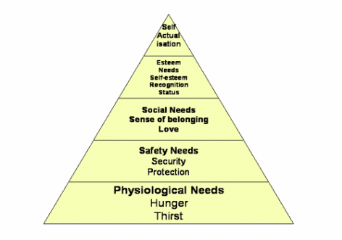

**BOM (bill of materials)**

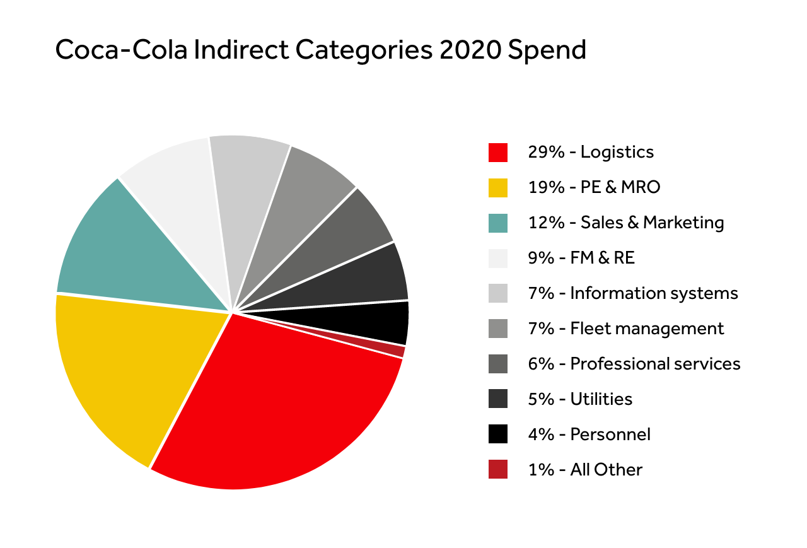

**BRM (business relationship management)**

Collaborative customer relationships can be defined as relationship building strategies that aim for strong and lasting commitments that are especially suited to customers.

Coca-Cola is under stress in its customer relationships as an organization. For example, Coca-Cola will work closely with its largest customers to build diverse relationships. In addition, the operational links and information exchange system are important to ensure that the products and services offered meet the needs and desires of customers. They work with their customers to provide every consumer with a higher quality beverage choice.

**Conclusion**

The Coca‑Cola Company's business model defines their actions, relationships and aspirations to create value for all stakeholders in the short, medium and long term. It all starts with their resources. They manage the resources that their business has.

Financial: share capital, debt obligations.

Production: factories, warehouses, distribution centers.

Human: employees, partners.

Intellectual: brands, standards, processes, corporate reputation.

Social: local communities, customers, suppliers, various stakeholder groups, NPOs (non-profit organizations), IOs (intergovernmental organizations), industry associations.

Partner: cooperation with The Coca‑Cola Company.

**Reference**

https://studycorgi.com/coca-cola-company-consumer-behavior/

https://studycorgi.com/coca-cola-company-consumer-behavior/

https://docs.oracle.com/cd/E16754_01/doc.75/e23300/cpt_product_overview.htm

https://www.aiim.org/what-is-bpm

https://www.bmm.eu/en/about-bmm/about-bmm-membership

https://www.wordnik.com/words/BM

https://promo.coca-cola.uz