**COURSEWORK SUBMISSION FORM**

|  |  |  |  |
| --- | --- | --- | --- |
| **STUDENT USE** | | **STAFF USE** | |
| Module Name | Introduction to Cryptocurrencies | First Marker’s  (acts as signature) |  |
| Module Code | 5FNCE003C-n | Second Marker’s  (acts as signature) |  |
| Lecturer Name | Qobiljon Yunusov | Agreed Mark |  |
| UoW Student IDs | 00010443 | **For Registrar’s office use only (hard copy submission)** | |
| WIUT Student IDs | 00010443 |
| Deadline date | 16 December 2021  (upload by 23:59) |
| Assignment Type | 🗌Group☑Individual |

**SUBMISSION INSTRUCTIONS**

**COURSEWORKS *must* be submitted in ELECTRONIC unless instructed otherwise.**

For online submission instructions refer to: [http://intranet.wiut.uz/Shared%20Documents/Forms/AllItems.aspx](http://charlotte.wiut.uz:36765/Shared%20Documents/Forms/AllItems.aspx) - Coursework online submission instructions.doc

|  |
| --- |
| **MARKERS FEEDBACK (Continued on the next page)** |
| **Agenda**  **The decentralized exchange and what problem it can solve**  **How DEX works**  **About Platform:**   * **Atomic swaps** * **User interface**   **Crowdfunding**  **Video Conclusion** |

**The decentralized exchange and what problem it can solve**

There are centralized, decentralized, and hybrid exchanges in the cryptocurrency industry. The second have only been gaining popularity since 2017. Centralized exchanges involve the work of third parties, which can greatly exacerbate the situation. Cryptocurrency communities urge partners to always be wary of centralized exchanges. And the statistics confirm this: hackers stole $ 300.1 million at the rate of 2020 from exchanges last year. This is a huge danger for anyone looking to invest in CEX. Similarly, physical institutions like banks do not guarantee the reliability of storing resources on a client's personal account. Hackers can break into data at any time and store a huge amount there is also not reliable. The continuation of the problems is the cost of services. In money transactions, banking institutions charge interest on their transfer services. It is not profitable for the client to lose a certain amount. That is why, in this project, it is planned to launch a decentralized exchange (DEX), where togris pass without intermediaries, such as exchanges, banks, and so on. Users interact directly with each other: buy and sell without any outside parties.

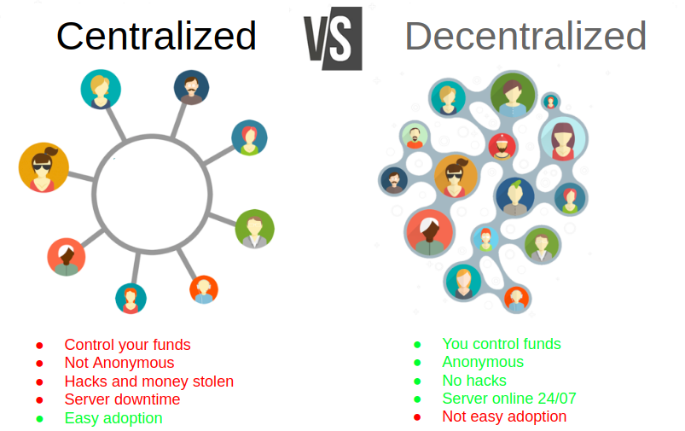

From a technical point of view, the decentralized exchange is built on the basis of the blockchain, which makes it a priori genuine. Blockchain is a distributed database that contains information about all transactions carried out by system participants. Information is stored as a chain of blocks. Each of them contains a certain number of transactions.

Each transaction in such an exchange is stored in a public blockchain, and every copy of which is held by any participant in this system. The second, important point is that the crypto exchange does not have access to the investor's assets, which means that the attention of hackers to such an exchange will be minimized. Why hack the exchange to take money if it doesn't have it? It's just illogical.

The simplest example would be FIAT currency and cryptocurrency (bitcoin for example). No one controls the cryptocurrency, no one can forge the blockchain. Too resource-intensive and almost impossible.

Another problem that decentralized exchange can solve is the costly paperwork. It is replaced by the Smart Contract computer algorithm.

There are three main types of decentralized exchanges: Automated market makers, Order books DEXs and DEX aggregators. All of them allow users to trade directly with each other through their smart contracts. The first decentralized exchanges used the same type of order books, similar to centralized exchanges.

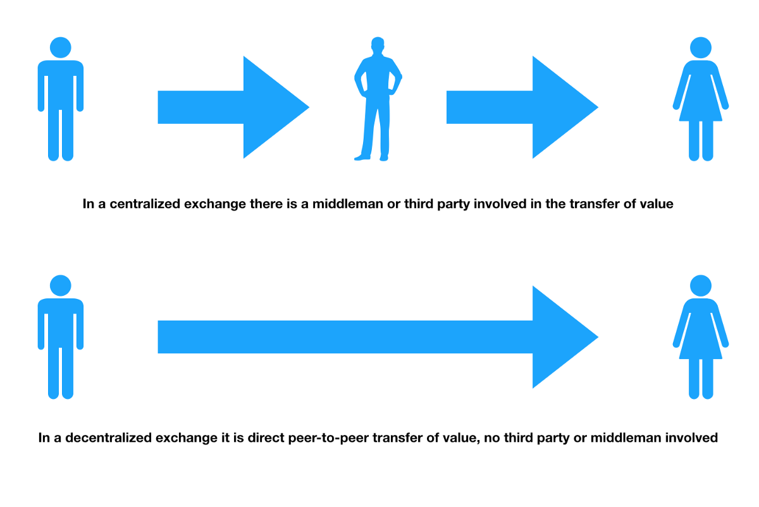

**About Platform**

Thus, we create a platform for decentralized exchange, which consists of P2P trading, linking it with smart contracts in order to rid people of third parties, thereby we will solve the problem of the security of our clients' resources, where only the owners of these resources will have access to the resources.

If the state punishes the creation of “its own” fiat currency (which is directly stated in the criminal code), then launching own crypto asset is completely legal.

The DEX 'Anonymous' platform is a server where users can exchange resources among themselves without the participation of third parties. Users can use cryptocurrencies, exchange them for fiat money (government currencies such as dollars, sums, etc.), or vice versa. Also, when paying taxes, the clients of the platform will spend much less than for the services of banking institutions.

**How DEX works**

*Authentication process.* Our site generates a one-time login key that will be valid for a certain period of time, after which the key becomes inactive. After logging in, the user can make an exchange. Some sites may require passing the KYC procedure if the user's transaction volume has exceeded a certain limit. Registration is optional.

*Exchange process.* It uses atomic swaps to automatically exchange one cryptocurrency for another. Transactions are carried out in accordance with the PLUG & PLAY concept, that is, everything happens here and now, without the need to connect a cryptocurrency wallet to the platform or transfer the required amount to the exchange deposit, which is not time-consuming.

**Atomic swaps**

Atomic swaps mean a type of peer-to-peer exchange of virtual assets without the participation of third parties, including exchangers. Usually, with their help, people exchange one cryptocurrency for another, but there may be options with the exchange of data, certificates, and so on.

By their nature, these are smart contracts that work with two blockchains and use the Lightning Network protocol for exchange. Within such contracts, either a parallel concurrent exchange algorithm or an algorithm using two-way escrow.

Pros of Atomic Swaps:

- Low price

- Decentralization

- Fast speed

- Ease of transactions

- Safety

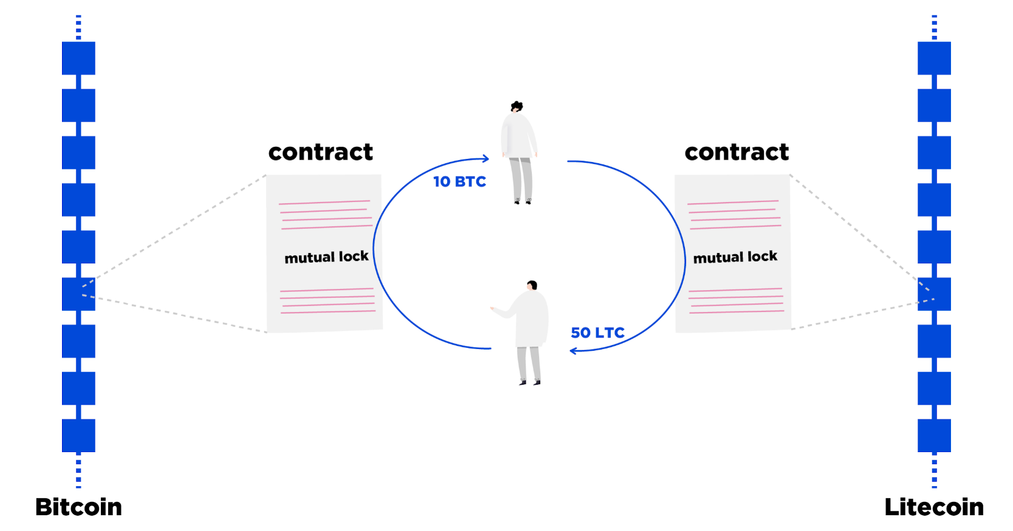

**User interface.**

The platform design will be pleasant and easy to learn.

Functions:

*Registration.* Creating a user profile is possible using an email address or through integration with a Google or Facebook account. When creating your own peer-to-peer cryptocurrency exchange or exchanger, the user can also connect registration via a phone number or integration with local social networks.

*Profile customization.* The ability to add a photo, address, phone number, location and other information that other users will see, as well as payment information that will be hidden from everyone except the administration of the service.

*Placing a request*. Tools for creating and placing an order to buy or sell cryptocurrency, indicating currencies, amount, rate, payment method and other data.

**Customer support channels**

Customer support is not just a mechanism for eliminating problems with users, which are often complex or not experienced enough to properly handle the exchange. It is also a tool for upgrading our own platform, since no one will give feedback or suggest what needs to be added, removed or improved better than the client itself. Staff will provide feedback, respond to complaints, approve or reject KYC requests, and so on.

For support, there are both live operators and a hybrid system: a neural network is dealt with simple questions in the form of a bot, and in case of complex questions, it switches the user to an operator.

**Crowdfunding**

Since this kind of platform will be launched on the territory of Uzbekistan for the first time, it can easily attract investors who are interested in cryptocurrency.

A guaranteed step will be the availability of this program to all users, both those who are well versed in this industry, and those who are newbies. This will give investors the opportunity to receive a stream of passive income, and enables users to make quick transactions, efficiently, safely and reliably manage their finances, where there is no accumulation of funds in incomprehensible places, payment immediately goes to user's wallets.

That is why the start-up project tokens are planned to launch an ICO - the initial offer of a certain amount of new cryptocurrency in order to attract investment. This will be hosted on Bybit.co.com

With the help of a team where financiers, programmers, designers, targetologists, smm specialists, content specialists, editors, community specialists will work successfully, it is possible to attract large investors. The idea and the whole essence of the project will be written in White Paper.

The creation of the platform is planned on Ethereum - this is an environment created by a huge number of interconnected nodes (nodes). This combination works as a single machine, which is called the Ethereum Virtual Machine (abbreviated EVM). A system of smart contracts operates on the basis of the network. Ethereum technology makes it possible to register any transactions with any assets based on a distributed base of blockchain-type contracts, without resorting to traditional legal procedures.

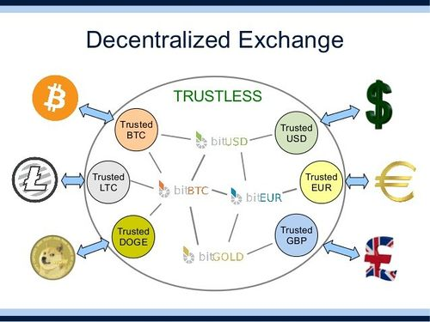

Video Conclusion

https://www.loom.com/share/6cff84cd101a48a3a95d344e033e81e5