Lecturer’s Name: Feruza Akhmedova
Report
Topic: Academic life
Title: The impact of clubs on academic life?
Word count: 2252
Executive summary
The point of this report is to introduce the discoveries of the exploration which examined understudies' commitment in clubs. A survey (google form) on understudies' perspectives with reference to effect of interest in clubs on their scholastic life was led. The outcomes uncover that the majority of understudies who are engaged with a clubs are have quite normal imprint in their investigations, also someone who is taken an interest in clubs haven't flopped in their tests or courseworks. The paper reasons that the impact of cooperation in clubs on students scholastic life is incredibly positive. The individuals or makers of clubs are prescribed to enhance nature of clubs by ordinary and gainful segments to attach more understudies.
Contents

1. Introduction 2
2. Literature review 2
3. Methodology 3
4. Results 3
5. Discussion 12
6. Conclusion 13
7. Limitations 13
8. Recommendations 14
9. References 15

Introduction
  - Background information
As of late, there has been a developing enthusiasm for investment in clubs since the advantages of clubs were obviously illustrated. Shockingly, some portion of the understudies even don't have the foggiest idea what is club itself. As the term 'college clubs' will be experienced commonly in the setting it ought to be appropriately characterized. As per Jones (2015) clubs are unpaid movement which is made by chipping in among understudies who has explicit information in the particular region.
  - Aim
Since clubs are getting common for benefits provided in the universities, we chose to direct our own exploration in WIUT and investigate understudies' assessments in wording cooperation in clubs, the effect on their examinations, just as their commitment rate. Through our perceptions numerous understudies are burning through their time in containers or spending time with companions. The fundamental point of this exploration is direct the effect of clubs in their examinations , so as to open understudies eyes to take an interest clubs instead of killing the time.
1.3 Purpose
The reason for the flow paper is to give an account of the discoveries of our exploration that planned for looking at WIUT understudies' investment in clubs , and dependent on the acquired information propose further proposals for understudies and the scholastic stuff. In this way, potential members and makers will profit by the completed research.
Literature review
Gellin (2003) determined that engagement in clubs and organizations was shown to be linked to several areas of cognitive and psychological development. Student organization and club members score higher than non-members on factors such as educational involvement, career planning, lifestyle planning, academic autonomy and academic progress (Johnston, Hamilton and Zhang, 2008). However, King (2006) argues that it is no myth that club members can possibly have fun and potentially learn simultaneously, but a problem arises when students get overly attached and lose their sight of main purpose which is academic preparation for their future life and career. While Garland (2010) states that extracurricular activities help students create their identity, increase their leadership skills and become more autonomous. Doherty (2007) maintains that joining student-led organizations can have a positive effect on their study, as long as they limit the number of clubs they involve.The greater student’s participation in university, the greater will be his or her successin university (Fry, 2006).
Methodology:
The current part aims to focus on the study participants and the research-related ethical issues. In addition, the section addresses both the research questions and the methodology applied throughout the analysis. The principal study participants concentrated on investigating the participation of WIUT students in clubs.
Moreover, the targeted information were gathered from Westminster International University students in Tashkent from all levels and faculties. The information collected from the 50 students total, 62 percent of whom are males and 38 percent female students.
The purpose of the research was adequately clarified to the participants before dissemination of the questionnaires and their anonymity was guaranteed. In the study, personal and sensitive questions were omitted with a view to avoiding ethical matters. In addition, the participants were told that, upon completion of the study, they would become familiar with the findings.
For collect this data, a method of quantitative data collection was used to obtain it. The online questionnaire was created using Google Forms and disseminated through Telegram messenger. Additionally, the importance and main purpose of our research was clearly explained to them. The applied method was useful for research, because, firstly, there is no pressure, respondents have time to think about their answers, and usually they are not required to respond immediately. Secondly, since this was an anonymous questionnaire, none of the respondents would be affected by the study. Finally, quick results and easy analysis. In general, this method facilitates the work because it is simple and fast for students to complete, and the research was easily analyzed.
Results:
The survey was aimed at collecting data about the involvement of WIUT students in clubs. The section below contains comprehensive details about findings from the research.
To continue with, the questionnaires were conducted in full with all the questions being answered properly. According to the results, it was collected data from 50 anonymous respondents. Moreover, most of the respondents 62% were aged 18-20 years. The remaining 24% were mature students aged 21 to 23 years. Over 10% of respondents are over 23 years old.
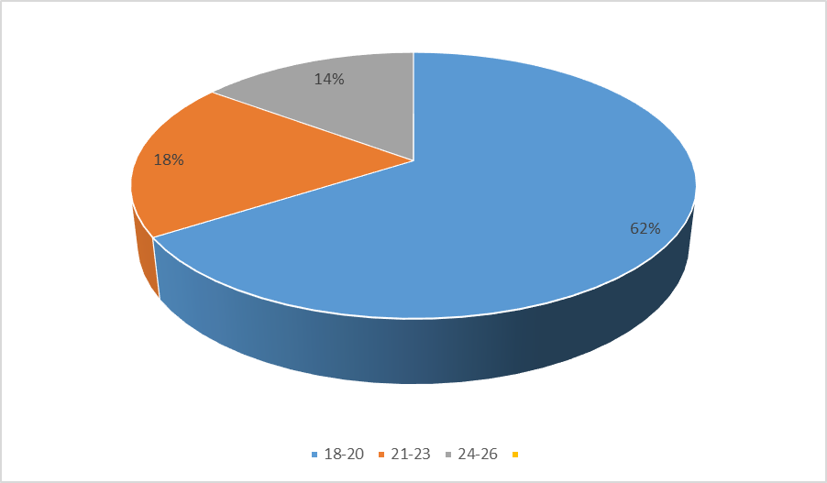
All of the survey participants were in different faculties and study levels. It is important of mentioning that almost three-fourth of the participants was CIFS students, while only about ten and fifteen percent of students who filled survey form were Level 4 and Level 5 students respectively.
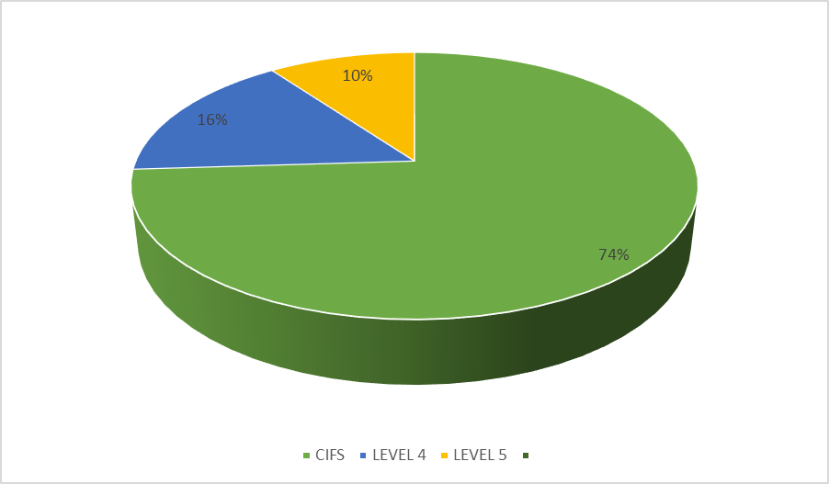
However, the first question was asked about “How many clubs in WIUT?” 12 percent of respondents had no idea if there were WIUT clubs or not. A small number of participants, about 30 percent, stated that only 2 to 4 clubs were registered. Exactly 30 percent of the participants were right about the exact number of clubs that had a WIUT, which ranged from 40 to 50. The remaining largest group of respondents, more than two-thirds (62%), thought that there were about 20 clubs in the WIUT.
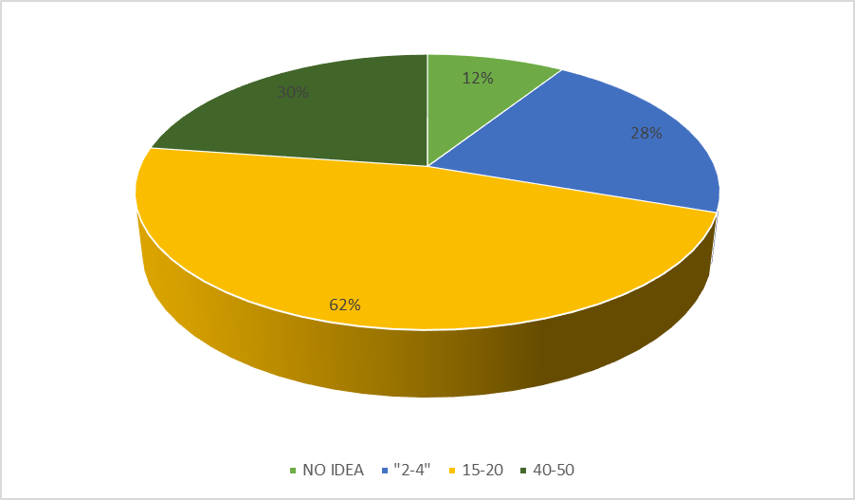

The next question was asked about whether they attended clubs or not. Russian and photo, vocal and fashion clubs were least popular among our participants, accounting for just below 10 percent. Those who attended the fitness club were 17 percent. 13 percent of the participants have never attended clubs at all. Interestingly, the reading club and Titan’s community were preferred by the largest number of respondents, about 20 and 30 percent respectively.
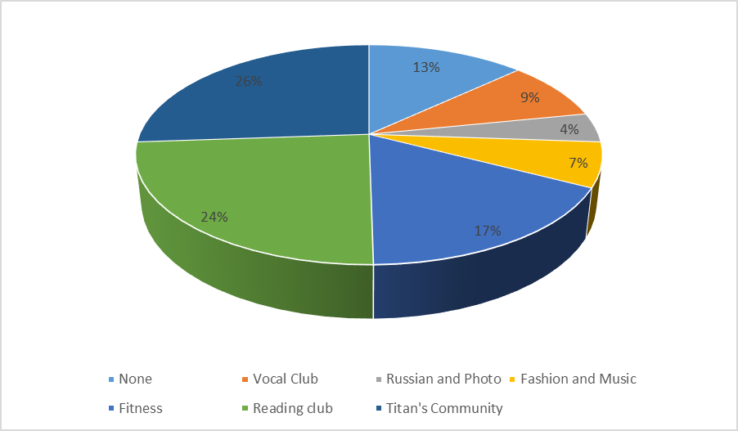

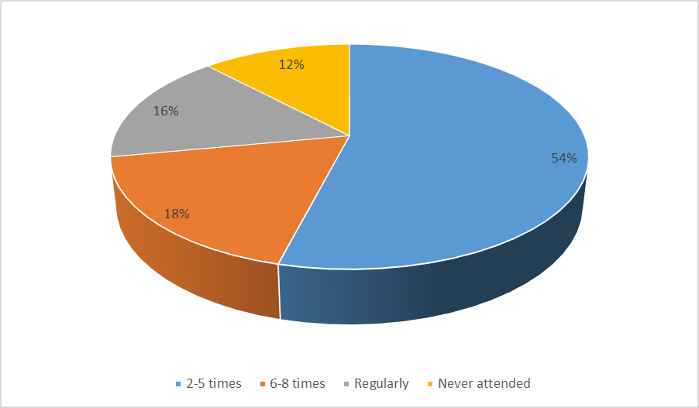
Figure 1 Student participation in clubs
In the sixth question, in order to find out about their attendance at clubs, the participants of the research were asked to indicate the number of times they have attended a specific club (see Figure 1). The survey yielded that 54% of participants responded 2-5 times, 18% of the respondents showed that they had attended 6-8 times. Interestingly, 16% of the participants said that they were active club members and attended always and 12% never attended.

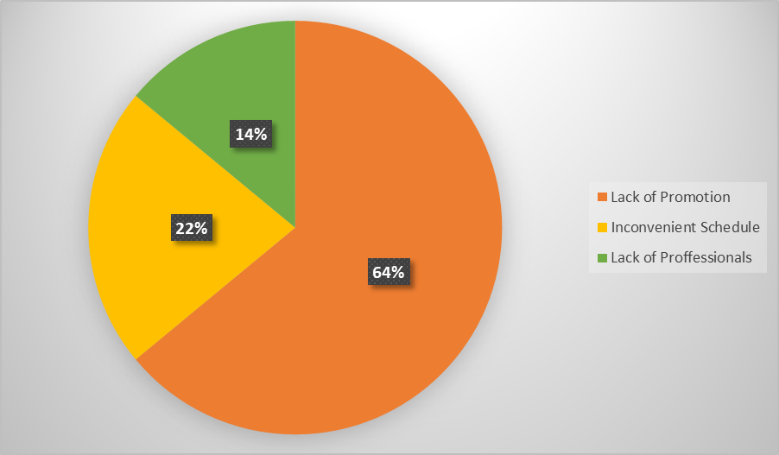
Figure 2 The reasons for unpopularity of clubs
The respondents of the survey were also asked their opinions on the matter of why clubs are so unpopular or unknown among the WIUT students (see Figure 2). The results showed that 64% of survey respondents hold an opinion that the primary reason for unpopularity of clubs is because they do not promote their sections well or at all. Meanwhile, 22% of participants stated that they can not join clubs even if they want to due to an inconvenient schedule and 14% gave the lack of professionals at clubs as a reason.
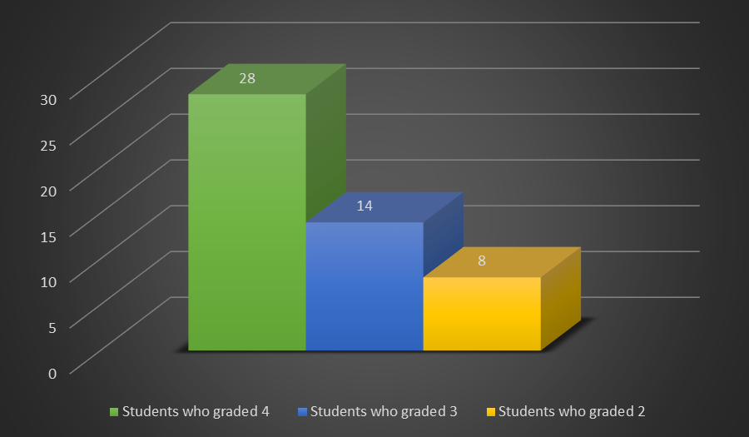
Figure 3 The importance of club attendance.
Next, the participants of the survey were inquired to grade the significance of club participation on a scale 1 to 5 (see Figure 3). In which 1 denotes that the club participation is of little importance, whilst 5 represents that attendance holds high priority. As demonstrated in the chart, 28 students scaled club participation 4, 14 graded 3 and 8 indicated 2.

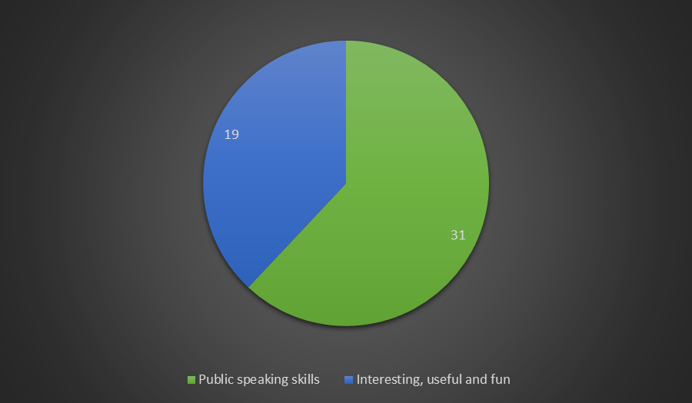
Figure 4 The motivation for joining clubs
Afterwards, the motivation behind joining clubs were identified (see Figure 4). Interestingly, the survey results determined that there were 2 common answers among respondents. The first motive was that clubs were seen as the best possible way to improve one’s public speaking skills and interpersonal skills due to the fact that at clubs students have to interact with other students frequently. The second reason was because students consider clubs interesting, useful and fun.
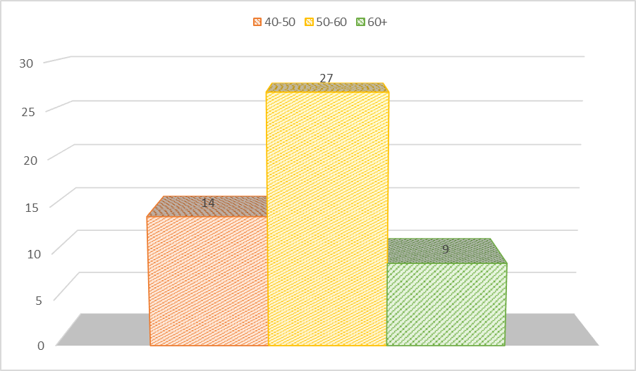
Figure 5 Students average marks
In order to find out information on the impact of club participation on academic life, we asked students their average marks (see Figure 5). Just to clarify the survey, 44 out of 50 respondents were actively or at least temporarily involved in clubs. As Figure 4 illustrates 14 students had marks ranging between 40 and 50, 27 participants had 50 to 60 and 9 have 60+ scores (7 out of these 9 students were active members of their respective clubs).
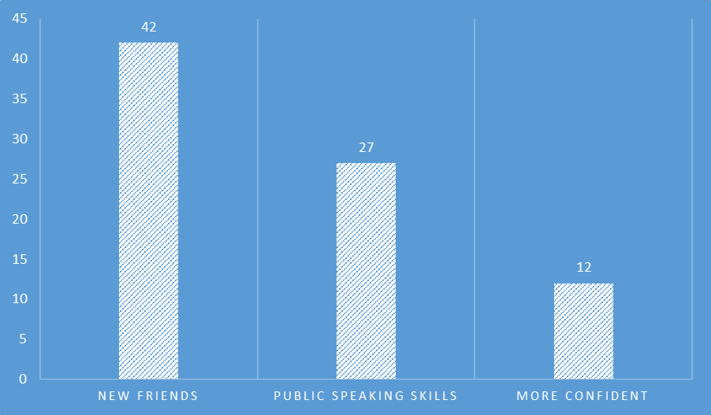
Figure 6 What students gained by joining clubs
The next question respondents were asked was about what they gained by becoming engaged in clubs (participants were allowed to choose more than one option). It was identified that 42 survey participants made new friends by socializing, 27 students reported that they greatly honed their public speaking skills and 12 stated that they become more confident by overcoming their shy nature and nervousness.
Finally, participants were asked to express their own opinions about how to make clubs more interesting. Our survey determined that club promotion, interesting and engaging activities and also flexible schedule were regarded as main ways to improve club, according 50 students’ responses.
Discussion
In order to clarify our research more globally, we have examined other researches which were carried out by other researchers across the globe.
Firs of all, our major finding was that the primary motive behind joining clubs was indicated to be usefulness and fun. Whereas the similar research conducted by King (2006) determined that most students were interested in clubs, because students can socialize and learn useful skills at the same in clubs.
Secondly, our next major finding was that the reason for the unpopularity of clubs is because they do not hold any promotional events or activities which makes them unknown to most students. Furthermore, Garland (2010) research has similar findings which clearly supports our own findings. In his research he states that clubs remain unknown because they fail to provide necessary or basic information about their clubs which makes it difficult for students to notice their presence.
Furthermore, we have concluded that clubs have positive impact on academic performance, for example club participants had above-average marks, meanwhile the most active club members had very high scores. Similarly, Doherty (2007) links active club engagement to high academic performance. In her study, club members performed better at exams than non-members.
Conclusion
From obtained data, it can be assumed that despite low visit rating, there many motivated students, who want to attend interesting and productive clubs' sections. There are some conclusions related to club's effect on students. First of, cognitive sections help people to reveal themselves in various areas, gain new experiences and knowledge that may be useful in life or at work.
Secondly, some students, after classes, have a huge amount of free time that they can just waste. Participation in clubs helps them find hobbies, spend their time correctly and usefully.
Thirdly, there're registered various sports and psychological clubs at WIUT. Students can engage in sports, participate in competitions, learn how to properly interpret their speeches in front of an audience, sing or dance and so on. Combine studies and think professionally about career choices through clubs. However, almost no club is still popular among WIUT students. There are several reasons for this. Firstly, too many clubs were registered at the university. People get confused and it is difficult to follow the schedule of each of them. In addition, many clubs do not regularly conduct their sections and some of them are boring and useless. Secondly, informative and interesting clubs have poor promotion. Students do not always search what kind of activities, events are taking place on campus. Therefore, many clubs are left behind the shadow.
Limitations
Regarding our research work, we had some limitations, such as lack of survey respondents. Answers from questionnaire were not enough to make reliable research, to get some new ideas, suggestions or even discontents to improve clubs organizations. Moreover, there was lack of experience in conducting this work due to it is our first problem solving research, where should be done serious decisions regarding issue we chose. Recommendations
According to the results of the survey, it can be said that most of the participants in activity we compiled for the research, there was no popular answer among visited clubs. This indicates the low efficiency of clubs on the territory of the University. To improve the quality of clubs in WIUT and frequent visits to students, it is recommended to conduct regular and productive sections in clubs. During events such as Club's day, you need to interest as many students as possible with the proper promotion to capture a large audience. Organizers can show new chips and give unusual information according to the area of the clubs. Moreover, other ways to attract a large number of students are through creative posters or online announcements about new sections. Also it is important to consider the competent organization of classes, which helps to draw even more attention to the authority of the club, causing positive reviews. Interested participants will be motivated to attend regular sections and invite their friends.

Reference list:
Doherty, K (2007). Linking student engagement and strategic initiatives: Using NSSE results to inform campus action. Assessment Update, 19 (3), 13-31. Available from https://www.researchgate.net/publication/234721442_Linking_Student_Engagement_and_Strategic_Initiatives_Using_NSSE_Results_to_Inform_Campus_Action [Accessed 17 February 2020]
Foubert, J and Grainger, L (2006). Effects of Involvement in Clubs and Organizations on the Psychosocial Development of First-year and Senior College Students. NASPA Journal, 43(1), 166-182. Available from https://www.researchgate.net/publication/229086188_Effects_of_Involvement_in_Clubs_and_Organizations_on_the_Psychosocial_Development_of_First-Year_and_Senior_College_Students [Accessed 16 February 2020].
Fry, M (2006). My Freshman Year: What a professor learned by becoming a student. Phi Kappa Phi Forum, 86 (2), 39-40. Available from https://www.researchgate.net/publication/236767260_My_Freshman_Year_What_a_Professor_Learned_by_Becoming_a_Student_review [Accessed from 15 February 2020].
Garland, A (2010). Assessing the Relationship between Student Involvement and Academic Performance in Higher Education. Masters Theses& Specialist Projects. Available from https://digitalcommons.wku.edu/cgi/viewcontent.cgi?article=1214&context=theses [Accessed 17 February 2020].
Gellin, A (2003). The effect of Undergraduate student involvement on critical thinking: A meta-analysis of the literature 1991-2000. Journal of College Student Development, 44 (6), 746-762. Available from https://muse.jhu.edu/article/49034/ [Accessed 15 February 2020].
Johnston, L., Hamilton, E and Zhang, J (2008). Learning through engaging with Higher Education Institutions: A Small Business Perspective. International Small Business Journal 26 (6), 649-673. Available from https://journals.sagepub.com/doi/pdf/10.1177/0266242608096087
King, M (2006). Finding balance. Campus Activities Programming, 38 (6), 27-49. Available from https://www.naca.org/JCAPS/Documents/JCAPS_Issue_1.pdf [Accessed from 14 February 2020].
Luke, P et al. (2011). The role of entrepreneurship clubs and societies in entrepreneurial learning. International Small Business Journal, 29 (1), 37-57. Available from https://journals.sagepub.com/doi/abs/10.1177/0266242610369876 [Accessed 16 February 2020].
Olson, A and Johnson, J (2010). Aviation Student Involvement in Campus Based Extracurricular Organizations at a Midwestern University. College Aviation Review, 28 (2), 47-59. Available from https://www.researchgate.net/publication/283597633_Aviation_Student_Involvement_in_Campus_Based_Extracurricular_Organizations_at_a_Midwestern_University [Accessed 14 February 2020]

