COURSEWORK SUBMISSION FORM
STUDENT USE |  | STAFF USE
Module Name | DBSD | First Marker’s  (acts as signature)
Module Code |  | Second Marker’s  (acts as signature)
Lecturer Name |  | Agreed Mark
UoW Student IDs |  | For Registrar’s office use only (hard copy submission)
WIUT Student IDs | 00010443
Deadline date
Assignment Type | Group Individual

SUBMISSION INSTRUCTIONS

COURSEWORKS must be submitted in both HARD COPY (to the Registrar’s Office) and ELECTRONIC unless instructed otherwise.
For hardcopy submission instructions refer to: http://intranet.wiut.uz/Shared%20Documents/Forms/AllItems.aspx - Coursework hard copy submission instructions.doc
For online submission instructions refer to: http://intranet.wiut.uz/Shared%20Documents/Forms/AllItems.aspx - Coursework online submission instructions.doc

MARKERS FEEDBACK (Continued on the next page)
Table of Contents
Section 1 3
Section 2 4
Section 3 5
Section 4 6
Section 5 7

Section 1

The selected company for current case study is Cambridge Learning Center in Uzbekistan. This local company is a training center that was founded in 2004 by a Westminster International University in Tashkent graduate. The company has 6 branches in Tashkent and several in other regions of the country. Over the 7 years of its existence, their team has created many other different projects. The company is focused on education. They graduate thousands of students every month who study in various courses. Basically, the center is focused on teaching English and preparing for the most popular exam in the world - IELTS. In Tashkent and among its students, the Cambridge team has a good reputation for both teaching efficiency and staff service. That is why the case study will be conducted on the work of this company.

Section 2
According to the structure of this company, in this case study a diagram was created to build a database. The ER diagrams was created by using UML notation.

The following objects were used to build the diagram, such as tutor, student, works on, course, building, bathroom, administration. For each object there were created entities, attributes, which are provided in each entity. Also, each entity is represented as a superclass or subclass.

Superclass is an entity type that includes various subclasses that need to be represented in the data model.
Subclass - A subclass is an entity type that plays a separate role and is also a member of the superclass. In some cases, an entity type can have several different subclasses.
An entity, its subclasses, subclasses of these subclasses, and so on are all referred to as the type hierarchy. The diagram shows superclasses such as Tutor, Course, Student and Building. The rest of the tables are subclasses.

There are types of attributes such as Multivalued and Composite. A multivalued attribute may have one or more values for a particular entity. For example, Location as the attribute of an entity called ENTERPRISE is multivalued, because each enterprise can have one or more locations. Composite attributes are not atomic because they are assembled using some other atomic attributes. A typical example of a composite attribute is a person's address, which is composed of atomic attributes, such as City, Zip, and Street.
For example, for entity 'Tutor', attributes such as ID, Name (Last, First), Email, Phone, Date Of Birth and Working Hours were included, where Phone is a multivalued attribute. Also, in entity 'Student' the composed attribute was included as Address.

All of these entities are related to each other in a relationship. Tutor and Student are linked by Association Relationship. Tutor teaches Student, Student learns from Teacher. An association relationship can be represented as one-to-one, one-to-many, or many-to-many (also known as cardinality). So, in this case this is cardinality association relationship, because there can be many teachers and many students. Association relationship entities does not dependents from each other. Unlike Composition Relationship. This relationship represents a whole – part relationship and is a form of aggregation. For example, in diagram if Tutor would be removed, Works_On would also be automatically removed, because there cannot be Works_On without Tutor. There is also one composition relationship in diagrams. It's connection between building and administration with bathroom. There could not be any bathroom and administration without building itself. The third relationship is an aggregation, it is a subtype of an association relationship in UML. An aggregation relationship can be described in simple words as “an object of one class can own or access the objects of another class.” Here Building is main entity and it has access to Tutor, Students, Course entities.

Section 3

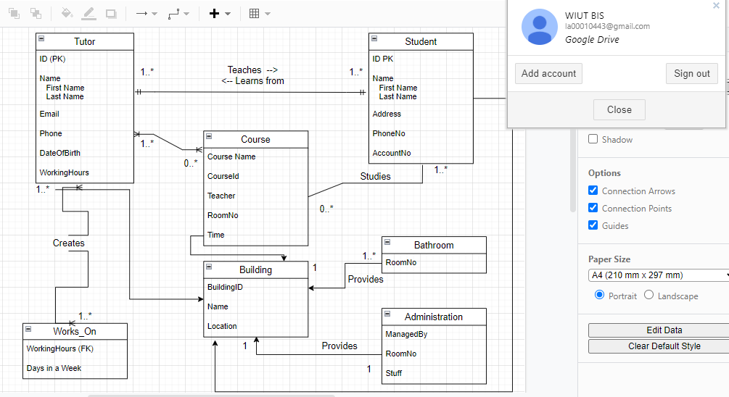
Section 4
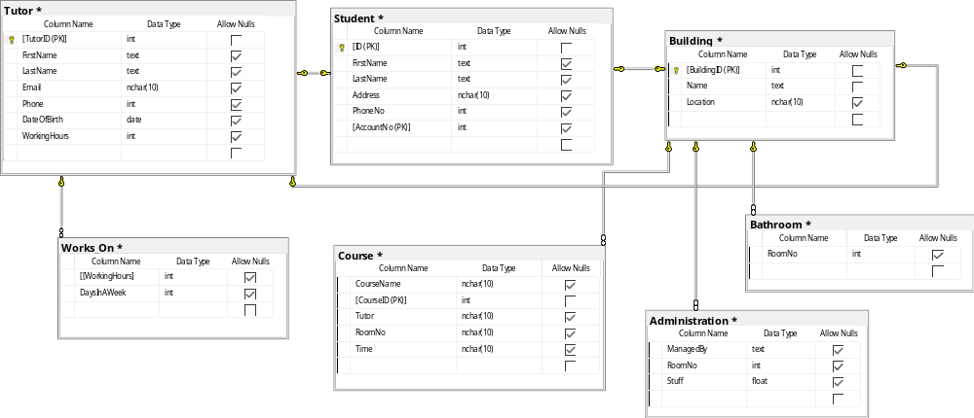
Section 5

Tutor
TutorID -> FirstName, LastName, email, phone, DateOfBirth, WorkingHours

Student
ID, AccountID -> FirstName, LastName, Address, PhoneNo

Course
CourseID -> CourseName, tutor, RoomNo, time

Building
BuildingID -> Name, Location

Task 2
Section 1.

USE [00010443]
GO
SET ANSI_NULLS ON
GO

SET QUOTED_IDENTIFIER ON
GO

CREATE TABLE [dbo].[sysdiagrams](
[name] [sysname] NOT NULL,
[principal_id] [int] NOT NULL,
[diagram_id] [int] IDENTITY(1,1) NOT NULL,
[version] [int] NULL,
[definition] [varbinary](max) NULL,
PRIMARY KEY CLUSTERED
(
[diagram_id] ASC
)WITH (PAD_INDEX = OFF, STATISTICS_NORECOMPUTE = OFF, IGNORE_DUP_KEY = OFF, ALLOW_ROW_LOCKS = ON, ALLOW_PAGE_LOCKS = ON) ON [PRIMARY],
CONSTRAINT [UK_principal_name] UNIQUE NONCLUSTERED
(
[principal_id] ASC,
[name] ASC
)WITH (PAD_INDEX = OFF, STATISTICS_NORECOMPUTE = OFF, IGNORE_DUP_KEY = OFF, ALLOW_ROW_LOCKS = ON, ALLOW_PAGE_LOCKS = ON) ON [PRIMARY]
) ON [PRIMARY] TEXTIMAGE_ON [PRIMARY]
GO

EXEC sys.sp_addextendedproperty @name=N'microsoft_database_tools_support', @value=1 , @level0type=N'SCHEMA',@level0name=N'dbo', @level1type=N'TABLE',@level1name=N'sysdiagrams'
GO

