Please note that this plugin is in **Alpha** stage.

In this example, we have the “code1.exe” sample file with a huge function (at 0x403F13) that consists of a set of force-inlined functions that are called multiple times inside the parent function.

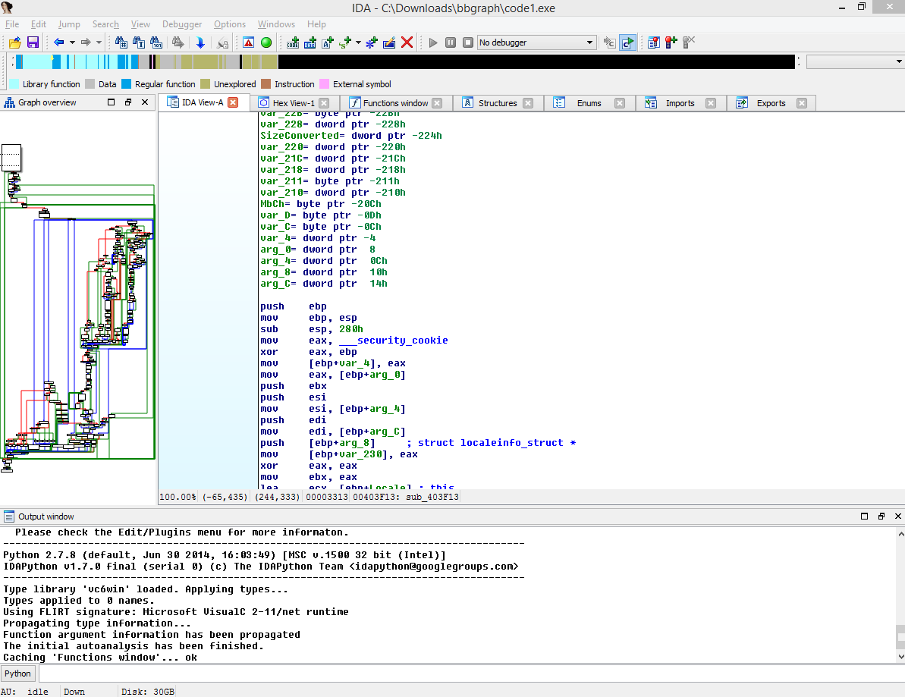

Notice how the graph is complicated.

If you zoom in, you may spot similar blocks, but this is a tedious operation.

Navigate to the function address at 0x403F13. Now, let us invoke GraphSlick plugin by pressing Ctrl-4.

**Press “U” to show the similar nodes in expanded form.**

We will see the result of matched blocks in a new window called “Graph Slick – Panel” and the basic block display (similar to IDA’s graphview) in the “Graph Slick – View” window.

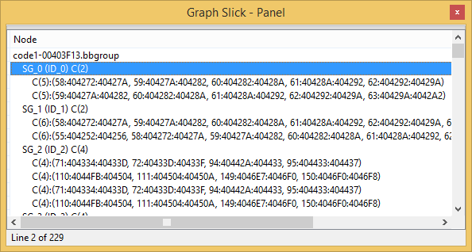

This is how to interpret the results:

1. The root node is named after the database name followed by the function’s start address
2. Each “SG_n” stands for Super Group or a group of similar set of basic blocks
   1. Each super group have a node set. The super group format is: SG_n C(N) <- where N describes how many node sets exist in this super group
   2. Each node set has the following format: C(n) <- that designates how many basic blocks belong to the same instance
3. Each node set has the following format: (node_id: start_address: end_address, …)

In the screenshot below, we focus on SG_3 that has 4 node sets (of similar possible inlined functions):

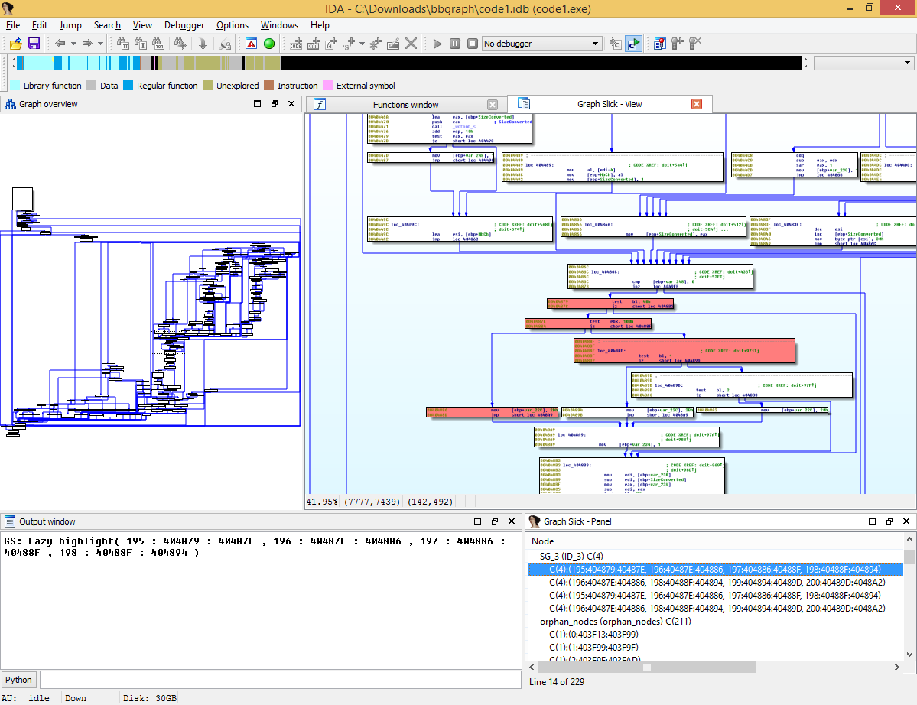

Double clicking on the super group will highlight all the similar node sets.

Double clicking on individual node set will just highlight the nodes in that set.

Other actions you can apply in the “Graph Slick – View”:

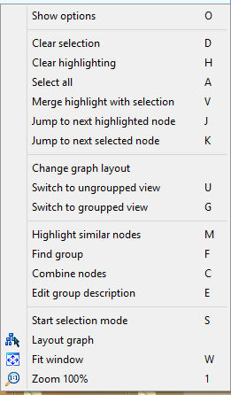

In the following screenshot, we pressed “G” to group all similar node set into a single node having the name as the super group.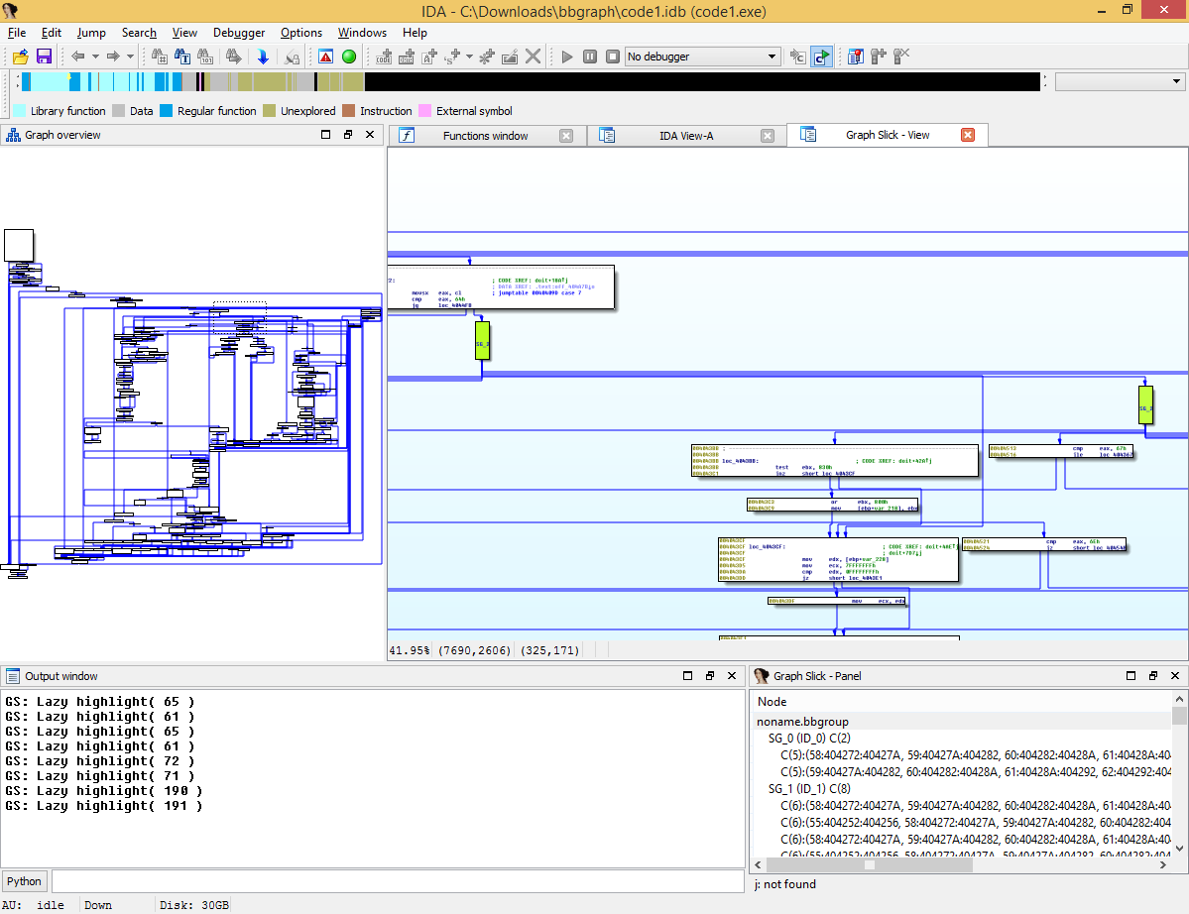

You can right-click on the super group and rename it:

