Tabish Chauhan

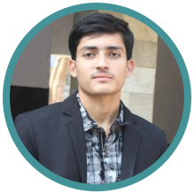

[tabish.chauhan.mca.2017@miet.ac.in](mailto:tabish.chauhan.mca.2017@miet.ac.in)



8791102951



siwal khas , Meerut, India



**EDUCATION** **SKILLS**

**10th** JAVA SQL



From Millennium public school with 75%



*2013*,

**12th**



From Millennium public school with 65%

*2015*,

**BCA**



From Shanti Institute of technology with 69%

*2018*,

**MCA**



From Meerut Institute of Education and Technology with 77%

*2020*,

Artificial Intelligence ad Machine Learning using python



C programming HTML CSS

**PERSONAL PROJECTS**

Predicting credit card spend(Supervised Learning)

Segmentation of credit card customer(Unsupervised Learning)

Object Detection(YOLO)

Image Classificaion

Air Quality Monitoring device

Face Recognition camera

**INTERNSHIP**

**Machine Learning and Artificial Intelligence**



STAQO

*02/2020 - 07/2020*, *NOIDA*

*Staqo is an oﬀshoot of a billion-rupee conglomerate - Sheela Foam Limited (SFL).*

**LANGUAGES**



English



Hindi

**INTERESTS**



SPORTS VIDEO GAMING WEB SERIES