Intelligent Detection and Counteraction Platform System
- Abstract
This project aims to design and construct an automated platform based on computer vision and a rotational mechanism. The system utilizes its omnidirectional observation capability to detect and track targets, facilitating the testing and validation of onboard countermeasure systems assigned to the platform.
The research spans multiple disciplines, including computer-aided design (CAD), mechanism verification, additive manufacturing, circuit design, and mechatronics in hardware implementation, as well as image processing, computer vision, sensor integration, control systems, network communication, 3D rendering, and graphical user interface (GUI) design in software development.
Since the 112 academic year, I have actively developed the conceptual framework and implementation plan of this project, while conducting various technical validations. Initial hardware and software validation was completed in the second semester of the 113 academic year, followed by system construction and assembly. By the 114 academic year, the system had been fully built, with ongoing calibration and functional refinement.
- Methodology and Results
  - Concept
The concept of this project is analogous to a Close-In Weapon System (CIWS). The primary structure consists of a fixed base and a rotational mechanism mounted above it, accompanied by a handheld control unit serving as the user interface.
In recent years, unmanned aerial vehicles (UAVs) have been increasingly utilized in military and various other domains, leading to a growing demand for counter-UAV systems, which motivated the selection of the topic for this project.
However, conducting such research in a practical manner generally necessitates the use of a physically realized test platform, and there are currently no commercially available development platforms for this purpose, nor are there prior similar projects within the institution.
Therefore, I adopted a bottom-up approach, encompassing everything from implementation planning to the design and development of the system’s hardware and software. The system continues to be iteratively refined to support further research and development.

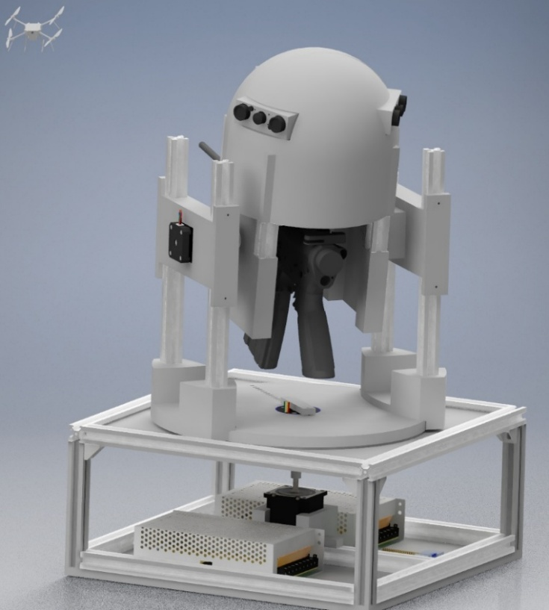
→Figure 1. Primary structure drawnusing Autodesk Inventor.
  - Hardware Architecture
    - Primary Structure
The primary structure measures approximately 40 cm in length and width, and 70 cm in height. The main frame is constructed using aluminum extrusions, while components requiring complex geometries are fabricated using 3D printing. The system is broadly divided into two parts: a fixed base and a rotational mechanism providing elevation and traverse (T&E) motion.
The fixed base houses the input/output interfaces, power supply system (110V AC to 12/24V DC), a single-board computer (Raspberry Pi) responsible for I/O processing and control, as well as the traverse drive system, which consists of a stepper motor paired with a microcontroller-based driver.
The rotational assembly contains the core functional components. The elevation mechanism includes a top enclosure housing the cameras, an embedded computing unit (NVIDIA Jetson) responsible for image processing, target recognition, and control command generation, as well as an inertial measurement unit (IMU). The assembly is driven by coaxial actuators on both sides.
    - Slip Ring
To enable continuous rotation of the mechanism while maintaining power and signal transmission, a connecting mechanism which acts as a slip ring assembly is required for electrical interfacing. Commercial solutions meeting the system’s specific power and communication requirements would need to be custom-manufactured to specification and are therefore impractical in terms of cost and replaceability. Thus, a custom hybrid design was adopted.
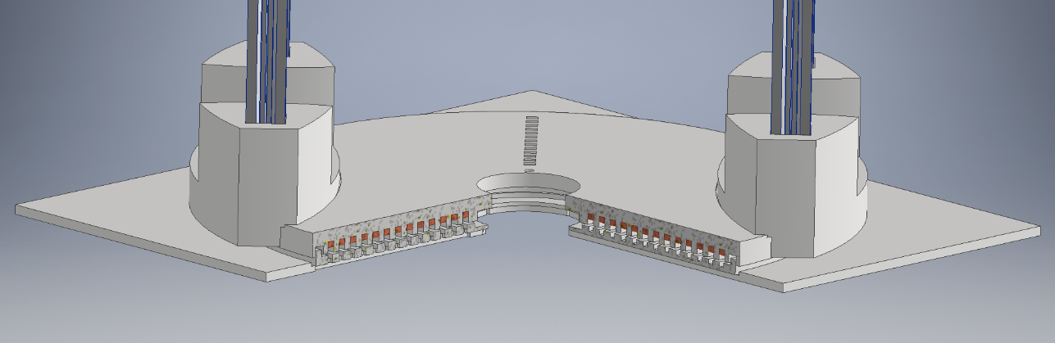
The proposed design consists of two main parts. The brushes and their mount are installed on the fixed structure, with wiring routed through feedthrough holes to the lower compartment. The rotating base supports the entire rotational assembly and incorporates solid copper slip rings embedded within internal grooves, also featuring feedthroughs for electrical connections. The slip ring assembly is directly driven by the motor located at the base.
Figure 2. Connecting mechanism drawn using Autodesk Inventor.
During the development of this system, multiple brush designs were evaluated, including graphite packing and commercially available carbon brushes. These approaches exhibited limitations in terms of reliability, ease of installation and replacement.
The current implementation adopts a custom design based on a 1.25 mm² stranded wire. In this design, sections of insulation are removed along a single conductor, and selected strands are split at the midpoint and bent outward in opposite directions to form two contact points. Each brush assembly provides multiple contacts, while the remaining uncut strands maintain electrical continuity, eliminating the need for additional interconnections.
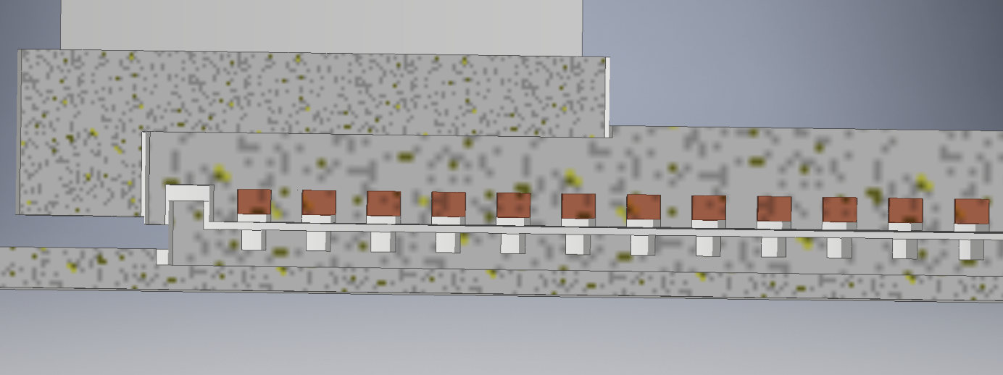
This configuration significantly improves reliability and has demonstrated stable performance in testing.
Figure 3. Slip ring assembly drawn using Autodesk Inventor.
The contact configuration described above provides stable performance for power delivery and low-frequency signal transmission. However, signal attenuation and impedance-related effects prevent reliable transmission of high-frequency differential signals through this structure, with the maximum verified data rate limited to approximately 1.5 Mbps (corresponding to USB low-speed).
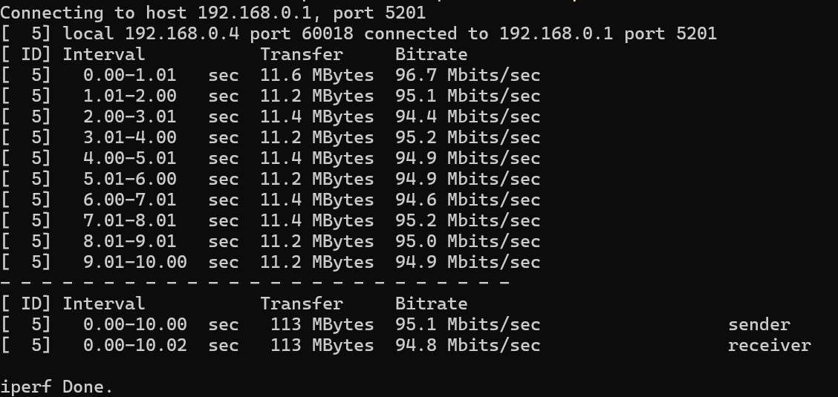
To meet the communication requirements of the system, a transmission method capable of supporting higher-frequency signals is therefore required. Commercial slip ring assemblies are typically designed with controlled impedance and proper signal isolation, but this also results in significantly higher cost. In particular, slip rings intended for high-frequency applications such as Ethernet communication are substantially more expensive than those designed solely for power transmission with a similar number of channels. Furthermore, such components are generally not serviceable and must be replaced in the event of failure. For the purposes of this research, a low-cost slip ring with four electrical channels and no specified high-frequency capability was selected and evaluated. By directly interfacing it with a 100BASE-T Ethernet cable, stable full-speed data transmission was achieved in testing. Due to its standard form factor and cost-effectiveness, this component was adopted as the high-speed communication link between the rotating and fixed sections of the system. The Ethernet slip ring connects upward to the Jetson and downward to a network switch, forming a local area network (LAN) with the Raspberry Pi and other devices (e.g., a PC). The network is isolated from the Internet to reduce security risks, and all devices operate using preconfigured static IP addresses, eliminating the need for a router.
Figure 4.、iperf3 speed/throughput test result
    - Countermeasure System and Power System Enhancements
The payload mounted on the rotational mechanism consists of a countermeasure system constructed from commercially available airsoft electric gun (AEG) components and a custom mounting bracket. The bracket secures the system to the structure, allowing it to follow the rotational motion of the platform. Firing is electronically controlled to simulate and evaluate hard-kill systems, enabling the study of recoil effects and ballistic characteristics.
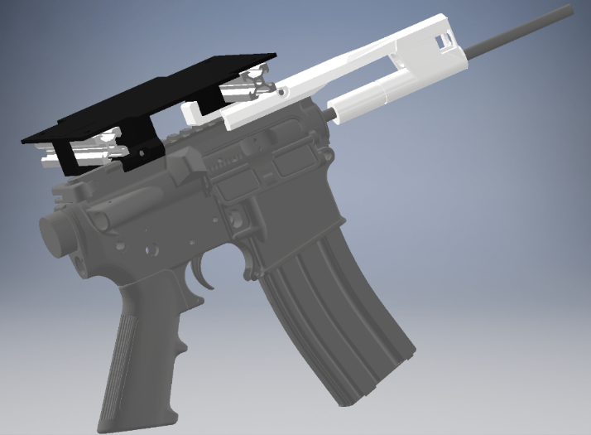
Due to the high transient load required to drive the AEG, such systems are typically powered by lithium batteries rather than a regulated DC power supply as used in this project. The large transient current drawn by the AEG causes significant voltage fluctuations on the shared power supply, which can adversely affect the stability of other loads. To address this issue, a supercapacitor module is integrated into the rotational assembly to provide energy buffering, releasing stored energy during peak load conditions to stabilize the power supply.
Figure 5. Countermeasure system drawn using Autodesk Inventor
In addition, the countermeasure system is equipped with a laser module for auxiliary aiming and calibration.
    - Modular Design
Modular design is a key aspect of the system’s hardware architecture. To facilitate maintenance and modification, the system can be assembled from fully integrated modules within 15 minutes. When divided only into the fixed base and rotational assembly, disassembly or reassembly can be completed in under 5 minutes.
The mechanical structure is designed with simplicity as a primary objective, consisting primarily of aluminum extrusions and 3D-printed components. All motors are directly coupled using rigid couplings, eliminating the need for complex transmission mechanisms and significantly reducing maintenance complexity.
Future work will focus on further refinement of both mechanical components and electrical systems to improve overall reliability.
    - Control Interface
A handheld control unit is used as the primary operator interface. The enclosure is fabricated using 3D printing and integrates various input and feedback devices, along with an LCD for displaying the graphical user interface (GUI). A joystick provides manual control and mode switching between manual and automatic operation, while toggle switches are used for fire control (motor actuation) and safety of the countermeasure system. Additional controls include a trigger button, an emergency stop button, and status indicators, all of which can be reconfigured based on functional requirements.
The control unit does not include its own power supply or wireless communication capability. Instead, it is connected to the main system via D-sub and VGA cables, through which power, I/O signals and video are transmitted. The front panel features a hinged design for easy maintenance, and the display is mounted on an articulated arm that can be folded when not in use.
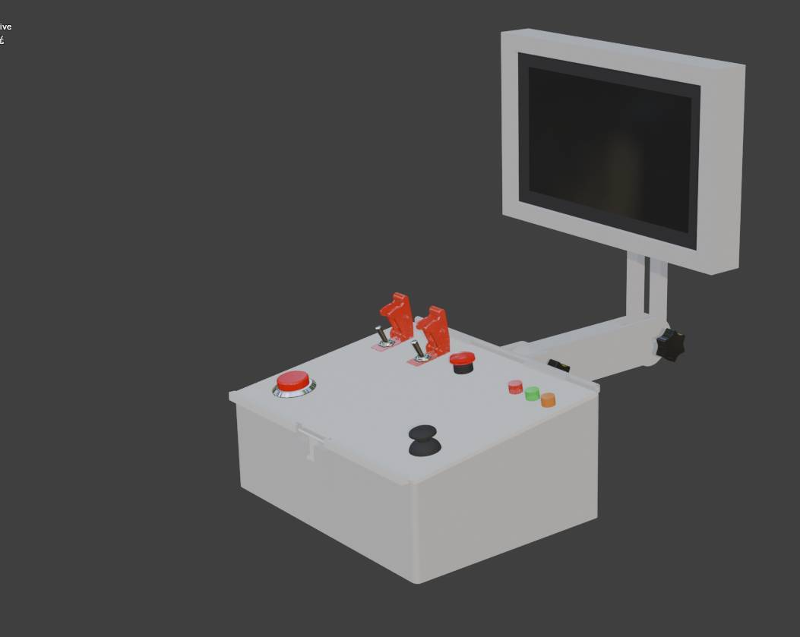
Although the use of wired communication limits operating distance, it reduces system complexity and overall weight while minimizing latency. More importantly, it mitigates the risk of communication failure or interference caused by electromagnetic disturbances, aligning with the overall system design philosophy.
Figure 6. Control unit drawn using blender.
    - Perception Architecture
Target detection in this system is currently based entirely on computer vision. Three IMX-219-160IR wide-angle camera modules are arranged with 120-degree angular separation to provide omnidirectional coverage. These cameras are equipped without infrared cut filters and are paired with infrared illumination, enabling operation in both daytime and low-light conditions.
The cameras are mounted on top of the rotational assembly. One camera is aligned with the countermeasure system and serves as the primary sensor for target locking and tracking, while the remaining two are used for target detection.
In addition, an inertial measurement unit (IMU) is installed on the rotational assembly to measure azimuth and elevation, providing absolute orientation sensing. Encoders integrated within the motor controllers provide more precise and stable relative position feedback.
  - Software Architecture
    - Structure
The software for this project is primarily implemented in Python and runs on a Linux-based environment. Execution of individual modules is managed through shell scripts, while configuration files are defined using YAML format. Version control is handled using Git, with the repository hosted on GitHub to enable synchronization across devices and to allow access by AI-assisted development tools (e.g., Codex and GitHub Copilot) for code review and suggestion.
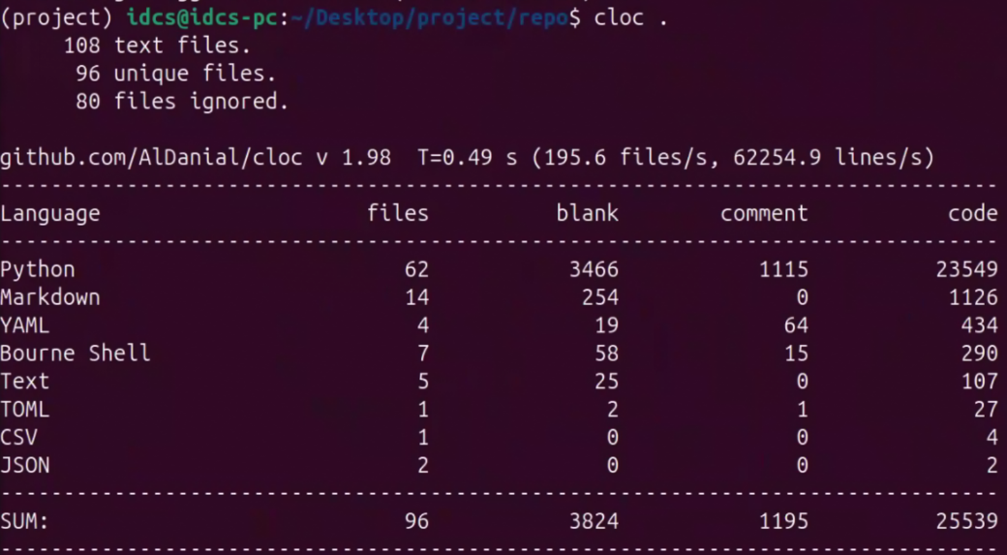
The codebase is organized by device. For example, the “Jetson” directory contains modules responsible for control computation, image processing, and video streaming services running on that platform, while the “common” directory include common mathematical utilities and configuration synchronization protocols.
Figure 7. Statistics of the repository
    - Image Processing
All image encoding, decoding, and model inference processes are executed on the NVIDIA Jetson platform. Video streams are decoded using hardware acceleration, after which inference is performed on the GPU via the TensorRT SDK. Detection results, along with latency-related information, are forwarded to the control pipeline and used to overlay bounding boxes on the original video frames.
After rendering the graphical user interface, the processed video stream is transmitted over the network to a receiving device (e.g., Raspberry Pi or PC). The streaming pipeline is implemented using GStreamer, supporting UDP-based transmission and the Jetson-specific Libargus camera API.
The computer vision model used in this system is a custom-trained Ultralytics YOLO26 model. As of 2026, it represents the state of the art among models provided by Ultralytics, offering significant improvements in both accuracy and inference speed over previous versions. The model is trained to detect two primary target classes—personnel and unmanned aerial vehicles—and the system can be configured to track detected objects belonging to these classes.
On the NVIDIA Jetson Orin NX module, the YOLO26s model achieves approximately 50 FPS at an input resolution of 1280x1280, providing sufficient sampling rate for real-time control. In contrast, the YOLO26n model achieves approximately 37 FPS at 1920x1920, offering higher spatial resolution at the cost of increased latency.
Based on these characteristics, the detection pipeline operates in two stages. In the search mode, the YOLO26n model is used to scan the scene and detect targets, leveraging its higher resolution. Once a target is detected, the system actuates the mechanism to align with the target direction while simultaneously activating a tracking mode using the YOLO26s model. In this mode, inference is performed on a cropped central region of the input image matched to the model resolution. Upon successful detection by the tracking model, the system fully transitions into tracking mode.。
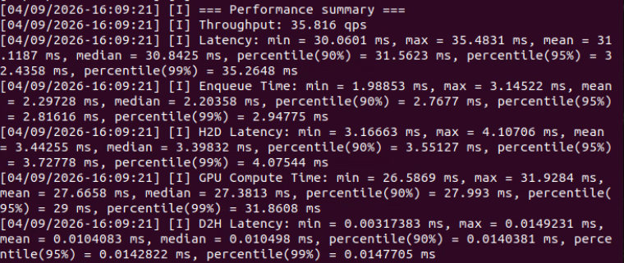
Figure 8. Benchmark result of YOLO26n with imgsz=1920x1920 using trtexec
    - 模擬影像
Given that development and testing take place within an indoor academic environment, experiments involving real UAV targets are not always practical or safe, and relocating the system for outdoor testing is non-trivial. To address this limitation, a simulation framework was developed to enable testing and demonstration under controlled conditions. The simulation is implemented as a custom-developed application and supports both a fully virtual mode, in which the mechanism is simulated without physical actuation, and a hybrid mode, where the physical system operates in conjunction with the simulation, with real system states fed back into the simulated environment.
The simulation is generated on a PC by computing the virtual camera orientation based on control commands received from the Jetson module on a per-frame basis. The resulting frames are then streamed back to the Jetson for processing. Two rendering modes are currently supported: a CPU-based renderer implemented using OpenCV with 2D image assets (e.g., JPG, PNG), and a GPU-based renderer using ModernGL for rendering 3D models (e.g., STL, OBJ) within the simulated environment.

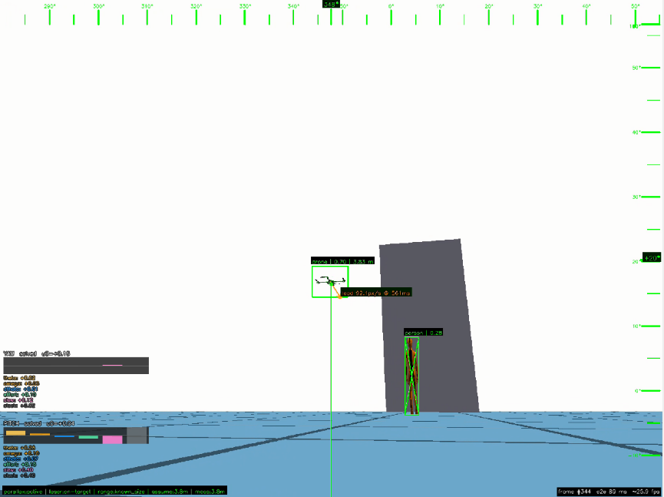
The current simulation environment includes basic elements such as a background, ground plane, simple geometric structures, and target objects. Future work will focus on extending scene complexity and improving rendering techniques, including support for additional object types and enhanced shaders.。
Figure 9. The simulation video feed with GUI
    - Control System
Significant effort in this work is devoted to the design and implementation of the control system. A key consideration in the initial design is the parallax between the camera and the countermeasure system. As a result, control commands cannot be generated by simply aligning the target with the center of the camera’s field of view.
To reduce system complexity, the hardware is designed such that no additional parallax exists along the vertical axis. Nevertheless, the control system is capable of compensating for parallax across all three axes.
The mechanism is required to aim at and track fast-moving targets, imposing strict real-time constraints. However, latency introduced by multiple processing stages accumulates and significantly degrades system performance. Improvements in hardware performance or software architecture alone are insufficient to fully mitigate this issue.
Therefore, a compensation-based approach is adopted at the control level to account for and reduce the effects of system latency. The initial controller design is based on a PID controller, which does not provide explicit compensation for system latency and instead focuses on minimizing tracking error. Additional features include velocity and acceleration constraints, as well as a simplified Kalman filter for target position prediction.
Although limited in functionality, the PID controller has a very low computational cost. It is therefore used during the transition from search mode to tracking mode. Once the system enters tracking mode, control is switched to a model predictive control (MPC) framework.
MPC is employed to optimize system performance by defining a cost function tailored to the system dynamics and operating conditions. The cost function used in this work consists of the following components:
- Theta: angular error, penalizing deviation between the system orientation and the target direction
- Omega: velocity error, penalizing differences between the system’s angular velocity and the target’s motion
- dTheta: rate of change of angular error, reducing overshoot and oscillations
- Effort: control effort, penalizing large control inputs to avoid overly aggressive actuation
- Slew: rate of change of control input, limiting rapid variations in command signals
- Slack: slack variable term, activated under large angular or velocity errors to allow more aggressive corrective action (applied in conjunction with the Theta and Omega terms)
In addition, hard constraints are imposed on angular position, velocity, and acceleration to ensure that all control commands remain within the system’s physical limits. The prediction horizon and sampling time are configurable for each control cycle, allowing a trade-off between computational complexity and control accuracy.
The prediction model estimates target motion based on error measurements accumulated over multiple frames, compensating for the system’s own motion to derive target velocity and predict future target positions. These predictions are used as inputs to the optimization process, which is solved using the OSQP solver.
To address the previously discussed latency issue, the system estimates a rolling delay based on persistent tracking error and incorporates this into the control loop for targeted compensation. Additional configurable delay terms are also included; for example, in hard-kill scenarios, projectile time-of-flight is modeled as an extra delay component.
    - Motor Control
To reduce circuit complexity and improve system reliability, integrated motor controllers mounted directly on the stepper motors are employed. All controllers communicate via a unified RS-485 interface using a UART-based protocol, with communication managed through a converter connected to the Jetson module. As the interface operates in half-duplex mode, only one controller can communicate on the bus at a time, which limits throughput. However, this limitation is mitigated by the short communication time of individual commands, typically under 1 ms at a baud rate of 256000 with message sizes of fewer than 10 bytes.
Since all controllers share a common bus, the number of required connections is minimal, simplifying debugging and maintenance. Each command packet includes a fixed header, a controller ID, and an error-checking code, ensuring robust communication and minimizing the likelihood of erroneous actuation. Controllers also return status information upon receiving commands, enabling continuous feedback and allowing the system to resend commands or report errors in the event of communication failure.
Given that each communication cycle introduces latency on the order of several milliseconds, embedding serial communication directly within other control loops would significantly degrade system performance. To address this, a dedicated communication process is implemented to handle all interactions with the motor controllers. This process periodically polls status information (e.g., operating state, encoder readings) and processes incoming control requests from other modules by queuing commands and publishing received responses.
    - Device Synchronization
During system operation, multiple processes must coordinate and share information in real time. In addition, configuration data must be synchronized across devices prior to system initialization. Both the initialization procedure and the previously described request–response communication mechanism are implemented using the ØMQ (ZeroMQ) framework to achieve high performance and asynchronous communication.

This messaging framework is used extensively throughout the software architecture, supporting the exchange of control commands, operation modes (manual/automatic), target detection data, and system state information. Communication follows a publish–subscribe model and operates transparently across processes and devices. All devices are configured with predefined static IP addresses specified in the configuration files to ensure consistent and reliable connectivity.
  - Operation Procedure
To operate the system, all connections must first be verified, including the main power supply (110V AC), the control unit cable, and all communication interfaces, followed by powering on the system.
In development and testing scenarios, an additional device (typically a PC) with command-line or remote desktop access is required to initiate processes on each subsystem. Once configuration synchronization is completed across devices, the system begins operation according to the predefined settings. System shutdown is performed via command-line instructions, or by directly cutting power in emergency situations.
For full system demonstration, a keyed switch is activated after powering on. Upon detecting the switch state, each subsystem automatically launches its background services without requiring manual commands. In this mode, onboard cameras are used as the video source, and the graphical user interface is streamed to the display integrated into the control unit.
- Prospects
As of the time of writing (April, Academic Year 115), the primary objectives of this project have largely been achieved; however, several functionalities remain to be further refined. Upon completion of all planned features, future work will focus on improving system performance and user experience. The following directions are identified:
Currently, circuit protection relies primarily on built-in safeguards of individual components and a single fuse at the power input. Future improvements will include the integration of current and voltage sensing, as well as additional protection mechanisms at critical nodes to better safeguard sensitive components and provide real-time diagnostic information to the operator.
The existing software architecture is implemented entirely in Python without reliance on external frameworks. While this allows flexibility for customization, it is limited in functionality. Future development will aim to replace the current basic 3D simulation environment with mature robotics simulation platforms such as Isaac Sim or PyBullet, and to adopt ROS2 for sensor integration and control systems, thereby standardizing the simulation, testing, and development workflow.
From a user interaction perspective, additional features such as first-person view (FPV) capability can be introduced to enhance usability. Leveraging the system’s 360-degree field of view, integration with VR headsets could enable head-tracked visualization, with control transitioned to dedicated VR input devices.
Although the current system employs a low-cost, vision-only sensing approach, its perception capability is inherently limited compared to multi-sensor fusion systems (e.g., systems integrating radar and forward-looking infrared sensors). Future work will explore methods to enhance detection performance and expand sensing capabilities.
- Conclusion
This work adopts a practical, engineering-driven approach to develop a fully functional and reliable experimental platform capable of supporting a wide range of testing scenarios and producing consistent, reproducible results. It reflects a strong integration of technical skills, system-level thinking, and sustained development effort.
Rather than pursuing superficial novelty, this project focuses on a challenging problem with tangible research value, emphasizing meaningful implementation over purely conceptual design. Through this process, valuable experience has been gained in system integration, control design, and real-world engineering trade-offs, providing a solid foundation for future development and further research.

