**Interactive Device Design Summer 2018**

**Homework 2: Text Entry Device**

**Cameron Riley & Jason Zhou**

**Github URL:**

<https://github.com/IDD-su18/hw2-jasonxzhou>

**What text entry technique you chose and why:**

**How you implemented character recognition (i.e., how your code works):**

**How you constructed the physical device:**

**Images & Wiring Diagram:**

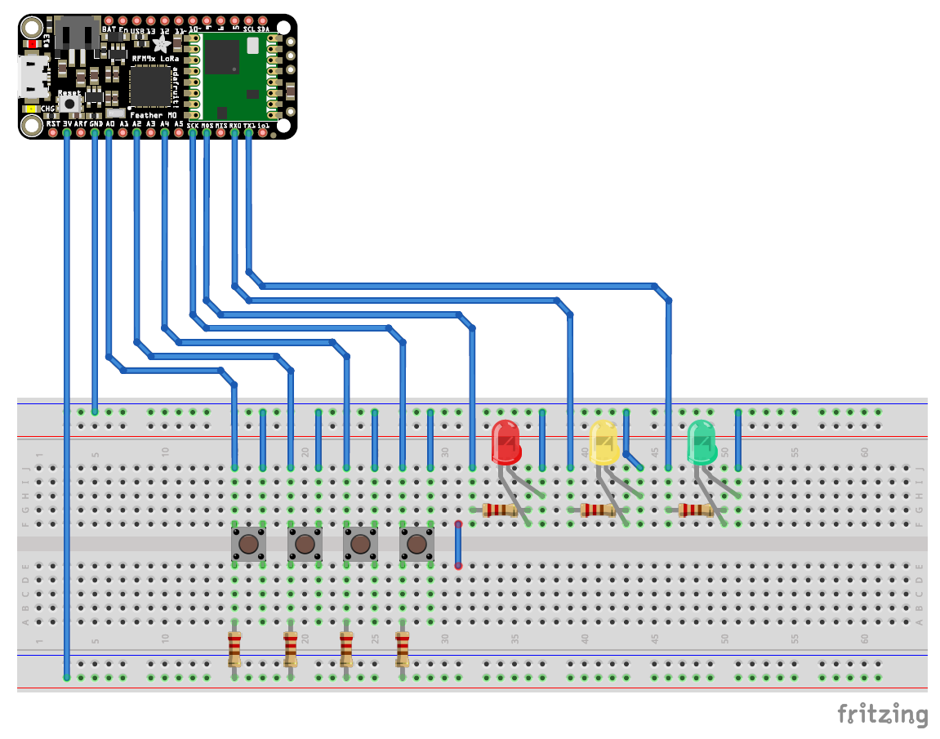

**Reflection:**

**Link to video:**

**Link to your code**

<https://github.com/IDD-su18/hw2-jasonxzhou/blob/master/hw2/hw2.ino>