**Green Code**

Contents

Team members 1

Stages 1

Creating a team 1

Coming up with the idea 1

Communication 2

Block Scheme. 3

Software we used 4

Completed Tasks 5

# Team members

|  |  |  |
| --- | --- | --- |
| Name | Class | Roles |
| Stanislav Tzeneviz | 10 B | **Scrum Trainer** |
| Ivan Dimov | 10 V | **Back-end Developer** |
| Kevin Rusev | 10 G | **Back-end Developer** |
| Teodora Lozeva | 10 A | **Front-end Developer** |

# Stages

## Creating a team

We found people that are willing to collaborate with us and join our team.

1. Selecting a team
2. Distribution of roles

* Identified the tasks and responsibilities that need to be completed.
* Assigned roles to team members based on their skills, experience, and interests.
* Created a role definition for each role, including the tasks and responsibilities, authority, and reporting structure.
* Communicated the role definitions to the team members.

## Coming up with the idea

1. We brainstormed ideas together and came up with a project idea that we're all excited about.
2. We analyzed our team's skills and interests, and then researched potential project ideas.
3. We generated a list of potential project ideas and then evaluated each one based on its feasibility, impact, and potential for success.
4. We selected the best project idea and then developed a plan to make it happen.

## Communication

For communication we used MS Teams and Discord, to arrange meetings to discuss our ideas. For sharing files, we used GitHub and OneDrive

## Block Scheme.

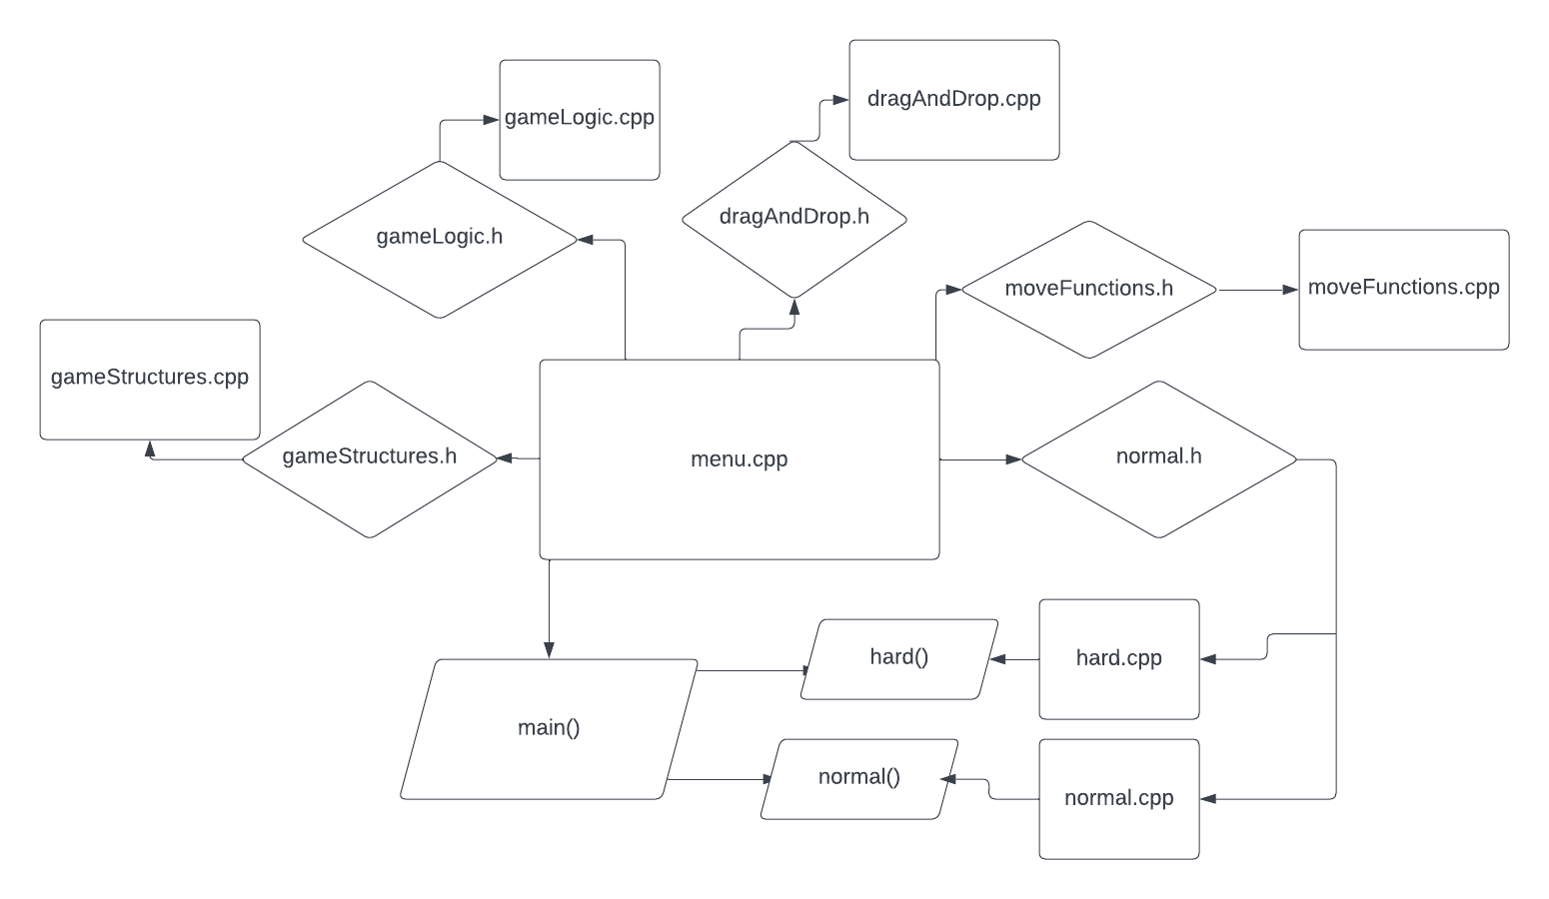

## Software we used

MS Teams - communication

Discord - communication

GitHub – sharing files

MS Word – creating the documentation

MS PowerPoint – creating the presentation

Visual Studio 2022 – writing the code

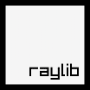 Raylib – writing the code

# Completed Tasks

|  |  |  |
| --- | --- | --- |
| № | Task | Status |
| 1. | Gather a team | ✔ |
| 2. | Distribute the roles and tasks evenly | ✔ |
| 3. | Start working on the code | ✔ |
| 4. | Start working on the presentation and documentation | ✔ |
| 5. | Debug the game | ✔ |
| 6. | Make the QA table | ✔ |
| 7. | Push all files to GitHub | ✔ |