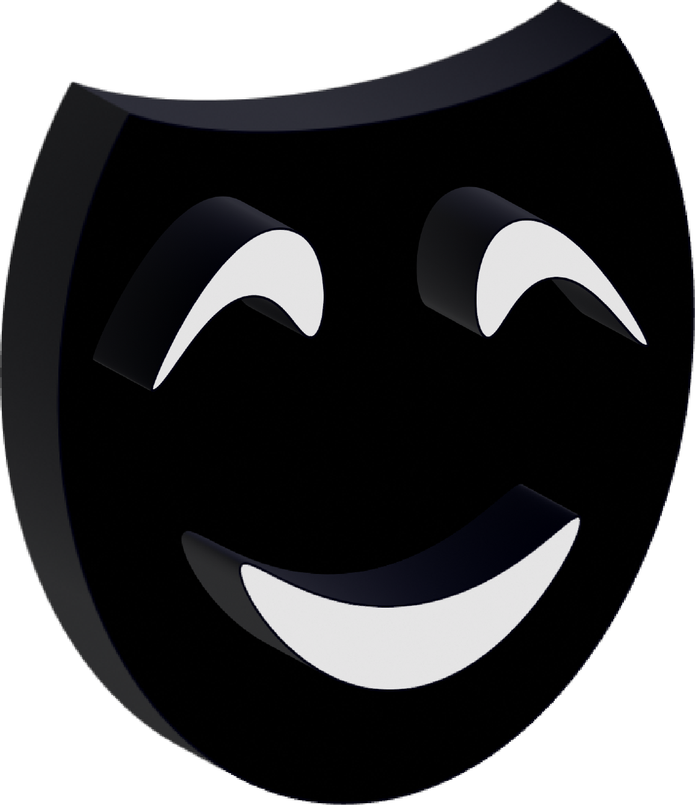

Masquarade

Masquarade | Banking | 2024

Contents

1. Members 2

2. Idea of the project 2

3. Realization steps 3

4. Used technologies 3

# 1. Members

|  |  |
| --- | --- |
| Name | Role |
| Ivan Dochev | Scrum Trainer |
| Alex Kazakov | Back-end Developer |
| Yavor Penkov | Back-end Developer |
| [Ivan Tsvyatkov](https://github.com/INTsvyatkov21) | Designer |

# 2. Idea of the project

Our idea is to make a register and login system for a hypothetical bank, where when we are logged in, we can pass our will on to someone of our choice.

# 3. Realization steps

|  | Stages of realization |
| --- | --- |
| 1 | Idea  We came up with a basic idea but tried to implement it as a web application using Django |
| 2 | GitHub Setup  We used GitHub to commit changes to the code. |
| 3 | Organization  We organized ourselves so that there isn’t anything only one particular person can do a certain task, making sure to involve ourselves in whatever we can. |
| 4 | Design  We designed our logo using applications that are referenced below. |
| 5 | Coding  We faced difficulty trying to do something new while coding and we learnt a lot of things |
| 6 | Execution of presentation & documentation  The presentation & documentation can be found in the documents folder in our GitHub repository. |

# 4. Used technologies

|  | Stage of realization |
| --- | --- |
| 1 | Languages We used c++ to make a template of what the app should look like in a console application and then recreated it using Python and Django to host it to our localhost |
| 2 | Text Editor  Visual Studio 2023  Visual Studio Code |
| 3 | Documentation Tools  ***Word; PowerPoint***  Used to create the presentation and documentation |
| 4 | Design Tools  ***Illustrator***  Our logo was fully custom made using Illustrator |
| 5 | Communication tools  ***MS Teams***  We communicated via MS Teams |
| 6 | Extra tools  ***GitHub; Git***  We used git and github as our collaborative application of choice |