Module: Take a Pause
Script | On Slide Text | Animation Notes
Hi! How are you feeling right now?  Do you have 30 seconds?  Before you get started in the ParentText programme, let's take a quick pause together. | Take a Pause
Sit down somewhere comfortable and close your eyes.  Take a deeeeeeeep breath.  [pause]  Feel the air moving in, and out, of your body.  In;  [pause]  and out;  [pause]  In;  [pause]  and out;  [pause]  In; [pause]  and out;  [pause]  Notice how your body feels while you breathe.  [pause]  Notice where you feel tension in your body.  [pause]  try to let it relax.  [pause]  When you are ready, open your eyes again. |  | Circle, expanding and shrinking, over and over.
Now, notice if you are feeling any differently than when you started this activity.
[pause]
Try to Take a Pause whenever you feel angry, overwhelmed, stressed or worried.  Even a few deep breaths or connecting with the ground beneath you can make a difference.  You can also Take a Pause with Your Teen! | Try it with your teen.

Module: Spend 1-on-1 Time with My Teen
Script | On Slide Text | Animation Notes
Here are three tips to make the most of spending 1-on-1 time with your teen:  DAY,  PLAY,  and STAY | Spend 1-on-1 Time with My Teen  - Day  - Play  - Stay
The first tip is, Day:  Try to spend 5 minutes or more with your teen EVERY day! | DAY  5 minutes or more every day!
The second tip is Play.  Let your teen choose the activity.  Begin by asking your teen to spend time with them. Let them choose what to do or talk about.  This should be fun! | PLAY  Let your teen choose.
Our final tip is Stay: Stay focused on your teen.  Switch off the TV and put aside phones. Look at your teen. Nod or say “I see” to show you are really paying attention. Avoid judgement and when your teen opens up, rephrase back what your teen says. It shows you are really listening to them. | STAY  Stay focused on your teen.
Remember: Day,  Play  and Stay  for 1-on-1 time with teens!  Your Home Activity this week is to spend at least 5 minutes of 1-on-1 time with Your Teen every day.  It will make such a difference!  Do you have time to do it today? | - Day  - Play  - Stay  Home Activity:  At least 5 minutes of 1-on-1 time with your teen every day. | Animate words to text.

Module: Give Praise
Script | On Slide Text | Animation Notes
Welcome back to ParentText! Today we are learning about giving our teens praise. You can support good behaviour and positive relationships by praising your teen in three easy steps: SEE IT, SAY IT, REPEAT IT.  Let’s learn more. | Give Praise  - See it  - Say it  - Repeat it
[1] The first step is to See it:  Look out for anything your teen does that is helpful or good.  [2] The second step is to say it.  Give them praise for the good or helpful thing they are doing.  Be enthusiastic - really mean it when you say it!  They may not seem to notice at first, but soon, you will see them repeat this good behavior.  [3] The final step is to REPEAT IT.  Try to find something every day to thank them for.  Even something really small.  Remember: See it, Say it, and Repeat it  Praising our teenagers for good behaviour can help them repeat this behaviour more often. | SEE IT  Notice anything your teen does that is helpful or good and give them praise.  SAY IT  Give enthusiastic praise!  REPEAT IT  Notice and praise good behaviour every day! | Animate words to text.
You are doing great, you should be very proud of yourself.  Your Home Activity today is to praise your teen. Can you try it today? | Home Activity:  Praise your teen.

Module: Talk About Feelings
Script | On Slide Text | Animation Notes
Today’s tip is on talking about feelings or emotions. Here’s how we can help our children understand and manage their emotions with six simple steps: OPEN, SHARE, LEARN, TALK, NOTICE, CARE. | Talk About Feelings  - Open  - Share  - Learn  - Talk  - Notice  - Care
The first step is OPEN. Be Open.  Your child looks to you for support and reassurance.  Listen when they have something to share.Accept how they feel and offer them comfort and encouragement. | OPEN  Listen when your teen shares, accept their feelings, and give them comfort.
Next, Share.  The way we behave in front of our children has a huge influence on their own behaviour.  Talk about how you are feeling.  This will help your child recognise, understand, and manage their own feelings, too. | SHARE  Set a good example and share your feelings, too.
Third, Learn.  Learn about emotions.  There are 6 basic emotions: happy, sad, angry, disgusted, surprised and afraid.  As children get older, they learn to identify many other emotions, such as excited, frustrated, proud, lonely, peaceful, guilty or confused. | LEARN  Happy  Sad  Angry  Disgusted  Surprised  Afraid
The fourth step is to TALK  Some people find it difficult to talk about their feelings and express their emotions, but we all experience them.  When you share difficult emotions such as anger, disappointment or frustration, you are helping your teen learn how to express them in a safe way. | TALK  Talk about emotions with your teen.
Step five is NOTICE. Notice your emotions and help your teen notice them, too.  You can also help your teennotice how positive emotions such as happiness, serenity and excitement make them feel. | NOTICE  Notice your emotions and your teens.
The final step is to CARE. Offer your teen care and comfort.  Use physical and verbal support to make your teen feel accepted and loved.  Hugging, smiling, or telling them you understand, can mean a lot.  Remind your teen that you are there for them and that they can always talk to you. | CARE  Make your teen feel accepted and loved.
Remember, talk about feelings with your teen by being [1] open, [2] sharing your own feelings, [3] learning about emotions, [4] talking with your teen about feelings, [5] noticing your emotions and your teens, and [6] offering your teen care with love and acceptance.  You’re doing great!  Your home activity is to talk to your teen about the six steps to coping and talking about emotions, OPEN, SHARE, LEARN, TALK, NOTICE, CARE.  Knowing these steps will help give Your Teen the courage to share their feelings! Can you do it today? | Talk About Feelings  - Open  - Share  - Learn  - Talk  - Notice  - Care  Home Activity: Talk with your teen about the 6 steps to coping and talking about emotions. | Animate words to text

Module: Care for Myself
Script | On Slide Text | Animation Notes
Hello! Parenting can be stressful, and it is time for you to take care of yourself! | Take Care of Yourself
[pause] Close your eyes. [pause]  Sit in a way that suits you.  [pause] Relax your body and listen to my words.  [pause]Picture yourself in your mind as an empty cup. [pause] Can you see yourself?  [pause] An empty cup of water is like someone who is exhausted, drained, tired and even angry.  [pause]Now picture yourself as a cup filled with water.  [pause] A full cup of water is like someone who is feeling energized, content, and confident in what they are doing.  [pause] Without opening your eyes, think about which of these you are at the moment?  Are you a full cup or an empty cup?  Or maybe somewhere in the middle?  [pause]  It is important that we as caregivers have ways to fill up our own cups.  [pause]  You can open your eyes. |  | Cup, slowly filling?
Here is a simple activity to keep your water cup full and take care of yourself. It is called Box Breathing. Let’s do this together.
To Box Breathe, EXHALE for four counts  [pause]  1  [pause]  2,  [pause]  3  [pause]  4 | EXHALE | Numbers 1-4
Now, HOLD your lungs empty for four counts  [pause]  1  [pause]  2,  [pause]  3  [pause]  4 | HOLD | Numbers 1-4
INHALE for four counts  [pause]  1  [pause]  2,  [pause]  3  [pause]  4 | INHALE | Numbers 1-4
HOLD your lungs full for four counts  [pause]  1  [pause]  2,  [pause]  3  [pause]  4 | HOLD | Numbers 1-4
To box breath, EXHALE for four counts  [pause]  1  [pause]  2,  [pause]  3  [pause]  4 | EXHALE | Numbers 1-4
Now, HOLD your lungs empty for four counts  [pause]  1  [pause]  2,  [pause]  3  [pause]  4 | HOLD | Numbers 1-4
INHALE for four counts  [pause]  1  [pause]  2,  [pause]  3  [pause]  4 | INHALE | Numbers 1-4
HOLD your lungs full for four counts  [pause]  1  [pause]  2,  [pause]  3  [pause]  4 | HOLD | Numbers 1-4
Finally, exhale. You can return to normal breathing now. [pause]  Your home activity is to try to box breathe on your own. Can you try it now? | Home Activity: Box Breathe at least once per day.

Module: Have Fun While Learning
Script | On Slide Text | Animation Notes
Here are three tips to help you make learning joyful and fun for your teen:  Be Playful  [pause]  Be Positive  [pause]  And Be Creative | Have Fun While Learning  - Be Playful  - Be Positive  - Be Creative
First, Be Playful.  Being playful while learning improves your teen’s physical and mental health AND their ability to learn and remember important facts!  To help make learning playful, you can play educational games in person or online.  If your teen starts to feel overwhelmed with school work, you can help them reduce their stress by taking a pause.  [2] The second tip is to be positive.  Remember, very few teens actually enjoy school work.  You can recognise their frustration, but remind them why school work matters:  It strengthens what they have learned at school, and teaches them how to manage their time wisely.  Encourage and praise your teen’s effort when they are learning.  [3]Finally, be creative.  Allow your teen to be creative when learning.  For example, encourage your teen to use images, like pictures or photos, or go outside to help their learning.  If your teen is interested in a new topic, like biology, encourage them to explore and find out more about it.  Help them meet with experts, access new books, or learn new topics online.  Set a good example:  Let your teen see you being creative or trying something new, even if you are not good at it yet. | BE PLAYFUL  Play educational games and help your teen take a pause.  BE POSITIVE  Praise your teen for their efforts!  BE CREATIVE  Explore new, interesting topics together!
Remember, to help your teen have fun while learning, you should play educational games together and encourage your teen to take a pause when they need it.  Spread positivity by praising your teen for their efforts in learning.  And allow creativity in learning by exploring new and interesting topics together.  Your home activity is to invite your teen to take a small break from homework and do something active for five minutes. You can dance, play football, do jumping jacks, or go for a jog. Breaking up their school work will help them remember information and the physical activity will keep them alert for studying. Do you have time to do it today? | Home Activity: Invite your teen to take a small break from homework and do something fun.

Module: Help Your Teen Learn
Script | On Slide Text | Animation Notes
Welcome to ParentText! Here are 3 important tips to help your teen learn:  Set Goals  [pause]  Ask Questions  [pause]  And Make Connections | Help Your Teen Learn  - Set Goals  - Ask Questions  - Make Connections
[1] First, SET GOALS.  Talk to your teen and find out what their goals are. What would they like to accomplish this year? Perhaps they want to join a club, make new friends, or earn high marks at school. Help them make their goals specific and measurable. The goals should be something that they can complete within a specific amount of time.  Help them understand the connection between a specific learning activity and achieving their goals.  This builds their motivation to learn.  [2]Next, ASK QUESTIONS.  Encourage your teen to ask questions, and ask your teen questions too! Don’t worry if you do not know the answers to their questions. Try finding the answer together by looking online, or asking experts in your community. Curiosity will help your teen’s brain grow!  [3]Finally, MAKE CONNECTIONS  Ask your teen to connect new information to things they already know, such as one of their interests or a topic from school. This develops and promotes deeper thinking and understanding of concepts. | SET GOALS  Help your teen understand the connection between learning and achieving their goals.  ASK QUESTIONS  Encourage your teen to ask questions, and find answers together!  MAKE CONNECTIONS  Connect learning to your teen’s interests.
Remember, to help your teen learn:  Help them identify their goals and understand that learning will help them achieve their goals. Encourage your teen to ask questions and find answers together, and make meaningful connections between what they are learning and what they are interested in.  Your home activity today is to spend 5 minutes and help your teen set a goal to study, or complete their school work this week. Do you have time to do it today? | - Set Goals  - Ask Questions  - Make Connections  Home Activity:  Spend 5 minutes to find out your teen’s school goals.

Module: Create a Positive Learning Space for Your Teen
Script | On Slide Text | Animation Notes
Welcome back to ParentText! Let’s create a positive learning space for your teen.  A great learning space requires these things:  Quiet  [pause]  Routine  [pause]  And Support  Let’s learn more together. | Create a Positive Learning Space for Your Teen  - Quite  - Routine  - Support
[1] First, Quiet.  [pause]  Effective learning requires focus. [pause] Find a space for your teen to learn without distractions.  Ask your teen to keep their phone away from the study space, turn off music, and reduce other noise so your teen can concentrate.  [2]Next, Routine  [pause]  Help make learning an important part of your teen’s daily routine.  If possible, encourage your teen to complete school work before beginning their chores. This shows your teen that their education is important to you.  [3]Finally, SUPPORT your teen in their studies.  [pause]  Try to let your teen focus while they are working. Let them know you are here to help if they need support.  You can also show support by asking what they need to accomplish today, and praise them if they achieve their goal. | QUIET  Help your teen focus with a quiet space.  ROUTINE  School work comes before household chores.  SUPPORT  Ask them what they need to accomplish and praise them when they achieve their goal. | Cross out phone and music
Remember, to create a positive learning environment for your teen, help your teen focus with a quiet space, Set a daily routine for learning, before household chores, and support your teen in their studies by letting them know you are there to help if needed, and then leaving them to study undisturbed.  Your home activity today is to talk with your teen to find the right study spot in your home. Do you have time to do it today? | Home Activity:  Work with your teen to find a study spot in your home.

Module: Learning from Mistakes
Script | On Slide Text | Animation Notes
Hi there! As a parent, you can help your teen know how to learn from their mistakes. Here are four tips on how to do this:  Talk  [pause]  Praise Effort  [pause]  Allow Mistakes to Happen  [pause]  And Share  Let’s learn more together. | Learning from Mistakes  - Talk  - Praise Effort  - Allow Mistakes to Happen  - Share
[1] First, Talk. Create space and time for your teen to talk with you about their life.  Try asking your teen how their day went at school. If their day was challenging, listen to them, and give space to let them share.Give them support and show you care. Tell them, "that sounds difficult.”  [2] Next, Praise their effort.  Praise your teen for the effort they put into their learning even if they did not succeed. Celebrate this effort together! Effort is more important than mastering a specific skill.  [3] Third, allow for mistakes to happen.  Allow your teen to make mistakes. Let them learn from their own mistakes so they can grow. It is tempting to want to solve every problem for your teen, especially when you know better, but this will not teach them how to solve their own problems. Talk to your teen about their mistakes and allow them to find ways to solve their problems and do better next time.  [4] Finally, SHARE  Try sharing your own failures with your teen and discuss how they helped you develop and grow.  This helps your teen learn that you do not have to be perfect all the time. | TALK  Talk about your teen’s day at school.  PRAISE EFFORT  Effort is more important than mastering a skill.  ALLOW MISTAKES TO HAPPEN  Teens must learn from their own mistakes.  SHARE  your own failures
Remember, to help our teens learn from mistakes:  [pause]  [1] Create space and time for your teen to talk with you about their life.  [2] Praise your teen for the effort they put into their learning even if they did not succeed.  [3] Allow your teen to make mistakes. Let them learn from their own mistakes so they can grow.  [4] And share your own failures with your teen and discuss how they helped you develop and grow.  Your Home Activity is to share a story with your teen about a time you learned from a mistake. It can be from school, or another life lesson. [pause] Do you have time to do it today? | - Talk  - Praise Effort  - Allow Mistakes to Happen  - Share  Home Activity:  Share a story with your teen about a time you made a mistake and what you learned from it.

Module: Learning How to Work with Other People
Welcome to ParentText. You can help your teen learn how to work with other people by encouraging them to be social and to engage in team work.  Let’s learn more together. | Learning How to Work with Other People  Be Social  Team Work
First, Be Social. Allow your teen to go and study with friends in a safe way. You can call these friends, ‘study buddies.’  You can also help your teen engage in team work by encouraging them to listen to others and respect their ideas. | Be Social  Allow study buddies.  Practice Team Work  By respecting others.
Your Home Activity today is to chat with your teen and identify a possible study buddy for the next week. Do you have time to do it today? | Home Activity  Help your teen identify a study buddy.

Module: Create Routines with My Teen
Script | On Slide Text | Animation Notes
Hello! In this skill, we will learn about how to create routines with your teen.  From schoolwork to household tasks, making daily routines with your teen can help them feel safe and secure. Here are three things to remember when creating a routine:  Be a Team  [pause]  Be Consistent  [pause]  Give Praise | Create Routines with My Teen  - Be a Team  - Be Consistent  - Give Praise
First, Be a Team.  [pause]  Talk to your teen about what they want their daily and weekly routines to look like.  Your teen is more likely to follow routines when they help to set them. | BE A TEAM  Work together to set your routine or schedule.
Next, Be Consistent  [pause]  Once you set the daily plan, make sure your teen follows their routines daily.  This helps your teen feel safe and secure.  Feeling secure means your teen has space to grow and develop.  Here are some suggestions for routines that you could establish with your teen:  Bedtime  Schoolwork  Chores  Mealtime  Play/free time  T.V. or gadget time  Storytime  Spending time with friends and as a family | BE CONSISTENT  Daily routines help our teens feel safe.
Finally, Give Praise.  [pause]  Thank your teen for creating a daily routine with you and praise them when they keep to it! | GIVE PRAISE  Praise them when they keep to their daily routines!
Remember, to create a routine with your teen:  [pause]  [1] Be a team and work together to set up the routine or daily plan.  [2] Help your teen be consistent with their daily routine.  [3] Finally, give praise. Praise your teen for setting up their routine with you and again when you notice they are keeping to their routine.  Your home activity is to have a conversation with your teen about daily routines. Are you ready? | - Be a Team  - Be Consistent  - Give Praise  Home Activity:  Have a conversation about daily routines with your teen.

Module: Set Family Rules
Script | On Slide Text | Animation Notes
Hello!  Today’s Parenting Skill is about how we can create family rules with our teens. When you are making household rules with your teenager, remember these four steps:  Be a Team  [pause]  Keep it Real  [pause]  Be Consistent  [Pause]  Praise Often | Set Family Rules  - Be a Team  - Keep it Real  - Be Consistent  - Praise Often
[1] First, Be a Team.  Involve your teen when creating family rules. This will make it more likely that your teen will follow them. Discuss the reasons for the rule and listen to their views.  [2] Next, Keep it Real.  Make the rules realistic for what your teen can do. One rule at a time is easiest. Be clear and specific so they understand what you want them to do. Make sure the rule is fair.  [3] Step 3 is to be consistent. Once you set a rule together, stick to it! If you always expect your teen to follow a rule, they will be more likely to follow it. If the rule is something that also involves you, like having a meal together as a family once a week, then it is important that you stick to it too.  [4] Finally, Praise Often. Praise your teen for setting family rules with you. And just like when they follow an instruction or behave well, praise them whenever they follow the rule! | BE A TEAM  Create rules together  KEEP IT REAL  Keep your rules realistic, clear, and specific.  BE CONSISTENT  Make sure you and your teen follow the rules consistently.  PRAISE OFTEN  Praise your teen whenever you notice they are following the rule.
Remember:[pause]  [1] Be a team and create the rules together.  [2] Keep the rules reasonable and concise.  [3] Apply the rules consistently.  [4] Praise your teen often. Give them praise for helping you make the rule and when they follow it.  Your home activity is to try to create at least one family rule with your teen. Can you do it today? | - Be a Team  - Keep it Real  - Be Consistent  - Praise Often  Home Activity: Create at least one family rule with your teen.

Module: Know Online Safety Basics
Script | On Slide Text | Animation Notes
Hi there! Keeping your teen safe online and creating healthy online habits might feel overwhelming at times, but online safety is an important step to help your teen be part of the digital world.  When it comes to online safety, there are four tips to keep in mind:  LEARN,  PROTECT,  BUILD HABITS,  and BUILD TRUST.  [1] Today, we are reviewing the tips [pause] LEARN [pause] and PROTECT.  The next lesson will cover [pause] BUILD HABITS [pause] and BUILD TRUST.  Let’s begin. | Know Online Safety Basics  - Learn  - Protect  - Build Habits  - Build Trust | [1] circle draws around learn and protect
First, learn the dangers of being online.  [pause] Content,[pause] Contact,[pause] and Conduct  [1] First, content. Your teen might come across harmful content online, like violence, hating women, pornography, wrong information, or hating people from other countries.  [2] Next, contact. Your teen could be contacted online by strangers or adults pretending to be teens, asking for sexual pictures or even to meet up.  [3] Finally, conduct, or behaviour. Teens can act in ways that hurt others online, or be the victim of this behaviour.  It sometimes feels overwhelming to keep our teens safe from all of these dangers. Luckily, there are lots of ways you can protect them. | LEARN  - Content  - Contact  - Conduct
There are many ways to make the internet a safer place for your teen.  [1] Talk to your teen: which apps and websites are safe and which are not? Why?  [2] Help your teen learn how to make strong passwords to protect their devices. | PROTECT  - Talk with your teen  - Set strong passwords
In the next session, we’ll continue learning about online safety. Today, your home activity is to ask your teen, “what do you do to stay safe online?”  You may find that they are already thinking about online safety. Praise your teen for any efforts they make.  Can you talk with Your Teen today? | Home Activity  Ask your teen: What do you do to stay safe online?

Module: Building Habits and Trust Online
Script | On Slide Text | Animation Notes
Hi again! Keeping your teen safe online and creating healthy online habits might feel overwhelming at times, but online safety is an important step to help your teen be part of the digital world.  When it comes to online safety, there are four tips to keep in mind. Previously, we reviewed the tips to LEARN and PROTECT.  Today we are reviewing the tips to BUILD HABITS and BUILD TRUST.  Let’s begin. | Keep My Teen Safe Online  - Learn  - Protect  - Build Habits  - Build Trust
First, build habits in your home that promote online safety and a positive relationship with the internet.  [pause] Plan no-phone times in your house, like during meals, homework, or in bed.  [pause] Only let your teen chat online with people they already know. They should never share personal information in a chat room or with strangers.  [pause]Before completing forms that ask for personal information, check that the web address begins with https://. Websites that begin with http:// may not be secure.  [pause] Help your teen create strong passwords for their accounts.  Good passwords are  [pause] long  [pause] do not include obvious personal information like your name or birthday,  [pause] and include upper and lower case letters, numbers and symbols. | BUILD HABITS  Set no-phone times in your home  Check web addresses  http:// https://  Set Strong Passwords:  -Long  -Don’t include personal information  -DO include upper and lowercase letters, numbers, and symbols. | Animate password details to explain better.
Finally, BUILD TRUST with your teen.  [1]  Together, look at the websites, social media, games, and apps they use.  [2]  Ask questions - this helps you learn more about your teen’s interests!  [3]  If you come across anything worrying together, talk about it with them.  [4]  Tell your teen that if they feel scared, unsafe or upset about something online, they should tell an adult as soon as possible and ask for help reporting it.  Just as you keep your teen safe in the real world, you also need to make sure they are safe in the digital world. By following these steps you can protect them and make sure that their online time is secure so they can keep using it to learn. You’re doing a great job! | BUILD TRUST  - Look at websites, social media, games and apps that your teen uses, together  - Ask questions  - Talk about worrying things together.  - Tell your teen if they feel scared or unsafe, they should tell an adult.
Here’s something you can do with your teen today to start making sure they stay safe online:  [1]  First, write down or draw the apps and websites your teen uses  [2]  Next, praise your teen for how good they are at using the web!  [3]  Then, talk about which sites or apps might be unsafe. Discuss why they might be unsafe.  [4]  Finally, talk together about how your teen and their friends can use the internet more safely.  Can you and your teen complete this task today? | Home Activity:  [1] Write down or draw the apps and websites your teen uses  [2] Praise your teen for how good they are at using the web!  [3] Talk about which sites or apps might be unsafe. Why?  [4] Together, talk about how your teen and their friends can use the internet more safely. | Illustrate as needed

Module: Understand Needs & Wants
Script | On Slide Text | Animation Notes
In this goal, we are learning about four steps to building a family budget with our teens. This will help you and your teen understand more about how money is saved and spent in the family.Today we will learn about step one: [pause] understanding needs and wants. | Understanding Needs and Wants
Make a list of things that you or your teen think you cannot live without. These are things that are important for your family to survive. This might include things like [pause]food, [pause]soap, [pause]medicine, [pause]school fees, and rent. | Identify Needs | Time entry of want list animated. Localize currency
Next, identify wants.  Make a list of things that you or your teen want. These are things that are nice to have but not essential.  [pause]  For example a data bundle, [pause]new phone, [pause]transport money to visit a friend, [pause] or a special treat. | Identify Wants | Time entry of need list animated. Localize currency
Finally, talk.[pause]  People often see things in different ways. Talk with your teen about what the different NEEDS and WANTS you each have. This will help you understand each other. With understanding, you can involve them in making decisions together about what to spend money on. Involving your teen helps teach them about managing money, and it will strengthen your relationship. | Talk
Your Home Activity is to try to discuss your financial wants and needs with your teen. Do you have time to do it today? | List your needs and wants, TOGETHER.

Module: Talking about Monthly Expenses
Script | On Slide Text | Animation Notes
In this goal, we are learning about the four steps to building a family budget with our teens. Today, we are learning about step two: [pause] talking about monthly expenses.  Here is an easy and fun way to do this with your teen. | Talking about Monthly Expenses
Get a piece of paper or anything else you can write on, and a pen. Next, draw pictures of all the things you and your family members spend money on each month.  [pause]  Then, write next to each picture how much each thing costs. Lastly, add up how much you spend monthly. | - Gather supplies  - Draw pictures  - Write in costs  - Add up the costs | 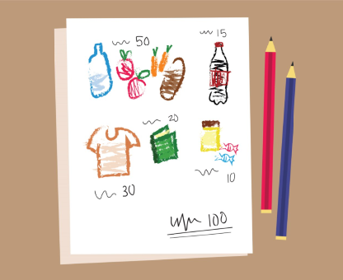  Begin with blank page  add items to blank piece of paper  add prices on to this piece of paper
Take a picture of your monthly expenses. You’ll need this information for the next lesson!  This is a great first step to family budgeting! |  | See if there’s a way to show a camera flash?
Your Home Activity is to find time to do this activity with your teen. Do you have time to do it today? | Home Activity: Make a list of monthly expenses with your teen.

Module: Making a Monthly Budget
Script | On Slide Text | Animation Notes
In this goal, we are learning about the four steps to building a family budget with our teens. Today, we are reviewing step three: [pause] making a monthly budget | Making a Monthly Budget
First, take the piece of paper from the monthly expenses activity that shows all the things you spend money on during a month. |  | Show end of prev. Module pic
Second, add up the money your family has available each month. This can be from a job, welfare grants, or even money sent to the family by other relatives. |  | Show scribbles adding up
Now, decide with your teen which of the expenses are things that you NEED and which are things that you WANT. Draw a star next to everything that you NEED. Add up all the things that have a star next to it. |  | Return to prev. Module pic and insert hand drawn stars
Is the amount more or less than your monthly budget? If it is less, you can add some things that you WANT. If it is more, then you may want to discuss with your teen which things are really NEEDS. You may need to make difficult choices between different things. |  | Show bottom of both pages (Star total and income total) with total sums circled
Your home activity is to work with your teen to create your family budget together. Do you have time to do it today? | Home Activity: Work with Your Teen to Set a Monthly Budget

Module: Make a Saving Plan
Script | On Slide Text | Animation Notes
In this goal, we are learning about the four steps to building a family budget with our teens. Today, we are reviewing the final step: [pause] make a saving plan. | Make a Saving Plan
First, discuss with your teen different reasons that you might want to save money. These could include: [pause]  Preparing for emergencies, [pause]  Buying something nice for you or your teen, [pause]  Doing something fun together as a family, or [pause]  Planning for future big expenses like improvements on your home or for your teen’s education. | Decide: What are you saving for? | Images timed to show reasons for saving
Second, set a target amount that you want to save. [pause]  Look at your monthly budget from the last activity.  [pause]  Discuss with your teen how much you can save each week and each month. | Decide: How much can you save each week or month towards your goal? | Illustrate how small amounts saved over time, create a large sum
Third, talk with your teen about different ways to keep money safe for future use. [pause]  These could include: [pause]  Saving at a bank, [pause]  Keeping money safe at home, [pause]  Keeping money in a savings and loan group, or [pause]  Buying livestock like goats or cattle. [pause]  Decide which way of saving money would work best for the family. | Decide: The best way to keep saved money safe.  - At a bank  - At home  - In a savings and loan group  - Buying livestock, like goats or cattle
The final step is identifying ways to get support. Your government or community groups may be giving money, vouchers, or food parcels to families in need. Think about whether there are places in your community that provide support. | Find Support
If you can try and save even a tiny amount each month for the future or for an emergency. This can make a big difference over time.  Your home activity is to create a saving plan with your teen. Do you have time to do it today?  Remember to praise yourself and your teen for taking the time to make a savings plan together. Congratulations! | Home Activity: Create a saving plan with your teen.

Module: Be Kind to Myself
Script | On Slide Text | Animation Notes
Welcome to ParentText. There are three steps to help you be kind to yourself. In a few days, we will learn to use the same steps with our teens, but first, let’s practise with ourselves: NOTICE, SAY IT’S OKAY, and BE KIND.  Let’s get started. | Be Kind to Myself
First, NOTICE.  Sometimes, it seems easier to ignore negative feelings so they will go away. But ignoring them only means they will come up later - or get worse! When you feel any negative emotion, notice that you are feeling it. It can be helpful to name this feeling for yourself. You can notice that you are feeling shameful, embarrassed, jealous or angry.  Next, SAY IT’S OK.  Take a pause or a few deep breaths. Now, say to yourself, “It’s OK,” because it is OK to have negative feelings - everyone does sometimes! Often, these feelings come up for a good reason and can tell us something. It really is OK!  Finally, BE KIND  When you notice these feelings, it’s important to be kind and patient with yourself. Think about what kind of advice a loving friend or family member might give you now. | Notice your emotions, even if they are negative.  Say “It’s OK,” because it is!  Be kind to yourself.
Before we finish, let's practise self-care.  Sit down  [3 sec pause]  close your eyes  [2 sec pause]  listen to your breath as it goes in and out.  [3 sec pause]  Notice how you feel.  [3 sec pause]  When you are ready, open your eyes again.  [3 sec pause]  Do you sometimes feel your feelings are too much?  Talk to someone.  Talk to someone you trust. Talk to a friend. Talk to family.  Get your worries off your chest and then let them go. Even if it’s just for a moment.  [pause]  How do you feel now?  A joy shared is twice the joy and a problem shared is half the problem.  Parents sometimes need help and support just like teens do! | Take a Pause | Box Breathing GIF
Your Home Activity Now is to take a moment to practice taking a pause again today. The more you practice self care and taking a pause, the easier it will become! Can you do it? | Home Activity  Take a Pause

Module: Help my Teen with Stress
Script | On Slide Text | Animation Notes
In this goal, we are learning about caring for our teen’s wellbeing. One way to care for your teen’s wellbeing is to help them with stress.  Here are 3 tips on how you can support your teen when they are stressed about something.  Notice  [Pause]  Talk  [Pause]  Be There  Let’s learn more together. | Help my Teen with Stress  - Notice  - Talk  - Be There
[1]  First, notice when your teen feels stressed. Their behaviour will often show when they are stressed. They might get angry a lot, want to be alone all the time, struggle to focus, feel tired, or have no motivation to do any work.  Look for these signs so you can address stress more directly.  [2] Next, talk. Ask your teen about what makes them stressed.  Try to accept whatever they say. You might find they feel a lot of stress about something that feels small to us. But to them, it might feel huge!  Let them tell you about what gives them stress without judging them.  [3]Finally, Just be there for them.  Listen to what they say, even if you can’t do anything about it, and remind them it is okay to feel stressed.  Help them decide which things are more important to worry about, and which aren’t. You could also help them take steps to change what is causing their stress where they can, or to prepare for whatever they are stressing about. This will really help them feel supported and secure. | NOTICE  Look for the signs of stress in your teen.  TALK  Learn what makes your teen feel stressed, without judgement.  BE THERE  Be available to your teen and help them learn how to manage it.
Remember, to help your teen with stress:  [1]Notice the signs of stress in your teen  [pause]  [2]Talk with them about what makes them feel stress.  [pause]  [3]And be there for them when they are feeling stressed.  [pause]  Your home activity is to talk with your teen about what makes them stressed. Make a list with them of some things give them stress, and what they could do to either avoid them if possible or cope with the stress when it happens.  Ask your teen how you can help them when they are stressed, too. You can come back to this list next time you notice your teen might feel stressed.  Can you do this with your teen today? | - Notice  - Talk  - Be There  Home Activity: Make a list with your teen about the things that give them stress and talk about what they could do to cope with them.

Module: Show my Teen Kindness
Script | On Slide Text | Animation Notes
In this goal, we are learning about caring for our teen’s wellbeing. One way to care for your teen’s wellbeing is to show them kindness and support them, especially when they are having a hard time. Here are four simple steps to remember:  Notice  [Pause]  Listen  [Pause]  Say It’s Okay  [Pause]  And Comfort | Show my Teen Kindness  - Notice  - Listen  - Say It’s Okay  - Comfort
[1] The first step is Notice. It is important that you are aware and notice when your teen is frustrated or upset. Look out for common behaviour, like angry outbursts, shouting, or spending lots of time alone.  [2] The second step is to listen. Give space for your teen to share what they are experiencing. Try to accept what your teen is saying. Let your teen know that you are listening by repeating, or restating, what they’ve already told you.  [3]Next, let your teen know that their feelings are normal and that everyone feels like this sometimes. Tell them it is okay to feel like this.  [4]Finally, comfort your teen, and remind them to be kind to themselves. Be patient and give them time to work through their emotions. If you think it could help, speak to them about what they could do differently next time. | NOTICE  Look for signs or behaviours that might show your teen is upset.  LISTEN  Allow your teen to share their feelings.  SAY IT’S OKAY  These feelings are normal.  COMFORT  Remind your teen to be kind to themselves.
Of course, not every feeling or situation is okay. Remember, if you need help in a crisis, you can type HELP in ParentText to receive a list of community resources where you may find support. | HELP | Phone typing
Remember, to treat your teen with kindness,  Notice signs or behaviours that show your teen is upset.  Listen to them when they share their experience.  Say It’s Okay and remind them that their feelings are normal.  Finally, Comfort them. Remind them to be kind to themselves.  Take some time and go through these tips again so you can easily use them when you need them. To review, you can rewatch this video.  Can you review them today? | - Notice  - Listen  - Say It’s Okay  - Comfort  Home Activity:  Review these tips again.

Module: Know the Warning Signs
Script | On Slide Text | Animation Notes
In this goal, we are learning about caring for our teen’s wellbeing. An important way to care for your teen’s wellbeing is to know the warning signs. Warning signs tell us that our teen needs help.  Here are three steps to help you know the warning signs:  [pause] Notice  [pause] Act Early  [pause] and Get Help | Know the Warning Signs  - Notice  - Act Early  - Get Help
First, notice the warning signs and behaviours that could show that there may be a problem with your teen’s mental health. These symptoms include:  A lot of sleeping or no sleeping  Loss of interest in hobbies  Sudden loss in school and decrease in grades at school  Sudden changes in personality, for example a lot of anger  Feeling sad, empty, or worthless  A lot of worry  Irritability or restlessness  Not wanting to be around people or take part in activities  Extreme panic  Drug and alcohol use  Signs of self-harm, such as cut marks  Or Expressing ideas about killing oneself | NOTICE  A lot sleeping or no sleeping  Loss of interest in hobbies  Sudden loss in school and decrease in grades at school  Sudden changes in personality, for example a lot of anger  Feeling sad, empty, or worthless  A lot of worry  Irritability or restlessness  Not wanting to be around people or take part in activities  Extreme panic  Drug and alcohol use  Signs of self-harm, such as cut marks  Expressing ideas about killing oneself | Time text to spoken words
Next, it’s important to act early if you notice some of these signs.  It could be that these warning signs could develop into serious problems. Early intervention can have a positive impact on their well-being. | ACT EARLY  before things get worse.
The third step is Get Help.  Getting help is important, but be sure to respect your teen’s privacy. Talk to your teen about what kind of support they might need.  Support for you is also really important. Ask for help if you need it. Having a support system can make all the difference. | GET HELP  Find support for you and your teen.
Remember, to help care for your teen:  [1] Notice the warning signs  [2] Act early before it gets worse.  [3] and get help  Your Home Activity is to have a conversation with Your Teen about different sources of support in your community. Share how these resources can be helpful. You can involve other members of the family, too.  Can you make a list with your teen today? | - Notice  - Act Early  - Get Help  Home Activity: Talk with your teen about places of support in the community.

Module: Manage My Stress
Script | On Slide Text | Animation Notes
In this goal, we’re learning about managing your teen’s behaviour. To care for our teen, we must first care for ourselves. Learning how to manage your stress is really important for your health and mental well-being, and it will help you develop positive relationships with your teen.  Here are 3 steps on how you can manage your stress:  Reflect  [pause]  Identify  [pause]  And routine. | Manage my Stress  - Reflect  - Identify  - Routine
First, Reflect.  Grab a pen and piece of paper and take a moment to reflect on how much stress you are feeling. Write down from 0 to 100 how stressed you are.  Reflect on how you feel the stress in your body? Do you feel tense, do you have low energy, trouble sleeping and concentrating, overwhelmed. Write all these feelings down.  Knowing how your body responds to stress, can help you manage it. | REFLECT  Write down how stressed you are, from 0 to 100.  Write down your feelings. | Show chart, 0 to 100 and a pin-point.
Now, write down the main stressors in your life. Knowing why you feel stress can help you address the stressor and learn how to cope and manage it.  Next, write down a list of activities that make you happy. These will be your self-care activities. There are different types of self-care activities, such as walking, praying, having tea with friends, or gardening. | IDENTIFY  The things in life that cause you stress and the things you do that bring you happiness.
The final step is routine.  How can you reduce stress in your daily life?  [pause]  How many self-care activities can you fit in your routine?  Try and make time for at least one self-care activity a day. | ROUTINE  Adjust your routine to reduce your stress and practice self-care.
Remember to manage your stress:  [1] Reflect on how you are feeling.  [2] Identify the things that cause you stress, and those that help you feel joy.  [3] Adjust your routine to reduce stress and increase moments of happiness.  For your home activity, write down a list of activities that you can do for yourself that bring you joy. They can be something simple like going for a walk or chatting with a friend.  Can you do it today? | - Reflect  - Identify  - Routine  Home Activity: Write a list of activities that bring you joy.

Module: Manage Teen Misbehaviour
Script | On Slide Text | Animation Notes
In this goal, we’re learning about managing your teen’s behaviour and today we’re learning how to manage misbehaviour. This skill is all about how you can reduce negative behaviour by redirecting your teen to positive ones. When you think your teen is about to misbehave, you can stop their misbehaviour before it starts with redirection.  Here are 4 steps to redirect teen behaviour:  Be calm, quick, clear and positive.  Let’s learn more about these steps. | Manage Teen Misbehaviour  - Be Calm  - Be Quick  - Be Clear  - Be Positive
[1] First, be calm. Try to take a pause or a few breaths before redirecting your teen. Speak with a calm voice.  [2]Be quick. Try to redirect your teen before the bad behaviour begins or gets worse. It is much easier that way!  [3]Be clear. Rather than telling them to stop doing something, tell them what you want them to do. For example, if your teen is being too loud, rather than saying “don’t shout” you can say “please speak more quietly.”  [4]Be positive. Praise your teen when they behave well. | BE CALM  Take a pause then speak with a calm voice.  BE QUICK  Redirect them before the bad behaviour begins or gets worse.  BE CLEAR  Tell your teen what you want them to do.  BE POSITIVE  Praise your teen when they do what you ask.
Redirecting your teen to a positive behaviour will help you avoid conflicts and keep your teen under a Sunshine of Positive Attention. You can do it!  Remember, to manage teen misbehaviour, they should be redirected. To redirect, you should:  [1] take a pause and be calm when you communicate with them.  [2] be quick and redirect them immediately when you notice the behaviour.  [3] be clear and tell your teen what you want them to do, rather than what you want them to stop doing, and  [4] Be positive and praise your teen when they do as you ask.  Your home activity is to share these four steps with another member of your family. Sharing these skills will be great for everyone’s well being.  Can you share these tips today? | - Be Calm  - Be Quick  - Be Clear  - Be Positive  Home Activity: Share these steps with another member of your family.

Module: Solve Problems with My Teen
Script | On Slide Text | Animation Notes
Hello! In this goal, we’re learning about managing your teen’s behaviour and today we’re learning how to solve problems with our teens. When something bad happens, we often get upset and blame our teenagers. But what they really need is someone to help them work through their problems.  First, Take a Pause! Become aware of anger and stress. Take a few deep breaths before you react. Then respond in a calmer way.  Here are 4 basic steps on how you can help your teen learn how to solve problems: KNOW IT, SOLVE IT, TRY IT, TEST IT | Solve Problems with My Teen  - Know it  - Solve it  - Try it  - Test it
Step 1 is Know It. Identify the problem by talking with your teen about what the problem is. Put the problem into words. | KNOW IT  Put the problem into words.
Step 2 is to Solve It. Think of all the possible solutions to your teen’s problem with them. Imagine together what their results will be. What could you or your teen do differently in this situation in the future? | SOLVE IT  Think of the possible solutions to your problem, and their outcome.
Step 3 is to Try It. Choose 1 solution and try it out the next time your in a similar situation. | TRY IT  Choose 1 solution to try next time.
Step 4 is to Test It. When you have the chance again, and try the solution out, ask yourself whether it worked. If it did, that’s great! If not, talk with your teen again to find a new solution. | TEST IT  “Did it work?”
Remember, to solve problems with your teen:  [1] Know the problem by putting it into words.  [2] With your teen, come up with ways to solve the problem.  [3] Choose 1 solution and commit to trying it next time.  [4] Test the solution. Did it work?  Try to find solutions together. Listen to your teen, accept how they see and feel things, and thank them for trusting you.  Remember, helping your teen learn how to solve problems will be something they take with them for the rest of their lives.  Your home activity is to talk with your teen about the four steps to problem solving by reviewing this module together. Knowing how to solve problems is something they can use for the rest of their lives!  Can you do it today? | - Know it  - Solve it  - Try it  - Test it  Home Activity:  Talk with your teen about the four steps to problem solving.

Module: Teach my Teen Consequences
Script | On Slide Text | Animation Notes
Hello! In this goal, we’re learning about managing your teen’s behaviour and today we’re learning how to teach our teens consequences.  All teenagers misbehave sometimes. It is normal while they are figuring out who they are and how they fit in the world. This parenting skill is about responding when our teens misbehave so they can learn what they should do instead.  Here are 3 simple steps:  Be Calm  Be Fair  Be Positive  Let’s learn more about these steps. | Teach my Teen Consequences  - Be Calm  - Be Fair  - Be Positive
The first step is to Be Calm. The most important thing you can remember is to be calm when giving your teen consequences. If you start shouting, it will just make things worse. Take a couple of deep breaths or, walk away if you need to. Then respond in a calm and clear way.  [2] The second step is to Be Fair.  Make sure the consequence is reasonable and one you can follow through on. For example, take away their game for one hour, rather than a week.  When your teen misbehaves, give them the chance to follow your instruction before giving a consequence. For example, you can say, “Either you do your schoolwork now, or you cannot watch your favourite T.V. show tonight.”  This step is easiest if you have agreed on the consequences in advance. When you set household rules or routines, be sure to discuss the consequences for not following them.  [3] The third step is to Be Positive. Remind your teen what you do expect of them, and praise them every time you see behaviour you want to see. Another way you can avoid giving consequences in the first place is by redirecting your teen to something else, like: "How about you go for a quick walk?"  If you do give them a consequence, involve them in a positive activity afterwards.  Using consequences teaches teenagers to act knowing how it might affect themselves or others. It helps them make better decisions and take more responsibility, which are important lessons to learn as they get older. | BE CALM  Shouting will only make it worse.  BE FAIR  Be reasonable and give your teen the chance to obey.  BE POSITIVE  Say the behaviour you want to see.
Remember, to teach your teen consequences:  [1] communicate with them calmly.  [2] be fair in the consequences you offer and first give them a chance to obey, and  [3] Be positive. Remember to tell your teen what you want to see them doing, try redirecting their behaviour, and follow every consequence with a positive activity.  Your home activity is to write a list of consequences you can use that are fair. The list doesn’t have to be long. Think of reasonable responses to misbehaviour. This will prepare you for next time your teen is behaving badly.  Can you do it today? | - Be Calm  - Be Fair  - Be Positive  Home Activity:  Write a list of fair consequences.

Module: Community Safety
Script | On Slide Text | Animation Notes
Hello! This goal is all about keeping your teen safe and today we are learning about community safety.  One way to keep your teen safe is to create a safety map with them. Together you can identify the safe and unsafe places in your community.  You can create a safety map in just three easy steps: Draw, Decide, and Discuss. | Community Safety  - Draw  - Decide  - Discuss
The first step is to DRAW. Draw a map of your community that includes the main places you and your teen go. [1] This will include places like your house, school, streets, shops, and other places your teen visits. | DRAW | Begin with blank sheet. Animate on [1]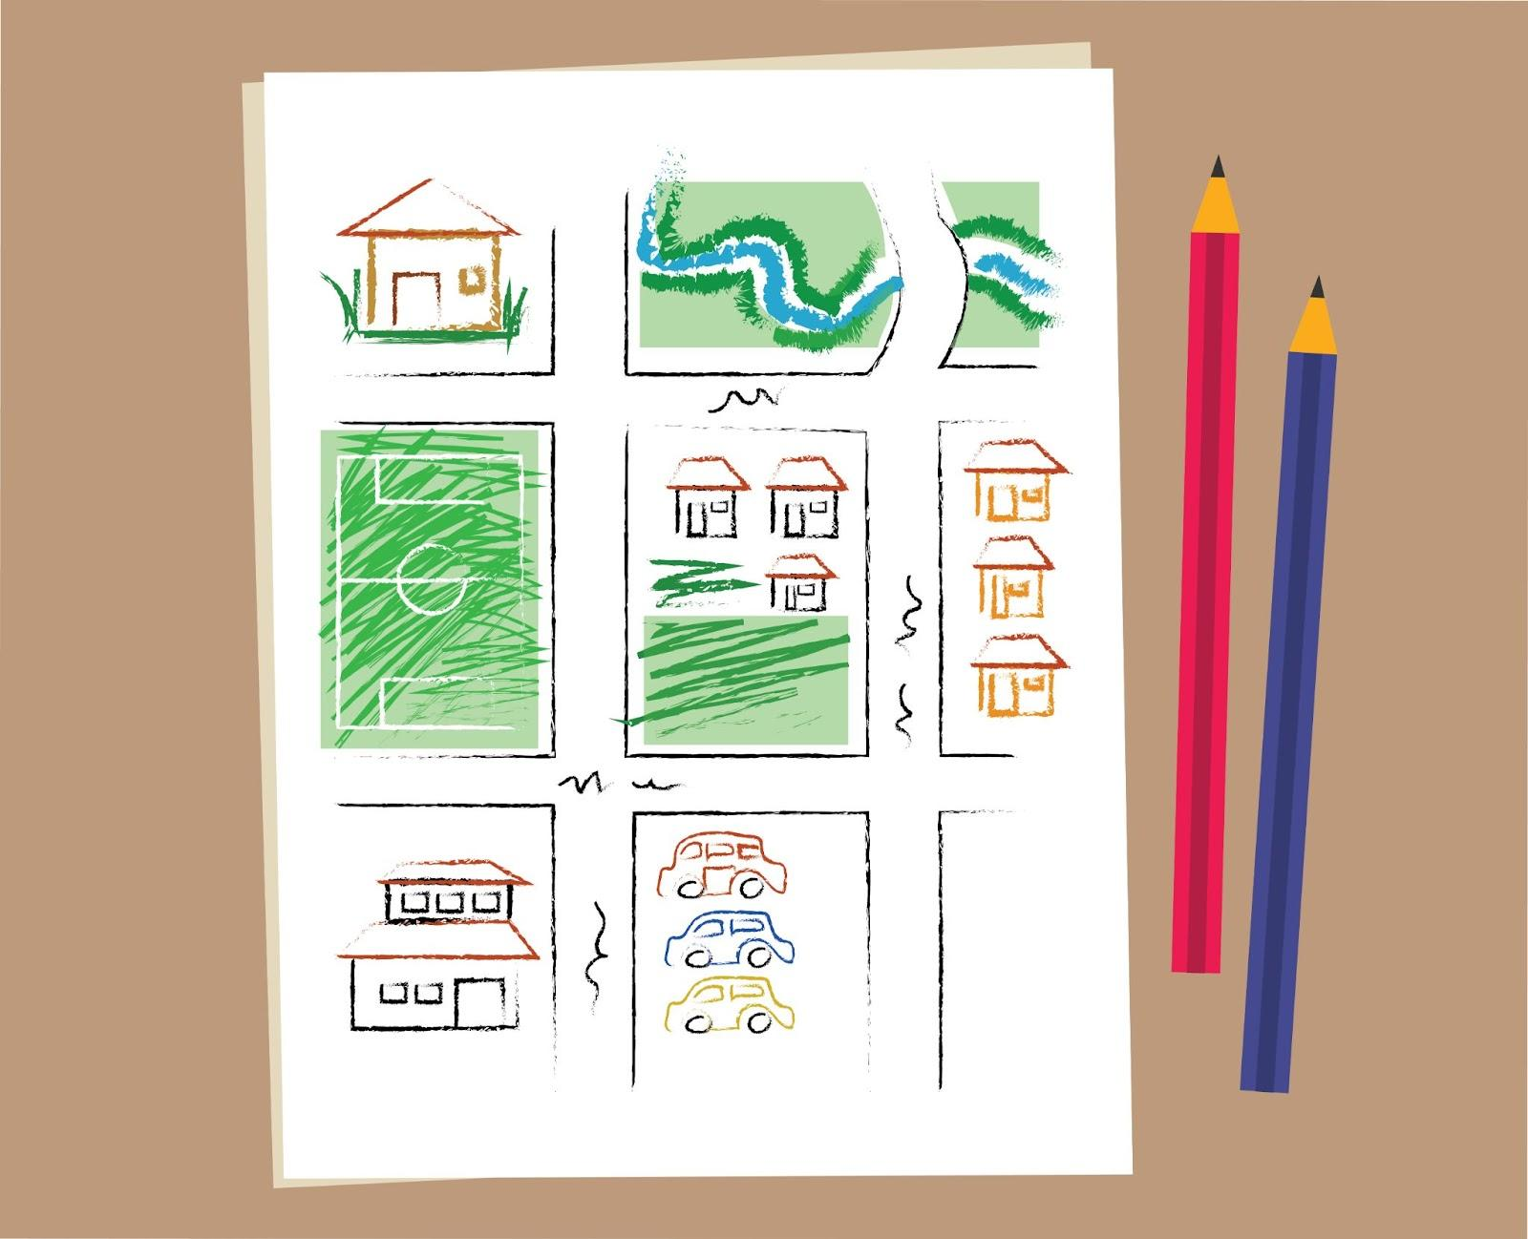
The next step is to DECIDE. Talk about places on your map and decide whether they are safe or not. Listen to your teen: they might have ideas about what’s safe too! When you have decided which are safe, circle those places. [1] Then, cross off any places that aren’t safe for teenagers. | DECIDE | Begin with previous sheet. Animate on [1]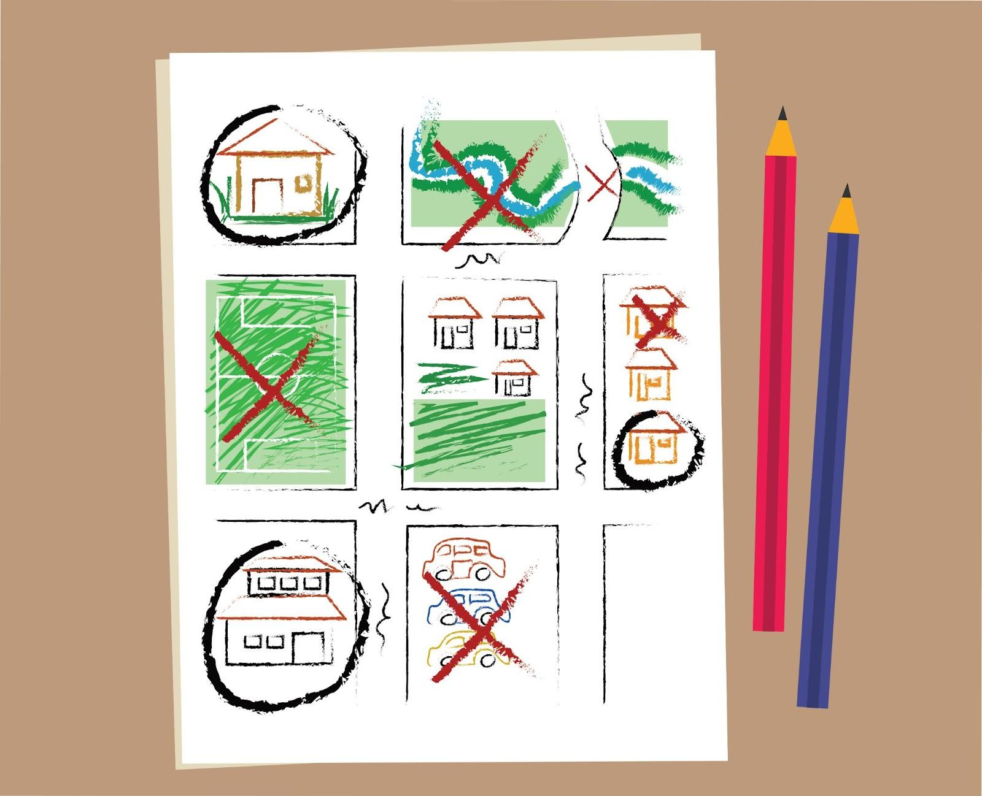
The final step is to DISCUSS. Sometimes, we find ourselves in trouble. Discuss where you and your teen can get support in a crisis. This may be home, school, a police station, or a clinic. [1] Mark these places clearly on your map. | DISCUSS | Begin with previous sheet. Animate on [1]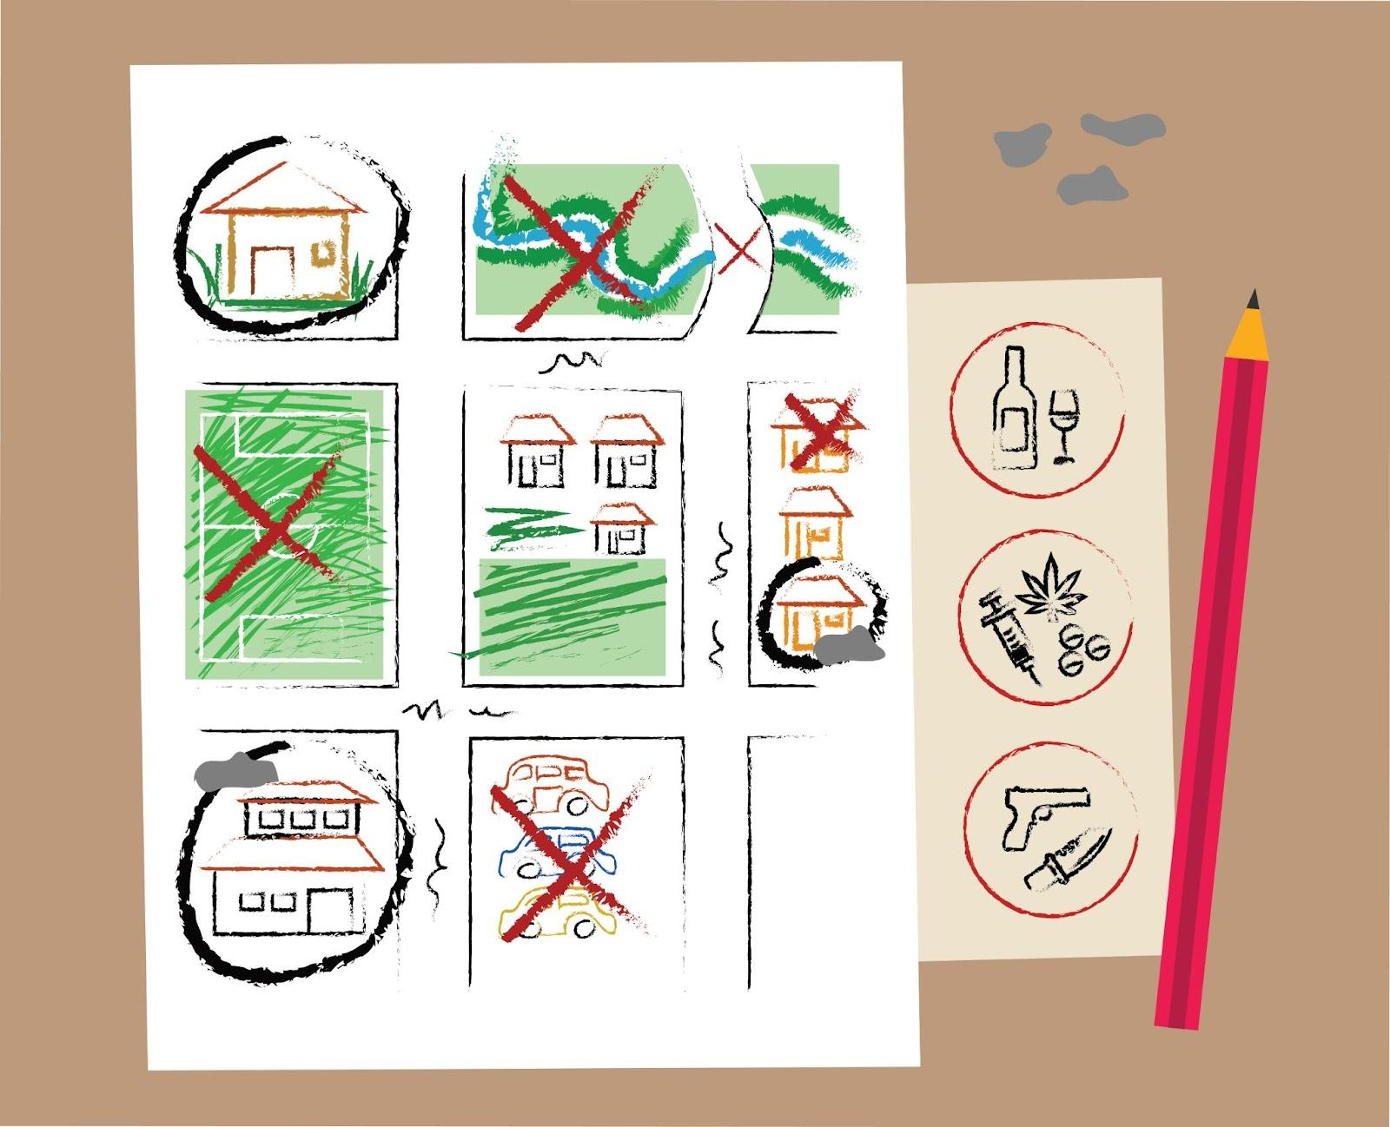
Remember, to create a community safety map:  [1] Draw a map of your community  [2] Decide with your teen the places that are safe and unsafe.  [3] Discuss where they can go for help, and mark those places on the map.  Talking about safety with your teen is a small way to make a big difference. Remind them that they can tell you about anything unsafe that happens without you getting angry. This will help you build trust with your teen.  Your home activity is to build a community safety map. Do you have time in the next few days to create a community safety map with your teen? | - Draw  - Decide  - Discuss  Home Activity: Create a community safety map with your teen.

Module: Respond to Crises
Script | On Slide Text | Animation Notes
Hello! This goal is all about keeping your teen safe and today we are learning about how to respond to your teen in a crisis.  It is important to support your teen when they experience a difficult situation. When helping your teen in a crisis, remember: breathe, listen, respond and comfort.  Let’s learn more about these steps together. | Respond to Crises  - Breathe  - Listen  - Respond  - Comfort
[1] While at first we might feel concerned, anxious or even angry, it’s important to remain calm, approachable and open.  The first step is to breathe. Stay calm. Ask yourself, “What does my teen need right now?”  [2] Next, listen. Allow your teen to share what they need to. Notice what they are feeling, such as shock or anger, and tell them you notice their emotions. This helps them feel understood. Tell your teen you are there for them and love them.  [3]The third step is to respond. What might help the situation? You might need to help your teen talk about their feelings or redirect their focus. Or you might need to discuss immediate actions to help them. You can give consequences later if needed.  [4]Finally, comfort your teen. It can be hard to see your teen feeling upset or confused, but there is a lot you can do to support them. They need you to accept them and provide comfort when in difficult situations. | BREATHE  Remain calm.  LISTEN  Listen to your teen and name their emotions.  RESPOND  What can help your teen right now?  COMFORT  Give your teen comfort.
Remember, you can always type HELP to ParentText to receive a list of contacts in your community for crisis support. They may be able to help. | HELP | Help Template
It can be difficult to see your child feeling upset or confused, but remember that there’s plenty you can do to support them during a difficult time. You’ve got this, you’re such a great parent!  Follow these steps whenever your teen shares something difficult. Supporting your teen through a crisis will also teach them how to support others in difficult times.  For your home activity, [1] Find a calm time to talk with Your Teen about possible crises that may happen. [2] Discuss what to do if they happen. [4] Revisit the Mapping Activity to identify other sources of support in the community. [5] And thank your teen for taking the time to chat about this.  Do you have time to do this today? | - Breathe  - Listen  - Respond  - Comfort  Home Activity: [1] Talk with your teen about possible crises. [2] Discuss what to do if they happen [3] Revisit the community safety map and identify other sources of support in the community. [4] Thank your teen. | Animate sentences to script either as bullets or in paragraph form. Show map from previous activity.  

Module: Teach Self Defence
Script | On Slide Text | Animation Notes
Hello! This goal is all about keeping your teen safe and today we are learning about self defence.  When we do not feel safe, we are allowed to do anything to get away. We can USE OUR VOICE and USE OUR BODIES to protect ourselves. | Teach Self Defence  - Use our voice  - Use our bodies
When we do not feel safe, we are allowed to do anything to get away.  Remember the last scenario, where the man tried to force the girl into his car? How could the girl use her voice to get away? She might shout…  - ‘No!’  - “Someone help me!”  - “I will call the police if you touch me again”  - "Do not touch my bum”  ;  Or she might try something else…  - “I will do anything you want, just please don’t hurt me.”  - “No lift for me, thanks. Last time I got a lift I threw up EVERYWHERE!”  - “I can see that you are angry. Let’s sit together and talk about it.”  - “I will give you my phone if you let me go.”  Consider, what would you do? There’s no wrong answer. | USE YOUR VOICE  - No!  - Someone help me!  - I will call the police if you touch me again  - Do not touch my bum  - I will do anything you want, just please don’t hurt me.  - No lift for me, thanks. Last time I got a lift I threw up EVERYWHERE!  - I can see that you are angry. Let’s sit together and talk about it.  - I will give you my phone if you let me go.
Next, use your body. When our voice does not stop the situation, we can use our bodies to defend ourselves. You should know your attacker’s targets and do what you can to hurt them: Scratch, Pull, Punch, Kick, or Twist your attacker. | USE YOUR BODY  Use your body to defend yourself.  - Scratch  - Pull  - Punch  - Kick  - Twist
There are four primary targets to know:  [1] The eyes  [2] Throat  [3] Groin  [4] and knees |  | Use illustration of body parts, add circle or dot or star to appear over each primary target animated with text.
There are also seven secondary targets:  [1] Temple  [2] Ears  [3] Nose  [4] Solar Plexus (the space between the ribs)  [5] Fingers  [6] Shin  [7] In Step (top of the feet)  Attack any of the targets to hurt your opponent and get away. |  | Use illustration of body parts, add circle or dot or star to appear over each primary target animated with text.
Your home activity is to share this information with your teen so they are ready to defend themselves. You can do it and ParentText can help. Type “SAFE” to repeat this lesson with your teen. Can you do it today? | Home Activity:  Type “SAFE” and repeat this lesson with your teen.

Module: Prevent Sexual Violence
Script | On Slide Text | Animation Notes
Hello! This goal is all about keeping your teen safe and today we are learning about preventing sexual violence.  In a dangerous situation, we may not know what to do and freeze or respond in an angry way – this is normal. These tools can help keep you and your teen safe:  KNOW IT  SEE IT  SAY IT  DO IT | Prevent Sexual Violence  - Know It  - See It  - Say It  - Do It
[1] First, know it. Know the difference between healthy and unhealthy relationships. If you are attacked, know that it is never your fault. You are allowed to say and do what is needed to stay safe and get away – do not worry about what others may think. You are worth being defended. You are strong and powerful.  [2] Next, see it. When someone makes you (or someone else) feel uncomfortable with what they say or do, that is never okay! We all have the right to feel safe, especially at home. Follow your intuition. When you feel attacked with words or actions, your goal is to get away.  [3] Third, say it. Your voice can stop many attacks. Yell ‘No!’, call for help, warn of consequences, name the behaviour, act crazy, pretend to go along to buy time, use humour, calm them down, or negotiate. Be clear, confident, and direct. Speak using your voice, body language, and eye contact.  [4] Finally, do it. When our voice is not changing the situation, we can use our bodies. Know the ‘weapons’ on your body and know the ‘targets’ on your attacker’s body. Use what is free on your body that you can fight with and what is open on the attacker’s body to hit.  If you do get hurt by someone, remember it is never your fault. Ask someone you trust for help, and make sure your teen knows they can tell you anything so you can find a solution together. | KNOW IT  Know that it is not your fault.  SEE IT  Recognize when you are unsafe.  SAY IT  Use your voice to get away.  DO IT  If your voice doesn’t work, use your body to get away.
Remember, you can always type HELP to ParentText to receive a list of contacts in your community for crisis support. They may be able to help. | HELP | Help Template
Your home activity is to help your teen be prepared by repeating this lesson together. To repeat this lesson type “PREVENT.” Can you do it today? | Home Activity: Type “PREVENT” and repeat this lesson with your teen.

Module: Treating each other as equals
Script | On Slide Text | Animation Notes
This goal is all about having a healthy relationship with our partners. Today, we are learning how to treat each other as equals. Let’s explore five ways to treat your partner as an equal and strengthen your relationship. | Treating each other as equals
[1] First, share decision making. The next time you are making a decision, try involving your partner and ask what they think.  [2] Involve your partner. It can sometimes be hard to remember to involve our partners in decision making. If you forget, keep trying!  Asking for their opinion shows that you care and want them to be involved.  [3] Remember, timing makes a difference. If you have a decision to make, bring it up during a time when you and your partner are not too busy, such as early in the morning or later in the evening.  [4] Finally, practice makes perfect. It can take time to get used to making decisions together. Give yourself time and keep trying! Remember that by communicating with your partner, you will both eventually start to feel more comfortable talking and sharing decisions. | - Share decision making  - Involve your partner  - Timing makes a difference  - Practice makes perfect
Your home activity is to involve your partner in a decision you are making today. Can you do it? | Home Activity: Involve your partner in a decision.

Module: Being a supportive partner and parent
Script | On Slide Text | Animation Notes
This goal is all about having a healthy relationship with our partners. Today, we are learning how to be a supportive partner and parent.  Here are some simple ways you can become a more confident and supportive partner AND parent. | Being a supportive partner and parent
[1] First, Show appreciation  Show your partner that you appreciate it when they spend quality time with your children.  [2] Next, work together.  If you are unsure how to work together with your partner, you should ask them! By asking, you show that you care and want to be involved!  [3] Step three is Lend a Hand. It can sometimes be difficult to remember to ask if your partner needs help. Once you start asking, they may realise you want to be more involved, and begin asking for your help on their own.  [4] Finally, ask for help. It can be hard to ask for help. Sometimes we expect our partners to know we need help even if we don’t ask them. Once you start asking, they will likely start offering to help more in the future. Remember to thank your partner! | - Show appreciation  - Work together  - Lend a Hand  - Ask for help
Your home activity is to try doing childcare or housework together with your partner. Do you have time to do it today? | Home Activity: Try doing childcare or housework with your partner

Module: Share Family Responsibilities
Script | On Slide Text | Animation Notes
This goal is all about having a healthy relationship with our partners. Today, we are learning how to share family responsibilities.  To share family responsibilities with your partner, try these four tips: | Share Family Responsibilities
[1] First, create a routine.  This can be hard to remember! Establishing a routine around caregiving or housework tasks can sometimes be helpful.  This also lets you talk to your partner about how to share the workload.  [2] Next, talk about the workload with your partner  Talking with your partner about how you can share family responsibilities helps both of you understand each other better.  It also shows that you care!  [3] Finally, remember to ask for help  It can be hard to remember to ask for help.  Be kind to yourself if you forget to ask and try again another time.  Asking for help and sharing family responsibilities benefits the whole family! | - Create a routine.  - Talk about the workload  - Ask for help
Your home activity this week is to invite your partner to discuss how you can share family responsibilities more evenly at home! Do you have time to do it today? | Home Activity: Discuss family responsibilities with your partner

Module: Resolving Conflicts Peacefully
Script | On Slide Text | Animation Notes
This goal is all about having a healthy relationship with our partners. Today, we are learning how to resolve conflicts peacefully.  Here are some tips you can try to resolve conflicts with your partner in a peaceful way. | Resolving Conflicts Peacefully
[1] First, Count to ten.  It can sometimes be really hard to stay calm when we’re having a disagreement with others.  Try to think of something that you can do that might help, like taking a couple deep breaths or counting to ten.  [2] Next, take a pause  Do you remember on the first day of this course, you learned how to close your eyes, breathe deep, and take a pause? Taking a pause before responding can help us stay calm and respond better a little later.  When you feel yourself getting angry, try taking a pause. You can do this!  [3] Finally, walk away if necessary.  Sometimes others respond to us negatively when we’re having a disagreement.  In these situations, especially if you feel fearful or threatened, it may be best to walk away for a bit until everyone has calmed down. | - Count to ten  - Take a pause  - Walk away if necessary
Remember, if you need help in a crisis, you can type HELP in ParentText to receive a list of community resources where you may find support.  Today’s home activity is to practise taking a pause before responding when you are feeling frustrated. Do you have time to practise taking a pause today? | Type HELP if you need assistance.  Home Activity: Take a pause today

Module: Listening and Talking to Each Other
Script | On Slide Text | Animation Notes
This goal is all about having a healthy relationship with our partners. Today, we are learning how to listen and talk with our partners.  Here are some tips on how you and your partner can listen and talk with each other in a supportive and loving way: | Listening and Talking to Each Other
[1] First, share how you feel with your partner.  Sharing how we feel and talking about the difficulties we’re facing is a sign of strength and can make everyone in the family stronger!  By sharing emotions you can better understand and support each other.  [2] Next, choose what you share.  Sharing your challenges with your partner is about making them more aware of how you are feeling.  Remember, you decide how much you share, and you can always choose to share more at a later time.  [3] Third, be kind to yourself.  Starting something new can be difficult. Give yourself and others time to get used to it.  [4] Finally, choose a time when you feel comfortable.  It’s okay if you don't always want to share your emotions.  You can choose to share how you’re feeling at a later time once you feel calmer. | - Share how you feel  - Choose what you share  - Be kind to yourself  - Choose a time when you feel comfortable
Today’s home activity is to try setting aside some time to talk to your partner about your feelings and any difficulties you’re facing. Do you have time to do it today? | Home Activity: Share your feelings and difficulties with your partner.

