HopeLine Application

# Getting Started

###### **NET Core 2 Install**

All are required to install **.NET Core 2.1** if haven’t already. Download the SDK from <https://www.microsoft.com/net/download> and install to your machine.

###### **TODO**

Before start coding, check all the TODO list that are already available to edit or implement. If using VS 2017, see the **task list** by doing this:

To open **Task List**, select **View** > **Task List**, or from the keyboard press **Ctrl**+**\**,**T**.

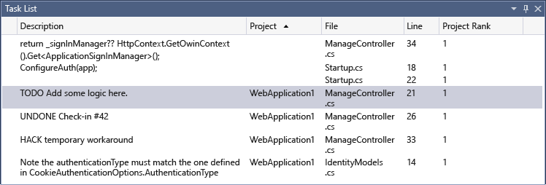

However, if using VS Code, install an extension called [TODO Highlight](https://marketplace.visualstudio.com/items?itemName=wayou.vscode-todo-highlight). To see more details, click [here](https://tommcfarlin.com/visual-studio-code-todo/).

To add task, follow this:

//TODO : description _or_comment - name_to_address(optional)

# Tech Stack

The Application is mostly using NET Core 2 for class libraries and web app. Make sure when creating a library, choose NET Core 2.1 for framework and NET Core Library for Project.

# Database Connection

###### **Connection String**

"Server=tcp:prj.database.windows.net,1433;Initial Catalog=HopeLineDB;Persist Security Info=False;User ID=hopeline;Password={same_password_as_outlook_with_FirstLetter_Uppercase)};MultipleActiveResultSets=False;Encrypt=True;TrustServerCertificate=False;Connection Timeout=30;"

# Project Dependencies

Below is the project dependency:

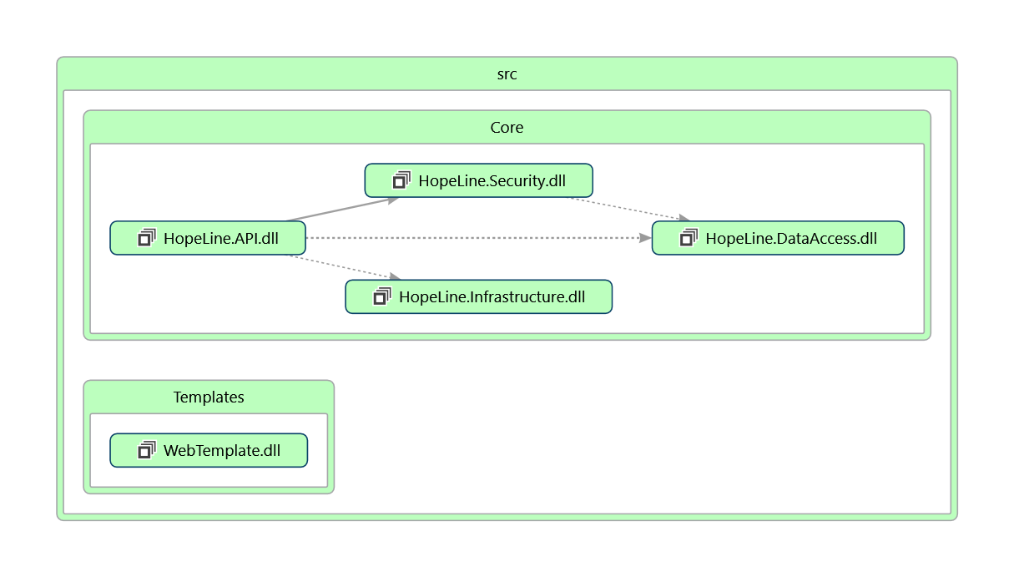

# Git/Github

###### **Zenit**

Make sure to pull *master* the repo from github to Zenit every Wednesday at 11pm.

###### **Branches**

All branches name should be meaningful and related to the task or logic implementing.

To create branch from master see the following:  
 <https://services.github.com/on-demand/github-cli/create-branches-git>

###### **Master**

Changes here are made before the meeting.