IdMUnit
Installation Guide

Prepared for Public Release (GNU GPL)

11570 Popes Head View Lane
Fairfax, VA 22030
www.trivir.com

January 10, 2007 v.1.2

Summary
IdMUnit is a must-have automated testing tool that integrates with Designer for Identity Manager. This suite, based on xUnit and Spring Framework architecture will automatically transform documented test cases into actual automated tests, execute them, and record the results (pass/fail/warning) in text and/or HTML output. This suite provides integrated policy, driver and system testing to accelerate the project release time-frame, ease development risk, control scope, and ensure logical compliance with functional requirements from design until deployment and beyond. Complete functional testing can now be completed for the entire identity management solution in seconds rather than weeks.

IdMUnit provides a quality-control compliment to Identity Manager as it quickly certifies that installed drivers are functioning according to business rules and solution specifications. It also works with TriVir's Data Comparator, which validates the state of every synchronized object and attribute to ensure that synchronization is working as expected throughout connected production systems. TriVir is is working on the release of a freely-distributable, open-source version of IdMUnit. If interested in participating or receiving a demo of the software, please send a request to info@trivir.com to obtain more information.

This document contains instructions for the installation and basic use of IdMUnit. More information can be obtained by emailing info@trivir.com or going to www.idmunit.org.

License information:
IdMUnit - Automated Testing Framework for Identity Management Solutions
Copyright (c) 2005-2006 TriVir, LLC
This program is licensed under the terms of the GNU General Public License
Version 2 (the "License") as published by the Free Software Foundation, and
the TriVir Licensing Policies (the "License Policies"). A copy of the License
and the Policies were distributed with this program.

The License is available at:
http://www.gnu.org/copyleft/gpl.html
The Policies are available at:
http://www.idmunit.org/licensing/index.html

Unless required by applicable law or agreed to in writing, this program is
distributed on an "AS IS" BASIS, WITHOUT WARRANTIES OR CONDITIONS
OF ANY KIND, either express or implied. See the License and the Policies
for specific language governing the use of this program.

www.TriVir.com
TriVir LLC
11570 Popes Head View Lane
Fairfax, Virginia 22030
IdMUnit
Keep the bar green to keep the solution clean!
Microsoft and Excel are registered trademarks of Microsoft Corporation. OpenOffice.org is a trademark of Team OpenOffice.org. Designer and Identity Manager are registered trademarks of Novell, Inc. IdMUnit is a registered trademark of TriVir, LLC.

Installation
The installation of IdMUnit consists of the following high-level steps:
- Download Designer for Identity Manager (Designer)
- Download the vanilla Eclipse 3.2 SDK
- Overlay Designer installation with Eclipse 3.2 (vanilla configuration)
- Install IdMUnit libraries
- Configure and execute IdMUnit tests

Note that IdMUnit 1.2 has been tested and validated with Designer 1.2 (the current shipping release as of January 2007) and with pre-release versions up to Designer 2.0 M5.1. Using IdMUnit with an officially tested/supported version of Designer is highly recommended. However, if a newer version of Designer is already being used, IdMUnit may be imported following the instructions in this document (skipping the step of downloading/installing Designer). Issues running IdMUnit with any newer release builds of Designer may be submitted to the IdMUnit project at http://sourceforge.net/projects/idmunit.

Also note that the instance of Designer running IdMUnit does not need to be the same instance of Designer where the project is installed. Running IdMUnit in one installation and/or instance of Designer while running another version of Designer is fully supported for those that like to run the nightly-builds of Designer and don't want to import IdMUnit into each installation of Designer.

At least a couple GB of hard disk space is required in order to follow these instructions. 1GB RAM or more is recommended.

Note that this documentation assumes that the target audience has experience in each of these areas:
- Novell Identity Manager
- Designer for Novell Identity Manager
- Microsoft Excel or OpenOffice Calc spreadsheets (note that at least one of these products should be installed on the IdMUnit machine in order to manipulate test spreadsheets)

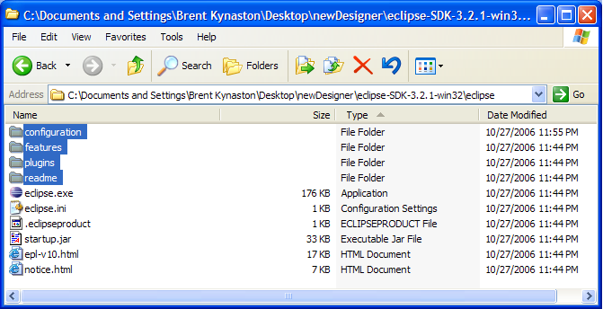
Installation Steps

Download and extract the latest built of Eclipse 3.2 to a temporary directory. Novell's packaged installation of Designer eliminated pieces of Eclipse that were not being used in order to streamline the install size. IdMUnit needs to leverage some additional Eclipse features not included in Designer distribution. Those dependencies will be included in the Eclipse archive. Eclipse may be downloaded from http://www.eclipse.org/downloads/

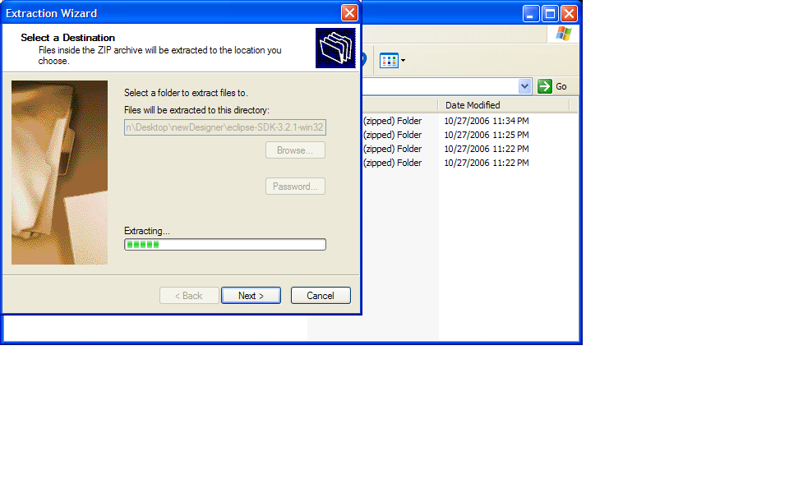
(Skip this step if Designer 1.2 or later is already installed) Download and install Novell Designer for Identity Manager from http://www.novell.com/coolsolutions/dirxml/designer/
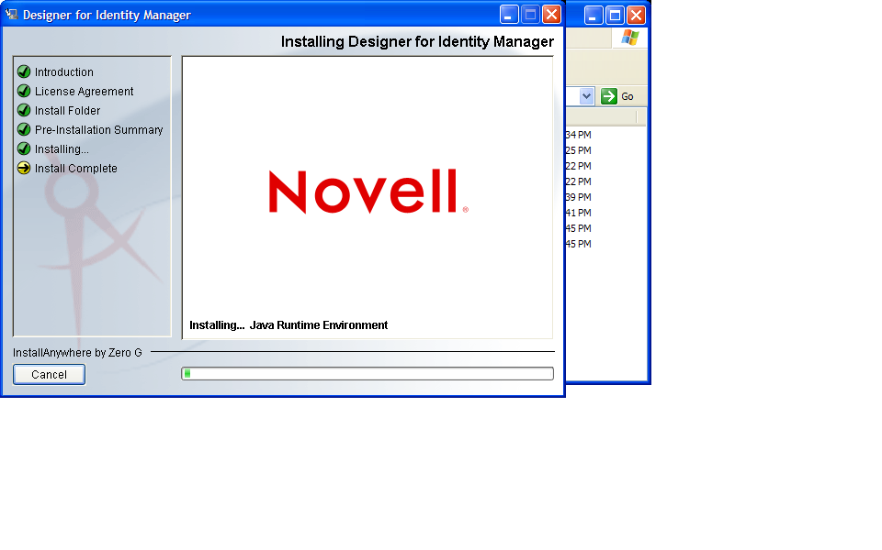

Run and validate the Designer installation.
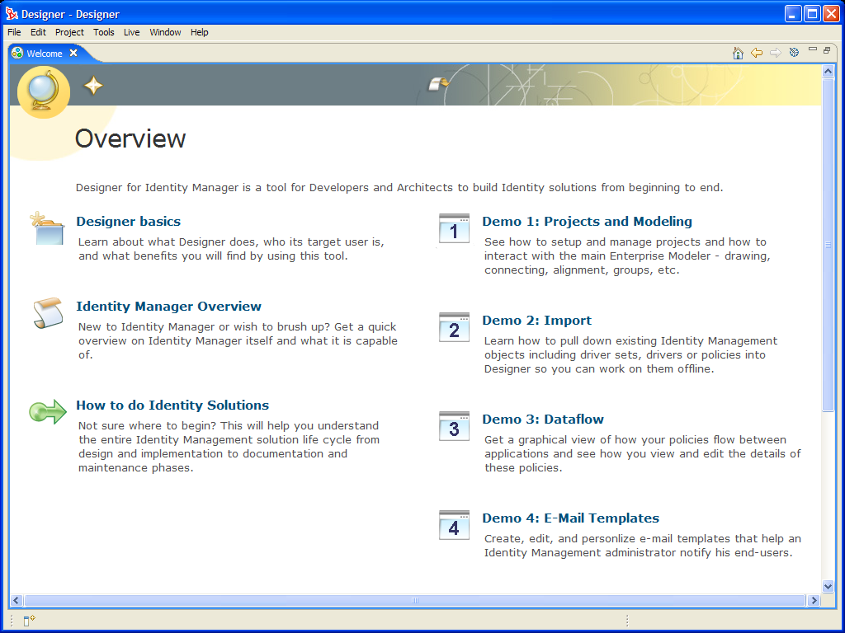

Next, overlay the latest Eclipse libraries over the Designer installation. This will enable standard Eclipse functionality (like the JUnit plug-in) that does not currently ship with Designer. Close Designer and copy the following extracted Eclipse 3.2 directories over the corresponding directories in the Designer installation directory. (Note that the Eclipse logo will now be displayed when loading Designer. In order to re-enable the Designer logo, copy the config.ini file from the Designer installation archive into eclipse/configuration).

configuration

features

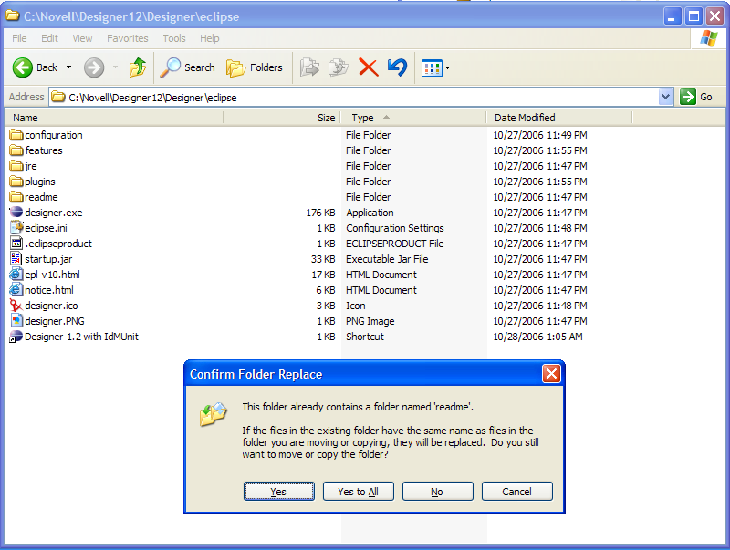
plugins

readme

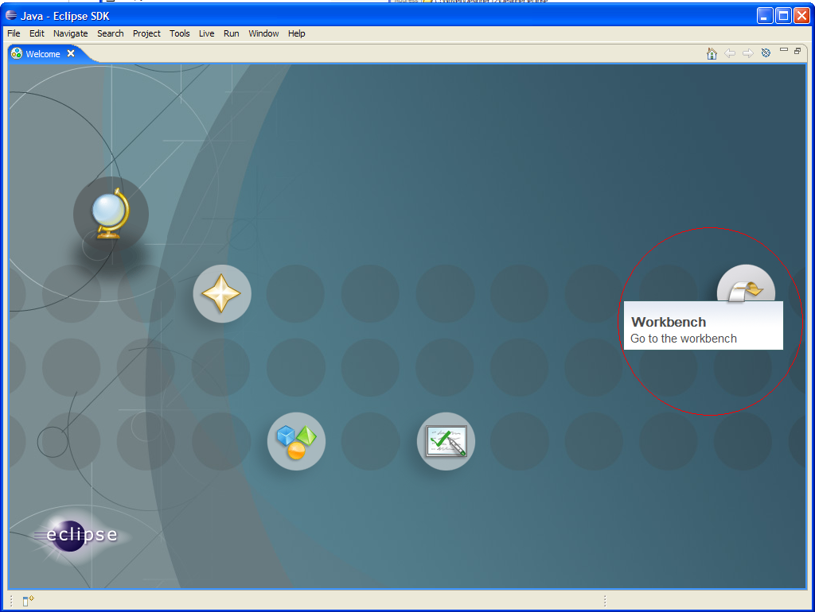
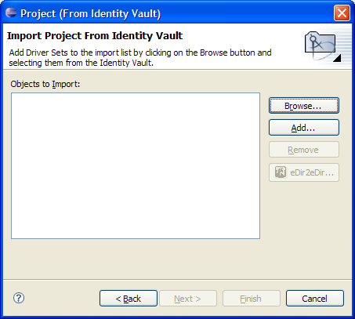
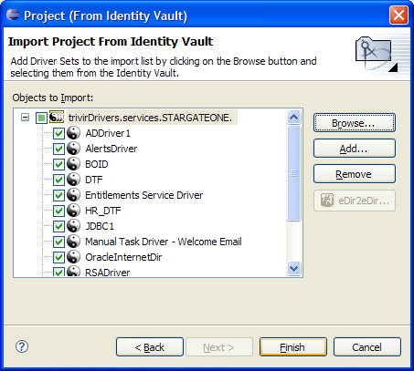
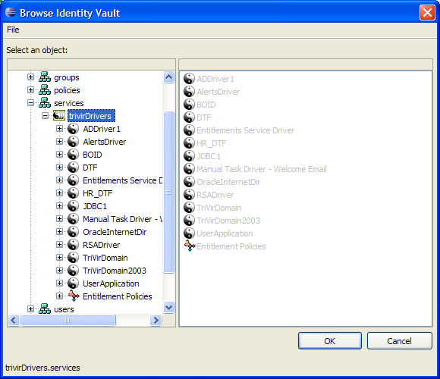
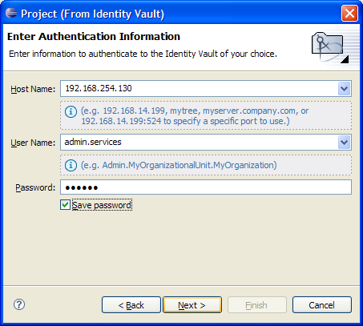
Download a copy of the appropriate version of IdMUnit from http://sourceforge.net/projects/idmunit. IdMUnit versions correspond to the latest shipping release of Designer (i.e. v.1.2). However, IdMUnit should also work fine with stable/tested pre-releases of Designer (i.e. v.2.0 M5.1).

Extract the IdMUnit release into the desired location. Note that the myProfiles folder contains system connection information and encrypted credentials. Generally there is a separate IdmUnit folder for each user when working in a shared development environment. The myTests folder contains the actual test definition spreadsheets, and may be shared between users. It is recommended that these spreadsheets be managed in a version control system.

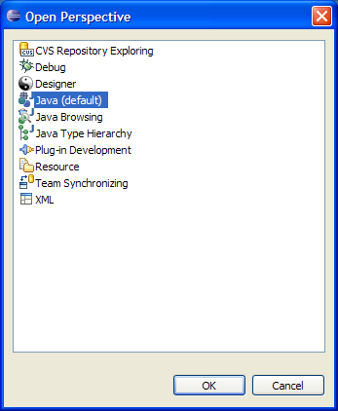
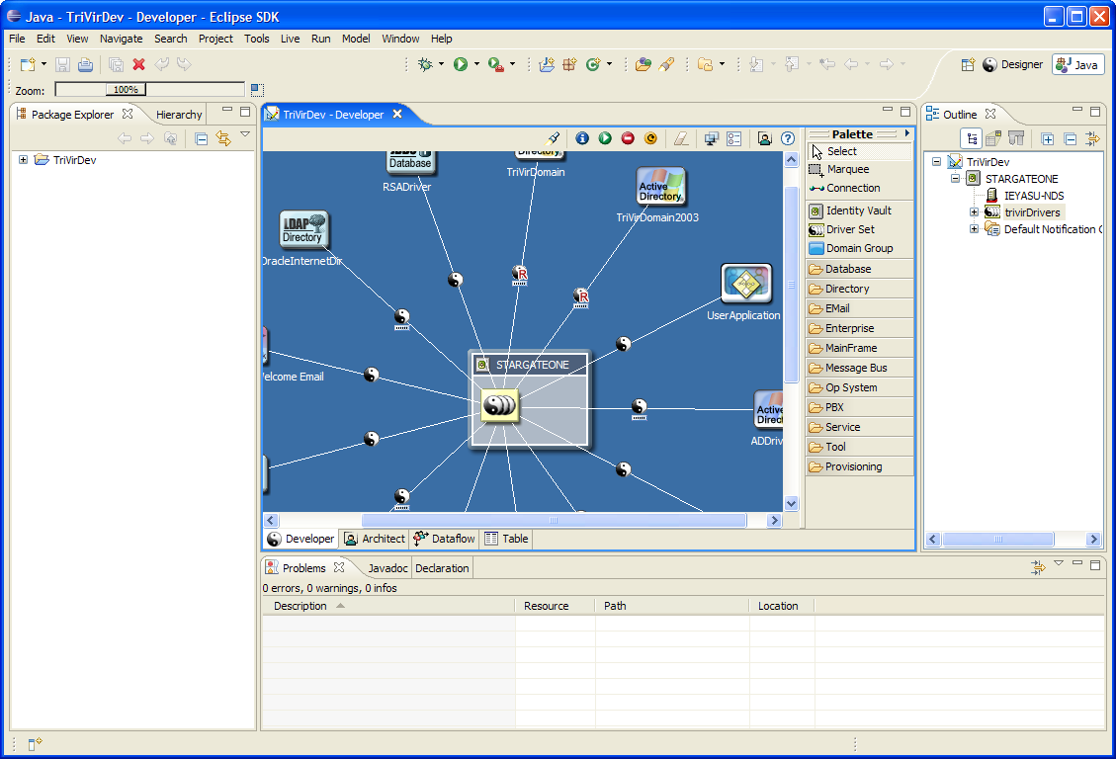
Setup the IdMUnit and Designer projects

Note that environment profile configuration for IdMUnit (i.e. IP addresses, credentials, etc.) is stored in the IdMUnit/myProfiles/idmunit-config.xml file. It is recommended that the following installation instructions are completed prior to modifying this file. Once installed and validated, IdMUnit may then be configured to talk to the local environment. Note that in addition to configuring the idmunit-config.xml file it will be necessary to update the example test spreadsheets to implement the appropriate test steps. See the IdMUnit usage guide for more details on this process.

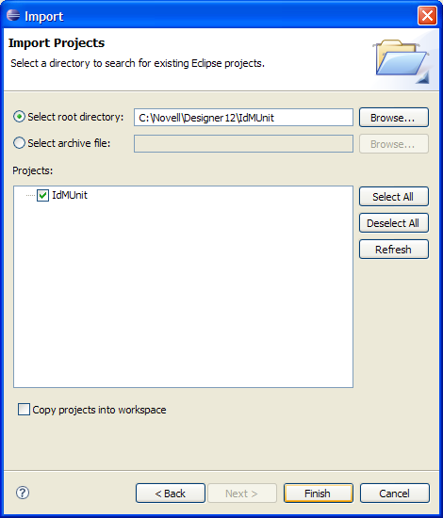
Run Designer, go to the Workbench and import/create a Designer project (see the Designer documentation for assistance as necessary to complete this step)

Switch to the Eclipse Java perspective by clicking Window --> Open Perspective --> Other --> Java

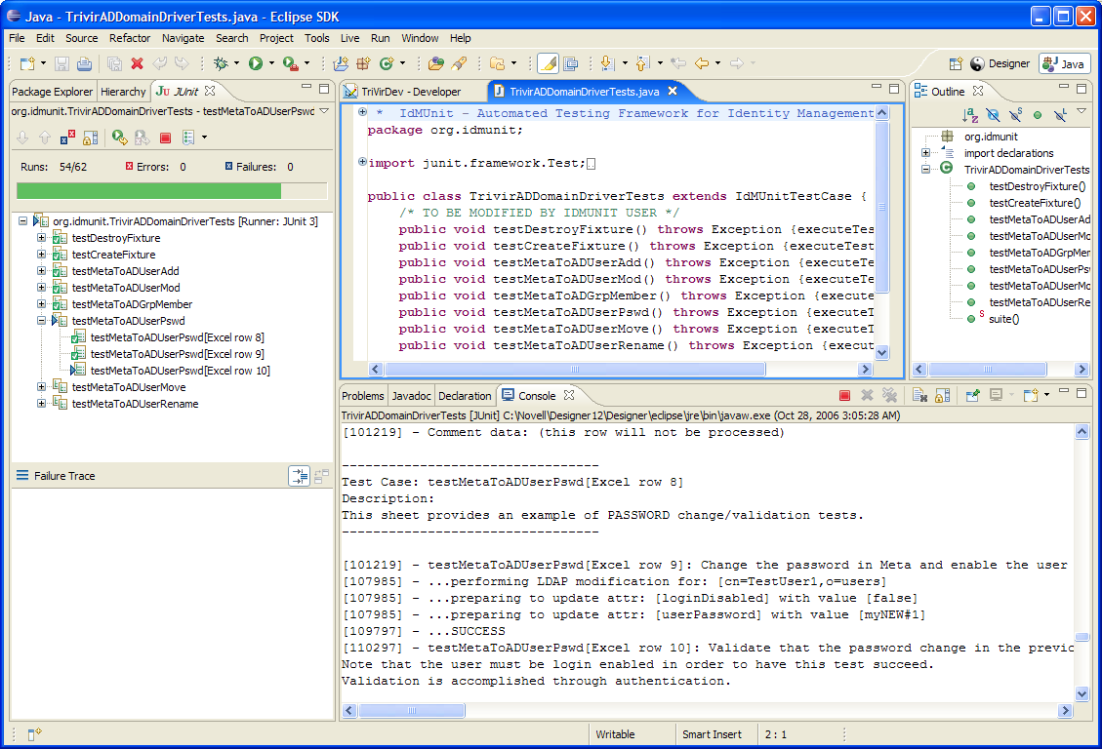
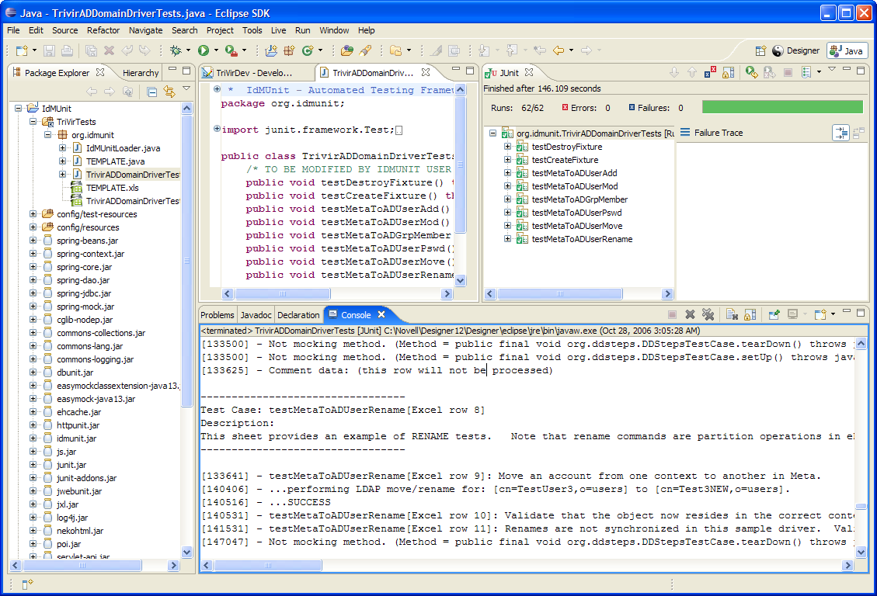
Import the IdMUnit project by clicking File --> Import --> expand the General section --> select Existing Projects into Workspace --> browse to the IdMUnit folder and click Finish. IdMunit should be visible now in the Package Explorer on the left pane.
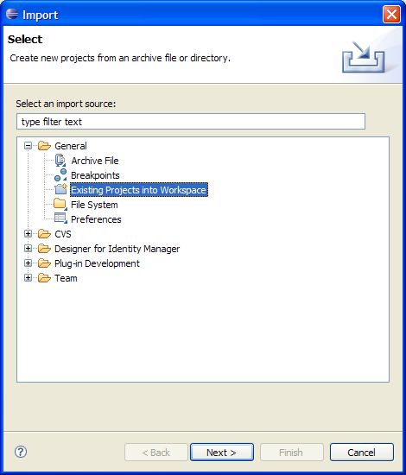
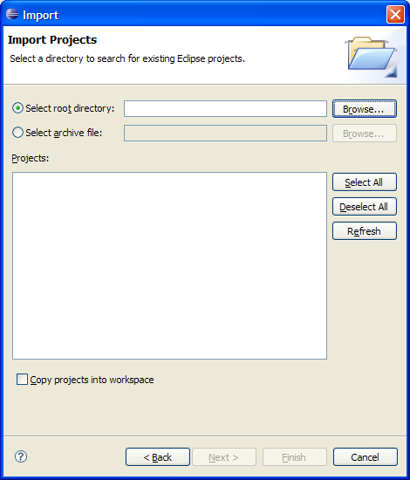
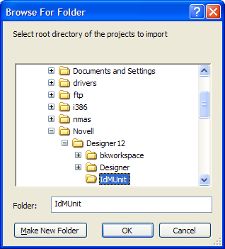
Once the IdMUnit project has been imported, configure the IdMUnit project to link in the desired profile configuration and test spreadsheet location by performing the following:
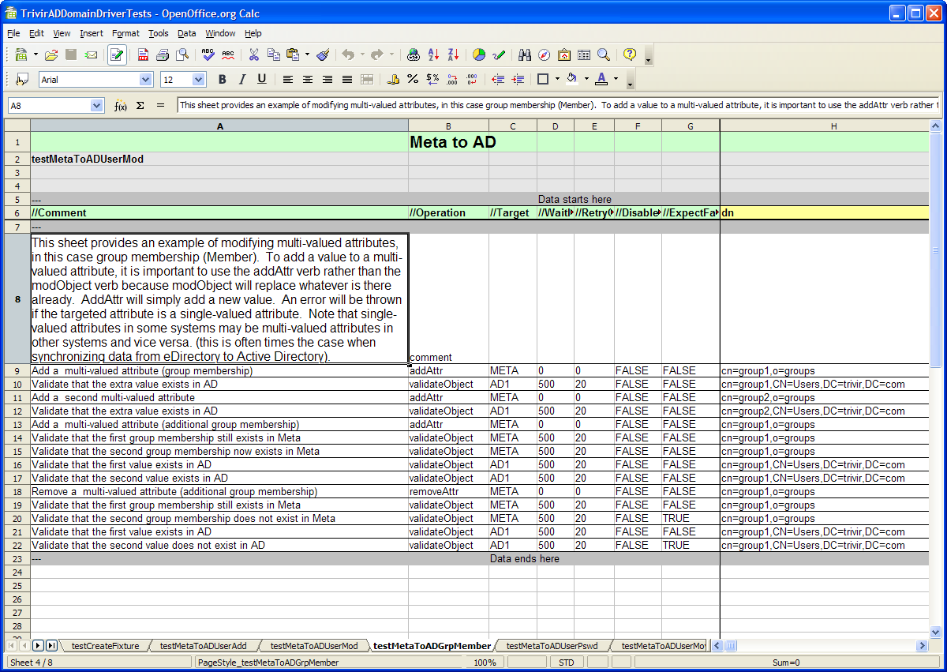
Select the IdMUnit project in the Package Explorer View. Click Project --> Properties --> Java Build Path --> click the Source tab --> double-click the SampleProfiles folder and update the file system path to point to the folder that contains the desired idmunit-config.xml for this project --> click Finish. Also double-click the SampleTests folder and update the path to point to the location where test spreadsheets are located (this folder should point to the org folder in the path org/idmunit where spreadsheets are stored in the idmunit folder). Note that IdMUnit is supported in a multi-user environment (i.e. terminal server, etc.) when a separate IdMUnit folder exists for each user. This step #4 can be repeated for every user .

Basic Usage

Expand the IdMUnit sample tests

Load the TrivirADDomainDriverTests.java test by double-clicking

Execute the TrivirADDomainDriverTests by running the test as a JUnit test (IdMUnit leverages the JUnit graphical user interface)

Highlight the TriVirADDomainDriverTests and click Run --> Run-As --> JUnit test
Note that firewall software such as Norton or McAfee might complain about the Java sub-system trying to listen on a network interface on port 4296. It is not necessary to allow this rule in the firewall. However, the firewall might need to be opened if remote debugging is desired.

As the IdMUnit tests for the selected test spreadsheet launch, the layout and placement of the test runner may be configured by dragging and dropping the Eclipse tabs

The Designer perspective and Java perspective may both be activated simultaneously and navigated by simply by clicking between the Designer project tab and the test tab in the upper right corner
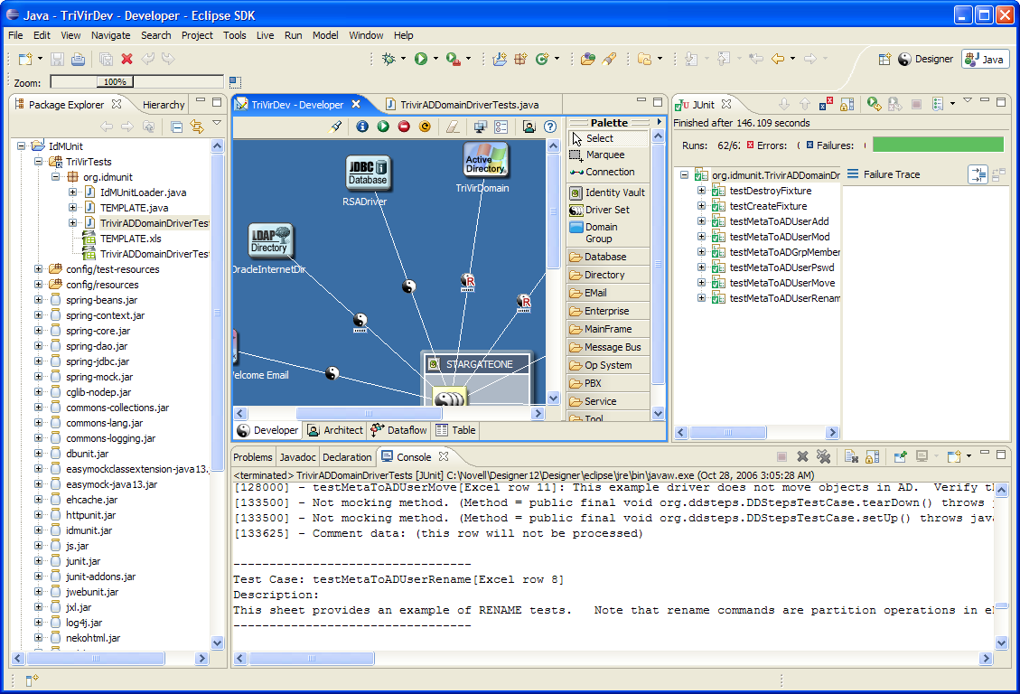

Test spreadsheets may be accessed and modified by double-clicking within the Eclipse Package Explorer view (Use OpenOffice or MS Excel for editing). Note that the first time a spreadsheet is opened from Designer, right-click and open with “System Editor”.

After saving a change in a test spreadsheet, it must be refreshed in the Eclipse project before it will go live (may refresh by right-clicking and selecting refresh, or by pressing F5 while selected)

A new test spreadsheet may be created by navigating on the file system to IdMUnit/myTests/org/idmunit and copying/pasting the test spreadsheet xls file and corresponding .java file. After copying and pasting, right-click the IdMUnit project in the Package Explorer view of Designer and select refresh. The .java class will need to be updated to contain the correct class name in the top of the class, and in the bottom test method. A simple search and replace with Ctrl-F can perform this function.

Appendix A – IdMUnit Profiles

Profile Configuration
Profiles contain a collection of connection information required for target systems. A single profile represents all of the necessary information required to talk to Identity Manager-connected systems within a single environment, like the development lab, test lab, or production environment. For additional details on the layout of a profile, see idmunit.dtd.

Sample profile excerpt:

<profile name="trivirLab">
<connection>
<name>META</name>
<description>Connector for the identity vault</description>
<type>org.idmunit.connector.LDAP</type>
<server>172.19.18.132</server>
<user>cn=admin,o=services</user>
<password>B2vPD2UsfKc=</password>
<keystore-path/>

Profile Selection
The “live-profile” specified at the top of the idmunit-config.xml file will be the profile used by IdMUnit for test execution. For example:
<idmunit live-profile="trivirLab" enable-email-alerts="true" enable-log-alerts="true">

This configuration would execute tests against the connections specified in the “trivirLab” profile.

Profile Use in a Multi-User Environment
The classpath of the project will determine which idmunit-config.xml file is applied. The Designer/Eclipse project properties link in the directory that contains the idmunit-config.xml file. This may be modified, per project to point to a separate directory. If multiple users are leveraging separate Designer workspaces on the same machine, they can each link in their own profiles folder so that tests can be run concurrently against different profiles. Note also that the build.xml file may be updated to point to any path for the profiles directory (this is the command-line Ant runner for IdMUnit).

Encrypt a password for use in the IdMUnit profile configuration
- Open the EncTool class in the Package Explorer
  - Expand the idmunit-core folder in the Package Explorer --> expand the org.idmunit package --> right-click EncTool and select Run-AS --> then select the green Run button
  - Select Java application in the left pane of the new pop-up window
  - Click the “new” icon in the top left-hand corner and a configuration layout will appear to the right
  - Select the arguments tab
  - In the Program Arguments field, type the following where mypassword is the actual password of the system
IDMUNIT1 mypassword

  - Click Run at the bottom and the password will be encrypted with DES and base-64 encoded.
  - Copy the generated password to the idmunit-profiles.xml for the target system
- Note that the key IDMUNIT1 may be changed, as long as the bytes for the key are specified in the top of the EncTool source in the “iv” class member variable:
private final byte[] iv = { 0x0a, 0x01, 0x02, 0x03, 0x04, 0x0b, 0x0c, 0x0d };

Import a certificate into IdMUnit for SSL communication via the LDAP connector
- Export a DER encoded trusted-root certificate (from the target AD DC, eDirectory or other LDAP server)
- Copy the DER encoded certificate onto the machine where IdMUnit is running. It may be copied into IdMUnit/util/security where a batch file resides that will help with importing the certificate into a Java certificate store
- Edit the IdMUnit/util/security/importCert.bat file to import the certificate into a known keystore as follows where MYCERT.cer is the name of the exported certificate file and the MYSSLKEY is the alias name of this certificate in the keystore:
SAMPLE importCert.bat:
java sun.security.tools.KeyTool -import -file MYCERT.cer -keystore keystore -alias "type=r.name=MYSSLKEY"

When executed, the keytool will ask for a password. Any password may be assigned to the keystore (remember this password in order to add additional certificates later on). The certificate file name and alias name may be parameterized with %1 and %2.

Questions/Comments?
Refer to www.idmunit.org or http://sourceforge.net/projects/idmunit for more information
or email info@trivir.com for training, support, consulting and mentoring services.

