Midterm exam

S11159005 黃毓峰

紅色為解答, 藍色為說明或是補充

1. What is the data type of variable x in the following C++11 code:

B. double

1. In C++, some of the following are legal identifiers. Which? Why?

legal identifiers (合法的): B, D

C++ 變數命名標準 : 非std裡面的名稱, 且只能用英文字母, 數字, _

第一個要是英文字母,

1. What is the output of the following, if it were embedded in an otherwise correct and complete program and run?
2. 10 13 16 19 . . .

附註 C, 不是無限迴圈, 當x overflow變成負數時就會結束

1. Which control construct repeats a sequence of statements zero or more times?
2. While
3. for statement
4. Here is a complete function that purports to return one of the roots of a quadratic given suitable parameters. It looks good, but fails to compile. Why?

以下可以編譯成功 ( *gcc version 10.2.1 20210110 (Debian 10.2.1-6)* )

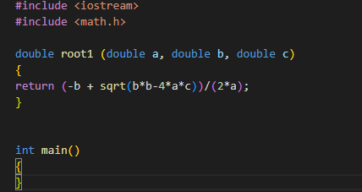

如果按照題目說明的程式編譯不成功, 有可能是忘了include math

或是把root1寫在其他function裡面(例如main), 如過是寫在function裡面要用lambda

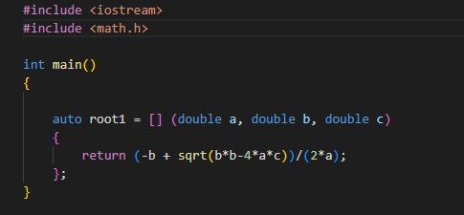

1. Here is a small program. Which of the statements about the variables is correct?
2. value is local variable in the main function
3. d is a local variable in the numTimes function.
4. There may be more than one correct answer. You must give all correct answers for full credit. An explanation is required.
5. j == 4, k == 18;

void One(int first, int & second), second 是 pass by ref, 所以會直接修改數值

並且second = first(固定會是17) + 1, 所以second會是固定18, 所以One(j, k), k的內容會是18, j是對應到first是pass by value,故不會收到修改.

8.  Consider the function

B. The call to doStuff results in the assignment n2 = 222;

如第七題, void doStuff(int parValue, int& parRef), parRef 是pass by ref, 故當呼叫doStuff(n1, n2);時只有n2會收到影響, 並且 parRef 會固定等於222.

1. Consider the following function definition:

Given these definitions what (if anything) is wrong with the following?

1. There is an illegal index in the loop.

準確來說, array b 的長度為5所以有效index範圍是 0~4, 但是i的範圍是1~5,會存取到array以外的內容, 發生無法預期的問題.

1. Explain the error in the following code. You may give the warning message, or error message, your compiler might give for the following error,  or you may describe the error. However you present the error, you must explain clearly what is wrong.

當把a(const int*)傳入show_array(int ar[], int size)的時候, 想當於把const int* 轉換成 int*, 這是不允許的.

簡單來說就是const不能消失.

1. Consider the class and struct definitions below.

True or False: All these statements will compile with no problem.

give some explanation…..

False, 因為b.i = 3;是private, 其他沒有問題.

1. What is the error in the following structure definition?

少一個分號

1. struct A
2. {
3. int b;
4. int c;
5. }; Where
6. int main()
7. {
8. A x;
9. // other code
10. }
11. It is legal to call a constructor as a member function of an object of a class, as in

 w.A(2,3); 不合法, 建構式只能在建構的時候使用, 解構式同理

14.  Which of the following are legal access to the class or struct members? Assume each is outside of the class member definitions, give me the explanation of each term

a) s.x (不行, 編譯錯誤, struct 忘了加;)

b) c.x (不行, x是private)

c) d.x (可以)

d) c.z (不行, z是private)

e) d.z (不行, z是private)