Create a name pattern on 8*8 led grid using Raspberry Pie.
Code:- import max7219.led as led matrix=led.matrix()
matrix.show_message("KAZIM,TALIB,VINO,SURAJ")

device = led.matrix() device.orientation(270)
device.show_message("RASHMITHA,VINDYA,MANITA,KIRAN,RASHMI ")
Output:-
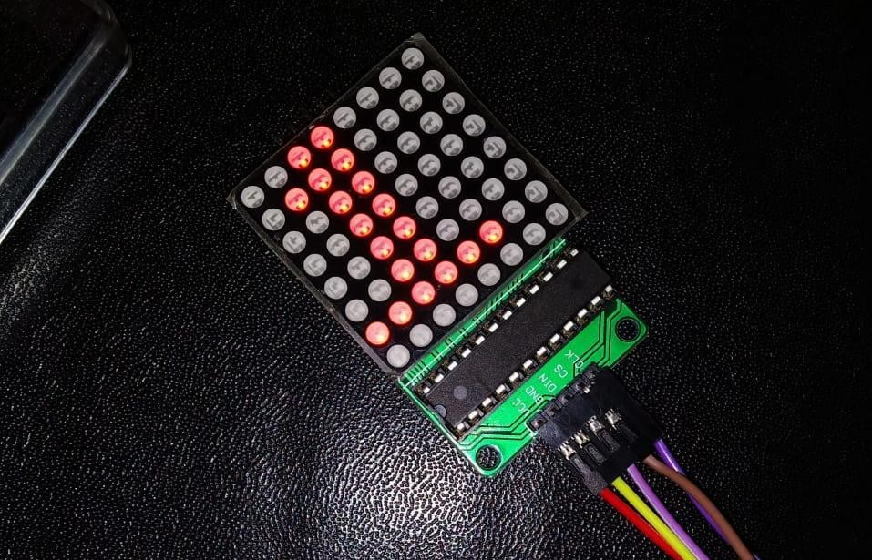

Smiley Face: -
Code:-
import max7219.led as led device=led.matrix() device.pixel(0,2,1) device.pixel(0,3,1) device.pixel(0,4,1) device.pixel(1,1,1) device.pixel(2,0,1) device.pixel(3,0,1) device.pixel(4,0,1) device.pixel(5,0,1) device.pixel(6,1,1) device.pixel(7,2,1) device.pixel(7,3,1) device.pixel(7,4,1) device.pixel(6,5,1) device.pixel(5,6,1) device.pixel(4,6,1) device.pixel(3,6,1) device.pixel(2,6,1) device.pixel(1,5,1) device.pixel(2,2,1) device.pixel(2,4,1) device.pixel(4,2,1) device.pixel(5,2,1) device.pixel(5,3,1) device.pixel(5,4,1) device.pixel(4,4,1)

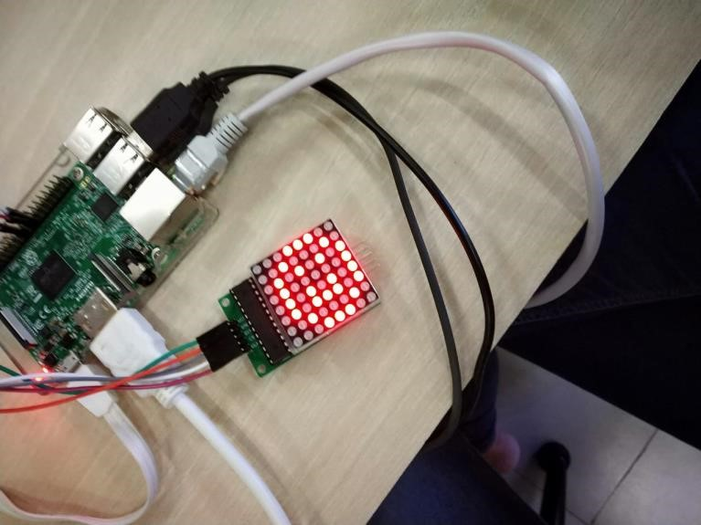
Output:
-

