Requirements-
- A Breadboard

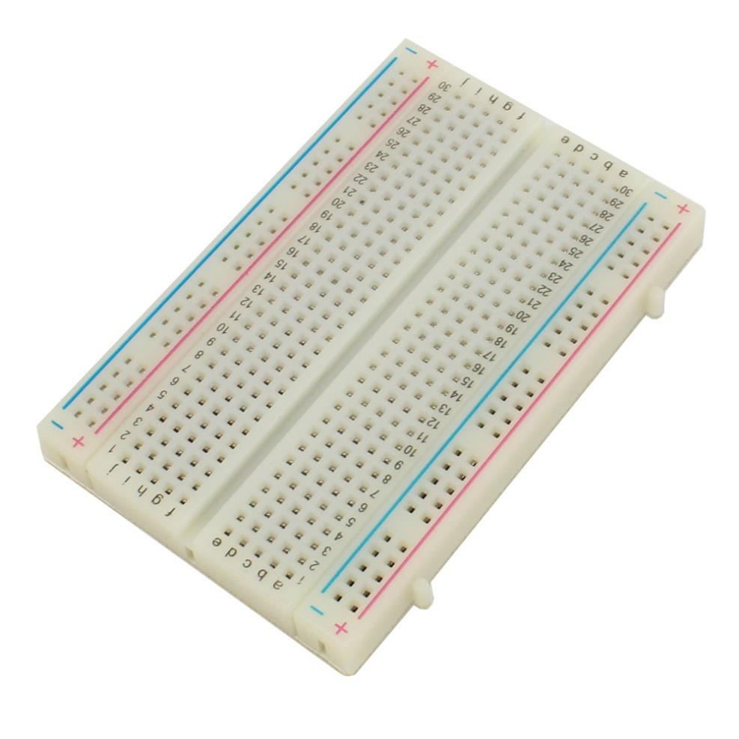

- An LED 3. Two Male Female jumper wires
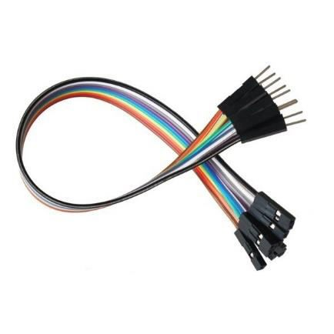


4. A 330 ohm resistor


Led On/Off:-
import RPi.GPIO as IO import time IO.setmode(IO.BOARD)
IO.setup(11,IO.OUT) IO.output(11,1) time.sleep(5) IO.cleanup() time.sleep(1)
IO.setmode(IO.BOARD)
IO.setup(11,IO.OUT) IO.output(11,1) time.sleep(5) IO.cleanup() time.sleep(5)
IO.setmode(IO.BOARD)
IO.setup(11,IO.OUT) IO.output(11,1) time.sleep(5) IO.cleanup()
time.sleep(5)

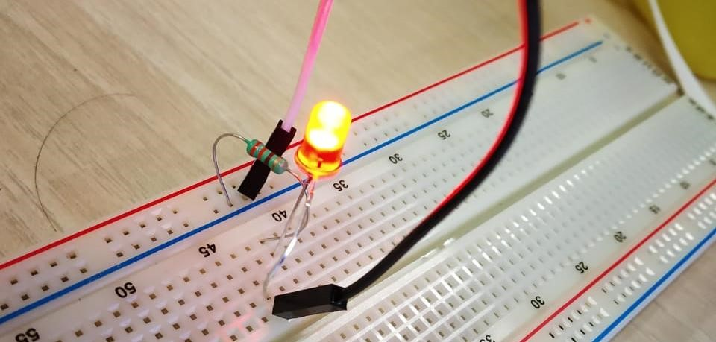
Output:
-

Led Blinking:-
Code: - import RPi.GPIO as IO import time IO.setmode(IO.BOARD)
IO.setup(18,IO.OUT) IO.output(18,1) time.sleep(1) IO.cleanup() time.sleep(1) IO.setmode(IO.BOARD)
IO.setup(18,IO.OUT) IO.output(18,1) time.sleep(1) IO.cleanup() time.sleep(1) IO.setmode(IO.BOARD)
IO.setup(18,IO.OUT) IO.output(18,1) time.sleep(1) IO.cleanup() time.sleep(1)

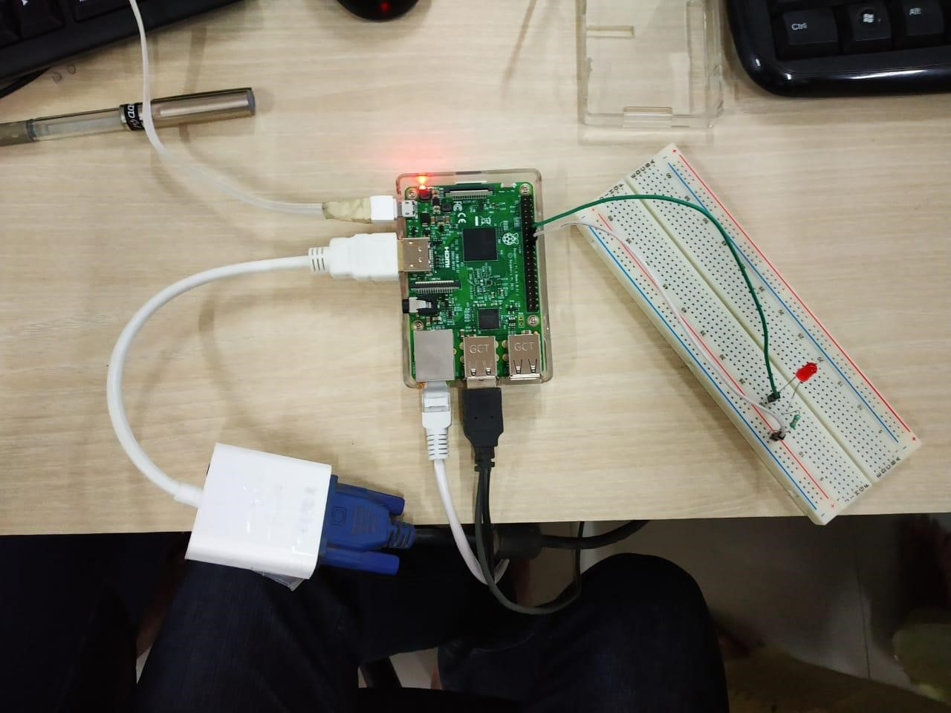
Output:
-

