INSTALLING RASPBIAN DEBIAN OPERATING SYSTEM USING WINDOWS
FORMAT THE SD CARD
1) Dowload the file “RASPBIAN Debian” and extract the image file.

2) Locate your SD card drive, in Windows Explorer, and secondary-click the mouse to bring up the context-senstive menu. From the menu select Format…. Ensure that the option FAT32 (Default) is selected and click Start.

Selecting an SD card to format
3) A few moments later you will see a confirmation that the format has been completed and you SD card is now ready for the next stage.
Formatting the SD card

USING WIN32DISKIMAGER
Download the Win32DiskImager utility from the Sourceforge Project page (it is also a zip file); you can run this from a USB drive.
Having plugged in your SD card, (re)start Win32Diskimager. Choose the drive you want to copy the image to (in my case F:).
choose the drive with your SD card to write the OS image on
Then click on the folder icon and choose the unzipped .img file from earlier that you want to put on the SD card. Then click Write, to write the Operating system on the card from the .img file.
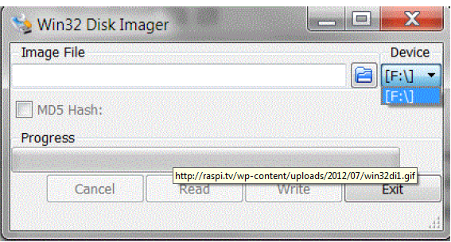

Write OS image from .img file to SD card
You will then be asked to confirm. Check carefully that you are writing to the correct device and if so, click Yes.
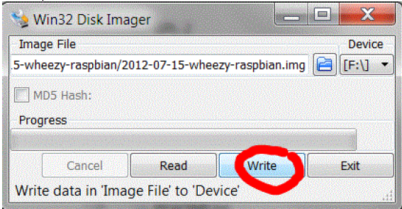

Check device and confirm
The progress bar will show you how far it’s got.
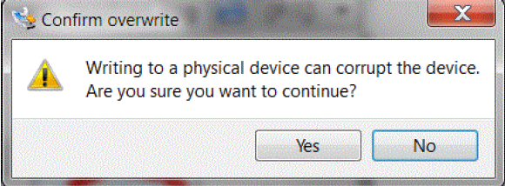

Progress indicator
When it’s finished it looks like this.
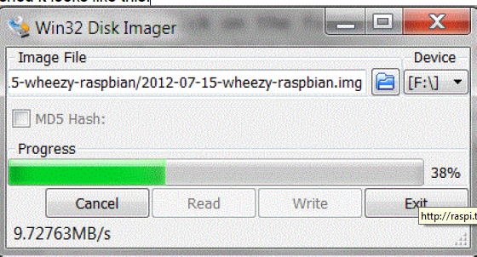

Finished
Then you can eject the card reader and remove the SD card. Then you can try it out in your Raspberry Pi
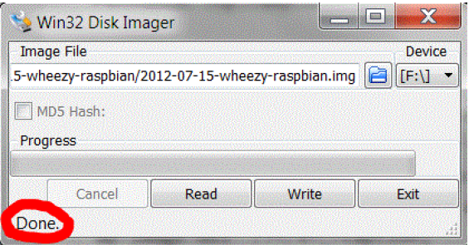

PLUGGING IN YOUR RASPBERRY PI
1) Begin by slotting your SD card into the SD card slot on the Raspberry Pi, which will only fit one way.
2) Next, plug in your USB keyboard and mouse into the USB slots on the Raspberry Pi. Make sure that your monitor or TV is turned on, and that you have selected the right input (e.g. HDMI 1, DVI, etc).
3) Then connect your HDMI cable from your Raspberry Pi to your monitor or TV.
4) If you intend to connect your Raspberry Pi to the internet, plug in an Ethernet cable into the Ethernet port next to the USB ports; if you do not need an internet connection, skip this step.
5) Finally, when you are happy that you have plugged in all the cables and SD card required, plug in the micro USB power supply. This action will turn on and boot your Raspberry Pi.

LOGGING INTO YOUR RASPBERRY PI

1). Once your Raspberry Pi has completed the boot process, a login prompt will appear. The default login for Raspbian is username pi with the password raspberry. Note you will not see any writing appear when you type the password. This is a security feature in Linux.

2) After you have successfully logged in, you will see the command line prompt pi@raspberrypi~$.

3 ) To load the graphical user interface, type startx and press Enter on your keyboard

