Stats questions
Combinatorics:
Q. No of ways 4 students can be arrange in a row?
Q. How many ways 6 students can be seated, if two of the students insist on seating next to each other?
Q. married couples have bought 8 seats in the same row for a talent show. How many different ways can they be seated: (a) with no restrictions (b) if each couple is to sit together (c) if all men sit together to the right of all women?
Q. Why do we use (n-1) as circular permutation?
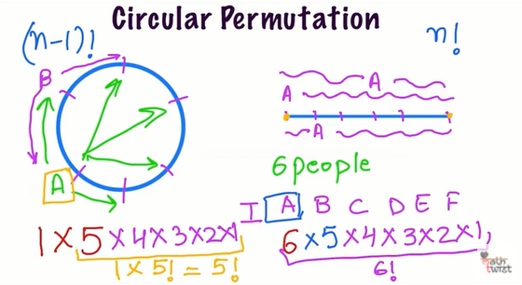
Circular permutation
is (n-1)!

Q. Boys and girls youtube lec By eddie woo
Q. Boys and girls roundtable lec by eddie woo

Appendix
Q. (n-1)
