Resources
learn about all keys , composite key , repeated attributes ,

The information in a database can be thought of as a spreadsheet, with columns (known as fields or attributes) representing different categories of information, and tuples (rows) representing all the information from each field associated with a single record.
Favourite sentences
COMPOUND KEY has two or more attributes that allow you to uniquely recognize a specific record. It is possible that each column may not be unique by itself within the database. However, when combined with the other column or columns the combination of composite keys become unique. The purpose of the compound key in database is to uniquely identify each record in the table.
In this example, OrderNo and ProductID can't be a primary key as it does not uniquely identify a record. However, a compound key of Order ID and Product ID could be used as it uniquely identified each record.

COMPOSITE KEY , similarly like The difference between compound and the composite key is that any part of the compound key can be a foreign key, but the composite key may or maybe not a part of the foreign key.
-----
A column or group of columns in a table which helps us to uniquely identifies every row in that table is called a primary key
Sometimes more than one attributes are needed to uniquely identify an entity. A primary key that is made by the combination of more than one attribute is known as a composite key.

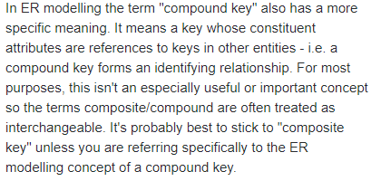
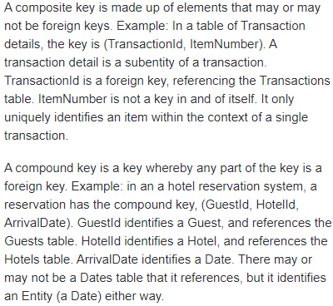

ALTERNATE KEYS . A table can have multiple choices for a primary key but only one can be set as the primary key. All the keys which are not primary key are called an Alternate Key.
In this table, StudID, Roll No, Email are qualified to become a primary key. But since StudID is the primary key, Roll No, Email becomes the alternative key.

CANDIDATE KEY is a super key with no repeated attributes. The Primary key should be selected from the candidate keys. Every table must have at least a single candidate key. A table can have multiple candidate keys but only a single primary key.
Example: In the given table Stud ID, Roll No, and email are candidate keys which help us to uniquely identify the student record in the table.
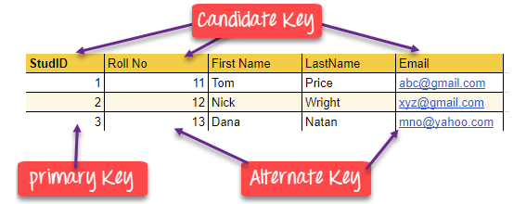
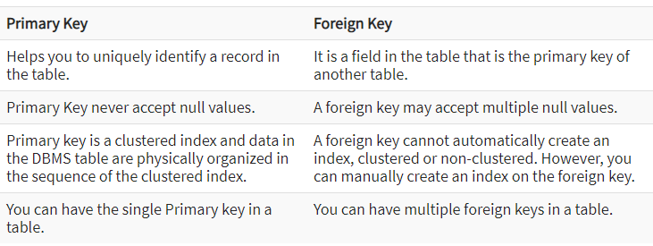
{The value in a primary key column can never be modified or updated if any foreign key refers to that primary key.}*
Candidate key:{ It should contain minimum fields to ensure uniqueness,Candidate key is also a unique key to identify a record uniquely in a table but a table can have multiple candidate keys. Primary key column value can not be null.Candidate key column can have null value. }*
Primary key is a minimal super key.
A superkey is a set of attributes within a table whose values can be used to uniquely identify a tuple.
Examples of superkeys in this schema would be {employeeID, Name}, {employeeID, Name, job}, and {employeeID, Name, job, departmentID}. The last example is known as trivial superkey, because it uses all attributes of this table to identify the tuple.
This is a minimal superkey—that is, a minimal set of attributes that can be used to identify a single tuple. employeeID is a candidate key.

The constituent attributes are called prime attributes. Conversely, an attribute that does not occur in ANY candidate key is called a non-prime attribute.
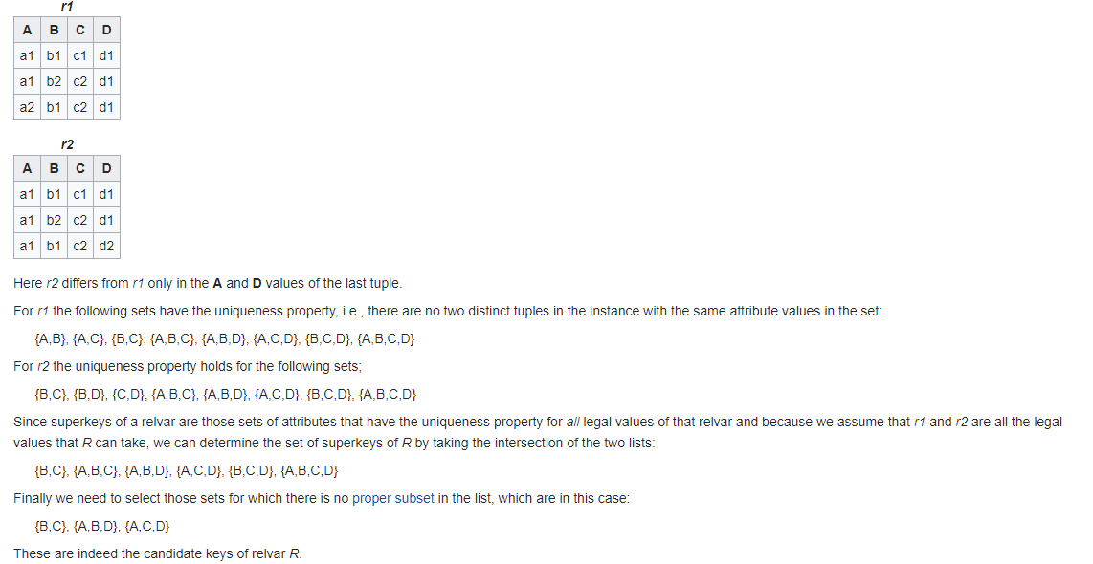
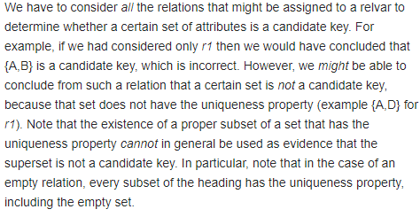

A candidate key is a minimal set of attributes necessary to identify a tuple; this is also called a minimal superkey
Unique key: {You can say that it is little like primary key but it can accept only one null value and it cannot have duplicate values. There may be many unique key constraints for one table, but only one PRIMARY KEY constraint for one table. }*
A super key with no repeated attribute is called candidate key? Idk why
Superkey is a group of single or multiple keys which identifies rows in a table. A Super key may have additional attributes that are not needed for unique identification.

PRIMARY KEY CANDIDATE KEY
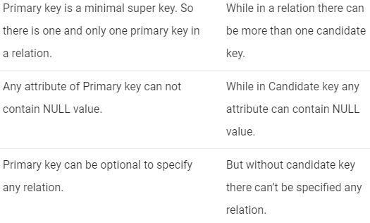

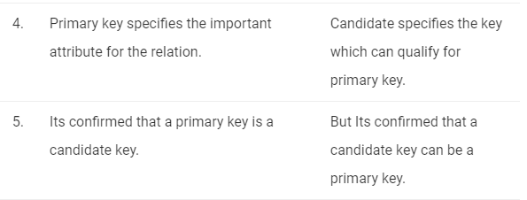

SUPER KEY PRIMARY KEY
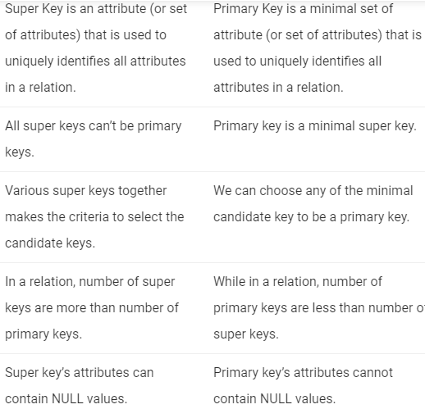

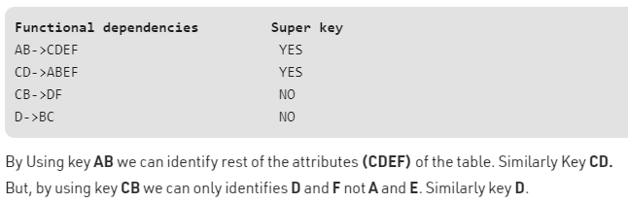

NORMAL FORM
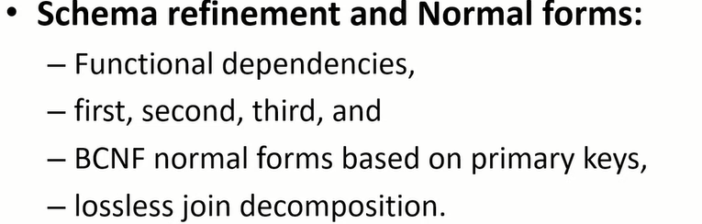

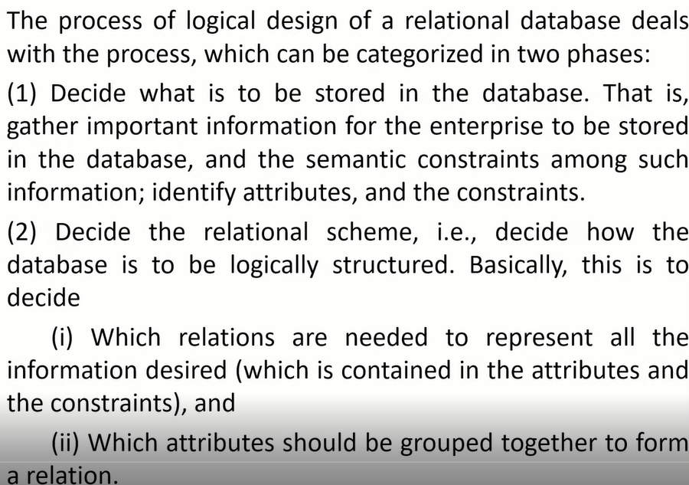
Constraints: Entity constraint, referential constraint, semantic constraint.
Semantic constraint:Datatype
